BUILDING MANAGERS LIST

REQUEST TO ADD/REMOVE BUILDING MANAGERS
SAMPLES OF EMAIL NOTIFICATIONS
VIEW THE CURRENT BUILDING MANAGER LIST

Table of Contents
SUMMARY 3
OBJECTIVES 3
ADDITIONAL NOTES 3
CHAPTER 1: REQUEST TO ADD/REMOVE BUILDING MANAGERS 4
1.1 ACCESS TO THE BUILDING MANAGER FORM 4
1.2 HOW TO SUBMIT A REQUEST TO “ADD” A BUILDING MANAGER 5
1.3 HOW TO SUBMIT A REQUEST TO “REMOVE” A BUILDING MANAGER 10
1.4 HOW TO SUBMIT A REQUEST TO “ADD” AND “REMOVE” A BUILDING MANAGER 14
1.5 IF A BUILDING # / NAME IS NOT FOUND 21
CHAPTER 2: SAMPLES OF EMAIL NOTIFICATIONS 23
2.1 NOTIFICATION THAT SUBMITTER’S REQUEST HAS BEEN SUBMITTED 23
2.2 NOTIFICATION THAT SUBMITTER’S REQUEST HAS BEEN APPROVED 25
2.3 NOTIFICATION THAT SUBMITTER’S REQUEST HAS BEEN DENIED 27
CHAPTER 3: VIEW THE CURRENT BUILDING MANAGER LIST 28

SUMMARY:

Northern Arizona University currently has a list of Building Managers that are associated with each Building within NAU Flagstaff Main Campus.
Building Managers, and other university employees, at Northern Arizona University provide invaluable assistance in preserving the functionality, safety and beauty of the campus and its buildings. A diverse group of university staff, service professionals, faculty, as well as full-time building managers, hold the distinction of being responsible for a campus building. Since NAU’s buildings are used for a variety of purposes and are at different levels of restoration, the Dean or Director should work closely with the Building Manager to clarify the scope of responsibilities expected of the Building Manager. Those responsibilities should be clarified for all building occupants.

OBJECTIVES:

The purpose of this document is to provide work instructions on how to:
- Request to Add/Remove Building Managers
- Samples of Email Notifications
- View the Current Building Manager List

ADDITIONAL NOTES:

- All information associated with the Building Manager List Program can be found at:
https://in.nau.edu/facility-services/fac_staff/

- Any questions about the Building Manager List process can be sent to BuildingManager@nau.edu or Contact the Facilities Work Control Center at 928-523-4227

- To communicate to all current Building Manager’s email at and email request will be approved by a moderator:
NAU-BUILDING-MANAGERS@xdl.nau

REQUEST TO ADD/REMOVE BUILDING MANAGERS

The following section will provide detail on how to submit a request to either Add and/or Remove a Building Manager from the existing Building Manager List.

1.1 ACCESS TO THE BUILDING MANAGER FORM

Step #1)
Go to the following website and click on “Update Form for Building Managers List”
https://in.nau.edu/facility-services/fac_staff/

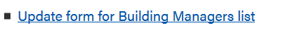

Step #2)
Once you have successfully CAS Signed In, the Building Manager Form will appear and the following section will auto populate based on your CAS Sign On.

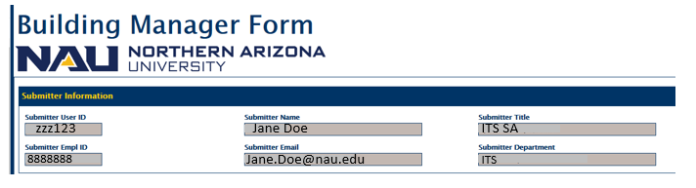

1.2 HOW TO SUBMIT A REQUEST TO “ADD” A BUILDING MANAGER

Step #1)
Within Request Type, select “Add”:

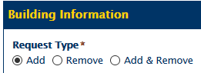

Step #2)
Select the Date you want the New Building Manager to be Added to the Building Manager List

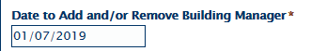

Step #3)

Within the following field, enter the Building # and/or Building Name in the following field & select “Building Search”

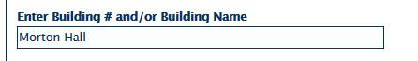

The following Results will Appear:

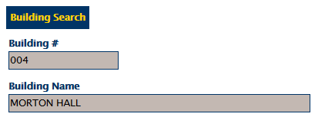

OR

Select “Building Search” to Select from a List of Existing Building’s on File

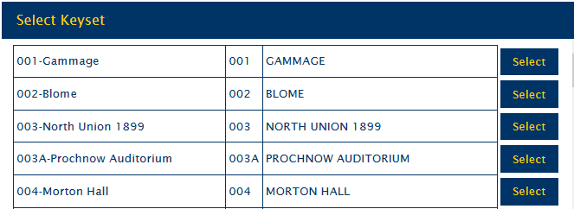

Step #4)

Within the “Add Building Manager” Section, provide the EMPLID (employee ID number) of the person that will be Added as the Building Manager List.

Note: If submitting “As Self to Become Building Manager”, select the appropriate button below.

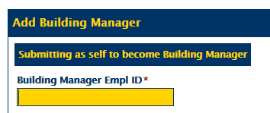

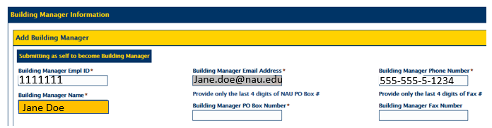

Step #5)

Add the 4-Digit PO Box Number associated with the new Building Manager

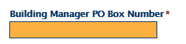

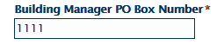

Step #6)

(OPTIONAL) – Add the 4-Digit Building Manager Fax Number

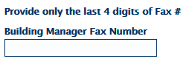

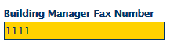

Step #7)

(OPTIONAL) – Add any Additional Comments:

Note: These Comments may be Added to the Master Building Manager List that will be available at https://in.nau.edu/facility-services/fac_staff/

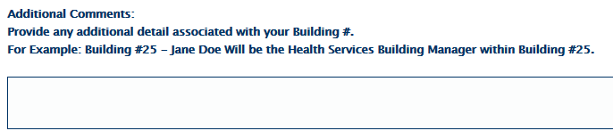

Step #8)

Select the “Submit” Button and the following message will appear.

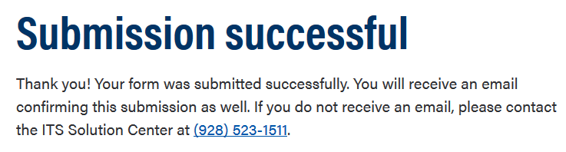

The Request will be reviewed and once Approved, Submitter will receive the following email notification. Sample Below:

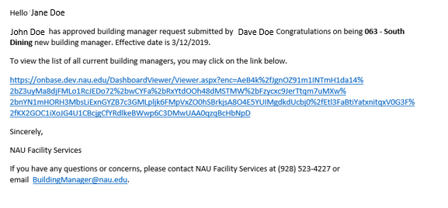

1.3 HOW TO SUBMIT A REQUEST TO “REMOVE” A BUILDING MANAGER

Step #1)
Within Request Type, select “Remove”:

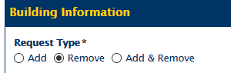

Step #2)
Select the Date you want the Building Manager to be Removed from the Building Manager List

Step #3)
To view the Current Building Managers on file, please go to
https://in.nau.edu/facility-services/fac_staff
and select “Building Managers list”

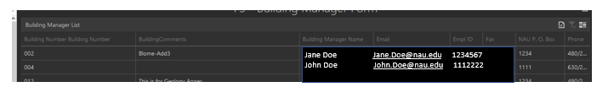

Step #4)

Within the following field, enter the Building # and/or Building Name in the following field and select “Building Search”

The following Results will Appear:

OR

Select “Building Search” to Select from a List of Existing Building’s on File

Step #5)
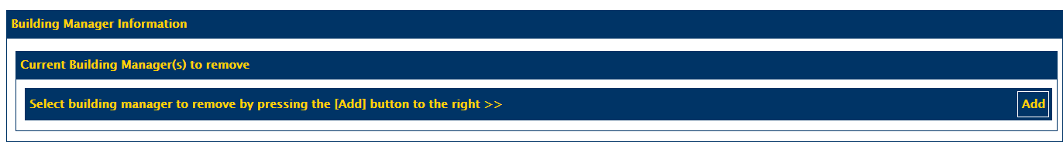
Select “Add” within the section below

If there is currently only (1) Building Manager is on file, the following fields will auto-populate

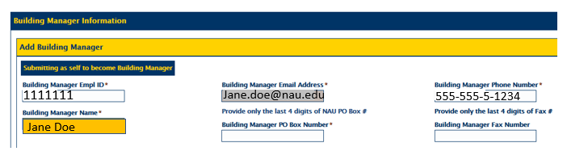
If there is currently more than one (1) Building Manager on file, select the individual on the list that must be removed from the current Building Manager List.

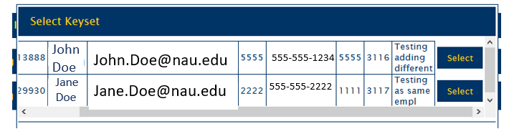

Step #6)
Once the correct Individual has been selected, select the “Submit” Button and the following message will appear.
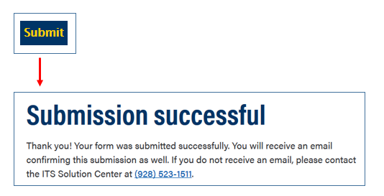
The Request will be reviewed and once Approved, submitter will receive the following email notification. Sample Below:
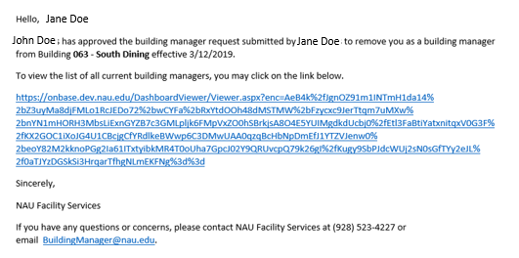

1.4 HOW TO SUBMIT A REQUEST TO “ADD” & “REMOVE” A BUILDING MANAGER

Step #1)
Within Request Type, select “Add & Remove”:

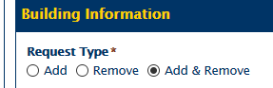

Step #2)
Select the Date you want the Building Managers to be Added and Removed from the Building Manager List

Step #3)
To view the Current Building Managers on file, please go to
https://in.nau.edu/facility-services/fac_staff
and select “Building Managers list”

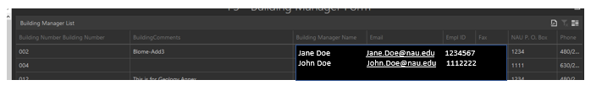

Step #4)

Within the following field, enter the Building # and/or Building Name in the following field & select “Building Search”

Note: The Individual that you have selected to “Add & Remove” must be for the same Building

The following Results will Appear:

OR

Select “Building Search” to Select from a List of Existing Buildings on File

Step #5)
For the Removal of an Individual from the Building Manager List, Select “Add” within this section below

If there is currently only one (1) Building Manager on file, the following fields will auto-populate
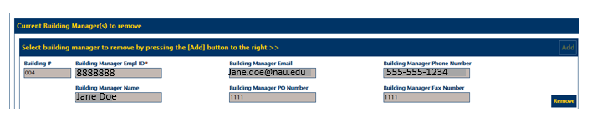

If there is currently more than (1) Building Manager on file, select the individual that must be removed from the current Building Manager List.

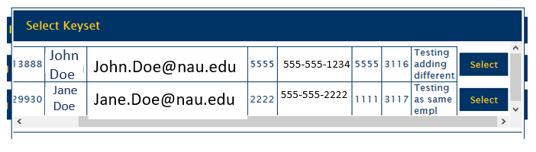

Step #6)

To Add an Individual to the Building Manager List, within the “Add Building Manager” Section, provide the EMPLID of the person that will be Added as the Building Manager List

Note: If submitting “As Self to Become Building Manager”, select the appropriate button below.

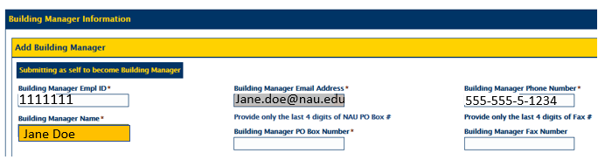

Step #7)

Add the 4-Digit PO Box Number associated with the new Building Manager

Step #8)

(OPTIONAL) – Add the 4-Digit Building Manager Fax Number

Step #9)

(OPTIONAL) – Add any Additional Comments:

Note: These Comments may be Added to the Master Building Manager List that will be available at https://in.nau.edu/facility-services/fac_staff/
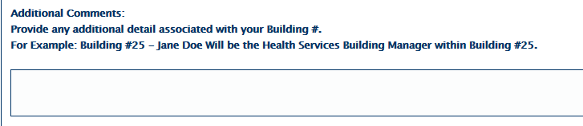

Step #10)
Once the correct Individual has been selected, select the “Submit” Button and the following message will appear.
The Request will be reviewed and once Approved (Both Add and Remove), submitter will receive the following email notification. Sample Below:

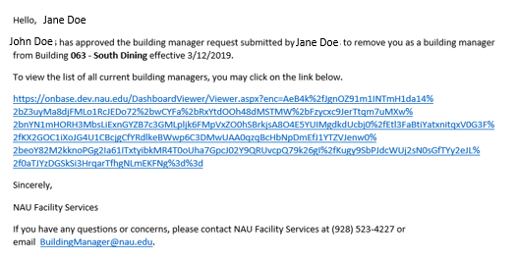

1.5 IF A BUILDING # / NAME IS NOT FOUND

If a Building # / Name is not found within the Building Search Field (Below) complete the following steps:

Step #1)
Check the following box:

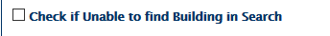

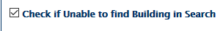

Step #2)
Add the Building # / Name in the Field Provided

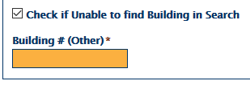

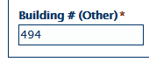

Step #3)
Select the Submit Button and the following message will appear.

The Request will be reviewed and the submitter will receive the following email notification. Email Notification Sample Below:

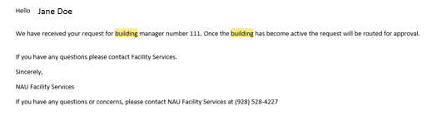

Once Building # is active, it will be reviewed by and Approved or Denied.

SAMPLES OF EMAIL NOTIFICATIONS

The following section will provide samples of Email Notifications during the overall OnBase Building Manager List Workflow

2.1 NOTIFICATION THAT SUBMITTER’S REQUEST HAS BEEN SUBMITTED

Email notification sent to the Submitter that their Request to Add a Building Manager has been submitted and is under review
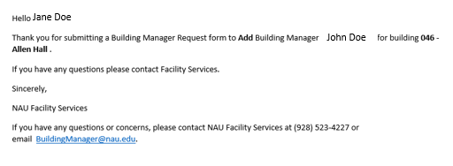

Email Notification sent to Submitter that their Request to Remove a Building Manager has been submitted and is under review.

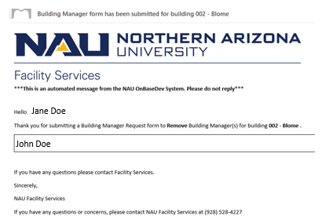
Email Notification sent to Submitter that their Request to Add & Remove a Building Manager has been submitted and is under review.

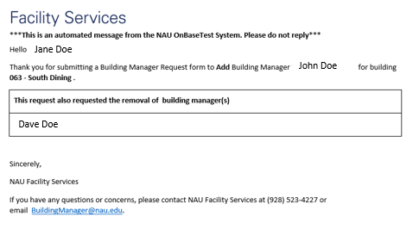

2.2 NOTIFICATION THAT SUBMITTER’S REQUEST HAS BEEN APPROVED

Email Notification sent to the Submitter that their Request has been Approved to Add a Person to the Building Manager List

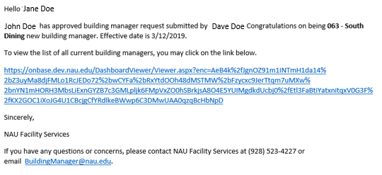

Email Notification sent to the Submitter that their Request has been Approved to Remove a Person from the Building Manager List

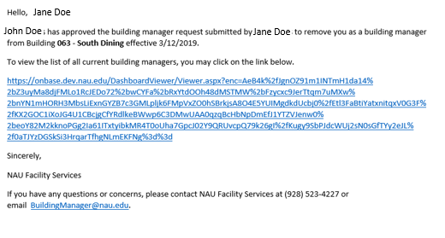
Email Notification sent to the Submitter that their Request has been Approved Add & Remove Persons to the Building Manager List

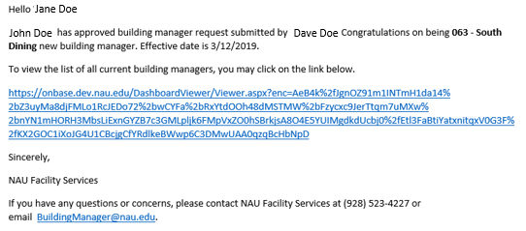

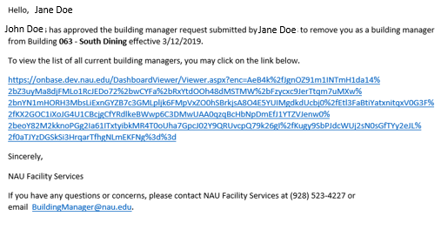

2.3 NOTIFICATION THAT SUBMITTER’S REQUEST HAS BEEN DENIED

Email Notification sent to the Submitter that their Request has been Denied to Add and/or Remove a Person from the Building Manager List
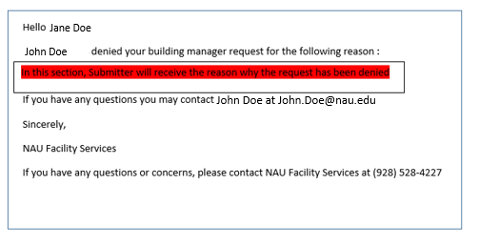

NOTE: Contact Facility Services to assist on your request or submit a new request with the instructions provided in the comments section.

VIEW THE CURRENT BUILDING MANAGER LIST

The following section will provide detail on how view the current Building Manager List.

Step #1)
Go to the following website and click on “Update Form for Building Managers List”
https://in.nau.edu/facility-services/fac_staff/

Step #2)

The following page should appear

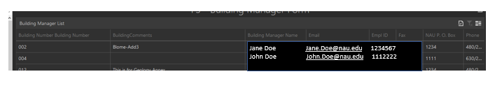

Step #3)

To export an Excel PDF file, hover over the following image in the upper right-hand corner.

Select either PDF, Image or Excel and then select.
This will provide the user the up-to-date Building Manager List.

