Green Fund Project Application

Green Fund Mission Statement: “The NAU Green Fund promotes student participation in and provides funding for projects that reduce NAU’s negative impact on the environment and create a culture of sustainability on-campus.”

Requirements for funding:
- We highly recommend meeting with a Green Fund member prior to submitting the application.
- Since the Green Fund distributes funding on a reimbursement basis, project teams must partner with an administrative office to provide upfront funding for the project. Once the project has met its agreed upon deliverables, the administrative partner will be reimbursed by the Green Fund.
- The person submitting the project must be an NAU student, faculty, and/or staff.
- Projects must provide all necessary documents, letters of support, and authorizations prior to reviewal.
- The project must be implemented on campus.

Disclaimer: This application is preliminary; you may be asked to provide more information in order for your project to be considered for evaluation. Incomplete applications will not be considered; however, applications may be conditionally approved with certain stipulations. If your project is approved, you may be asked to provide more detailed information regarding specific deliverables corresponding to the milestones defined in your timeline. The Green Fund is not responsible for acquiring the necessary permits, permissions, or approvals for a project; though, we will help if assistance is needed. Additionally, the Green Fund does not provide any ongoing costs. The sponsoring department must take responsibility for operations and management. All applications must and will go through a vetting process.

Reviewal timeline: Once your application is submitted, the Green Fund will review your project within three weeks during the regular school semester. Incomplete applications will not be reviewed until all components are submitted. The application review may take one meeting or several months as additional questions may be asked or approval from administration may be needed.

Application Components: All components must be included for the application to be reviewed by the committee.
- Project Overview
- Green Fund Criteria
- Application Information
- Detailed budget
- Project timeline, including milestone
- Any and all necessary permits, permissions, or approvals
- Operations & Maintenance Plan addressing:
  - Necessary maintenance schedule and duration
  - Individuals responsible for the maintenance
  - Any and all costs associated with the maintenance
  - Project Evaluation Plan
Project Overview
Contact Information
Project Leader Name: ________________ Phone: __________________ E-mail: ________________________
Project Advisor Name: _______________ Phone: _____________________ E-mail: _____________________
Sponsoring Department: ____________________________________________________________________
Project name: _____________________________________________________________________________
NAU Department/Unit for funding reimbursements (Attach letter of commitment from departmental representative): ____________________________________________________________________________
Does this project involve space needs or construction on campus (y/n)____________________
If yes, have you reviewed the “Space Committee Document” located on our Get Involved page? (y/n) _______
Executive Summary
Please provide a brief overview of your proposal. Please address how this project will support the goals of the Green Fund (student involvement, creating a culture of sustainability, and lessening NAU’s impact):

Green Fund Criteria

Please address with a short answer how your proposal meets the Green Fund criteria for funding a project. Your project does not need to fulfill each criterion, but your project should align with most.

Relationship to Carbon Neutrality/Green Fund Goals
- Carbon Neutrality Goals - Please review NAU’s Sustainability Action Plan and identify how your project aligns with the goals.

- Impact - What are the environmental costs and benefits associated with this project?

- Three Pillars of Sustainability: Describe how your project impacts economic, social, and/or environmental sustainability:

Campus Community
- Visibility - Is there a public outreach plan? How will faculty, staff, students learn about this? How will this project impact students educationally?

- Meets Student Priorities - Based on the survey results, does your project contribute to one or more of the student priorities?

- Campus Community Involvement – How are you working with other groups on and off campus?

Project Parameters
- Economic Feasibility - Is your project financially efficient? Is this a one-time expense or will you need future funding? Does the project have additional funding sources?

- Program Longevity – Who will run the program after you leave NAU? Will students continue to use the project in the future?

- Reasonable Timeline - How long will it take to implement your project? What is your timeline for when you will start and when you expect to begin to see results?

Preliminary Questions

Please answer the following questions:

- Does your project require space or construction on campus? If so, where? ________________________________________________________________________
If yes, review the “Space Committee Document” located on our Get Involved webpage and follow the steps to begin requesting a location.
- Have you obtained all necessary approvals for this project?
a. If Yes, please attach all letters of support. Letters of Support should include confirmation from the sponsoring department that they will cover all upfront expenses and work with the Green Fund manager to acquire reimbursement after project completion. If any ongoing operations and maintenance is required of your project, provide a Letter of Support from the entity that will be covering those costs and/or services.
b. If No, please explain your progress and plan for attaining letters of support.
- Will this project provide funding for student wages?
- Please list all additional sources of funding you have asked. Include departments, grants, ASNAU, GSG, etc.
- Has this project been submitted for consideration before?
  - If Yes, please ensure that all requested revisions have been addressed in the narrative.
- Have any of the Green Fund Committee members been involved in this project?
  - If Yes, please identify all committee members:

Detailed Budget

For the detailed budget, please include detailed information on how money will be spent on this page. Must be very specific, please add a line item of 5% for contingency.

Example:
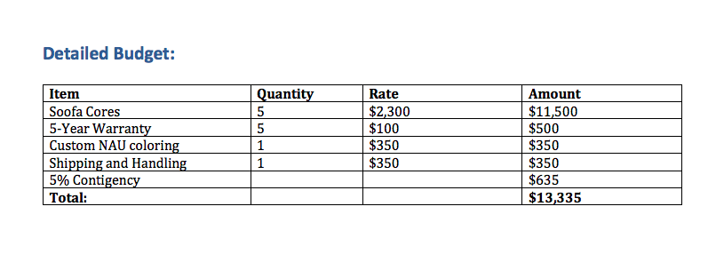

Timeline
The timeline should include significant implementation dates for your project. Please add information such as shipping time and consider any holidays or breaks.

Example:

