Enrollment Guide- 4 Step Process with Pictures
Step 1: Progression Plans: This is what your major’s department recommends you take every term to stay on track for graduation.
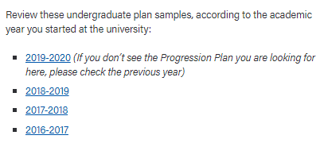
1.1 Visit nau.edu/progressionplans
Once on this page, scroll down to find your catalog year.
1.1
NOTE: This is the year you started at the university.

1.2 Using “Ctrl F” search for your major’s progression plan.
1.2
NOTE: If you are double majoring, look up both!
1.3
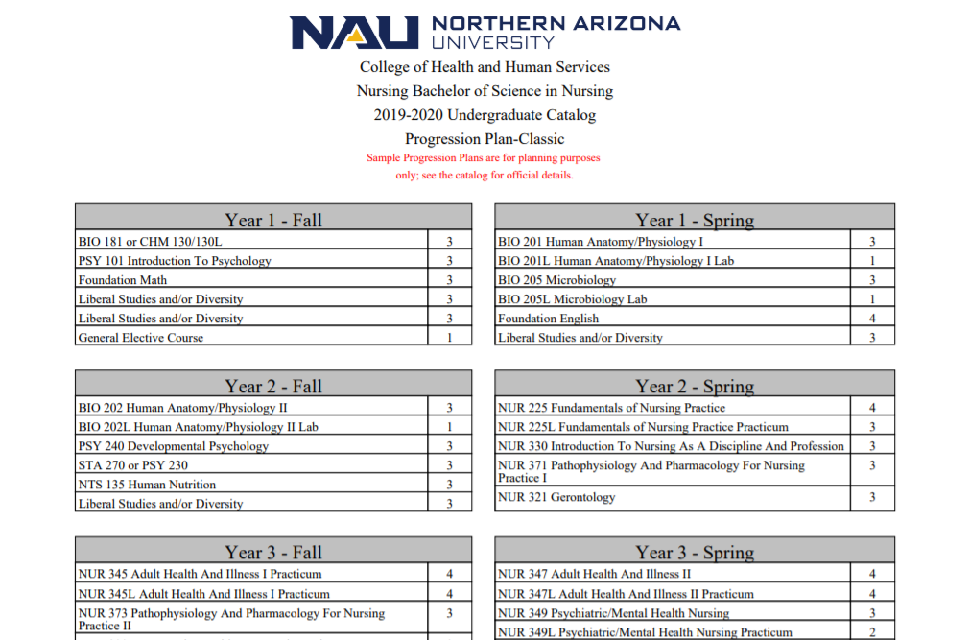
1.3 Once your progression plan opens, click “Print PDF” in the top corner.
1.4

1.4 Once the PFD view opens, look at “Year 1 + Year 2” to determine which of these courses you have taken and which are remaining. Write the remaining recommended courses on Step 1 of the enrollment Worksheet, for the next term(s) of enrollment.

Step 2: Academic Requirements Report:
Use this to determine the Liberal Studies and/or Diversity requirements you have met (Satisfied) versus those remaining (Unsatisfied).

2.1 Log into Louie. 2.2 Click on “Other Academics” > “Academic 2.3 Once the report opens, scroll
Requirements” > Double arrows. Down to view your Liberal Studies/ Diversity
Requirements.
2.2
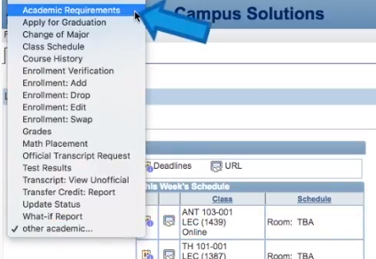
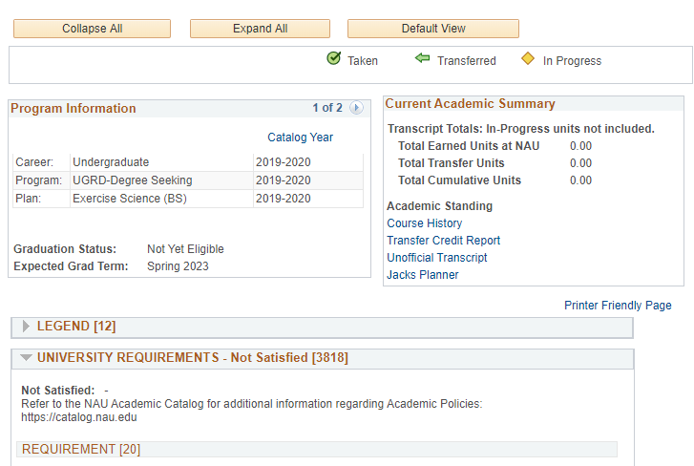
2.1
2.3

To Find Liberal Studies:
To Find Diversity:
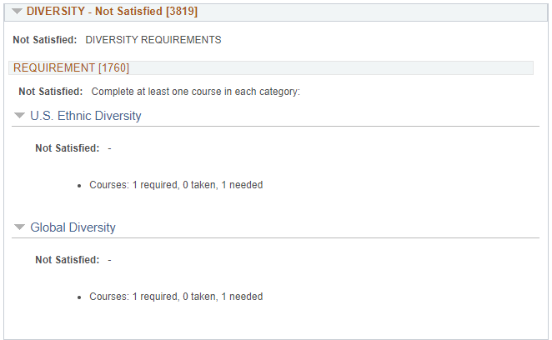
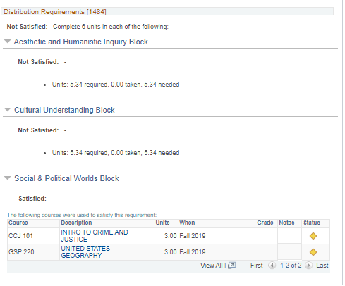
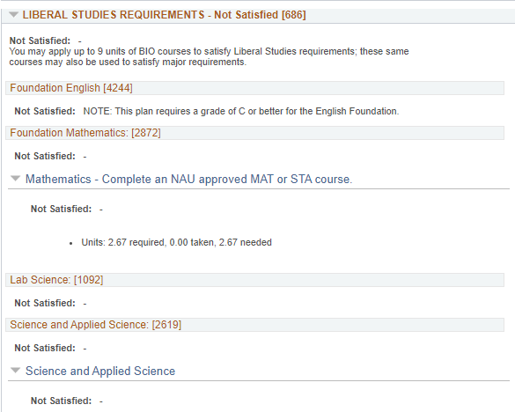
= Still need to fulfill
= Done with requirement

5.34= 2 more course needed
2.67= 1 more course needed

2.4 A
2.4 A
2.4 A

2.4 Fill in the Liberal Studies and Diversity table on Step 2 of your Enrollment Worksheet, based on what you learn in your Academic Requirements Report.
NOTE: If it shows “5.34 needed”, you need 2 more classes; if it shows “2.67 needed” you need 1 more class.
Step 3- Search + Build a Schedule: Now that you have a list of courses to enroll into (from Step 1) and are sure which Liberal Studies and/or Diversity courses you need to fulfill (Step 2), you can begin searching and adding courses to your shopping cart!
3.1 Log into Louie 3.2 Click the “Enroll” tab on the Left 3.3 Select the Term you’d like to enroll for:
3.3 A
3.2
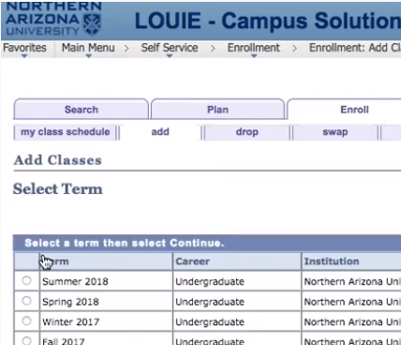
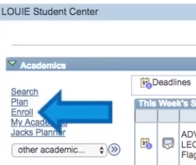
3.1 A
NOTE: On your enrollment date, you will be enrolling for both Fall 2020 and Spring 2021.

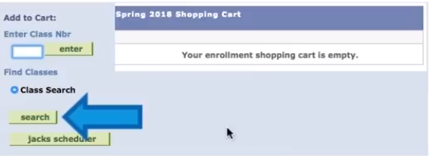

3.4
3.4 Click “Search” to begin adding classes to your enrollment shopping cart.

3.5 In the class search, use the Subject and Course 3.6 In the class search, use Reqmt Desig (Requirement Designation) to
Number lines to search for specific courses. search for Liberal Studies and/or Diversity courses.
3.5
3.6
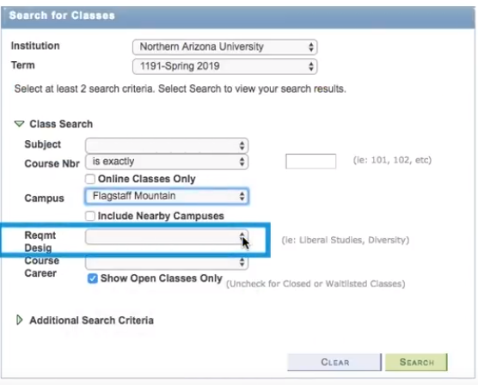
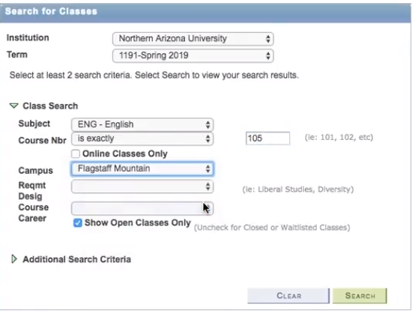

3.7
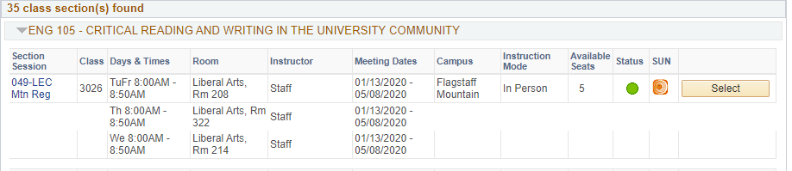

3.7 Once you have found a time that fits with your preferences and schedule, click “Select” and then “Next” to add the course to your Shopping Cart.

Step 4- Enroll: Once you have all of your classes in your Shopping Cart- you will want to proceed with enrolling.
NOTE: Just because the course is in your Shopping Cart, this does not mean you are officially enrolled into the class.
4.1 Check the box next to the listed course(s) in your shopping cart, then choose “Enroll.” Or click “Proceed to Step 2 of 3.” Then Choose “Finish Enrolling”

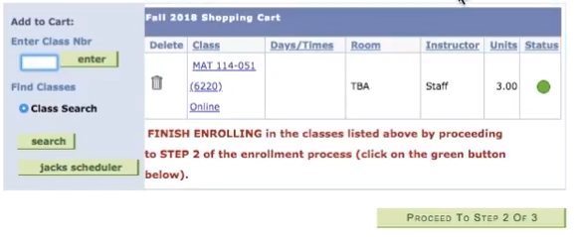
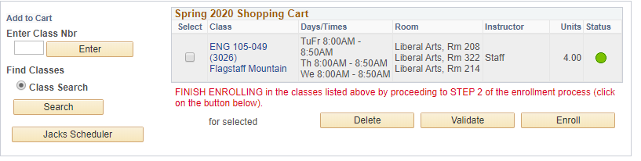

OR
4.1
4.1

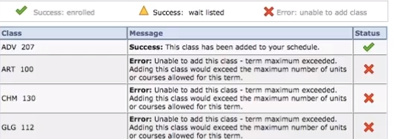
4.2 Check enrollment status.

YAY! You did it! You’re enrolled!

Oh no! Read the error message, and go back to your shopping cart! Contact your advisor if you need help.
4.2

Check out The Gateway Student Success Center’s YouTube Channel for helpful tutorials related to enrollment!

