Enrollment Guide- 4 Step Process with Pictures
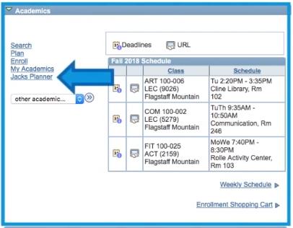
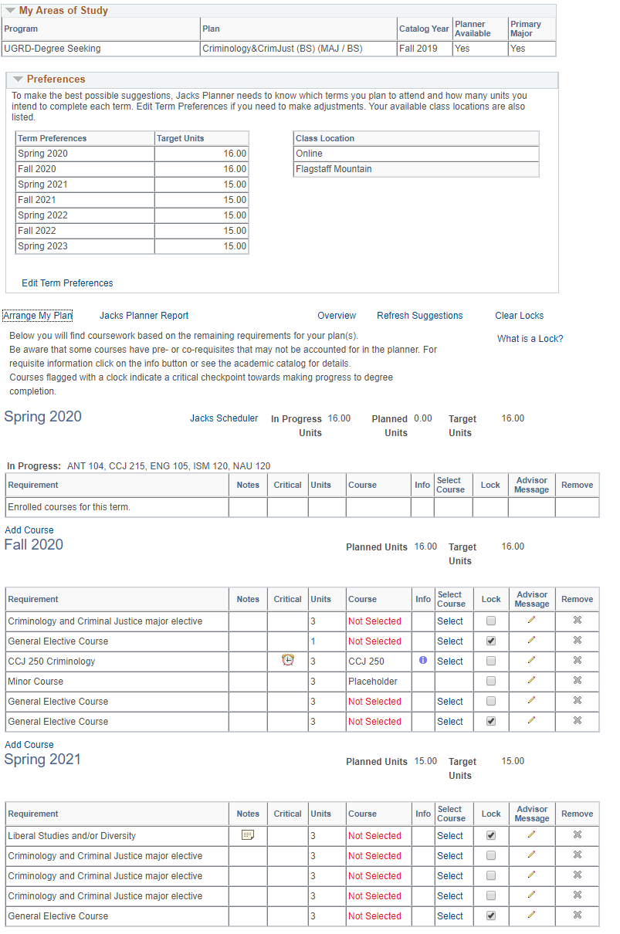
Step 1- Jacks Planner: Personalized planning tool based on your major and completed work that provides course recommendations for your next semester(s).
A
B
C

1.3
1.2
1.1
1.1 Log into Louie 1.2 Once in Louie, click on “Jacks Planner”

1.3 Review Jacks Planner for course recommendations. Write the recommended courses on Step 1 of the Enrollment Worksheet, for the next term(s) of enrollment.

A. Make sure that your major plan is correct.

B. Make sure that your remaining terms are planned for 14-17 units. Use “Edit Term Preferences” to add units or terms.

C. Choose “Select” to view a list of the courses that will fulfill the recommended requirement.

Other Jacks Planner functions:
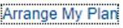
Use “Arrange My Plan” to move classes around.
“Critical” classes may be prerequisites for other major classes.
Click on the “i” to see course description.

Step 2: Academic Requirements Report:
Use this to determine the Liberal Studies and/or Diversity requirements you have met (Satisfied) versus those remaining (Unsatisfied).
2.3 Once the report opens, click “Expand All,” then scroll down to view your Liberal Studies/Diversity Requirements.
2.1 Log into Louie. 2.2 Click on “Other Academics” > “Academic
Requirements” > Double arrows.
2.3
2.2
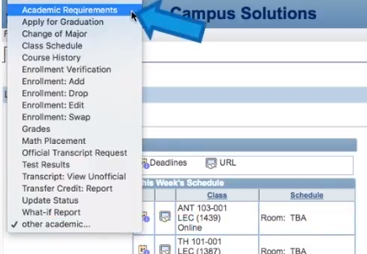
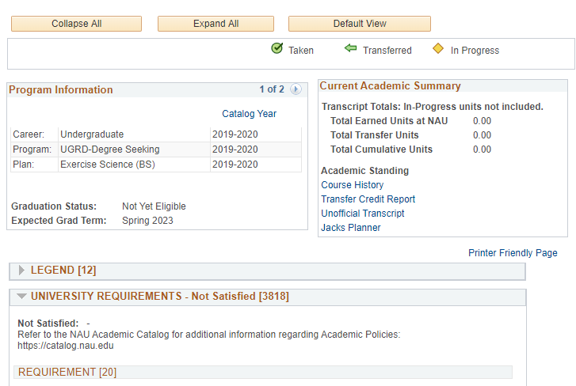
2.1

To Find Liberal Studies:
To Find Diversity:
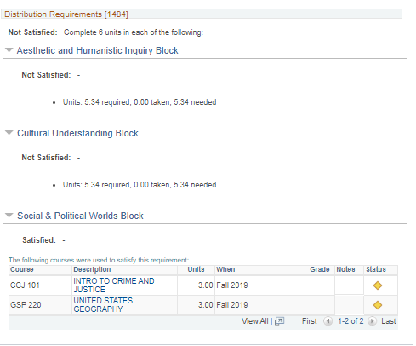
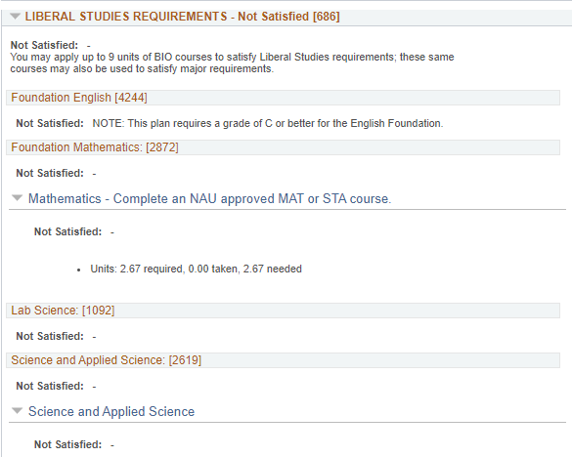
= Still need to fulfill
= Done with requirement
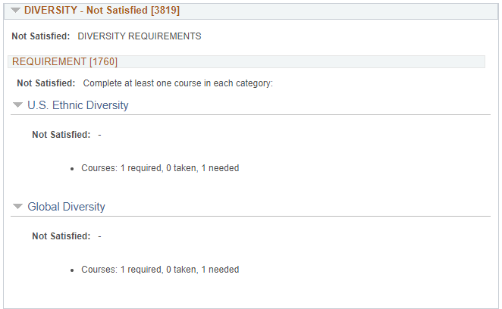

5.34= 2 more course needed
2.67= 1 more course needed
2.4 A
2.4 A
2.4 A

2.4 Fill in the Liberal Studies and Diversity table on Step 2 of your Enrollment Worksheet, based on what you learn in the Academic Requirements Report.
NOTE: If it shows “5.34 needed”, you need 2 more classes; if it shows “2.67 needed” you need 1 more class.
Step 3- Search + Build a Schedule: Now that you have a list of courses to enroll into (from Step 1) and are sure which Liberal Studies and/or Diversity courses you need to fulfill (Step 2), you can begin searching and adding courses to your shopping cart!
3.1 Log into Louie 3.2 Click the “Enroll” tab on the Left 3.3 Select the Term you’d like to enroll for:
3.3 A
3.2
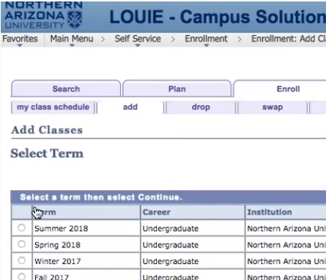
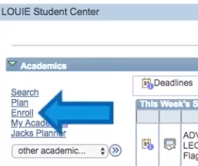
3.1 A
NOTE: On your enrollment date, you will be enrolling for multiple terms.

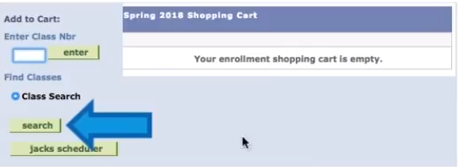

3.4
3.4 Click “Search” to begin adding classes to your enrollment shopping cart.

3.5 In the class search, use the Subject and Course 3.6 In the class search, use Reqmt Desig (Requirement Designation) to
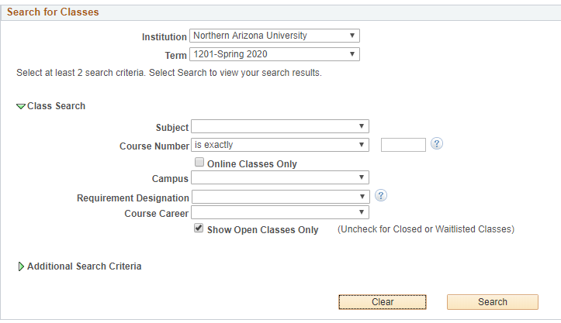
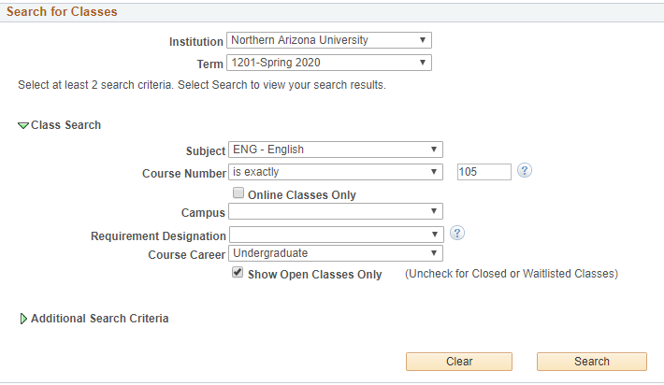
Number lines to search for specific courses. search for Liberal Studies and/or Diversity courses.
3.6
3.5

3.7
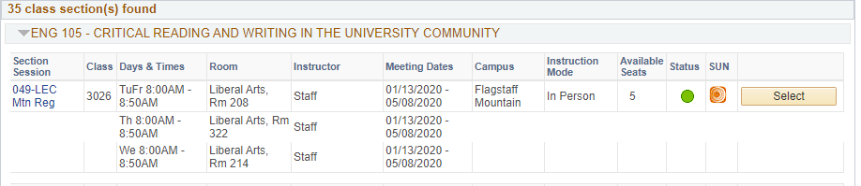

3.7 Once you have found a time that fits with your preferences and schedule, click “Select” and then “Next” to add the course to your Shopping Cart.

Step 4- Enroll: Once you have all of your classes in your Shopping Cart you will want to proceed with enrolling.
NOTE: Just because the course is in your Shopping Cart, this does not mean you are officially enrolled into the class.
4.1 Check the box next to the listed course(s) in your shopping cart, then choose “Enroll.” Or click “Proceed to Step 2 of 3.” Then Choose “Finish Enrolling”

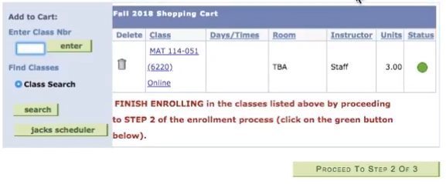
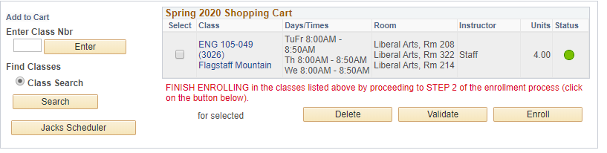

OR
4.1
4.1

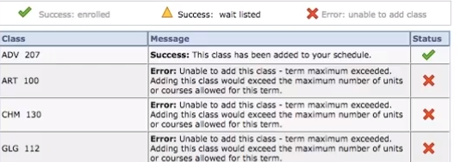
4.2 Check enrollment status.

YAY! You did it! You’re enrolled!

Oh no! Read the error message, and go back to your shopping cart! Contact your advisor if you need help.
4.2

Check out The Gateway Advising’s YouTube Channel for helpful tutorials related to enrollment!

