

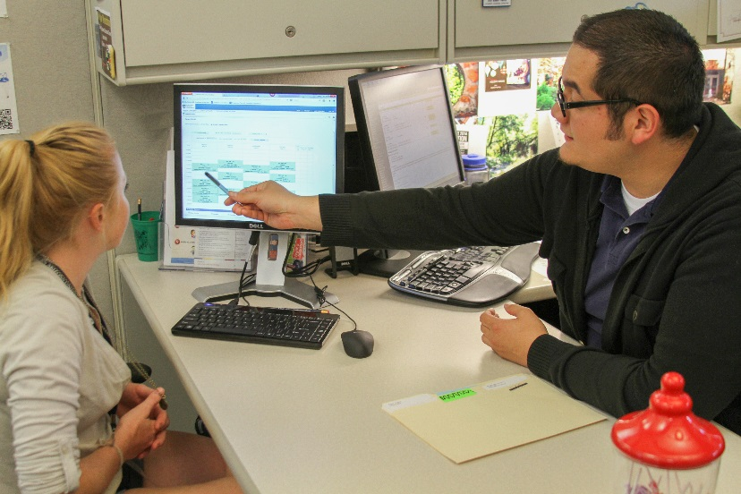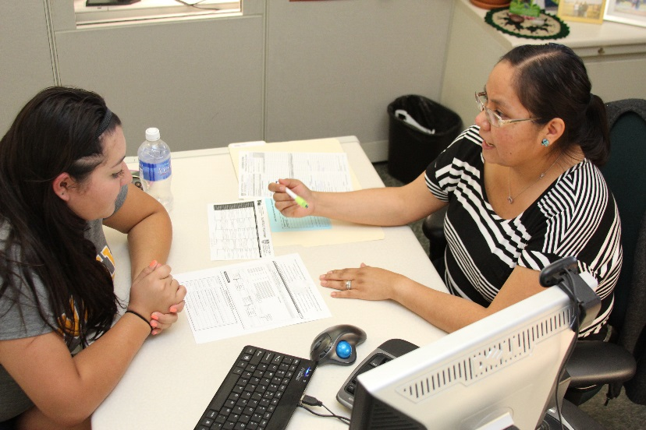

**Gateway Student Success Center**

***2014-2015 Annual Report***

Contents

[Mission & Philosophy 1](#_Toc424668347)

[Program Scope, Scale, and Structure 2](#_Toc424668348)

[Objective 1: Influence student learning, holistic development, encouraging self-reflection, engagement, and the mastery of learning outcomes 5](#_Toc424668349)

[Objective 2: Positively impact student success, retention, graduation, and degree progression 7](#_Toc424668350)

[Objective 3: Serve diverse populations of students by providing varied programs and services and fostering a supportive environment of inclusivity 14](#_Toc424668351)

[Objective 4: Facilitate student academic planning, exploration, and informed decision making 18](#_Toc424668352)

[Objective 5: Help students connect to NAU, and positively contribute to the student experience, as they transition into and through the university community 20](#_Toc424668353)

[Objective 6: Build and maintain a healthy organizational culture to promote effectiveness, efficiency, professional growth, job satisfaction, and staff retention 24](#_Toc424668354)

[Objective 7: Model cooperation and provide collaborative leadership to university initiatives, interdepartmental problem solving, and community development with University College, University Advising, academic departments, and other campus partners 27](#_Toc424668355)

[Objective 8: Enhance impact and efficiency through use of data, assessment, technology, and innovation 30](#_Toc424668356)

[Integrating Advising and Learning 32](#_Toc424668357)

[Future Goals and Program Direction 34](#_Toc424668358)

[Acknowledgements and Contact Information 37](#_Toc424668359)

# Mission & Philosophy

**Gateway Mission**

As a member of Northern Arizona University and University College, the mission of the Gateway Student Success Center is to provide academic advising services and programs for First-Year, Undeclared, University College, Premed, and Pre-Law students, as well as any student transitioning between majors in a supportive, positive, student-centered learning environment with efficiency, leadership, collaboration with campus partners, and a commitment to advising outcomes, best practices and innovation at all levels of advising and student success.

**Gateway Advising Philosophy**

Academic Advising is an ongoing process and an integral part of an NAU student's experience. We believe in empowering students to become self-directed learners, armed with the skills and knowledge needed to navigate the university experience. At the heart of advising is teaching and the holistic development of the student; advisors strive to engage and encourage students to take ownership of their educational experience and provide guidance for informed decision making.

# Program Scope, Scale, and Structure

**Gateway Student Populations for 2014-2015 Academic Year:**

|  |  |  |  |  |
| --- | --- | --- | --- | --- |
| First Year\* | Undeclared | B.U.S. | Premed | Pre-Law |
| 6,095 | **646** | **56** | **1,531** | **482** |

\*First Year is defined as summer and fall 2014 freshman admits, and students from the previous academic year who haven’t transitioned, remaining with Gateway into their 3rd or 4th terms. “Undeclared” (646) is also reflected in this number.

Typically, we also carry 300-500 Undeclared Post- Baccalaureate and Non-Degree Seeking students in the Gateway advising population.

**18 full-time Advisors, 2 Graduate Assistants, 4 part-time Academic Advisors, and 3 Advising Coordinators met with students through:**

* Early Enrollment Advising (EEA) (mandatory fall & spring)
* Walk-in Advising (offered daily)
* Other advising appointments (including B.U.S. advising, Undeclared advising, academic and career planning, probation or other at-risk advising)
* Premed advising appointments
* Pre-Law advising appointments
* Orientation Advising
* Email or phone

**Academic Advisors also offer additional programs or services**

* iAdvise (self-advising alternative to EEA for targeted groups of students)
* Priority Enrollment (PE) for in-coming students
* Bb Learn course for First Year Students, “Academic Advising 101”
* Premed and Pre-Law workshops, UC 199 course, Premed Bb Learn shell, USC 108: Introduction to Biomedical Sciences
* Premed Committee Recommendation Letters and additional letter service for medical school applicants

**Fall 2014 Visits**

|  |  |  |  |  |  |  |  |
| --- | --- | --- | --- | --- | --- | --- | --- |
| EEA | iAdvise | Walk-in | Other Advising | Premed | Pre-Law | Orientation *(Summer 14)* | PE *(Summer 14)* |
| 4,952 | 77 | 554 | 1074 | 127 | 23 | 4603 | 4270 |

**Spring 2015 Visits**

|  |  |  |  |  |  |  |  |
| --- | --- | --- | --- | --- | --- | --- | --- |
| EEA | iAdvise | Walk-in | Other Advising | Premed | Pre-Law | Orientation | PE |
| 3,572 | 186 | 638 | 825 | 143 | 22 | 137 | 84 |

In fall 2014 and spring 2015: 45% of students visited more than once per term

**Workshops or other presentations**

|  |  |  |  |  |
| --- | --- | --- | --- | --- |
| DCV | DNAU | Premed | Prelaw | Orientation |
| 3,572 | 186 | 638 | 7 | 22 |

**1147 Cohort movement through Gateway population**

**Increase in Gateway’s service population**

Gateway’s service population has increased both as a result of increasing First-Time Full-Time (FTFT) enrollment, and changes to policy driven by initiatives to support student success that have had students remaining in Gateway’s population into their third and fourth terms. Students remain in Gateway’s population after their first year due to low math progress (PMT student group), low degree progress, or not developmentally prepared (as determined by advisor).

However, the number of full-time advisors has not grown at the same rate. Below represents the overall increase in advisees per full-time advisor. Since 2009, we have managed to keep advising ratios lower than they would have been in relation to the growing population by hiring 3-10 part-time advising staff per term. For comparison, the sharp spike seen below for fall 2012 represents a term that no part-time staff were assigned advisees, resulting in much higher advising ratios for full-time staff. These part-time positions were funded by local accounts, and will not be a realistic opportunity for fall 2015 and forward. We are already anticipating a full-time advising ratio for fall 2015 of 438 students per advisor (up from 350 in spring 2015).

This will be monitored as FTFT enrollment continues to grow. Also, Gateway seeks to find the most comprehensive and accurate way to represent working full-time advising ratios for not only Gateway, but all of University Advising.

# Objective 1: Influence student learning, holistic development, encouraging self-reflection, engagement, and the mastery of learning outcomes

Currently, student learning is assessed through an Early Enrollment Advising (EEA) survey, given to students at the end of their EEA appointment in fall (n=2825) and spring (n=2951).

* When asked “Do you know how to locate these advising tools” *97%-99%* reported being able to locate the Academic Advising Report, Progression Plans, and Academic Catalog.
* When asked “Where did you learn about the above advising tools?” *97%* of students reported “My Gateway Advisor”.

I Learned…

“… a lot on how to find and choose which classes I need to take for my new major.”

“… what I needed to do to keep on track with my academic progression plan.”

“… a lot about what I need to do to get ahead.”

“… all my options to fulfil all requirements.”

“… about my requirements for next year and how to access that information...”

“… the classes I should be in next semester, and where I am in terms of graduating and my progression plan.”

*-from EEA Survey fall 2014*

This is an area of major growth for Gateway that began in the 2014-2015 academic year, and there will be data provided to demonstrate the impact on student learning and development at the end of the 2015-2016 academic year. This year in support of student learning and an outcomes based assessment model, the following was implemented:

* Development and introduction of an advising framework grounded in both Academic Development and Personal Growth, an advising curriculum, and a new model that incorporates developmental, appreciative, and intrusive advising models to individualize curriculum delivery to each student based on prior knowledge, skill, personality, and needs.
* Nine First Year Academic Advising Learning Outcomes (FYAALOs) were identified, and accompanying assessment rubrics and tracking mechanisms were built in collaboration with advising and support staff. Advisors will begin assessing and tracking student mastery in fall 2015 through their transition to department advisors, typically at the end of the first year.
* Modeled after the education method, “Blended Learning”, Gateway built and introduced to students to two Bb Learn shells. In May 2015 5,500 first-year students were enrolled into “Academic Advising 101” and 1,752 students into the Premed Bb Learn shell.
* Opportunities for reflection that support student learning, in our Probation Outreach efforts and “Academic Advising 101”.
* For 2015 Orientation, clearer advising objectives tied directly to student learning. These objectives will be assessed with a new Orientation Student Survey that was administered July 2015.

The EEA survey will continue to be used to assess each student’s perception of their learning, but questions will more closely align with the FYAALOs, focusing on self-assessment of learning and satisfaction with services.

# Objective 2: Positively impact student success, retention, graduation, and degree progression

**PreMajor Track**

The objective of PreMajor track (PMT) is to support students in math intensive majors (PMT majors) who have low math placement to progress to an on time graduation by hitting their major’s benchmark math course or changing to a non-PMT major by their 3rd term. Participation in PMT directly impacts a students’ degree progression and can impact timely graduation. During 2014-2015 Gateway sought to learn more about students in PMT, and their movement in and out of the student group (PMT). The primary questions are; how many terms are students spending in PMT, and what are the reasons they are exiting the group? Students in PMT will not transition from Gateway to department advisors.

**Students in PMT 3+ Terms**

One area to pay particular attention to are students remaining in PMT, and thus in the Gateway service population, for 3+ academic terms. Who are these students and what improvements can we make to our advising practices to encourage students’ positive degree progression, which results in an exit from the PMT program after 2 terms?

|  |  |
| --- | --- |
| Students remaining in PMT 3+ Terms | |
| At December 2014 Transition | At May 2015 Transition |
| 202 (55 enrolled for fall 14 term) | 169 (156 enrolled for spring 2015 term; 122 enrolled for fall 2015) |

At December 2014 transition, we identified 202 students for whom spring 2015 would be their 3+ term in PMT. A team of advisors assessed each of the students, to answer the following questions:

* How many students were enrolled for classes in fall 2014?
* How many students were / were not making progress towards their math benchmark? (“*Progress” was defined as passing at least 1 math class; “benchmark” defined as the math course a student must be eligible for to exit PMT*).

Only 55 / 202 students in PMT were enrolled for fall 2014. These 55 enrolled students became the target population to answer our second question about math progress. The remaining 147 were not enrolled, but were still active at NAU.

Of those 55 PMT students enrolled for fall 2014:

|  |  |  |
| --- | --- | --- |
| Math progress - Yes | Math Progress - No | Enrolled in benchmark for S15 |
| 34 (62%) | 20 (38%) | 14 (25%) |

Because this assessment was done prior to December’s PMT audit and transition, 14/55 PMT students were identified and enrolled in their benchmark math course (their 3+ term in PMT) for spring 2015. Meaning, only 25% of 3+term PMT students were eligible to exit PMT at the end of December 2014, and 75% would have continued in PMT into their 3+ term for spring 2015.

In addition, many of these PMT students were not taking math every semester, although it was recommended by their advisor. 38 / 55 (70%) dropped a math course at least once.

|  |  |
| --- | --- |
| Enrolled in math Fall 2014 | Enrolled in math Spring 2015 |
| 29 (53%) | 23 (42%) |

That **38% of these PMT students had not passed 1 math class**, and **only 25% were even eligible to exit PMT in spring 2015**, indicated that more clearly define advising protocol for PMT students was necessary. Specifically, strengthening the message to students who are not making progress towards their math benchmark earlier in their career, and generating outreach to PMT students who are going into their 3+ term. Following this assessment, the following was initiated:

* PMT Progression Plans for each PMT major were generated and made accessible to advisors
* Specific advising protocol was developed and presented to Gateway advisors, which differentiated messages for students making math progress and those students not making math progress, as well as by term, progressively strengthening the message around progress and major exploration.
* Following May 2015 transition students were identified for whom fall 2015 would be their 3+ term in PMT. We will repeat assessment of these students’ math progress towards benchmark.
* In July 2015, Advisors provided outreach to students for whom fall 2015 will be their 3+ term in PMT and are not making progress towards their math benchmark. The purpose is to engage those students in a major exploration discussion, with the intended outcome of identifying a non-PMT major that better fits the students’ interests and skills.

As a result of more clearly defined advising protocol and stronger intervention and outreach practices, a decrease in the number of students remaining in PMT for 3+ terms without math progress in the goal. Another question of interest is about those students leaving NAU; did their math progression negatively impact their retention? More analysis is needed to determine if this is the case.

**Intrusive Advising Interventions**

*The Intrusive Advising approach “incorporate[s] intervention strategies mandating advising contacts for students who otherwise might not seek advising” (NACADA).*

Advisors at Gateway provide targeted intervention and outreach to First Year students. This year, data collection was streamlined, utilizing EAN flags and existing reports, rather than individual advisor spreadsheets to improve data collection and validity.

In fall 2014 (n=1,019 students) and spring 2015 (*data not yet available*), immediately following the posting of Academic Standing, Advisors conduct personalized email outreach to every Gateway student on Probation and Continuing Probation. The purpose of this outreach is to encourage students to discuss the Academic Probation guidelines, restrictions, and to develop a plan of action to return to good academic standing. In the graph below, “Resp” = advisor received a response from student; “PROB Disc” = advisor engaged with student in a discussion about Academic Probation. Response rate was 30%, with 25% of students engaging in a probation discussion.

**Fall 2014 Probation Outreach Results**

N=1019

In fall 2014 (n=304) and spring 2015 (n=501) students with 3 or more D’s or F’s at midterm were contacted by their Gateway advisor one week prior to the last day to withdraw from the term. This outreach is especially intended to support students in making informed decisions to potentially avoid Academic Probation or Suspension. The following chart indicates the number of students who had a discussion with their advisor and the academic standing breakdown at the time of outreach.

**Fall 2014 and Spring 2014 D’s and F’s Outreach**

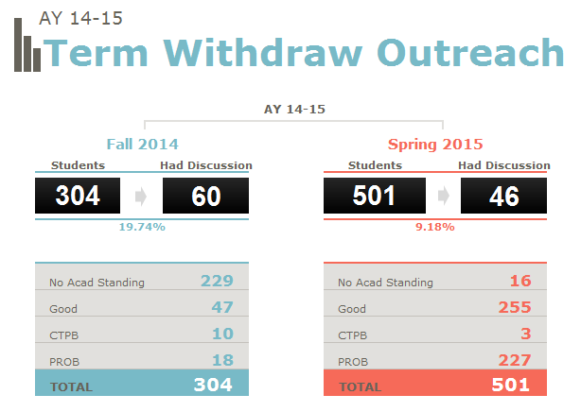

**Planned improvements to Gateway’s intervention and outreach efforts:**

* Outcome based assessment design of our outreach and intervention strategies will be a priority for the 2015-2016 academic year, with preliminary data regarding the impact of intrusive advising efforts on student success, degree progression, retention, and graduation.
* Historically, lower response rates through email outreach, indicate this is an area for further research and growth; what outreach and intervention strategies and approach have the most impact?
* Incorporating opportunities for student self-reflection with intrusive outreach, to better facilitate student learning and development.

**Academic Advising Holds**

Participation in EEA in the fall and spring is mandatory; guaranteeing a student will see their advisor during their first year. One area of consideration; however, is the use of analytics to differentiate high-risk and low-risk students, offering more choice in advising options for hold removal, and removing unnecessary roadblocks. One area being assessed is the removal of all advising holds at the end of an early and open enrollment cycle, to remove roadblocks from students who want to return to NAU from enrolling over winter or summer break. 440 holds were removed from students at the end of the spring 2015 term; assessment is underway to look at these students’ enrollment in fall 2015 courses and answer the following questions:

* At what rates are they enrolling?
* Do they attend advising anyway?
* If they enroll, are the courses appropriate for their degree plan and reflect positive degree progression?

**Bachelor of University Studies graduates (B.U.S.)**

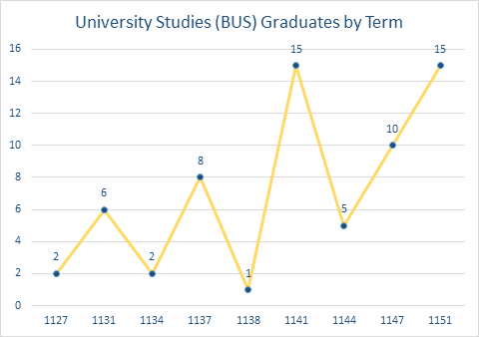

Terms

Number of Students

“Gateway Advisors and their expertise and consistent messaging about the B.U.S. degree have been invaluable to developing and growing this interdisciplinary program. The Faculty Steering Committee has been able to rely on Gateway Advisors to guide students toward this degree program, and helped the faculty committee and mentors shape the processes, forms, and feedback mechanisms that let student develop individualized plans. Without Gateway's support the B.U.S. program would not be serving our students as well as it was designed.”

*-Astrid Klocke, Ph.D., Associate Professor in CCS and B.U.S. Committee Chair*

**Premed and Pre-Law student matriculation**

Accurately reflecting NAU students who applied, were accepted, and matriculated to Medical Schools or Law Schools is a manual, and potentially subjective process. Other universities identify individual methods to reflect their students’ acceptance and matriculation rates. This data is narrowed to students who graduated from NAU and utilized Gateway’s Premed or Pre-Law programs, and their application and matriculation rates.

*75% of Doctor of Osteopathic (DO) school applicants who matriculated to a DO school used Gateway Premed Advising services*.

*100% of Doctor of Medicine (MD) school applicants who matriculated to a MD school used Gateway Premed Advising services.*

Mark [Cagle] was very insightful in my aspiration into the PA program. He provided awesome advice! He was also helpful in providing information about personal statements and with the PAE website. I hope to keep in touch with Mark during my PA program journey!”

*- NAU Premed Student*

# Objective 3: Serve diverse populations of students by providing varied programs and services and fostering a supportive environment of inclusivity

“My advisor really listened to everything I was concerned about and was able to help me answer the questions. She was very helpful and showed active listening!”

*-EEA student survey*

In order to better serve the diverse needs of our students we are gathering informational data on student demographics, population specifics, and student motivations to improve programs and services.

**Bachelor of University Studies (B.U.S.) applicants**

This year a new process was implemented to gather and track applicant data on B.U.S. students. Since July 1, 2014 there are 69 applicants for the B.U.S. program, 45 of whom declared B.U.S. Some applicants do not end up declaring B.U.S. after evaluating their options in an initial advising appointment.

**B.U.S. Students at time of Application**

|  |  |
| --- | --- |
| Average Credits Earned | Average G.P.A. |
| 92 | 3.30 |

**Reasons students report applying for B.U.S.**

Graph Legend

1= Interested in 2 or more disciplines to further career

2=Close to maximum credits for financial aid

3=No longer interested in major or did not hit milestone

4=Explored multiple majors but have not yet found a good fit

5=Other

Future assessment plans regarding B.U.S. applicants is a collaborative project with the B.U.S. program coordinator to track and follow B.U.S. students from application through to graduation, and beyond in order to better understand the B.U.S. student experience, motivations, and varied paths to a career.

**Undeclared patterns of major change**

One area of interest is identifying patterns of major change, particularly for Undeclared students, and particularly students’ final majors. To begin learning more about Undeclared students, trending cohort data from 2010-2013 was used. The data shows Undeclared as the top donor major, with 19.73% of students who change their major coming from Undeclared. Interestingly, this is also the top acceptor major from term one to term two with 5.57% of students in the FTFT cohorts changing their major to Undeclared.

Tracking the term to term progress of Undeclared students will be valuable, not only to identify patterns of major change, but also to identify in which term Undeclared students are declaring a major.

Lastly, a future assessment goal is to identify overall patterns of major change to potentially “cluster” Flagstaff Mountain Undergraduate degree plans based on common donor and acceptor majors, and in turn organize our advising teams around such “clusters”.

**iAdvise**

Gateway is also committed to finding new and innovative ways for students to interact with their academic advisor and advising resources. Gateway strives to meet the diverse needs of a growing service population, and finding ways to meet students where they are to most effectively impact their learning and development.

This was the second year of an innovative self-advising program called iAdvise. iAdvise was developed to offer an option for students identified as “low risk” to self-advise. Using indicators of high-risk for retention or academic issues, students who have the following risk factors are not eligible to participate.

* Undeclared
* Academic Probation
* student-athletes
* international students
* First Generation
* 3+ missed classes
* Ds or Fs at midterm

Students who are eligible are offered this option at the time of EEA. Identified in the data, consistently from fall 2013-spring 2014:

* A 25-30% acceptance rate
* Students approved for and accepting iAdvise are higher in the first week, dropping drastically in week 2, and remaining relatively consistent through the end of EEA.

**Participation in iAdvise 2013-2015**

|  |  |  |  |  |
| --- | --- | --- | --- | --- |
| Fall 2013 | Spring 2014 | Fall 2014 | Spring 2015 | % follow up in walk in (S15) |
| 154 | 194 | 77\* | 186 | 22% |

\*During Fall 2014 students were approved for iAdvise at a much lower rate, although acceptance rates were consistent with other terms, accounting for the lower participation of only 77 students. We will continue to track the approval and acceptance rates to see if this is consistent with future fall terms.

iAdvise is a priority in 2015-2016 as advisors take a more active role in the audits and outreach of iAdvise students, approvals will be integrated with FYAALOs, utilization of Bb Learn shell “Academic Advising 101” to enhance self-advising materials, and evaluate the effectiveness of risk factors to identify ways to open iAdvise to a larger pool of students.

“I am really grateful to have Jamie as my academic advisor this year, and continuing on. She has helped me in numerous ways, and I am very appreciative of that.’

*-EEA Student Survey fall 2014*

Lastly, we recognize the role each staff member plays in fostering an inclusive and welcoming environment that celebrates individual strengths, experiences, and reinforces good service to students. For 2015-2016, Gateway’s Academic Advisor Sr. group is planning a training series for Gateway staff that focuses how a student’s identification with a particular population could infrom their academic experience at NAU, and how Gateway advisors can adjust their techniques to best meet the needs of individual students.

# Objective 4: Facilitate student academic planning, exploration, and informed decision making

The creation of Gateway’s Undeclared Working Group two years ago created a space for experienced advisors to develop tools, resources, and events to specifically support undeclared students. This year the Undeclared Work Group did the following:

* Collaborated with Career Development in the creation of a new Undeclared Advising tool to facilitate discussions with students who don’t know where to start in their major exploration.
* Implemented Degree Exploration Day (DED) in fall 2014 and spring 2015, **increasing attendance by 100% from fall to spring .**
  + fall 2014: 34 students
  + spring 2015: 62 students

“I found this event [DED] to be amazingly helpful and encouraging, it was exactly what I needed. It’s nice to have a professional and outside opinion; the advisors I spoke with really helped me realize how my strengths play into my major / career choice…”

*Degree Exploration Day Survey spring 2015*

2015-2016 priorities for the Undeclared Working Group include:

* Design and implementation of an outcomes based Undeclared Advising training for all Gateway advisors
* Design and implement a survey to identify specific tools or resources Gateway advisors need to better serve and advise Undeclared students.
* Innovative marketing to continue to increase participation in DED

In addition, Gateway continues to provide leadership and work collaboratively to continue to enhance and maintain educational, advising, and exploratory tools, and find new ways to integrate them into our advising curriculum and approach. These tools include:

* Online tools and resources for major or career exploration
* Bb Learn shell “Academic Advising 101” module on Passion, Purpose, Potential
* Advisor training with Career Development team
* Progression Plans
* MyNAU Student Portal
* Jacks Scheduler, Jacks Transfer, Jacks Planner

Academic planning and exploration are happening in advising visits; EEA, walk-in, follow up appointments, over email and phone, as evidence by our EEA survey:

“The advising has helped me keep track of where I am and how I will continue to succeed towards my major.”

*-student EEA survey fall 2014*

“My advisor did an amazing job opening my eyes to all possible choices, and helped me make a decision on my major. I had a wonderful experience, Ms. Kuntz truly cares about her advisees and she is great at her job”

*- student EEA survey spring 2015*

**When asked what was most valuable about their advising experience** (from spring 2015 EEA survey)**:**

* “That she was honest with me and showed me how to be flexible with my planning.”
* “The warnings about not being able to get done in four years and to be aware that I might need to take a class over the summer.”
* “Laural helps me understand all that I need to finish on time, and different strategies to progress in my classes on time and even earlier than expected.”

In the future, the use of EAN comment flags to quantitatively track career and academic planning conversations during EEA, Premed, and Pre-Law appointments will be assessed. Gateway’s Assessment Committee is currently gathering feedback from Gateway advising staff on how and why they currently use the EAN flags.

# Objective 5: Help students connect to NAU, and positively contribute to the student experience, as they transition into and through the university community

Gateway has made great strides in facilitating a student’s connection to one academic advisor, and the development of that relationship to connect students to NAU and positively contribute to the student experience.

According to spring 2015 EEA survey results, *99% of students answered yes to* “To this point, has your Gateway advisor been available and accessible?” In addition, *99% of students answered yes* to “Did you have a positive experience in advising today?”

As a result of improvements to Gateway’s student group and advisor assignment maintenance processes, and accompanying business processes we have seen a 25% increase in students signing up for an EEA with their Advisor of Record from spring 2014 to spring 2015.

**Students signing up with advisor of record for EEA**

|  |  |  |
| --- | --- | --- |
| Spring 2014 | Fall 2014 | Spring 2015 |
| 68% | 87% | 93% |

One area for improvement is evaluating the current protocol for EEA appointment coverage in cases of unplanned advisor outage. Currently, back up coverage for students is sought for students to be seen that day. One consideration is offering students the option to schedule an appointment with their advisor of record for a later date. In spring 2015 93% of students signed up for EEA appointments with their advisor of record, but only 86% actually met their advisor of record.

Another area for improvement is to increase the percent of students meeting their advisor of record during enrollment walk-in and start of term walk-in advising. We do not track this for walk-in during EEA, which is only staffed by 1-2 advisor(s) per day.

**Students meeting advisor of record in walk-in**

For fall 2014, two planned improvements to attempt to increase this number are

* All advisors are on walk-in and available for students for the first two weeks of each term, and for two weeks at the enrollment period. Historically, all advisors are scheduled for 3 days.
* Strong recruitment efforts to hire and train student leaders as Enrollment Coaches, working side by side with students in the Resource Area on enrollment issues. Otherwise this is staffed by GAs and advisors, who then cannot meet students for walk-in advising.

**Appreciative Advising Techniques**

In addition to Intrusive Advising, we incorporate the model of Appreciative Advising, also referred to as Appreciative Inquiry.

*Appreciative Advising is the intentional collaborative practice of asking positive, open-ended questions that help students optimize their educational experiences and achieve their dreams, goals, and potentials. It is perhaps the best example of a fully student-centered approach to advising.*

* ”Welcome to Advising”, and “Good luck on Midterms” outreach is sent every semester to maintain advisor and student contact.
* Introduction of Bb Learn Academic Advising shell that emphasizes advisor availability, self-reflection and optimizing the educational experience. Also, the shell is available to students for 2 years to aid in transition not only into NAU, but through University Advising. Student feedback on the shell available 2015-2016.
* Orientation Advising improvements: For the 2014-2015 Orientation cycle Gateway underwent a full review of the processes, content, and training to focus our efforts around welcoming students to NAU, creating a connection to advising and Gateway, and preparing students for the start of the fall term. Data and feedback from students and staff will be available early fall 2015. Some changes include:
  + Enhanced business processes to allow more students to meet their Gateway advisor rather than a non-Gateway advisor.
  + Scaled back the amount of content introduced, focusing instead on building a connection to Gateway and advising and laying a foundation for things students will learn in the fall.
  + Improvements to advisor assignments process so students go no longer than 1 week without a Gateway advisor after attending Orientation.
* Maintenance of the 1:1 advising relationship; First-Year students remain with the same Gateway advisor for the full year to allow for all phases of the Appreciative Advising process to be most effective.

“I really appreciate Emilly caring about my education and helping me with which course path to pursue.”

*- student EEA survey spring 2015*

“Justin has been extremely helpful. He is very quick to respond to my emails or phone calls and he always gives me useful advise for my academics.”

*- student EEA survey spring 2015*

During this academic year, Gateway received anecdotal feedback from students on the Transition process, which is when students transition from Gateway to college/department advisors. Specifically, students experienced difficulty navigating this transition period, and were unsure how to access advising in their new advising office. To immediately address these concerns the following was implemented:

* Enhancements to student communication for May 2015 transition with details on the advising structure and scheduling appointments in their new advising office. In addition, reminder emails will go out in August 2015 to recently transitioned students.
* Clarified expectation of Gateway advisors’ role supporting recently transitioned students through the transitional period.

For 2015-2016 transition in December and May, students will receive a new transition survey for feedback on the transition experience, and their preparedness. This is an area for innovation and collaboration in identifying processes and procedures to add consistency and clarity to the university advising processes for students, including the advisor assignment process, appointment scheduling, or other advising related university processes.

# Objective 6: Build and maintain a healthy organizational culture to promote effectiveness, efficiency, professional growth, job satisfaction, and staff retention

As a result of shifting Gateway leadership, and as a part of the integration of advising and learning, Gateway not only seeks to shift the culture of our work with students, but the supervision and development of staff as well.

**Opportunities for staff feedback**

This year Gateway developed surveys and facilitated discussions to elicit feedback from staff on our processes, efficiencies, and any changes or new things as they were implemented. This includes Orientation survey, New Advisor training survey, B.U.S. Advisor training, EEA and PE processes. From a Gateway advisor email to Administration:

“I wanted to let you know that advisors at Gateway really appreciate administration’s willingness to solicit and accept feedback. We also really appreciate how that feedback is put into action when modifying practices. For example, when we changed the orientation procedures this summer and the feedback from advisors was that completing notes the same day was difficult, it was greatly appreciated when the policy was modified quickly to allow note completion the following day. I also really appreciated the modification to the walk-in advising assignment/protocol that was put into place this spring based on fall feedback from senior advisors. Finally, addition of EEA days for the spring 2015 semester based on feedback from fall 2014 was greatly appreciated and helped to alleviate stress for the spring semester. Thank you for all your effort with feedback in the office.”

From fall 2014 EEA survey to advisors:

* Two ideas to explore further in 2015-2016:
  + “Have slightly less EEA's per day for the last 2 weeks to accommodate all of the follow-up appointments that students schedule. Front load slightly more if possible.”
  + “An idea I have thought about is having an electronic advising form that can be typed and sent to each individual student via email. I find that several of my students lost their paper advising form and later emailed me asking for what courses to take. I think having a standardized advising form we can email students could help alleviate this problem.”
* From Orientation 2015 training survey, an idea to explore further in 2015-2016:
  + “Do break-out sessions for certain resources. This would allow for advisors who are familiar with a particular program could sit in on another program. This would allow for small group discussion and questions.”

**Job functions, standards, and appraisals**

A foundational element to strong organizational culture and job satisfaction are hiring practices, job functions and standards, and performance appraisals. Improvements implemented this year include:

* Clearer job functions and standards for Academic Advisor, Academic Advisor, Sr., and Coordinators. For 2015-2016, these will be built into the outcomes based New Advisor training and 6 month appraisal period.
* Implemented 360 degree appraisals, garnering feedback from advisors regarding supervisors, tied to their job functions and standards. Data not yet available.
* Positive reinforcement: weekly review of EEA surveys to share positive student comments during staff meeting.
* Encouraging supervisors to seek out and participate in professional development to build their knowledge base and supervision skills.
  + Supervisor Academy (2 in fall 2014, 2 in spring 2015)
  + Additional HR training and development (5 for fall 2014-spring 2015)
* Engagement of all advising and support staff in the learning outcome and assessment design process. Direct advisor feedback on the process:
  + “Being included each step of the way in our new learning outcome development as an advisor has helped me to feel valued, and that I’m contributing to a larger picture in the direction of our student experience.  It gives me the chance as well to put my day to day interactions with students into a framework of conceptualization that also drives my advising, and helps me to meet students where they are developmentally.  This has been an exciting process not just to witness, but in which to participate.”
* Fewer part-time advising staff, down from five to one going into fall 2015, partially in response to budget concerns, but also creates consistency in advisor availability and connection to students and other staff.

**Improvements in Advisor training**

|  |  |  |
| --- | --- | --- |
| New Advisor | Campus Training | Continuing Training |
| Training with any new Gateway advising staff | Orientation training, professional development, 1:1 liaison training | On-going training and updates with Gateway advising staff |
| 8 | 4 | 30\* |

\*Topics include policy(1), curricular(3), campus departments(3), Gateway processes(7), professional development(2), First Year Academic Advising learning outcomes(11)

“This is the best training I’ve experience at any job”

“This was the most through and engaging training I have been a part of”

*- feedback on Gateway New Advisor Training survey*

A priority for 2015-2016 is to adjust both new Gateway advisor and new B.U.S. advisor training to reflect an outcomes based model that focuses on assessment of advisor learning and mastery of advising skills. Specific learning outcomes and assessment design will be developed for each. In addition, this will tie seamlessly with the improved job functions and standards and the 6 month appraisal process, ensuring new advisors mastery of skills required to advise students.

In addition, seeking efficiencies and to encourage self-direction and self-discovery in the advising staff, administration will find innovative ways to deliver and assess mastery of material, incorporating the “flipped classroom” model and use of technology where appropriate.

# Objective 7: Model cooperation and provide collaborative leadership to university initiatives, interdepartmental problem solving, and community development with University College, University Advising, academic departments, and other campus partners

Gateway is consistently engaged in over 35 collaborative committees, work groups, and relationships, modeling leadership and providing momentum to university initiatives and long standing programs alike. These efforts support the success of students, and contribute to the overall impact on University College and NAU’s mission and goals. Examples of committees of working groups that at least 1 Gateway staff actively contributes:

* Transfer Improvement Group
* University Curriculum Committee
* EMSA Retention Committee
* Assessment Fair Committee
* NASS Scholar Advisory Board
* Portal Steering Committee
* Liberal Studies Committee
* Undergraduate University Academic Continuation Committee
* International Student and Scholar Services (ISSS)
* Intercollegiate Athletic Committee Compliance Subcommittee
* Liberal Study Petition working group

In addition, the Premed and Pre-law advising programs are highly collaborative, facilitating improvements to services and providing advising in conjunction with many faculty from across campus. Specifically, the Premed Committee Interviews with medical school applicants seeking NAU letters of recommendation are facilitated by staff, faculty, and upper administration, in joint service of student success and career advancement.

|  |  |
| --- | --- |
| Premed Interview Committee Members | Pre-Law Advisors (Gateway + Faculty) |
| 11 (6 faculty) | 19 |

“The committee interview and letter process was a good experience and very helpful. The second appointment gave me great feedback. I am happy to hear of my strengths and areas I can work on. Thank you to you and the committee!

*- feedback from student participant in Premed Committee Interviews*

“When I came to NAU, I sought out the opportunity to become a Pre- Law advisor. As a beneficiary of a law degree, I know firsthand the doors it can open and the power it can bestow. But I also know how hard it is to navigate law school admissions, particularly their opaque financial aid and scholarship programs. Working with Pre- Law students has been one of the more rewarding student experiences I've had at NAU. Teaching large classes makes getting to know students' personal goals more difficult. Helping students plan course selection, cultivate relationships with faculty who can recommend them, and identify and explore internships and shadowing opportunities is a wonderful way to develop mentoring relationships and help students progress in their academic and career goals more broadly.”

*-Colleen Maring, J.D.; Co-Director Arizona Innocence Project & Assistant Clinical Professor, CCJ*

One area of considerable involvement is the design and implementation of Academic Transition Program’s College Success Program (CSP). Specific areas of contribution for Gateway include:

* The design of matched course cohorts based on predictive enrollment and course capacity indicators. This includes the reservation of seats and management and tracking of enrollment.
* The design and enrollment of individualized schedules based on CSP student needs, interests, program requirements and course capacity.
* Creation and maintenance of CSP student group.
* Identification of nine Gateway academic advisors, who generally carry lighter advising loads, to advise CSP students. In addition to their deep advising knowledge and experience, CSP Advisors are provided additional training on advising students who are high-risk for retention or academic issues.
* To help improve communication to CSP students in preparation for 2014 June Orientation, CSP advisors facilitated phone outreach to CSP students regarding the program requirements and course enrollment. CSP advisors tracked students’ understanding of CSP program requirements covered in the phone outreach when they attended Orientation advising.

Students who received the outreach from advisors to discuss CSP prior to Orientation were more likely to understand the CSP program requirements at the time of Orientation advising. The plan is to continue this outreach for future Orientation cycles; however, its effectiveness will be evaluated in ways to present the matched cohorts and maximum units, two requirements with lower percentages of student understanding.

# Objective 8: Enhance impact and efficiency through use of data, assessment, technology, and innovation

**Shifting Gateway’s Assessment Culture**

This year considerable strides were made in laying a foundation and shifting the assessment culture of Gateway.

* In consultation with NAU’s Office of Curriculum, Learning Design, and Academic Assessment, a yearly assessment process, and supporting Assessment Design and Reporting documents to engage staff and Coordinators in intentional program assessment design, analysis and reporting were designed. These were rolled out late spring 2015, and will be fully implemented to begin in assessment cycle August 2015.
* The intentional discussion, presentation, and analysis of data, research or other best practices with all advising staff.
* Beginning stages of design and implementation of outcomes based assessment for all of Gateways programs, beginning with First Year Academic Advising Learning Outcomes.
* Creation of Gateway’s Assessment Committee, consisting of Gateway’s Assistant Director, 3 Academic Advisors, and a Career Development staff member.

**Improving Efficiencies**

For 2015-2016 it is a goal for every Gateway program to have individual program objectives that will focus and drive their assessment, and to move forward with developing Premed Advising Learning Outcomes.

As our Gateway population has steadily increased and our use of part-time advising staff has decreased, the focus is on finding efficiencies in all of the business and advising processes to meet outlined objectives and maximize impact to students. This year there was a thorough review of all of business processes, identifying areas for automation, redundancy, or protocols that no longer served the vision and objectives. The focus was on on creating as much time and space for academic advisors to facilitate advising, intervention, learning, and developmental opportunities with their students.

|  |  |
| --- | --- |
| Process Implementation | Results |
| Increased EEA days from 41 to 49. | **Lowered from 8-10\* to 5-6** appointments per day per advisor |
| More opportunities for walk-in advising; all advisors take walk-in shifts. | **33% increase** in walk-in visits (spring 2013 to spring 2014) |
| Reduction in “back up advisor” shifts and correlating changes to protocol for covering EEA appointments if advisor out. | Additional **88 hours** of open space on advisor calendars for follow up, prep, appointments. |
| Removal of physical student folders from all advising processes. | Hours saved building and processing files:  **107 hours, or 2.5 weeks of work time** |

\*Number represents actual appointments on calendar, once scheduled in with walk-in and back-up shifts, meetings, and other advising duties.

In addition, very positive feedback was received from staff regarding our changes to EEA, walk-in, and back-up.

* *100% of respondents answered “yes”* when asked: “This EEA season was extended by 9 business days in order to alleviate number of appointments per day while seeing a larger population of students. Do you think this objective was met while still providing quality advising services during this time frame?”

Improvements for 2015-2016 based on what was learned this year:

* Reduce “back up advisor” shifts to “0”. This will open up an additional 132 hours of time on advisor calendars. Continue with new protocol for appointment coverage.
* Increase the number of walk-in advisors scheduled during EEA from one to two per shift.
* Continued automation of processes within Priority Enrollment; particularly the issuing of students to advisors and transcript verification.
* Identify innovative practices or solutions for Orientation Advising while maintaining the 1:1 advisor connection and relationship building.

# Integrating Advising and Learning

One area of particular highlight is progress on a larger project called Integrating Advising and Learning. This learning initiative began one year ago to fully assess and shift all of the advising programs, processes, and protocols in a way that fully supports student learning, development, and has the strongest impact possible on their academic development, personal growth, retention, and progression. Essentially, there is a shift in what is means to be an Academic Advisor at NAU. Academic Advisors are teachers, who at Gateway, are not only supporting students as they navigate their first year academic experience, but teaching them the skills and knowledge along the way that they need to be successful in their first year and beyond, and retain at the university until graduation.

**Progress to date on Integration of Advising and Learning**

* Alignment of mission, philosophy, objectives with UC and new vision of advising
* Identification of theoretical foundation for advising practices that is grounded in models of Intrusive Advising, Appreciative Advising, and Developmental Advising.
* Development of Gateway advising curriculum and framework that is holistic in nature; building skills and knowledge in both academic development and personal growth.
* 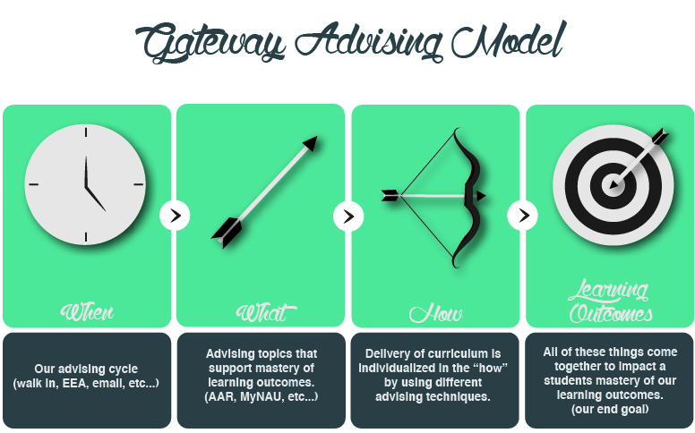Development of Gateway advising model that takes the traditional prescriptive model of advising and individualizes curriculum delivery.
* Development of First Year Academic Advising Learning Outcomes, accompanying assessment rubrics, an outcomes based assessment design, and tracking mechanisms and reporting.
* Efficiencies – to make the room for this type of advising – advisors need time and flexibility
* Bb Learn Shell – engaging students with learning and material before attending an advising appointment.

**Next Steps**

* Tracking of FYAALO mastery begins fall 2015; data available summer 2016
* Tracking activity and learning in Bb Learn begins fall 2015
* Continuing to find innovative ways to reach students, meet them where they are, and increase impact
* Expansion of learning outcomes to other populations of advising; beginning with Premed Advising learning outcomes.
* Professional development and on-going training for advisors and support staff to continue to add tools and strategies to their toolbox, and most effectively individualize advising curriculum to students.
* Identify audiences and opportunities to present on this project and its findings.

# Future Goals and Program Direction

**Integration of Advising and Learning**

* FYAALO tracking and assessment begins fall 2015; data available summer 2016
* Communication plan, updated materials and website to reflect the mission, philosophy, and alignment with learning, assessment, and University College goals.
* Continuing to foster a positive work culture and environment of innovation.
* Commitment to student learning, holistic development, innovation and best practices.
* Improvements to hiring practices and materials, holistic appraisal processes, and development of outcomes based training model for advisors.
* Providing leadership around learning initiatives, academic advising philosophy and bringing a student-centered approach across campus to strengthen advising’s overall impact on student success, retention, and graduation.

**Assessment Practices**

* Development of program objectives / outcomes for each individual Gateway advising program to focus on indicators of success and assessment design.
* Development of additional academic advising learning outcomes, beginning with Premed academic advising for 2015-2016, and B.U.S. academic advising for 16-17.
* Finding innovative methods of delivery to garner higher response rates and robust data from student and staff surveys, especially iAdvise, PE, Orientation and Transition.
* Providing leadership to campus wide assessment efforts, especially identifying cooperative efforts across academic advising and success initiatives to identify our most effective methods, strengthen our overall impact and tell the University Advising story.



**Advising Interventions**

* Additional professional development on Intrusive and Appreciative models of advising.
* Develop outcomes for our advising interventions that are grounded in our theoretical foundation, student risk factors, and provide focus for our intervention practices and assessment of impact.
* Increase our knowledge of predictive analytics practices and available programs and technology, integrating predictive data further into our interventions and advising and contributing to the campus community regrading student success.

**Efficiencies**

* Focus on Priority Enrollment and Orientation efficiencies to increase student time with advisors, impact program objectives, student learning and development, and advisor work satisfaction.
* Foster relationships with University Advising, academic departments, Registrar, and Admissions to find efficiencies and streamline university processes and policies that impact student satisfaction and transition through the university.

**Student Transitions**

* Design assessment strategy for student transition to department advising to assess student preparedness, student and advisor satisfaction, and to identify ways to innovate practices and find areas for continuous improvement.
* Continue to foster collaborative relationships with University Advising and other campus partners and find areas for improvement and cooperation in Orientation and student transition to department advising.

**Innovation in Advising Curriculum Delivery**

* iAdvise expansion and integration
  + Integration of advising materials with BBLearn “Academic Advising 101”.
  + Integration of FYAALOs with iAdvise quiz and qualifying data.
  + Integration of iAdvise auditing and outreach with other advising
  + Consider widening iAdvise criteria to increase the number of students who qualify to participate in iAdvise.
* Continue to explore the concept of case management and an advising dashboard to support advisors as they assess, track, provide advising and outreach to their cohort of students.
* Assess the effectiveness of innovative methods of advising intervention delivery.

**BBLearn**

* Integration of BBLearn “Academic Advising 101” into daily advising practices and delivery of academic advising curriculum; full assessment and data on student activity and feedback by summer 2016.
* Continuing to assess the effectiveness of BBLearn in Gateway training practices (both Gateway and University Advising) and find innovation in its use.

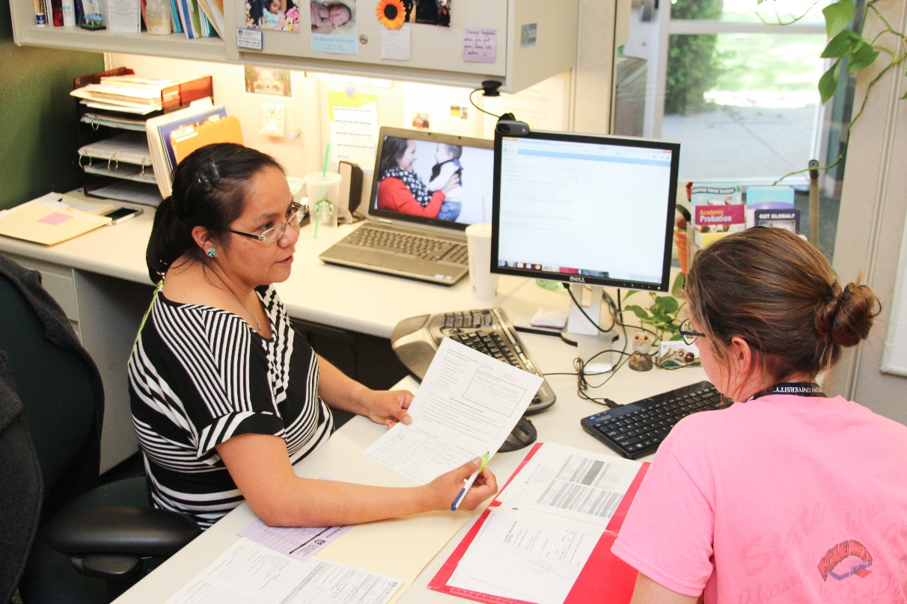

# Acknowledgements and Contact Information

|  |  |  |  |  |
| --- | --- | --- | --- | --- |
| Monica Bai Director |  | Maureen Fray Associate Director |  | Helen Hemmer Assistant Director |
|  |  | C:\Users\hbh8\Desktop\maureen1.jpg |  | C:\Users\hbh8\AppData\Local\Microsoft\Windows\Temporary Internet Files\Content.Outlook\49K600MX\IMG_2649.JPG |
| C:\Users\hbh8\AppData\Local\Microsoft\Windows\Temporary Internet Files\Content.Outlook\49K600MX\portrait.jpg  **Tel** 923 523 6514  Monica.Bai@nau.edu |  | **Tel** 928 523 8143  Maureen.Fray@nau.edu |  | **Tel** 928 523 9360  Helen.Hemmer@nau.edu |

**Additional report writing, data gathering and analysis support**: Emilly Borthwick-Wong, Rebecca Malone-Little Owl, Jamie Rivkin, Laural Hudson, Kelly Weston, Sarah Friedmann, Bryan Eisentraut, Cory Quackenbush, Kevin LaBranche, and the UCBA Team.

Gateway Student Success Center

Building #43

**Tel** 928 523 4772

nau.edu/Gateway