How to Complete a Data Request Submission Form

To submit a form, navigate to https://in.nau.edu/institutional-research/datarequest/. Select the Submission Form Option that best describes your role in relation to NAU. The data submission form will open in a new window. The instructions below will guide you through each section of the data submission form.

1) Submitter Information
NAU Faculty, Staff and Students will find that these fields auto populate. Submitters that selected “External to NAU”, will need to complete the following fields.
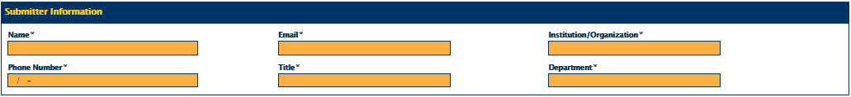

2) Timeline
Requested Data Due Date: The date that you wish to have the information returned.
Project Due Date: The date the information is due to for the final report, project, etc.
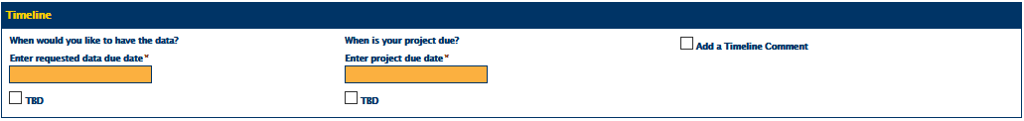

3) Request Type
Select “Other” and Institutional Research will update appropriately.
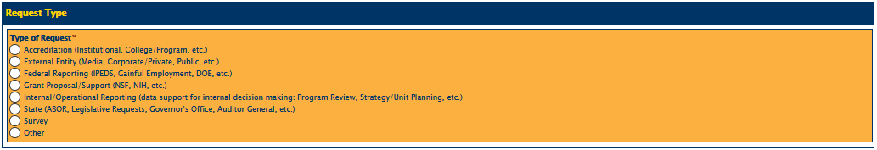

After Selecting “Other”, the following fields appear:
Entity Name: NAU Department or External Organization needing the data (ex. NAU Athletics, US News, etc.)
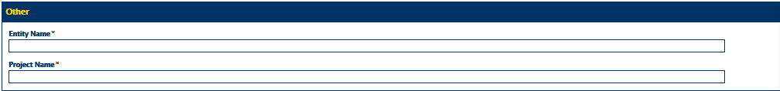
Project Name: Data Purpose (ex. Student Athlete Survey, US News Best Online Programs, etc.)

4) Request Frequency
Request Details: Enter relevant details and instructions in this field.
Data Request Date Range – Select the options that best reflect your request.
Attachments – You can include additional information by uploading relevant documents.
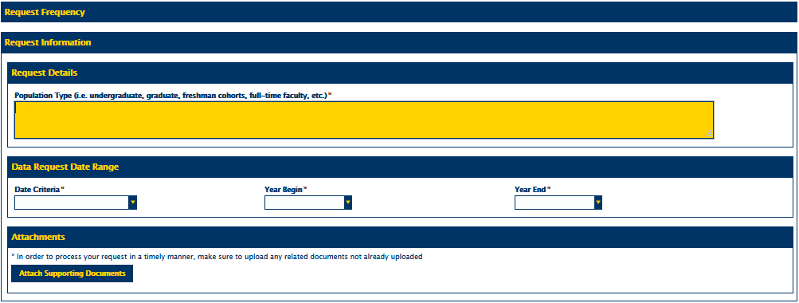

5) Click here if you are submitting on behalf of someone else.
Click this button if you are submitting on someone else’s behalf (otherwise skip to step 6). Select the button under Data Request Contact information that best describes who you are submitting for.

Faculty, Staff, Students and Affiliates will generate this contact form:
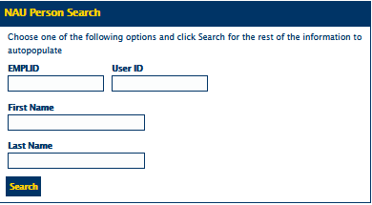
External Requestors will see the following:
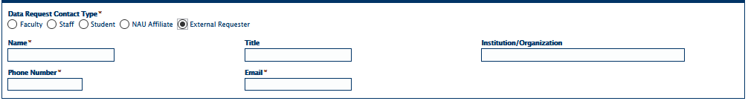

6) Submit
You should now be ready to click the Submit button. You also have the option to Save and Continue later. If you continue later, NAU users will receive an email with a link to the request, and non-NAU users will need to contact IRA for further assistance.

7) HELP?
If your form does not submit successfully:
- Ensure all required fields have been completed.
- Contact Institutional Research at 928-523-5804 or Institutional.Research@nau.edu

Note A: This tutorial was created using Firefox. You may find the field formatting and color schemes look different in other browsers. Note B: The orange highlighted fields in this document must be completed for all submissions. Note C: Admin users will first be directed to an introduction page before being routed to the form.

