Academic Structure Technical Implementation Steering Committee
Annual PeopleSoft Academic Restructure Final List

Introduction

Throughout the academic year, changes to organizational structures and names of colleges, departments, and academic programs are proposed and approved through university and ABOR processes. Each summer, the Academic Structure Technical Implementation Steering Committee and Project Team work together to ensure that PeopleSoft, along with all other impacted applications and functions connected to PeopleSoft (e.g., SalesForce, CollegeNet, Tableau, etc.) are aligned with the changes presented and approved throughout the academic year. For example, in 2018, when the College of Engineering, Forestry and Natural Sciences split into two colleges (the College of Engineering, Informatics and Applied Sciences and the College of the Environment, Forestry and Natural Sciences) and NAU’s student information system, PeopleSoft, was re-configured in August 2018 to reflect the college changes.

Due to the implementation of an Early Start initiative to ensure students’ completion of the fall semester before the Thanksgiving holiday, the first day of the Fall Semester will begin on August 12. Based on this decision, the Steering Committee reduced the scope of the Academic Restructure.

Timing of this year’s PeopleSoft Academic Restructure: August 9, 2020:
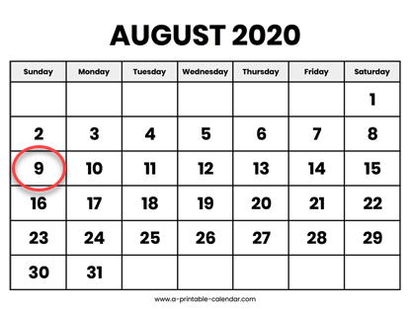

This proposal is organized in the following manner:
Topic | Pages
AY19-20 PeopleSoft Academic Structure Charts | 2-3
List of PS Academic Structure Changes for August 2020 (as of June 9, 2020) | 4-7
Organizational Changes | 4-6
Changes Supporting NAU Reporting Requirements | 7
AY20-21 PeopleSoft Academic Structure Charts | 8-10
Quick Reference for Aug 9 Academic Restructure | 8-15
Appendix 1. Academic Plan Campus Changes and Plan Deletions Already Approved for AY21-22 | 16
Appendix 2. Plan and Campus/Modality Requests Still Pending (Idea Submission Prior to May 31, 2020) | 17

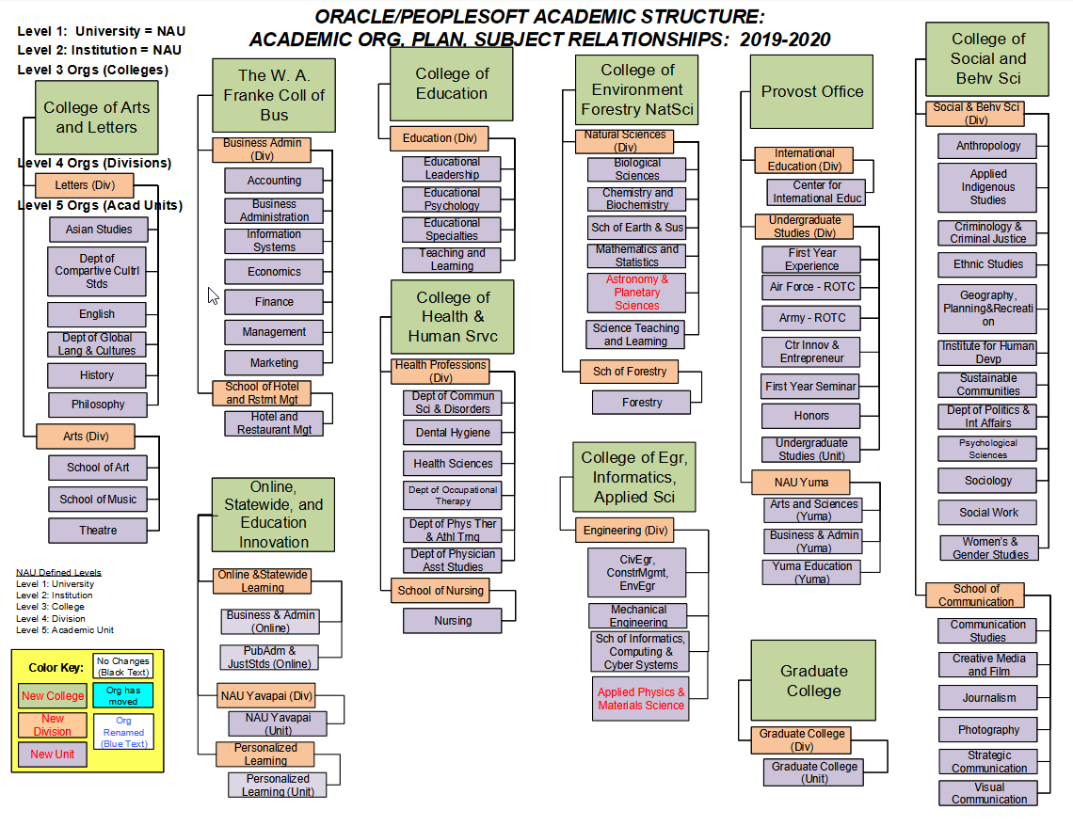

List of PS Academic Structure Changes for August 2020 (as of June 9, 2020)

Summary of Organizational Changes
The following organizational changes will be mirrored in the PeopleSoft Academic Structure for AY20-21.

- Center for Science Teaching and Learning
  - Move: From CEFNS to COE
  - Plan Code: the Plan Code for the Academic Unit CSTL will not be changing.
  - Academic Unit Name: Re-name Center for Science Teaching and Learning to STEM Education
  - Two plans (degrees) will move:
    - Science Teaching, MA (STMA)
    - Teaching Science with Certification MAT (SCICTMAT)
  - Two subjects (prefixes) will move:
    - SCI
    - TSM
  - The Center for Science Teaching and Learning will continue to exist, but will only house research endeavors, not academic programs.
- Re-name “Astronomy and Planetary Sciences” to “Astronomy and Planetary Science”
College of Environment Forestry NatSci
Natural Sciences (Div)
Biological Sciences
Chemistry and Biochemistry
Sch of Earth & Sus
Mathematics and Statistics
Astronomy & Planetary Sciences
Sch of Forestry
Forestry
Science Teaching and Learning
College of Education
Education (Div)
Educational Leadership
Educational Psychology
Educational Specialties
Teaching and Learning
STEM Education
MOVE
College of Environment Forestry NatSci
Natural Sciences (Div)
Biological Sciences
Chemistry and Biochemistry
Sch of Earth & Sus
Mathematics and Statistics
Astronomy & Planetary Science
Sch of Forestry
Forestry
AY 19-20
AY 20-21
AY 20-21

- Create “Continuing Education” Division and Unit in Online, Statewide and Education Innovation

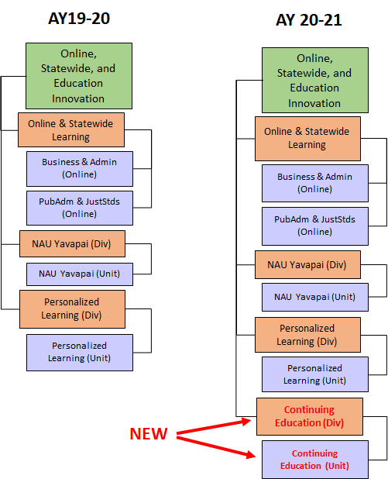

List of Changes to Support Reporting Needs as part of Academic Structure

Summary of Upcoming Campus Inactivations that were moved to Fall 2021
No Campus Inactivations will occur for Fall 2020 due to Early Start.
What about NAU-East Valley?
- We will remove all plans and students from NAU-East Valley. To external audiences, it will appear that we no longer have programs or students at NAU-East Valley.
- Yet, the full process for inactivating a campus must be coordinated across all areas of the university, and many university areas are engaged in activities to support Early Start. We will need more time than the Academic Restructure date to carry out those activities and conduct the checks on reporting. So, the full inactivation of NAU-East Valley will formally occur by next year’s academic restructure.
Plan Changes for ABOR Reporting Fall 2020
New ABOR Reporting Need: report students who completed accredited programs. Some of our plans include emphases (sub-plans) that are not accredited. We need to separate the degree + emphasis into separate degrees. Degrees impacted will be split as follows:
- Educational Leadership EDD (EDLEDD)
  - K-12 Administration Emphasis is CAEP Accredited
  - Community College/ Higher Education Administration Emphasis is not accredited
- Elementary Education MED (EEMED)
  - Reading K-8 Emphasis is CAEP Accredited
  - 4 other emphases are not accredited: Continuing Professional, Multiage, Elementary National Board Preparation, Positive Behavior Support
- Public Health MPH
  - Health Promotion Emphasis is working on CEPH Accreditation
  - Nutrition Emphasis is already ACEND Accredited
- Chemistry BS
  - Chemistry ACS and Biochemistry ACS Sub-plans are American Chemical Society Accredited
  - Three other emphases are not accredited: Chemistry Advanced; Forensics & Criminalistics; Health Preprofessional
Approved New Plans and Subplans, Plan and Subplan Inactivations, and Plan Campus Changes for AY20-21 (See Quick Reference Section)
CIP Code 2020 Changes
Four Plan CIP Code Changes
- Social Science Forensics Minor
- Intelligence Studies Minor
- Intelligence Studies UCERT/PB
- Applied Physics and Materials Science PHD
Subject-Level Changes
Moving four Subject prefixes from NAU-Yavapai to Personalized Learning, which will provide Personalized Learning more control over their unique “Personalized Learning” area to support more efficient reporting.
- ENTY
- HISY
- SIMY
Creation of a Fall Back Plan for Graduate area
This Fall Back plan will not display in the catalog. Fall Back Plans are for students who are in a PHD program and who would not be able to finish the PHD, yet who have completed enough units of credit at a high-enough quality level to “Fall Back” to a Master’s Degree.

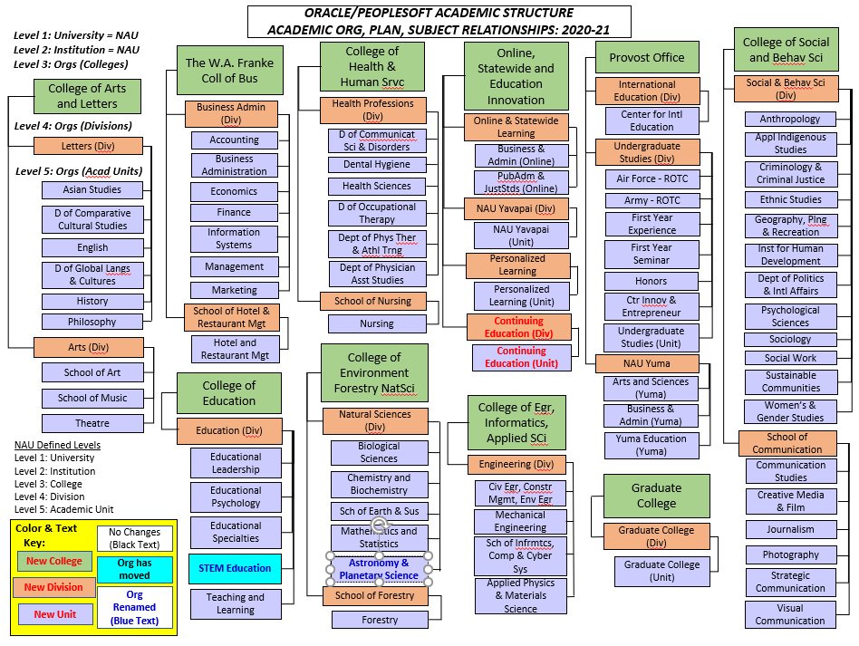
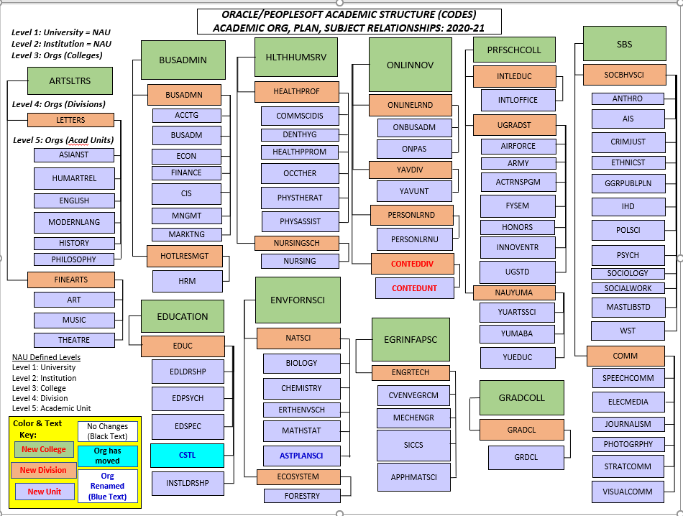

Quick Reference for Aug 9, 2020 Academic Restructure
The following is a quick “cheat sheet” on the proposed changes within PeopleSoft for the Fall 2020 Academic Restructure. Final approval and confirmation is pending on this information and notification will be sent out once formal approval has been received. (Note: This document represents data structures within PeopleSoft for subject/plan/org associations and may not reflect administrative reporting lines within the university).

New Group/Program Additions [None]

Changes by College:
- College of Arts and Letters
  - College-level changes: [none]
  - Division-level changes: [none]
  - Academic Unit-level changes: [none]
  - Plan –level changes:
    - New Plans
      - NEW PLAN Environmental Narrative GCERT (ENVNARCT)
    - Plan Campus Change
      - ADD CAMPUS Interior Design for Hotel and Restaurant Management Majors (IDHRMCT) Add Scottsdale Community College
    - Plan Inactivations (LTV until all students complete or are removed)
      - INACTIVATE PLAN English – Secondary Education MA (ENGEDMA)
      - INACTIVATE PLAN Navajo Secondary Education Minor (TNMN)
    - SubPlan Changes
      - NEW SUBPLAN Modern Languages BA (MLBAX/2/PB) Japanese Emphasis (JPNMF/2/PB)
      - NEW SUBPLAN Modern Languages BA (MLBAX/2/PB) Japanese Interdisciplinary Global Program Emphasis (JPNGSEM/2/PB)
      - SUBPLAN NAME CHANGE Modern Languages BA (MLBAX/2/PB) from French Emphasis (FRENF/2/PB) to French and Francophone Studies Emphasis
  - Subject –level changes: [none]

- College of Education
  - College-level changes: [none]
  - Division-level changes: [none]
  - Academic Unit-level changes:
    - RECEIVE Center for Science Teaching and Learning (CSTL), which will be re-named “STEM Education”
  - Plan –level changes:
    - Academic Tree Changes
      - RECEIVE Science Teaching, MA (STMA)
      - RECEIVE Teaching Science with Certification MAT (SCICTMAT)
    - New Plans
      - NEW PLAN Clinical Psychology PSYD (CPPPSYD) (Enrollments began Spring 2020)
      - NEW PLAN College and Career Readiness GCERT (CCRCT)
      - NEW PLAN PK-12 College and Career Counseling MED (P12CCMED)
      - NEW PLAN Reading Specialist K-8 GCERT (RDGK8CT)
    - Plan Campus Changes
      - ADD CAMPUS Educational Leadership EDD (EDLEDD) Add Scottsdale Community College
      - ADD CAMPUS Educational Leadership – Community College/Higher Education MED (EDLCCMED) Add Scottsdale Community College
      - ADD CAMPUS Educational Leadership – Instructional Leadership K-12 School Leadership MED (EDLSLMED) Add Scottsdale Community College
      - ADD CAMPUS Educational Leadership – Principal K-12 MED (EDLPCMED) Add Scottsdale Community College
      - ADD CAMPUS Elementary Education – Certification MED (EECTMED; EECTMEDP) Add Online (Enrollments began in Spring 2020)
      - ADD CAMPUS Principal GCERT (PRINCCT) Add Scottsdale Community College
      - ADD CAMPUS Special Education – Early Childhood Special Education with Certification MED (SPECCTMED, SPECCTMEDP) Add Online
      - ADD CAMPUS Special Education – Mild/Moderate Disabilities Certified MED (SPECCEAMED, SPCCEAMEDP) Add Online (Enrollments began in Spring 2020)
      - ADD CAMPUS Superintendent GCERT (SUPERCT) Add Scottsdale Community College
      - ADD CAMPUS Teaching Science with Certification MED (SCICTMAT) Add Online
      - REMOVE CAMPUS Educational Leadership EDD (EDLEDD) Remove East Valley
      - REMOVE CAMPUS Educational Leadership – Community College/Higher Education MED (EDLCCMED) Remove East Valley
      - REMOVE CAMPUS Educational Leadership – Instructional Leadership K-12 School Leadership MED (EDLSLMED) Remove East Valley
      - REMOVE CAMPUS Educational Leadership – Principal K-12 MED (EDLPCMED) Remove East Valley
      - REMOVE CAMPUS Elementary Education – Certification MED (EECTMED) Remove East Valley
      - REMOVE CAMPUS Human Relations MED (HUMRELMED) Remove East Valley
      - REMOVE CAMPUS Human Relations MED (HUMRELMED, HUMRELMEDP) Remove Yuma
      - REMOVE CAMPUS Principal GCERT (PRINCCT) Remove East Valley
      - REMOVE CAMPUS Reading Specialist Endorsement (RDGENADE) Remove Flagstaff
      - REMOVE CAMPUS Science Teaching MA (STMA) Remove Flagstaff
      - REMOVE CAMPUS Superintendent GCERT (SUPERCT) Remove East Valley
      - REMOVE CAMPUS Teaching Science with Certification MED (SCICTMAT) Remove Flagstaff
    - Split Plan
      - SPLIT PLAN Educational Leadership EDD (EDLEDD) into two plans
        - NEW PLAN Educational Leadership-K-12 Administration EDD (EDLK12EDD)
        - Educational Leadership- Community College/Higher Education Administration EDD (EDLEDD)
      - SPLIT PLAN Elementary Education MED (EEMED) into two plans
        - Elementary Education MED (EEMED)
          - SUBPLAN Continuing Professional – Emphasis (EECPM, ELMEDMEDP)
          - SUBPLAN Elementary National Board Preparation – Emphasis (EENBPM, ELMEDNBP)
          - SUBPLAN Multiage – Emphasis (EEMAEM; ELMEDMAP)
          - SUBPLAN Positive Behavior Support – Emphasis (POSBEHSSPM, ELMEDPBHP)
        - Elementary Education – Reading K-8 MED (EERDK8MED)
    - Subplan Changes
      - INACTIVATE SUBPLAN Educational Leadership EDD (EDLEDD) Community College Higher Education Administration Emphasis (CCHEADMN) (LTV Summer 2020)
      - INACTIVATE SUBPLAN Educational Leadership EDD (EDLEDD) K-12 Administration (K12ADMM) (LTV Summer 2020)
      - INACTIVATE SUBPLAN Elementary Education MED (EEMED) Reading K-8 Emphasis (EERKM; ELMEDRKP)
      - INACTIVATE SUBPLAN Special Education MED (SPECCENMED) Disability Studies Emphasis (SPEDISSTM)
      - NEW SUBPLAN Early Childhood MED (ECEMED) Early Childhood Multiage Emphasis (ECMAEM, ELMEDMAP)
      - NEW SUBPLAN Educational Leadership EDD (EDLEDD) Community College Higher Education Administration Emphasis (CCHEADMN) (FTV Fall 2020)
      - NEW SUBPLAN Educational Leadership EDD (EDLEDD) K-12 Administration (K12ADMM) (FTV Fall 2020)
      - NEW SUBPLAN Educational Technology MED (EDTCHMED) Assistive Technology Emphasis (ASSTTCHM, ETASSTTCHP)
      - NEW SUBPLAN Elementary Education MED (EEMED) Multiage Emphasis (EEMAEM, ELMEDMA)
      - NEW SUBPLAN Elementary Education MED (EEMED) Positive Behavior Support Emphasis (POSBEHSSPM, ELMEDPBHP)
      - NEW SUBPLAN Special Education MED (POSBEHSPM) Positive Behavior Support (POSBEHSPM, SPECPBMEDP)
  - Subject –level changes:
    - Academic Tree Changes
      - RECEIVE Subject prefix SCI
      - RECEIVE Subject prefix TSM
    - New Subjects
      - CPP for Clinical Psychology owned by Educational Psychology

- College of Engineering, Informatics, and Applied Sciences
  - College-level changes: [none]
  - Division-level changes: [none]
  - Academic Unit-level changes: [none]
  - Plan –level changes:
    - CIP Code Changes
      - CHANGE CIP CODE Applied Physical and Materials Science PHD (APMSPHD) from 14.1001 to 40.1001
      - CHANGE CIP CODE Applied Physical and Materials Science PHD / Applied Physics EMP (APMSPHD / APPPHYM) from 14.1001 to 40.1001
      - CHANGE CIP CODE Applied Physical and Materials Science PHD / Materials Science EMP (APMSPHD / MATSCIM) from 14.1001 to 40.1001
    - New Plans
      - NEW PLAN Civil and Environmental Engineering PHD (CIENEGRPHD)
      - NEW PLAN Civil Engineering Professional MENG (CIVPRMEG)
      - NEW PLAN Cybersecurity BS (CYBBS/2/PB)
      - NEW PLAN Cybersecurity GCERT (CYBGCT)
      - NEW PLAN Cybersecurity Minor (CYBMN)
      - NEW PLAN Cybersecurity MS (CYBMS)
      - NEW PLAN Materials Sciences MS (APMSMS)
      - NEW PLAN Multidisciplinary Engineering BS (MDEGRBS/2/PB)
        - ADD NEW SUBPLAN Audio Engineering Emphasis (AUDEGRM/2/PB)
        - ADD NEW SUBPLAN Engineering Design Emphasis (EDEGRM/2/PB)
        - ADD NEW SUBPLAN Energy Engineering Emphasis (ENEEGRM/2/PB)
        - ADD NEW SUBPLAN Sustainable Engineering Emphasis (SEEGRM/2/PB)
        - ADD NEW SUBPLAN User Experience Engineering Emphasis (UEEGRM/2/PB)
      - NEW PLAN Software Engineering BS (SEEGRBS/2/PB)
      - NEW PLAN WindU Consortium Graduate (WINDUGCS)
      - NEW PLAN WindU Consortium Undergraduate (WINDUUCS)
      - NEW PLAN Electrical Engineering Technology BS (EETBS/2/PB) (Enrollments will begin in Spring 2021)
    - NEW PLAN: FALL BACK
      - NEW PLAN Fall BACK: Astronomy and Planetary Science MS FB (ASTMSMFB)
    - Plan Campus Changes
      - ADD CAMPUS Wind Energy GCERT (WINDENCT) Add Online
    - Plan Inactivations (LTV until all students complete or are removed)
      - INACTIVATE PLAN Engineering – Computer Science and Engineering MENG (EGRCSEMENG)
      - INACTIVATE PLAN Engineering – Electrical Engineering MENG (EGREEMENG)
      - INACTIVATE PLAN Engineering – Civil Engineering MENG (EGRCIMENG)
    - Plan Name Change
      - CHANGE NAME WITH NO PLAN CODE CHANGE from Physics and Astronomy BS (PHYASTBS/2/PB) to Physics and Astrophysics BS
  - Subject –level changes:
    - New Subjects
      - BE – Biomechanical Engineering; owned by Department of Mechanical Engineering
      - CYB – Cybersecurity; owned by School of Informatics, Computer and Cyber Systems
      - EET – Electrical Engineering Technology; owned by School of Informatics, Computer and Cyber Systems
      - SE – Software Engineering; owned by School of Informatics, Computer and Cyber Systems
      - WU@TTU – courses taught by Texas Technical University for the Wind University Consortium; owned by Department of Mechanical Engineering
      - WU@UMA – courses taught by University of Massachusetts at Amherst for the Wind University Consortium; owned by Department of Mechanical Engineering

- College of the Environment, Forestry, and Natural Sciences
  - College-level changes: [none]
  - Division-level changes: [none]
- Academic Unit-level changes
    - Academic Tree Changes
      - MOVE Center for Science Teaching & Learning to COE; change name to STEM Education (CSTL)
    - Academic Unit Name Changes
      - CHANGE NAME WITH NO ORG CODE CHANGE from Astronomy and Planetary Sciences (ASTPLANSCI) to Astronomy and Planetary Science
  - Plan –level changes:
    - Academic Tree Changes
      - MOVE Science Teaching, MA (STMA) to COE STEM Education (CSTL)
      - MOVE Teaching Science with Certification MAT (SCICTMAT) to COE STEM Education (CSTL)
    - New Plans
      - NEW PLAN Climate Change Minor (CCMN)
      - NEW PLAN Ecology and Evolutionary Biology BS (EEBIOBS/2/PB)
    - Split Plans
      - SPLIT PLAN Chemistry BS (CHMBS) into two plans
        - SUBPLAN CHANGE Chemistry BS (CHMBS/2/PB)
          - Chemistry Advanced - Emphasis (CHADVM/2/PB)
          - Forensics & Criminalistics Emphasis (CHFCM/2/PB)
          - Health Preprofessional Emphasis (CHHPPM/2/PB)
        - NEW PLAN Chemistry – American Chemical Society BS (CHMACSBS/2/PB)
          - SUBPLAN NAME CHANGE from Chemistry – American Chemical Society Emphasis (CHMACSM/2/PB) to Comprehensive American Chemical Society Emphasis
          - Biochemistry American Chemical Society Emphasis (CHMBACSM/2/PB)
    - Subplan Changes
      - INACTIVATE SUBPLAN Forestry (FORMF) Ecology, Evolution & Conservation Biology Emphasis (EECBMFM)
  - Subject –level changes:
    - Academic Tree Changes
      - MOVE Subject prefix SCI to COE STEM Education (CSTL)
      - MOVE Subject prefix TSM to COE STEM Education (CSTL)

- College of Health & Human Services
  - College-level changes: [none]
  - Division-level changes: [none]
  - Academic Unit-level changes: [none]
  - Plan –level changes:
    - New Plans
      - NEW PLAN Clinical Nursing Specialist, Prescriptive Authority Course Bundle (CNSPABN)
      - NEW PLAN Public Health GCERT (HSPHCT)
      - NEW PLAN Health Sciences – Allied Health (HSAHBS/2/PB)
    - Plan Campus Changes
      - ADD CAMPUS Health Sciences – Allied Health BS (HSAHBS/2/PB) Add Yuma
    - Plan Inactivations (LTV until all students complete or are removed)
      - INACTIVATE PLAN Health Sciences – Allied Health BS (HSAHBSX/2/PB)
      - INACTIVATE PLAN Health Sciences – Diagnostic Medical Imaging and Therapy BS (HSDMITBSX/2/PB)
      - INACTIVATE PLAN Health Sciences – Medical Assisting BS (HSMEABSX/2/PB)
      - INACTIVATE PLAN Health Sciences – Paramedic Care BS (HSPARBSX/2/PB)
      - INACTIVATE PLAN Health Sciences – Physical Therapist Assisting BS (HSPTABSX/2/PB)
      - INACTIVATE PLAN Health Sciences – Respiratory Care BS (HSRESBSX/2/PB)
      - INACTIVATE PLAN Health Sciences – Surgical Technology BS (HSSURBSX/2/PB)
    - Split Plans
      - SPLIT PLAN Public Health MPH (HSMPH) into two plans
        - Public Health – Health Promotion (HSMPH)
        - Public Health – Nutrition (HSNTSMPH)
    - SubPlan Changes
      - NEW SUBPLANS Health Sciences – Allied Health BS (HSAHBS/2/PB)
        - NEW SUBPLAN Diagnostic Medical Imaging and Therapy (HSDMTM/2/PB)
        - NEW SUBPLAN General Allied Health (HSGAHM/2/PB)
        - NEW SUBPLAN Medical Assisting (HSMEAM/2/PB)
        - NEW SUBPLAN Paramedic Care (HSPARM/2/PB)
        - NEW SUBPLAN Physical Therapist Assisting (HSPTAM/2/PB)
        - NEW SUBPLAN Respiratory Care (HSRESM/2/PB)
        - NEW SUBPLAN Surgical Technology (HSSURM/2/PB)
  - Subject –level changes: [none]

- College of Social and Behavioral Sciences
  - College-level changes: [none]
  - Division-level changes: [none]
  - Academic Unit-level changes: [none]
  - Plan –level changes:
    - CIP Code Changes
      - CIP CODE CHANGE Social Science Forensics – Minor (SOCSCFORMN) from CIP Code 43.0106 to 43.0406
    - New Plans
      - NEW PLAN Anthropology MA (ANTHMA)
      - NEW PLAN Disability Resource Specialist (DRSGCT)
    - Plan Campus Change
      - ADD CAMPUS Indian Country Criminal Justice BS (ICJBS/2/PB) Add Online (Effective for Spring 2020)
      - ADD CAMPUS Sociology BS (SOCBS/2/PB) Add Yuma
      - ADD CAMPUS Sociology BS (SOCBS/2/PB) Add Online
    - Plan Inactivations (LTV until all students complete or are removed)
      - INACTIVATE PLAN Anthropology – Applied MA (ANTAPMA)
      - INACTIVATE PLAN Anthropology – Research MA (ANTREMA)
      - INACTIVATE PLAN Political Science GCERT (POLSCICT)
  - Subject –level changes: [none]

- Online, Statewide, & Education Innovation
  - College-level changes: [No changes]
  - Division-level changes:
    - ADD Continuing Education (Div) (CONTEDDIV).
  - Academic Unit-level changes
    - ADD Continuing Education (Unit) (CONTEDUNT)
  - Plan –level changes:
    - CIP Code Changes
      - CIP CODE CHANGE Intelligence Studies - Certificate (INTLDPCT/PB) from CIP Code 43.0118 to 43.0408
      - CIP CODE CHANGE Intelligence Studies - Minor (INTSTMN) from CIP Code 41.9999 to 43.0408
    - Plan Campus Changes
      - ADD CAMPUS Interdisciplinary Studies – Applied Human Behavior 90-30 B (ISAPHB9B/2/PB) Add Online
      - ADD CAMPUS Interdisciplinary Studies – Industrial Leadership 90-30 B (IDSIL9B/2/PB) Add Estrella Mountain Community College
      - ADD CAMPUS Interdisciplinary Studies – Strategic Leadership 90-30 B (ISSLEA9B/2/PB) Add Scottsdale Community College
      - ADD CAMPUS Interdisciplinary Studies – Strategic Leadership 90-30 B (ISSLEA9B/2/PB) Add Pima Community College - Downtown
    - Plan Inactivations (LTV until all students complete or are removed)
      - INACTIVATE PLAN Small Business Administration BA (PLSBABA/2/PB)
      - INACTIVATE PLAN Small Business Administration BS (PLSBABS/2/PB)
      - INACTIVATE PLAN Small Business Administration Minor (PLSBAMN/2/PB)
    - Subplan Changes
      - ADD SUBPLAN Management BA (PLMGMTBA/2/PB) Entrepreneurship and Business Development – Emphasis (PLMGTENM/2/PB)
      - ADD SUBPLAN Management BS (PLMGMTBS/2/PB) Entrepreneurship and Business Development – Emphasis (PLMGTESM/2/PB)
  - Subject –level changes:
    - Academic Tree Changes
      - MOVE Subject prefix ENTY from NAU-Yavapai (YAVUNT) to Personalized Learning (PERSONLRNU)
      - MOVE Subject prefix HISY from NAU-Yavapai (YAVUNT) to Personalized Learning (PERSONLRNU)
      - MOVE Subject prefix SIMY from NAU-Yavapai (YAVUNT) to Personalized Learning (PERSONLRNU)
- Provost Office
  - College-level changes: [none]
  - Division-level changes: [none]
  - Academic Unit-level changes [none]
  - Plan –level changes:
    - Plan Inactivations (LTV until all students complete or are removed)
      - INACTIVATE PLAN Sociology B (SOCIOLB/2/PB)
      - INACTIVATE PLAN Secondary Education – Biology Yuma (BIOBSED/2/PB)
      - INACTIVATE PLAN Secondary Education - Physical Science Yuma (PHSCBSED/2/PB)
  - Subject –level changes [none]

- W.A. Franke College of Business
  - College-level changes: [none]
  - Division-level changes: [none]
  - Academic Unit-level changes[none]
  - Plan –level changes:
    - Plan Inactivations (LTV until all students complete or are removed)
      - INACTIVATE PLAN Business Prep Program (BUSP/PB)
    - New Plans
      - NEW PLAN Business Analytics UCERT (BAUCT/PB)
      - NEW PLAN Financial Planning UCERT (FINPLNCT/PB)
  - Subject –level changes: [none]
- Graduate College – NO CHANGES
Appendix 1. Academic Plan Campus Changes and Plan Deletions Already Approved for AY21-22
- College of Arts and Letters – NO CHANGES
- College of Education
  - ADD CAMPUS Elementary Education BSED (EEBSEDX/2/PB) Add Yuma
  - REMOVE CAMPUS Educational Leadership – Community College/Higher Education MED (EDLCCMED, EDLMEDCCP) Remove Flagstaff
  - REMOVE CAMPUS Educational Leadership – Instructional Leadership K-12 School Leadership MED (EDLSLMED, EDLMEDSLP) Remove Flagstaff
  - REMOVE CAMPUS Educational Leadership – Principal K-12 MED (EDLPCMED, EDLMEDPCP) Remove Flagstaff
  - REMOVE CAMPUS Educational Leadership – Principal K-12 MED (EDLPCMED, EDLMEDPCP) Remove Yuma
  - REMOVE CAMPUS Principal GCERT (PRINCCT, PRINCCTP) Remove Flagstaff
  - REMOVE CAMPUS Autism Spectrum Disorders (School-Based) GCERT (AUTSPCT) Remove Flagstaff
  - REMOVE CAMPUS Applied Science – Early Childhood BAS (ECBAS, ECBAS2, ECBASPB) Remove Yuma
  - REMOVE CAMPUS Early Childhood Education MED (ECEMED, ERCHEDMEDP, ERCLDRMEDP, ERCMAMEDP, ERCNBMEDP) Remove Flagstaff
  - REMOVE CAMPUS Early Childhood Education MED (ECEMED, ERCHEDMEDP, ERCLDRMEDP, ERCMAMEDP, ERCNBMEDP) Remove Yuma
- College of Engineering, Informatics, and Applied Sciences – NO CHANGES
- College of the Environment, Forestry, and Natural Sciences – NO CHANGES
- College of Health & Human Services
  - ADD CAMPUS Health Sciences-Fitness Wellness BS (HSFITWBS/2/PB) Add Glendale Community College
- College of Social and Behavioral Sciences
  - INACTIVATE PLAN Applied Indigenous Studies BA (AISBA/2/PB)
  - INACTIVATE PLAN Professional Communication UCERT (PCCT/PB)
  - REMOVE CAMPUS Assistive Technology (ASSTTCHCT) Remove Flagstaff
  - REMOVE CAMPUS Community Planning GCERT (COMMPLCT) Remove Flagstaff
- Online, Statewide, & Education Innovation
  - REMOVE CAMPUS Interdisciplinary Studies – Public Administration 90-30 B (IDSPA9B) Remove Chandler-Gilbert CC
  - REMOVE CAMPUS Interdisciplinary Studies – Public Administration 90-30 B (IDSPA9B) Remove Paradise Valley CC
  - REMOVE CAMPUS Interdisciplinary Studies – Public Administration 90-30 B (IDSPA9B) Remove Glendale CC
- Provost Office
  - ADD CAMPUS Applied Science – Logistics and Supply Chain Management BAS (LSUCHBAS) Add Estrella Mountain Community College
  - REMOVE CAMPUS Applied Science – Technology Management 90-30 B (YUTMBAS) Remove Yuma
  - REMOVE CAMPUS Interdisciplinary Studies – Technology Management 90-30 B (IDSTM9B) Remove Yuma
  - INACTIVATE PLAN Elementary Education – Yuma (EEBSED)
- W.A. Franke College of Business
  - ADD CAMPUS Financial Planning UCERT (FINPLNCT/PB) Add Online
- Graduate College – NO CHANGES
Appendix 2. Plan, Campus/Modality Requests Still Pending (Idea Submission Prior to May 31, 2020)

- College of Arts and Letters
  - Piano Pedagogy UCERT

- College of Education
  - Integrated Behavioral Health GCERT

- College of Engineering, Informatics, and Applied Sciences
  - Bioengineering BS
  - Electrical Engineering Technology BS
  - Mechatronics and Robotics BS
  - Power and Sustainable Energy GCERT
  - Power and Sustainable Energy UCERT

- College of the Environment, Forestry, and Natural Sciences
  - Actuarial Science GCERT
  - Brewing and Fermentation Science GCERT
  - Greenhouse Gas Accounting GCERT

- College of Health & Human Services
  - Dental Therapy MS
  - Public Health MPH
  - Spa and Well-being Management UCERT
  - Master’s Entry into the Professional of Nursing MS
  - Physical Therapy DPT-Hybrid Modality

- College of Social and Behavioral Sciences
  - Aging GCERT
  - Archaeology and Geographic Information Systems MS
  - Diversity Leadership MS
  - eSports UCERT
  - Geographic Information Sciences and Remote Sensing MS
  - Indigenous Psychology UCERT
  - Outdoor Education and Leadership Minor and/or UCERT
  - Recreational Sports Minor and/or UCERT

- Online, Statewide, & Education Innovation – SUBMISSIONS COMPLETED for AY20-21

- Provost Office
  - Global Business Administration MGBA – hybrid modality request

- W.A. Franke College of Business
  - Hospitality Innovative Technology M
  - Interdisciplinary Studies – Hospitality Leadership 90-30 B
  - Risk Management and Insurance UCERT

- Graduate College – NO SUBMISSIONS (Operational Unit, does not own academic programs)

