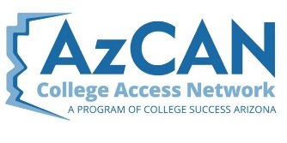
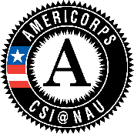

Arizona Ready for College and Career (ARCC) AmeriCorps
Mentor Partner Site Application 2020-2021

Purpose of AmeriCorps
The purpose of AmeriCorps is to improve lives, strengthen communities and foster civic participation through service and volunteerism.

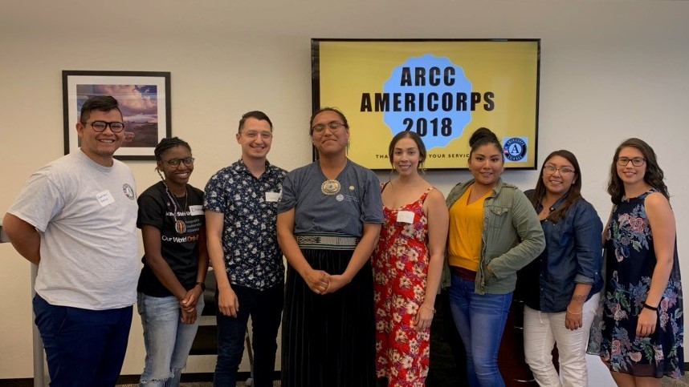

Purpose of Arizona Ready for College and Career (ARCC)
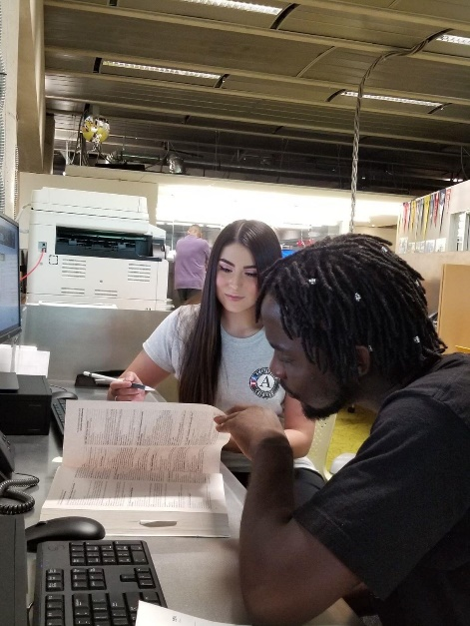
- Increase college and career readiness across Arizona
- Increase postsecondary/college on-time completion rates
- Build the professional skills of individuals through the AmeriCorps member service experience
- Assist underserved middle, high school and nontraditional students with key post-secondary/career planning steps to prepare for college and meaningful careers

NAU CSI ARCC AmeriCorps
Program Year 2020-2021

Scope
Less than half of working adults in AZ have a certificate or degree. The goal of this project is to increase college and career readiness and postsecondary completion rates for those most in need throughout Arizona.

The ARCC program is designed to utilize AC members to serve as college access "advisors" to middle, high school and non-traditional students. AC members can also assist colleges, universities and other vocational/postsecondary completion programs to help recruit non-traditional students and to assist those individuals in completing the programs on time (i.e. completing a bachelor’s degree within 4-5 years, etc.). AC members will deliver information and assistance with key college planning steps including: forming expectations about college, college applications, completing financial aid forms, preparing for entrance exams and selecting a college. The intervention is delivered by AC members who represent the community they are serving in 1:1 meetings and workshops to : (1) assess individual student needs and share information; (2) assist with key college planning action steps i.e. completing financial aid forms and college applications and (3) have follow-up meetings to address any questions, steps that remain i.e. selecting a college, scheduling new student orientation, FAFSA verification and measuring success of intervention with students. College includes: 2 year, 4 year and technical/trade schools.

This project seeks non-profit organizations, schools and community partners who would like to host AmeriCorps members to increase their capacity to serve students and families. AmeriCorps members may support other direct service activities at your partner site that relate to youth development and/or college and career readiness.

Target Demographic
This project aims to serve prospective first generation college students and individuals from low-income communities including: middle school, high school and nontraditional students (such as adults entering or returning to college) from school districts and communities with low graduation and post-secondary enrollment rates.

Geographic Focus
Non-profit agencies, educational institutions, and programs serving youth and young adults providing service in Cochise, Coconino, Gila, Maricopa, Mohave, Navajo, Pima, Pinal, and Yavapai counties.

Member Development
AmeriCorps service is intended to meet community need while developing the next generation of professionals. Partner sites should provide and allow the member to engage in opportunities to experience personal, professional and community growth. Civic Service Institute (CSI) ARCC staff will provide a Professional Training series and the partner site must allow time for the member to participate. Arizona College Access Network (AzCAN) will provide training to AmeriCorps members in college and career readiness on key college going steps. Members can elect to earn certifications from AzCAN and The National College Access Network (NCAN). Additionally, Members will have personal development funds provided by CSI to help offset cost for individual development opportunities such as conference/ workshop registrations; members serving 1200/1700 hours are eligible for up to $100 training funds; members serving less than 1200 hours will receive up to $50.

As part of service, AmeriCorps members are required to participate in National Days of Service. CSI refers to these days as Esprit-De-Corps (EDC) days as they embody the spirit of service and give members a chance to feel a part of a Corps of service members. Sites must allow members to participate in EDC National Service Days such as 9-11 and MLK Day. Service days allow members to re-connect with other members and the community in a different way than day-to-day service. Members across the nation complete service projects on days of service to make a large impact for our communities. NAU collaborates with other service programs and organizations to engage members in meaningful service day projects. 1700/1200 hour members are required to participate in 3 EDCs; 900 hour members are required to complete 2 EDCS; and 450 hour members complete at least 1 EDC. Members are welcome to complete additional program EDCs.

Current Project Requirements
In addition to the application, you must complete the following:
- Email NAU CSI AmeriCorps a current Copy of Agency Liability Insurance (details on pg. 4)
- Include a position description for each position you are applying for using the format included in the application.

Criteria for being chosen as an NAU CSI AmeriCorps mentor partner site for ARCC:
- Returning partner sites must be in good standing with the NAU CSI AmeriCorps office (paid invoices on time, completed all necessary documentation in a timely fashion, and provided a good mentoring experience for AmeriCorps Members).
- Goals of the partner site and of the specific positions are a good fit for project scope.
- Partner site has identified a staff member who has the time, expertise, and training to mentor. Partner sites must also identify a backup mentor who can fill in if the primary mentor is away. (Note: It is best practice to identify one Primary Mentor per every 2 Full Time or 4 Half Time Members).
- Partner site has shown that they have a funding source to pay the cash match.

Overview of Requirements and Guidelines:
Annual Term: The grant year starts on September 1, 2020 and ends on August 31, 2021.
- Quarter 1: Sept 1, 2020- Nov 30, 2020
- Quarter 2: Dec. 1. 2020- Feb. 28, 2021
- Quarter 3: March 1, 2021- May 31, 2021
- Quarter 4: June 1, 2021- Aug. 31, 2021

Slot Types available: Full-Time (1700 Hours); Reduced Full-Time (1200 Hours); Half-Time (900 Hours); Quarter-Time (450 Hours); for long and short periods:

We understand COVID-19 has likely affected your organization in a multitude of ways and want to do what we can to help. To offer support to our partner sites we are able to temporarily reduce the partner site cost match. For Partner Site Applications received before and during Quarter 1 of the 2020-21 program year sites will be able to onboard members with a reduced cash match. Partner site applications received in quarters 2, 3, and 4 will be required to pay the standard cash match.

Slot Type | Service Dates | Approximate hours | Q1 Reduced Cash Match (partner site cost for members requested by end of Q1, placed by end of Q2) | Standard Cash Match (partner site cost for members requested in Q2-Q4)
D) Half Time Short - 900 hrs | 36 weeks | 25-30 hrs/week | $3,800 | $4,500
E) Half Time Long– 900 hrs | 50 weeks | 18-20 hrs/week | $3,800 | $4,500
F) Quarter Time Short- 450 hrs | 14 weeks | 32-35 hrs/week | $2,000 | $2,750
G) Quarter Time Long- 450 hrs | 36 weeks | 12-15 hrs/week | $2,000 | $2,750

Self-Sustaining Projects
Projects need to be self-sustaining and continue to meet the community needs on or before the current funding cycle, which ends August 31, 2021. AmeriCorps members’ duties cannot and should not duplicate or displace staff duties.

Continuing partner sites must reapply each year describing how the AmeriCorps member will continue to serve current projects or propose a new project that will also need to be completed on or before August 31, 2021.

Transportation
The Civic Service Institute ARCC will reimburse mileage to members for ARCC required long distance travel for members. All partner site required travel for members must be reimbursed by the partner site at the partner site approved rate.

Liability Insurance
Partner sites must submit proof of liability insurance (see details below) with your application.
Commercial General Liability: with minimum limits of $1,000,000 per occurrence, and an unimpaired products and completed operations aggregate limit and general aggregate minimum limit of $2,000,000. Coverage shall be at least as broad as the Insurance Service Office, Inc. Form CG25031185, used on an Occurrence basis, and endorsed to add the State of Arizona, Arizona Board of Regents/Northern Arizona University as an Additional Insured with reference to this contract. The policy shall include coverage for: Bodily Injury; Broad Form Property Damage (including completed operations); Personal Injury; Blanket Contractual Liability; Products and Completed Operations, and this coverage shall extend for one year past acceptance, cancellation or termination of the services or work defined in this contract; Fire Legal Liability.

Cash Match
The Civic Service Institute requires mentor partner sites to provide a cash match payment payable within thirty days of AmeriCorps member placement. If you wish to use a Federal Funding Source for cash match, you must get prior approval from that federal source to do so. AmeriCorps mentor partner sites are also required to provide in-kind matching documentation on a quarterly basis while the AmeriCorps member is serving at the partner site.

Background Check & Accompaniment
NAU CSI AmeriCorps is required to screen applicants in accordance with Corporation for National and Community Service (CNCS) regulations as well as NAU regulations. An applicant will be ineligible to serve in our program if they: 1) are a registered sex offender or required to register as a sex offender, 2) have been convicted of a felony, or, 3) refuse to comply with a background screening. NAU AmeriCorps Program uses the CNCS approved FieldPrint and TrueScreen background checks. Member will not receive a background clearance card.

Partner sites should have a policy on criminal history checks for staff and members serving at their site and must be able to provide NAU CSI AmeriCorps Program with a list of offenses that would bar a member from serving in each position your site would host. Partner sites will need to provide accompaniment for members who are serving with access to vulnerable populations before their background checks have cleared. Those staff members who will be providing accompaniment for AmeriCorps members whose background checks are pending will need to have cleared a criminal history background check which is on file with their site.

Appendix: National Service Criminal History Information
Federal regulations require that any AmeriCorps member who has recurring access to vulnerable populations must be accompanied while waiting for their background check to clear. We will initiate new member background checks on or prior to their start date, but it could take as long as 2-6 (depending on facilities accepting appointments during COVID-19) weeks for a member to be cleared to serve without accompaniment. During that time the mentor and member will need to document on the member's time sheets who provided accompaniment during every period of time in which the member had access to vulnerable populations.
Definition of recurring access:
"The ability on more than one occasion to approach, observe, or communicate with, an individual, through physical proximity or other means, including but not limited to, electronic or telephonic communication."
Who is a vulnerable population?
Vulnerable populations include children age 17 or younger, persons age 60 and older, and/or individuals with disabilities. ‘‘Individuals with disabilities’’ has the same meaning given to the term in the Rehabilitation Act in 29 U.S.C. § 705(20)(B), and includes any person who has a physical or mental impairment which substantially limits one or more major life activities, has a record of such an impairment, or is regarded as having such an impairment.
What is accompaniment?
An individual is accompanied when he or she is in the physical or virtual presence of a person cleared for access to a vulnerable population. One possible way to document accompaniment is to indicate on the covered individual’s timesheet who did the accompaniment, on what dates, hours, and have the individual who performed accompaniment incrementally sign off attesting to the accuracy of the documentation.
Note: accompaniment is a higher standard than supervision and that mere supervision is inadequate.
Who can provide accompaniment?
Usually it will be the mentor's responsibility to provide accompaniment. Accompaniment can be performed by an employee or representative of a placement partner site if that individual’s clearance was established under the placement partner site’s rules. Parents and guardians of the vulnerable population may also perform accompaniment as appropriate for the program design.

Program Timeline
Partner site Deadline: Priority Deadline July 2, 2020
Awarded Partner Sites Notified On a Rolling Basis

All partner sites (returning and new) must attend the Mentor Orientation or meet independently with NAU CSI ARCC program staff.

AmeriCorps is a federally funded program and the NAU CSI ARCC AmeriCorps Program is contingent upon grant funding. CSI is taking applications for NAU CSI ARCC FY 2020-21. Federal notification is expected in June 2020. Note: NAU CSI AmeriCorps staff will be available for questions and feedback during the application process.
Date | Event Description | Location | Who Should Attend?
Email Completed Site Applications to AmeriCorps@nau.edu
As Needed | ARCC Staff can assist in member recruitment events. To request please email: AmeriCorps@nau.edu
08/26/2020 | Partner Site Orientation | Virtual | All New & Returning Partner Site Mentors
09/04/2020 | Mandatory Member Orientation | Virtual | All ARCC Members
9/7/20 | Members begin serving at host sites | Various | All members who completed member orientation
09/11/2020 | 9/11 Day of Service | TBD | Members
9/12/2020 | College Access Training | Virtual | Members
TBD 2020 | Arizona Summit for Service and Volunteerism | TBD | Members & Interested Mentors
01/18/2021 | MLK Day of Service | TBD | Members
March 2021 | AmeriCorps Week  Cesar Chavez Day of Service | TBD | Members
April 2021 | National Service Recognition Day | TBD | Members
June 2021 | Life After AmeriCorps | TBD | Members

NAU CSI AmeriCorps
Mentor Partner site Application 2020-2021

Form Directions: Click on the gray box to type in your specific information. The gray text box will expand to hold the text that you provide. There is no limit on the text entered unless otherwise specified in each section.

PARTNER SITE
Partner site Name:

Mailing Address:

Physical Address:

Main Phone Line:

Fax line:

Web Partner site:

Other Organizational Information:
STAFF
Partner site Designated Mentor (who will mentor member)
- Name:
- Phone: Email:
Partner site Designated Back Up Mentor (who will mentor member when mentor is on leave)
- Name:
- Phone: Email:
Would Back Up Mentor like to receive all of the emails that mentors receive? Yes No

Director (individual responsible for program/dept/organization)
- Name:
- Phone: Email:
Would Director like to receive all of the emails that mentors receive? Yes No

Accountant/Business Manager (individual responsible for the invoice and in kind reports)
- Name:
- Phone: Email:
Would Accountant like to receive all of the emails that mentors receive? Yes No

Additional Staff (use this space to add any additional staff members who are relevant to this application)
- Name:
- Phone: Email:
Would Additional Staff like to receive all of the emails that mentors receive? Yes No

- Name:
- Phone: Email:
Would Additional Staff like to receive all of the emails that mentors receive? Yes No

CASH MATCH
Source of Funding for Cash Match:
State Funding
Local (City or County) Funding
Private Funding
Other _________________

Reminder: Must have exception from federal source if using federal funding.

**Cash match will be due thirty days after invoicing of member placement.**

MEMBER REQUEST
Please indicate how many members your partner site is requesting:

Half Time (HT) Member (900 hours,) How many HT members?

Quarter Time (QT) Member (450 hours,) How many QT members?

Directions: Click on a gray text box to type in your information. The gray box will expand to hold the text that you provide.

- The CSI’s ARCC mission is to reach underserved middle school, high school and nontraditional students and families to increase college and career readiness throughout Arizona. Members will assist with key college going steps including: forming expectations about college, completing college applications/financial aid forms, preparing for entrance exams and selecting a college with the goals of increasing on-time high school graduation, career preparation and post-secondary enrollment. College includes: 2 year, 4 year and technical/trade school. Please describe how your organization is currently connected to this demographic, currently addresses this focus area and how you envision your partner site fitting into the ARCC project?

- During COVID-19, partner sites have been able to adapt their college and career services to provide virtual service activities for members and check-in supervision. Services have included: student advising virtually, by phone and email. Members have also had more opportunities for professional development and alternative projects provided by the AmeriCorps program and sites. If COVID-19 concerns should continue into the September 1, 2020- August 31, 2021 program year and cause sites to operate remotely, in what ways can you engage your AmeriCorps member?

Outcome Measurement, please share how your organization can track the ARCC program goals:

- 80% of students receiving assistance from AmeriCorps members will show feelings of optimism about plans for post-secondary education after receiving assistance from the AmeriCorps member(s). How will you be able to measure the optimism of the youth/students assisted?

In addition, 40% of students receiving assistance from AmeriCorps members will enroll in post-secondary education within the year of receiving assistance. How will you be able to measure enrollment in post-secondary education for those s assisted?

Furthermore, 30% of students receiving assistance from AmeriCorps members should have completed a post-secondary degree or certification within 6 years of enrollment in post-secondary education. How will you be able to measure completion of post-secondary degree for the students previously assisted by your AC members?

4 . Projects need to be self-sustaining and continue to meet the community needs after the current
AmeriCorps funding cycle, which ends August 31, 2021. In other words, AmeriCorps members
should not serve your basic staffing needs; you must be able to keep operating without
AmeriCorps support. How is your project self-sustaining?

5. How does your organization currently engage volunteers, and how do you hope to increase
volunteer engagement with the support of AmeriCorps?

6. How does your organization embrace diversity? How does your organization hope to become
more inclusive of people from varying backgrounds and ability levels with the support of
AmeriCorps?

7. Your member will have recurring access to vulnerable populations: How will your partner site
meet the requirement to provide accompaniment for the first 2-3 weeks of the member's term
while the background check is in progress?

Training:
8. Describe how the partner site will mentor, train and supervise the member. Include what type of partner site orientation the member will receive.

Partner Site Requirement Checklist:
9. Can you support the Partner Site Requirements? Please click each box to checkmark the requirements you can meet. If you cannot meet a certain requirement, please note the reason why and an NAU CSI AmeriCorps staff member will follow up.

☐ Provide guided work plans for NAU CSI ARCC AmeriCorps Members to accomplish
partner site goals in alignment with the ARCC project.
☐ Provide day-to-day supervision with member and regular check-ins on progress and
activities to meet overall goals.
☐ Provide transportation and/or transportation reimbursement at staff rate for project
related travel requirements.
☐ Provide materials and supplies related to the performance of duties as well as adequate
work space to carry out assigned duties i.e. computer, internet access, email, telephone
and relevant office equipment.
☐ Provide ARCC members on-partner site orientation and training.
☐ Support ARCC members in successfully completing other designated AmeriCorps
service responsibilities i.e. Esprit-de-Corps service days, member webinars,
professional development trainings and other ARCC duties.
☐ Complete ARCC Quarterly reports, In-Kind Donation reports, accompaniment logs and
other required documents in a time-sensitive manner.
☐ Monitor and approve member timesheets.
☐ Participate in ARCC Mentor Training and communicate with ARCC staff regularly.

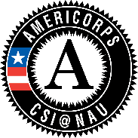
Please share any additional comments, concerns, or information about your partner site’s service assignment here:

2020-2021 Member Service Assignment Description

- Directions: The information provided below is the format to use in writing your position description. You must use this format. These position descriptions will be used to recruit AmeriCorps members for your specific service assignment(s). Please include any details that you think apply. You must complete a position description for every service assignment you propose. If you have more than one service assignment description please copy and paste the information below for all additional service descriptions you wish to include in this application. If the description is the same for all requested members please indicate the number of positions that this description applies to at the bottom. Member duties should extend partner site services and should not duplicate or displace staff.

Short Description of Your Organization and Your Mission:

Position Title:
Position Type (slot):
Please put a letter in the grey box above for the slot type of this position

Slot Type | Service Dates | Approximate hours | Q1 Reduced Cash Match (partner site cost for members requested by end of Q1, placed by end of Q2) | Standard Cash Match (partner site cost for members requested in Q2-Q4)
D) Half Time Short - 900 hrs | 36 weeks | 25-30 hrs/week | $3,800 | $4,500
E) Half Time Long– 900 hrs | 50 weeks | 18-20 hrs/week | $3,800 | $4,500
F) Quarter Time Short- 450 hrs | 14 weeks | 32-35 hrs/week | $2,000 | $2,750
G) Quarter Time Long- 450 hrs | 36 weeks | 12-15 hrs/week | $2,000 | $2,750

Bottom of Form
Reports To (Mentor Name and Title):
Location:
Primary Function / Purpose:
Major Responsibilities and Duties: (Please list as bullet points) Example:

- Conduct one-on-one advising appointments with students and parents
- Assist prospective and current college students with: college planning information, tools, and referrals
- Host student and family FAFSA events
- Prepare and facilitate SAT/ACT workshops

- Conduct one-on-one advising appointments with students and parents
- Assist prospective and current college students with: college planning information, tools, and referrals
- Host student and family FAFSA events
- Prepare and facilitate SAT/ACT workshops

Member Benefits:
- Living Stipend; Educational award/ Loan Forbearance
- Professional Development
- Full Time (1700 & 1200 hour) Members are Eligible for health coverage & day care

Qualifications:
Required: Examples:
- Excellent communication skills (verbal and written);
- Team-Oriented

Preferred: Examples:
- Experience working with students
- Public speaking Experience
- Experience using Microsoft Excel and PowerPoint

Please note that for AmeriCorps positions you want to limit the required qualifications as much as possible to only the most essential skills and abilities that cannot be taught to a member. Applicants for AmeriCorps often come with a diverse range of backgrounds, skills and abilities.

Training / Development Opportunities:
Work Environment: Include information about working conditions and any additional requirements for background screening or requirement to have reliable transportation, etc.

Qualified individuals with disabilities and those from diverse backgrounds are strongly encouraged to apply. We provide reasonable accommodations for qualified individuals upon request.

