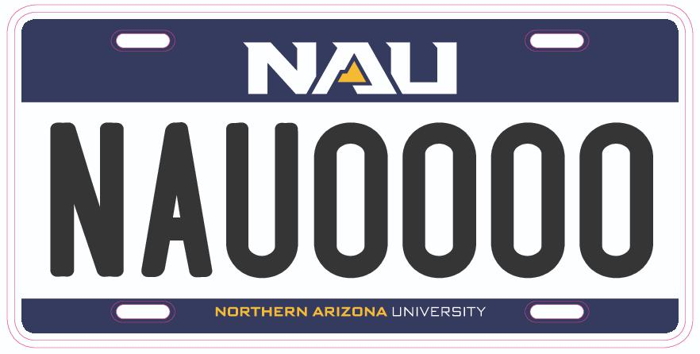
How To: Install a Front Parking Plate
Step 1: Find out what bracket you need for your make and model
- https://www.autozone.com/parts will tell you what type of bracket you need for your vehicle
Step 2: Decide how you want to mount your plate
- Depending on the make and model of your vehicle, you may have options about how to mount your plate
  - Method 1: You may already have a bracket on the front of your car!
  - Method 2: Adhesive Mounting
  - Method 3: Tow Hook Bracket
  - Method 4: Drilling Holes

Method 1: Existing Brackets
Some vehicles already have an existing place on the front for a parking plate
- Locate the screws at the corners of the plate and turn them counter clockwise with a screw driver. If there was already a plate in the bracket, this will cause the plate to come off
- If your vehicle is new, screws may be in the glove compartment
- If you need screws, the following auto part shops in Flagstaff have screws available for sale
- Place the plate into the bracket with the holes in all four corners aligned
- Insert the screws into the bracket (and frame, if applicable). Tighten by turning the screws clockwise with a screw driver
Method 2: Adhesive Mounting
Check with an automotive store to see if your vehicle is able to use an adhesive mount
- Purchase a bracket that fits your make and model (these can be found at the automotive stores listed below)
  - Check your vehicle’s manual for specific instructions
    - Some vehicles may attach to the front face of the bumper, while others may stick to indentations or gaps in the bumper
- Clean the mount of your vehicle with alcohol wipes and wait for it to dry before adhering the bracket
  - If the vehicle is not clean or dry, the bracket may not stay adhered
- Test the fit without removing the protective film
  - Place the bracket onto the mounting site to ensure that it fits your vehicle
  - If the bracket does not line up with your car’s bumper, you may have bought the wrong type of bracket for your make and model
- Remove the protective film and press the bracket onto the bumper
  - Try to be precise when you mount the bracket. Once the bracket is mounted, it is unable to be removed
- Screw the plate onto the bracket using method 1

Method 3: Tow Hook Bracket
Some vehicles have Tow Hooks on the front bumper; these are usually covered by plastic panel
Make sure you have a tow hook anchor before purchasing a two hook parking plate bracket kit (these kits can be found at the automotive stores listed below)
- Locate and remove the plastic panel that covers the tow hook anchor
  - Many models have a plastic plate in front of the bumper that can be popped out by pressing on the panel
- Screw in the tow hook stud
  - Grab the hook stud included in your kit and insert the threaded end into the anchor slot. Turn it clockwise until it is tight
- Align the hole in the bracket plate with the hole in the tow hook stud. Your kit should include a bolt that fits through the holes. Drive the bolt through the holes to attach the bracket to the tow hook stud. Turn the bolt with your fingers, then use a ratchet to finish tightening it
- Align the holes on the parking plate with the holes on the bracket and screw the plate onto the bracket using method 1
Method 4: Drilling Holes
Check if your bumper is fiberglass or metal. Drilling into metal is more complicated than drilling into fiberglass. If your bumper is metal, you will need to take a few more steps and use special tools, such as a center punch, a countersink bit, and safety glasses
- Align the plate, or plate bracket, with the center of your bumper. Using measuring tape to find the center of your bumper, mark the center with tape or a felt-tip pen
- Make guide marks through the holes in the bracket by holding your plate over the bumper’s center point and locating the pre-drilled holes.
- Drill shallow pilot holes into the bumper using a power drill. These holes should only be about 1/8th of an inch deep.
  - If your pumper is chrome, you will need to use a center punch before drilling
- Mount the bracket onto the bumper by lining up the holes using method 1

AutoZone Auto Parts
2138 E Rte 66, Flagstaff, AZ 86004
(928) 774-4406
Wednesday | 7AM–11PM
Thursday | 7AM–11PM
Friday | 7AM–11PM
Saturday | 7AM–11PM
Sunday | 7:30AM–10PM
Monday | 7AM–11PM
Tuesday | 7AM–11PM

O’Reilly Auto Parts
810 West W Rte 66, Flagstaff, AZ 86001
(928) 213-9304
Wednesday | 7:30AM–10PM
Thursday | 7:30AM–10PM
Friday | 7:30AM–10PM
Saturday | 7:30AM–10PM
Sunday | 8AM–9PM
Monday | 7:30AM–10PM
Tuesday | 7:30AM–10PM

NAPA Auto Parts- Grand Canyon Autosupply
1865 E Butler Ave, Flagstaff, AZ 86001
(928) 774-2733
Wednesday | 6AM–8PM
Thursday | 6AM–8PM
Friday | 6AM–8PM
Saturday | 7AM–8PM
Sunday | 8AM–5PM
Monday | 6AM–8PM
Tuesday | 6AM–8PM

Cost Estimates:
The cost of mounting a plate depends on the make and model of the vehicle, as well as whether or not the vehicle already has a bracket
If the car already has a bracket- $5-10
If the vehicle already has a bracket, screws are needed in order to mount the plate
If the car does not already have a bracket- $20-$30
If the vehicle does not already have a bracket, the cost can vary $20-$30 in order to buy a mounting kit
Kits can be found at any of the above auto motive parts or online

