**Sensory Information: The pathways to the brain**

**Background**

Macintosh HD:Users:christinemitchell:Desktop:brain.pdfEverything you experience is made possible by your brain – the memory of a science lesson, the smell of your favorite food, the pain of touching a hot pan. Your brain is the central hub of all activity in your body. It responds to stimuli (which can be any sort of information or sensation you experience) from the world around you by way of sensory receptors. After your brain has received information from a sensory receptor, it processes that information and either sends messages to the rest of your body to initiate an immediate response or stores the information as a memory.

**Activity**

Today you’ll explore some of your brain’s responses to stimuli using your senses of touch and taste.

**Two-Point Touch Distinction**

The two-point threshold is the minimum distance at which two distinct tactile (touch) stimuli feel like two distinct points. In other words, at any separation of the two points smaller than the two-point threshold, you will feel only a single stimulus.

*What do you predict your two-point threshold will be?* _______________mm

Materials

* Mathematical compass
* Ruler
* Data sheet

1. Break up into groups of two – one data recorder and one test subject
2. Test Subject: close your eyes or put on a blindfold (if you watch the test, you will bias the data)
3. Data recorder: Take your compass and place the two points at about 50mm from each other – record the actual distance you use in your data sheet.
4. Lightly place your compass onto your partner’s arm – **make sure that both points touch your partner’s skin at the same time**
5. Ask your partner how many points they feel and record their answer on your data sheet
6. If your partner says they felt two points, move the points of the compass in about 10mm and repeat the process.
7. Continue to move the two points of your compass inward by 5-10mm, recording the results on your data sheet, until your partner tells you they feel one point.
8. After your partner only feels one point, move the points of your compass outward in approximately 1mm increments until your partner says they feel two points. The results of this final test tells you your partner’s two-point threshold.
9. Now determine the two-point threshold of your partner’s leg, thumb, and back of the neck.
10. After you’ve figured out all of your partner’s two-point thresholds, switch and have your partner determine your two-point thresholds.

**Taste**

Sensory receptors in different areas of your tongue respond to the different tastes we sense. This activity will help you map which area of your tongue sense different tastes.

Materials

* Bottles labeled 1-4 (each containing a different taste)
* 24 Toothpicks/Cotton swabs per person
* Tongue map

1. Dip your toothpick or cotton swab into one of the numbered solutions
2. Lightly touch the dampened toothpick/cotton swab to your tongue (in area #1 on the tongue map). If you are able to taste the solution, mark the number of the bottle you tested on area #1 of your tongue map.
3. Repeat these steps using the same bottle for the rest of the areas on your tongue, marking the solution number on each area of your tongue map that you could taste the solution.
4. Drink a bit of water before switching to the next solution
5. Repeat these steps for each of the rest of the numbered solutions, marking your results on the tongue map

**Note**: If you taste the solution in multiple areas on your tongue, denote in which areas you tasted the solutions strongly and which you tasted the solutions weakly.

**Follow-up Writing Assignment**

Gather information about how sensory receptors respond to stimuli by sending messages to the brain for either immediate behavior or storage as memories. Choose a specific topic within this category and write an essay utilizing the information you gathered.

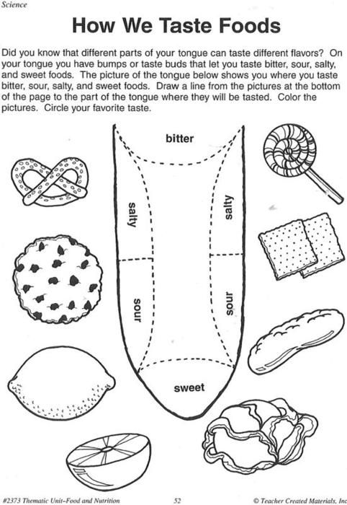

1

2

3

4

5

6