NGSS MS-LS1-1 (Students who can demonstrate an understanding of this concept can develop and use a model to describe why structural changes to genes [mutations] located on chromosomes may affect proteins and may result in harmful, beneficial, or neutral effects to the structure and function of the organism.)

The Genetic Code

Background
You know that every living creature has DNA and that an organism’s genes are what determine its physical characteristics. But did you know that each gene in your DNA holds the instructions for a specific protein which is ultimately how you end up with brown hair or blue eyes? Proteins are complex molecules (made up of many smaller molecules) that play important roles all over our bodies. They are required for the structure and function of all of our cells, tissues, and organs. Below are some examples of important jobs proteins hold in our bodies.
Protein Type | Description
Enzyme | These proteins are responsible for almost all of the chemical reactions in cells. They also help form new molecules by reading the information provided by our DNA.
Messenger | Messenger proteins transmit signals to help facilitate interactions between different cells, tissues, and organs. Hormones are an example of messenger proteins.
Antibody | These proteins bind to bacteria, viruses, and other particles that they don’t recognize to protect our bodies from illness.
Storage and Transport | These proteins carry small molecules within and between cells. They are also responsible for storing atoms and molecules within cells.
Structural | Structural proteins are responsible for creating structure and support for cells and for our bodies as a whole.

Now that you know how important proteins are, you can imagine what would happen if you possessed a mutation in your DNA that caused your body to make the ‘wrong’ protein. Because each protein is made up of a string of smaller molecules (called amino acids), even a change in only one amino acid in the string can change the entire protein. There are twenty different types of amino acids that can make up a protein. The sequence of these amino acids determines the structure and function of each protein.

Color blindness is one example of what happens when there is a mutation or change in someone’s DNA. The gene that gives us the ability to see the full spectrum of color codes for more than 300 amino acids. Someone who is color blind has a mutation in only three of these amino acids. Can you believe that a change this small can change alter the way a person sees color in such a big way?

We mentioned before that our DNA holds the information for making every protein in our bodies, but more specifically, our DNA codes for the amino acids that make up each protein in our bodies.

The diagram below shows how your DNA is the instruction manual for making amino acids and proteins.

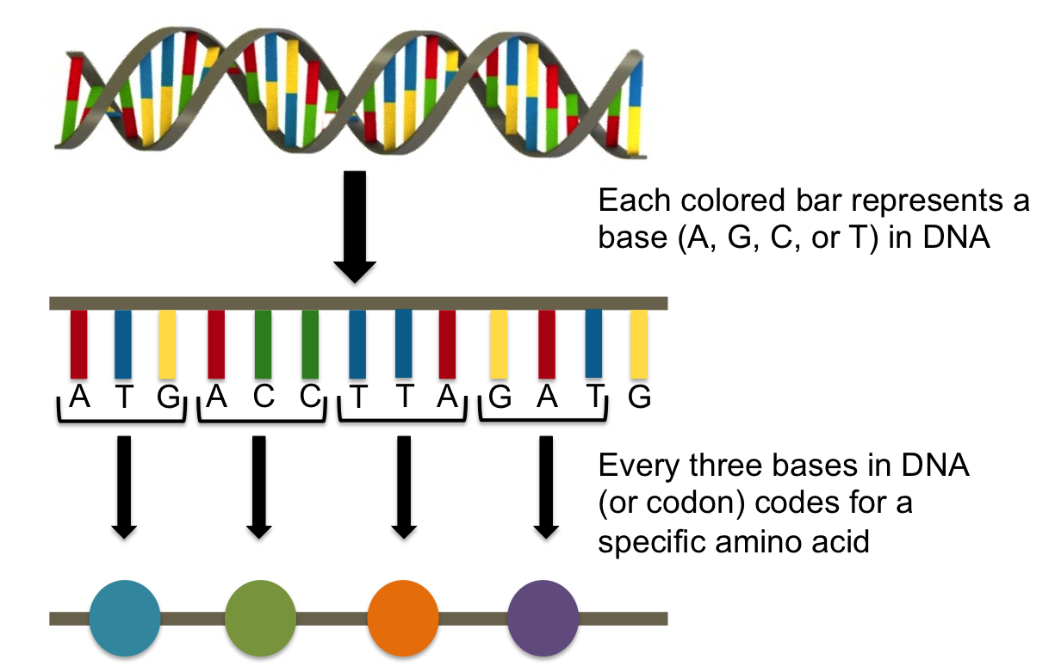

In today’s activity you will be modeling how different DNA strands code for different proteins and how changing one base in the strand of DNA can change the entire protein.

Activity
Today you will take on the role of a geneticist examining a few patients with potential genetic anomalies. You will look at sequences of the patients’ DNA compare them to strands of typical DNA and determine if there has been a mutation that has caused the protein sequence to change enough to cause a health concern.

First, you need to learn how to use the Genetic Code (shown below). This tool helps us determine which amino acid should be placed in the patient’s protein chain based on the sequence of their DNA.
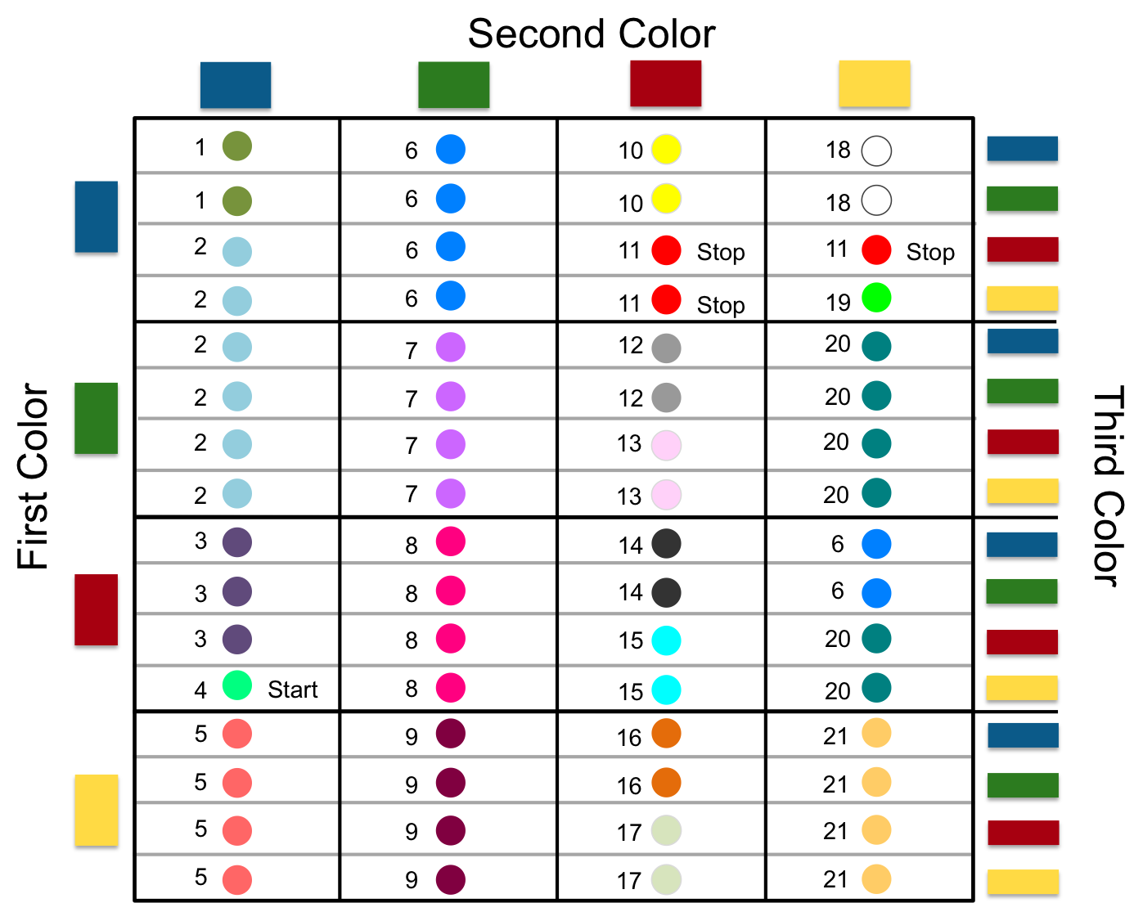

DNA can be broken down into smaller units called genes. Genes code for specific proteins in our bodies. Each gene is composed of several codons (see diagram on page 2). Codons are three consecutive bases in a DNA sequence. In the case of our activity, a codon is three consecutive colors in a DNA sequence.

When reading DNA for protein synthesis, you must always find the Start Codon - in our case this is the codon RED, BLUE, YELLOW. This codon tells you that you have found the beginning of a specific gene. You must then ‘decode’ all of the following codons (determining which amino acid to produce) until you reach a Stop Codon (either BLUE, RED, RED; BLUE, RED, YELLOW; or BLUE, YELLOW, RED) at the end of the gene.

By looking at this chart, you can see that many of the amino acids could be produced by a few different codons. This feature of the Genetic Code is called redundancy. Redundancy is often what protects us from exhibiting genetic abnormalities. For instance, there are several different ways your genes can code for any given amino acid, if one letter in your DNA changes, you wont necessarily produce a different amino acid.

Let’s look at an example of how to use the Genetic Code.

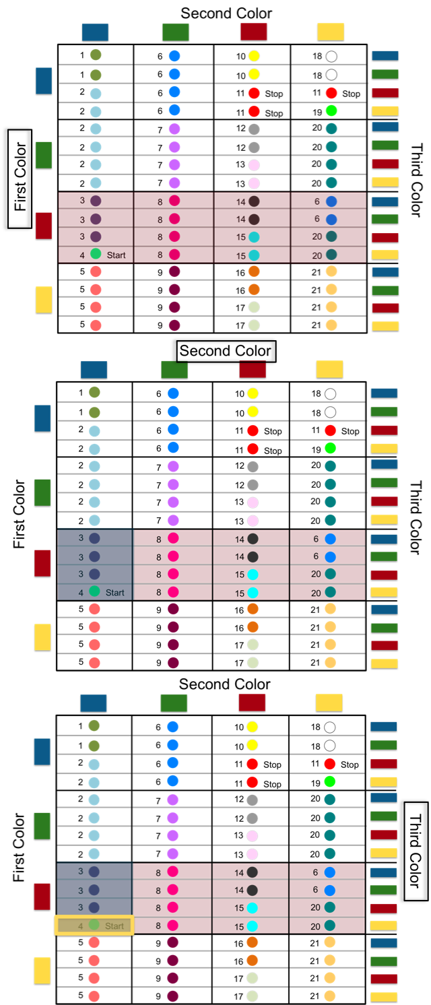
Sample DNA Sequence:

Step 1. Start with your DNA sequence. Remember to always look for your Start Codon (RED, BLUE, YELLOW) first. In this example, the start codon happens to be the first codon in the sequence.

Step 2. Refer to your Genetic Code chart to begin decoding your DNA sequence. First, determine the first color in the codon (in this case, RED) and find that color on the side of the chart that says “First Color”

Step 3. Determine the second color in your codon (in this case, BLUE) and find that color on the top of the chart where it says “Second Color.”

Step 4. Determine the third color in your codon (in this case, YELLOW) and find that color on the side of the chart that says “Third Color.”
Once you have found the box where the three colors intersect you know which amino acid to add to your protein chain. In this case, our codon led us to the amino acid #4.

Step 5. Continue to decode the DNA sequence until you hit a Stop Codon (either BLUE, RED, RED; BLUE, RED, YELLOW; or BLUE, YELLOW, RED)
- Your patient comes to you describing feelings of extreme silliness, excessive laughing, and intense happiness - all common signs of an enlarged funny bone, or humoritis. Your job is to determine if your patient suffers from humoritis.

The DNA sequence for the humoritis gene in a person who does not have humoritis is:

Your patient’s DNA sequence for the humoritis gene is:

Do you notice any mutations? If so, do you hypothesize that the mutation will be enough to change the protein produced by your patient’s humoritis gene?

Use the Genetic Code (on page 3) to determine the amino acid chain produced by both the unaffected person’s gene and your patient’s gene. Remember to begin at the Start Codon and end at the Stop Codon. Keep in mind that any change in the amino acid chain for the humoritis gene is enough to diagnose your patient with humoritis.

Unaffected Patient’s gene:

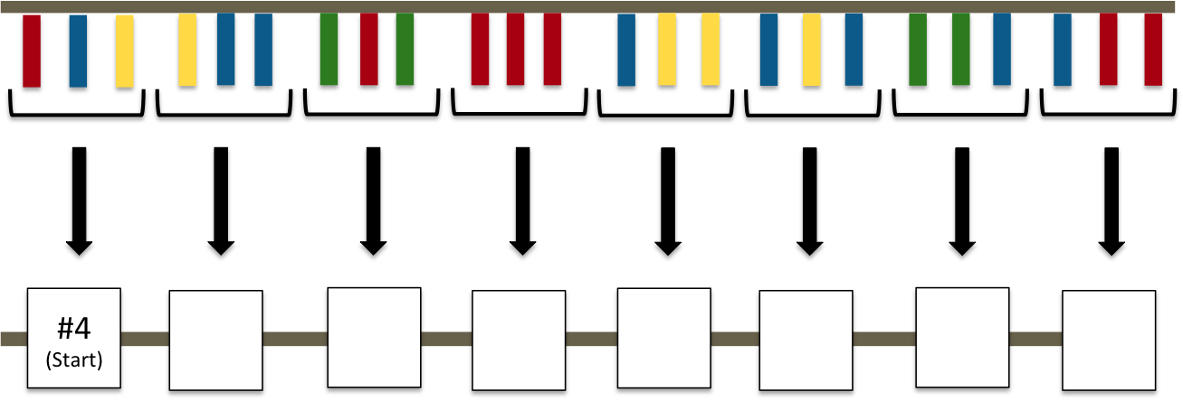

Your Patient’s gene:

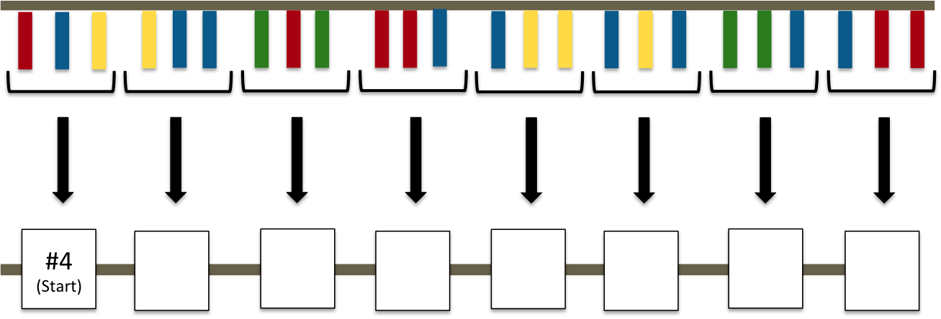

Did the mutation change your patient’s amino acid chain?

What is your diagnosis (i.e. is your patient unaffected, or do they have humoritis)?

- Your second patient tells you they are concerned that they may have Werewolf Syndrome. Your patient informs you that her mother has Werewolf Syndrome, and your patient knows that this condition can be passed down from one generation to the next. Your patient wants to know if Werewolf Syndrome will also affect them.

Again, use the Genetic Code to determine the amino acid chain produced by both the unaffected person’s gene and your patient’s gene. Remember to begin at the Start Codon and end at the Stop Codon. Keep in mind that any change in the amino acid chain for the Werewolf gene is enough to diagnose your patient with Werewolf Syndrome.

Unaffected Patient’s gene:

Your Patient’s gene:

Do you notice any mutations? If so, do you hypothesize that the mutation will be enough to change the protein produced by your patient’s Werewolf gene?

Fill in the amino acid chain for the unaffected patient (Note: you may not fill in every square – just stop whenever you reach a Stop Codon and leave the rest blank).

Fill in the amino acid chain for the your patient (Note: you may not fill in every square – just stop whenever you reach a Stop Codon and leave the rest blank).

Did the mutation change your patient’s amino acid chain?

What is your diagnosis (i.e. is your patient unaffected, or do they have Werewolf Syndrome)?

- Your last patient has previously been diagnosed with Green Thumb, commonly observed as an uncanny ability to garden. He isn’t convinced he has Green Thumb and wants you to give him a second opinion.

Use the Genetic Code to determine the amino acid chain produced by both a person with confirmed Green Thumb and your patient’s gene. Remember to begin at the Start Codon and end at the Stop Codon. Keep in mind that to diagnose your patient with Green Thumb, their amino acid chain has to match that of the affected patient.

Affected Patient’s gene:

Your Patient’s gene:

Do you notice any differences between the gene of the patient with Green Thumb and your patient’s gene? Based on what you see, do you think your patient actually has Green Thumb like they have previously been told?

Fill in the amino acid chain for the affected patient (Note: you may not fill in every square – just stop whenever you reach a Stop Codon and leave the rest blank).

Fill in the amino acid chain for the your patient (Note: you may not fill in every square – just stop whenever you reach a Stop Codon and leave the rest blank).

Is your patient’s amino acid chain different than the amino acid chain of the patient with Green Thumb?

What is your diagnosis (i.e. is your patient unaffected, or do they have Green Thumb)?

Follow up Activity

1. Knowing what you do about redundancy in the Genetic Code, give a brief explanation of why it is so important, and why redundancy is the reason genetic diseases are so rare.

2. Create some DNA sequences of your own - First, generate a reference sequence (like the one we used in #3 of the activity) and determine the amino acid chain produced by your gene. Then make a DNA sequence (with mutations) that would produce the same amino acid chain as your reference sequence. Lastly, generate a DNA sequence that would produce an amino acid chain different from the reference sequence using only one or two mutations.

3. Use your imagination - Name the genetic condition that would be exhibited by patients who produced the amino acid chain you created in #2 and give a brief description of the condition. Is it harmful, beneficial, or neutral to an affected patient?

