NGSS MS-LS4-3 (Students who can demonstrate an understanding of this concept can analyze displays of pictorial data to compare patterns of similarities in the embryological development across multiple species to identify relationships not evident in the fully formed anatomy)

Embryos and Evolution

Background
Biological evolution can be defined as the gradual genetic change in a population of organisms over time. The process of evolution is generally thought of as a long process by which an organism of a simpler form develops into one of a more complex form over thousands upon thousands of years. Evolution can also happen on a much quicker (although smaller) scale. For instance, populations of plants can evolve to better thrive in their changing environments in a matter of a few generations. Today we’ll be focusing on the long-term evolution whereby many different species descended from one common ancestor.

If all species alive on earth today descended from a common ancestor, why do we all look so different? We all evolved to meet the specific needs of our environments, which eventually led to the development of numerous different species. Even though various species end up looking so vastly different, during embryological development we all look strikingly similar due to our common evolutionary roots.

Activity
We’ll be examining the embryos of several different vertebrate species at a few points during development to show evidence that all species descended from a common ancestor. At each stage you will write which animal you think the embryo will develop into. Your choices are: Fish, Salamander, Tortoise, Chicken, Rabbit, Pig, Cow, and Human. Keep in mind: the order in which the embryo pictures are placed in each stage does not change, but you are allowed to change your guesses at each stage if you have changed your mind.

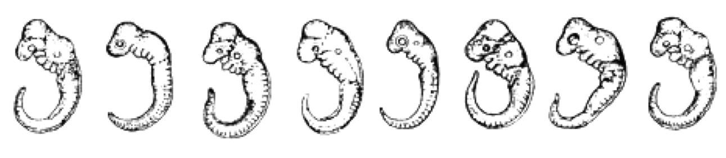
Early Stage Development
_______ _______ _______ _______ _______ _______ _______ _______

Intermediate Stage Development

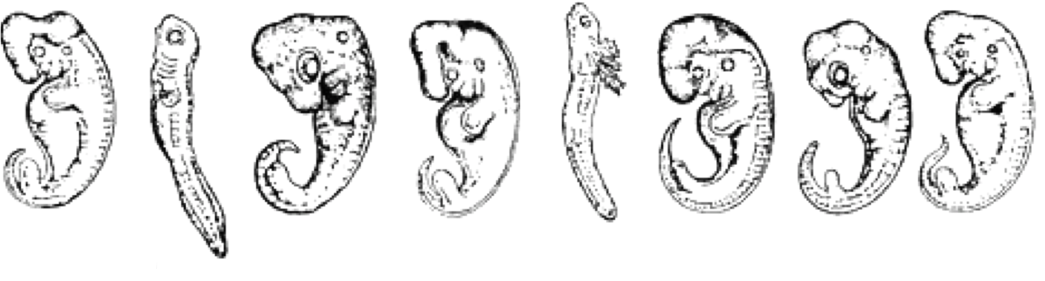
_______ _______ _______ _______ _______ _______ _______ _______

Late Stage Development

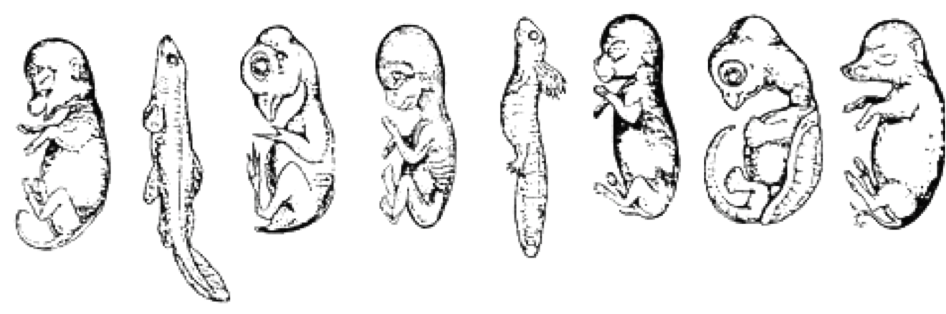
_______ _______ _______ _______ _______ _______ _______ _______

Do you notice any patterns in the appearance of the embryos at each stage? Are they more similar to each other than you thought they would be?

Are your guesses the same for the early stage development as they are for the late stage development? If not, when did you change your mind and why?

Do you feel confident that your guesses for each animal in late stage development are correct?
Below are pictures of what each embryo develops into as an adult. These pictures are in the exact same order as the pictures of the embryos above.

Adulthood
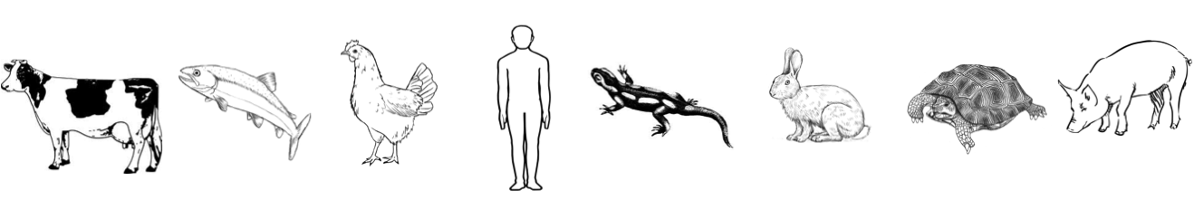

How many of your guesses were correct?

Describe how what you learned from this activity supports the theory that all animals descended from a common ancestor.

