**The Building Blocks of Life: An Investigation of Cells**

**Background**

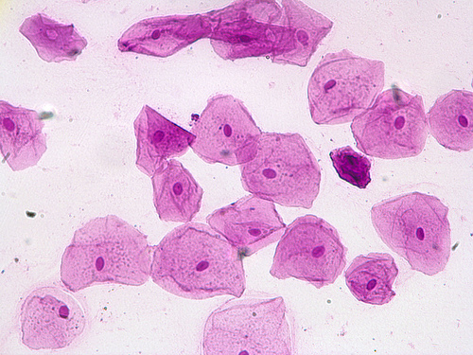Cells are the basic building blocks of all living organisms. In fact, some organisms are only made up of one single cell; so one cell can contain everything an organism needs to live its entire life! Humans, on the other hand, are made of trillions of cells, many with different functions within the body. For instance, we have cells that make up our skin and a completely different set of cells that work as our immune system, fighting off infections (which are - in some cases - single-celled bacteria). We also have a network of nerve cells that make up our nervous systems, allowing us to think and feel. But we mammals aren’t the only organisms made up of many types of distinct cells! Plants have different cells for keeping their structure than they do for transporting water. Today we’ll be looking at cells from many different organisms to gain a better understanding of the individual units of life that make all organisms who they are.

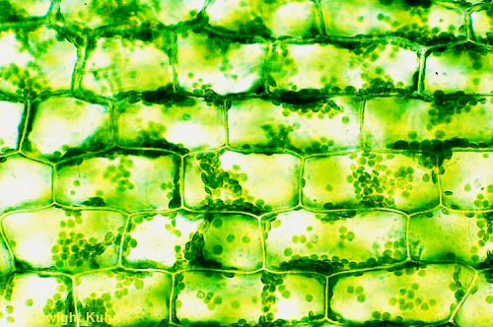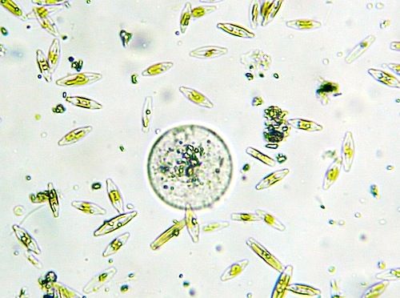These pictures show different types of cells as they would appear under a microscope. (**A**) depicts several single-celled organisms living in pond water, (**B**) shows living plant cells (with chloroplasts), and (**C**) is an image of stained human cheek cells.

**C**

**B**

**A**

**Supplies**

* Compound microscope
* Microscope slides x 4 per group
* Cover slips x 4 per group
* Distilled water
* Pond water sample
* Elodea leaves
* Sterile toothpicks
* Food coloring (or other stain)
* Carrot cross-sections

**Investigation**

Because cells are so small, we will be conducting this investigation using a microscope. This will allow us to get an up-close and personal look at many different types of cells.

**Pond Water**

*What kinds of organisms do you expect to see in this sample - single-cellular organisms, multicellular organisms, or both? Give a few examples of what you expect to find.*

To look at the cells lurking in the pond water, we must first learn how to properly make a slide. The type of slide mounting that we will be using today is called wet mounting. A wet mount consists of taking a small amount of your sample and putting it in a drop of water on the microscope slide, like in the diagram below.

Macintosh HD:Users:christinemitchell:Desktop:Wet Mount.pdf

**Step 1:** Ensure your slide is clean

**Step 2:** Place ONE drop of your distilled water

onto the microscope slide and lightly tap or swish

your toothpick/swab (containing your sample)

into the drop of water.

**Step 3:** Take the coverslip (BE CAREFUL, THIS IS

GLASS!) and gently drop it onto the slide at an

angle. Placing the cover slip on at an angle allows

the sample to be evenly dispersed underneath the

coverslip, it also largely eliminates air bubbles.

Because our pond water sample is a liquid sample, there is no need to add additional water, so we can prepare a wet mount following the steps in the following diagram.

Macintosh HD:Users:christinemitchell:Desktop:Wet Mount Liquid Sample.pdf **The only step that differs is** **Step 2**.

Instead of adding distilled water, you simply

add ONE drop of your sample of pond water

and cover it with a cover slip.

Once you have made a wet mount of your pond water sample, place the slide under the microscope and scan around the slide until you are able to see some organisms.

***Draw*** *what you see in the space provided below. Be sure to note the level of magnification you are using to view your sample*.

*Is anything moving? Is there anything that resembles a cell? What kind of organisms do you think you’re looking at* (hint: *bacteria, algae, etc.)?*

Magnification: ___________

**Plant Cells**

To view the plant cells, you will need to cut off one leaf of Elodea and place it on a slide. Then add one drop of water over the leaf and place the coverslip on top.

***Draw*** *what you see in the space provided below.* ***Label*** *the nucleus, cytoplasm, and cell wall. Be sure to note the level of magnification you are using to view your sample*.

*Is anything moving? Can you see chloroplasts?*

Magnification: ___________

Now we’ll look at some specialized cells in a carrot. The cells we will be focusing on in this exercise are called chromoplasts. Chromoplasts are cells that accumulate and store pigments. So the only reason a carrot appears orange is because it has chromoplasts that store an abundance of carotene, a yellow-orange pigment. Chloroplasts also store pigments (e.g. chlorophyll), but the pigments found in chloroplasts are different in color and function than those found in chromoplasts.

In order to view the chromoplasts in your carrot you will need to slice the carrot into very thin cross-sections. Your teacher will do this by slicing the carrot (with a razor blade) into sections so thin you can partially see through them with your naked eye. You will then take one of these cross-sections and place them onto a microscope slide with a drop of water and cover with a coverslip.

***Draw*** *what you see in the space provided below. Be sure to note the level of magnification you are using to view your sample*.

Magnification: ___________

*Do you see chromoplasts (cells containing the orange pigments)? Do you think these pigments have a purpose in the plant? If so, what purpose do you think they serve?*

**Human Cells**

The human cells you will be looking at today are your own! To collect a sample, use the long, flat side of a sterile toothpick to scrape the inside of your cheek. You should scrape for at least three seconds to ensure that you will be able to see your cells. You will need to make a wet mount (refer to the diagram on page 2) before you view your cells under the microscope. You will also need to stain you cheek cells - this can be done with food coloring or a chemical stain that your teacher will provide. Just follow the instructions in the diagram below!

Macintosh HD:Users:christinemitchell:Desktop:Staining.pdf**Step 1:** Place ONE drop of food coloring at one edge of the coverslip

**Step 2:** Hold a paper towel against the opposite edge of the coverslip (This will ‘pull’ the stain from one edge of the coverslip to the other)

Place your slide with stained cheek cells under the microscope and note what you see.

***Draw*** *what you see in the space provided below.* ***Label*** *the nucleus, cytoplasm, and cell membrane. Be sure to note the level of magnification you are using to view your sample*.

*Do these cells look any different from the cells you previously examined?*

Magnification: ___________