**NGSS MS-LS1-1** (Students who can demonstrate an understanding of this concept can conduct an investigation to provide evidence that living things are made of cells; either one cell or many different numbers and types of cells)

**The Building Blocks of Life: An Investigation of Cells**

Because this activity is heavily focused on microscopy, it is generally helpful to either use a microscope connected to a monitor or place pictures of what the students will likely be seeing on a projector so there is less confusion when students are discerning the contents of their slides.

**Background**

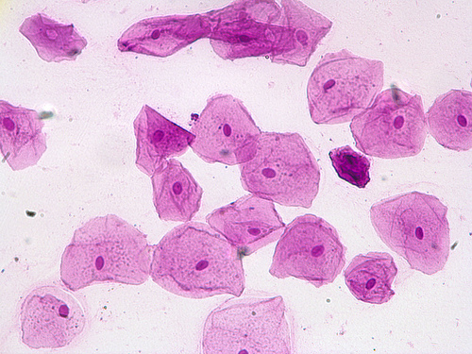Cells are the basic building blocks of all living organisms. In fact, some organisms are only made up of one single cell; so one cell can contain everything an organism needs to live its entire life! Humans, on the other hand, are made of trillions of cells, many with different functions within the body. For instance, we have cells that make up our skin and a completely different set of cells that work as our immune system, fighting off infections (which are - in some cases - single-celled bacteria). We also have a network of nerve cells that make up our nervous systems, allowing us to think and feel. But we mammals aren’t the only organisms made up of many types of distinct cells! Plants have different cells for keeping their structure than they do for transporting water. Today we’ll be looking at cells from many different organisms to gain a better understanding of the individual units of life that make all organisms who they are.

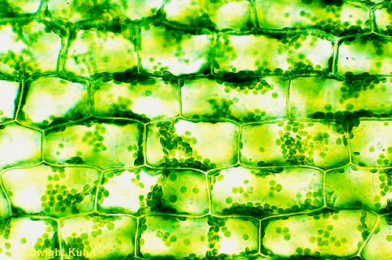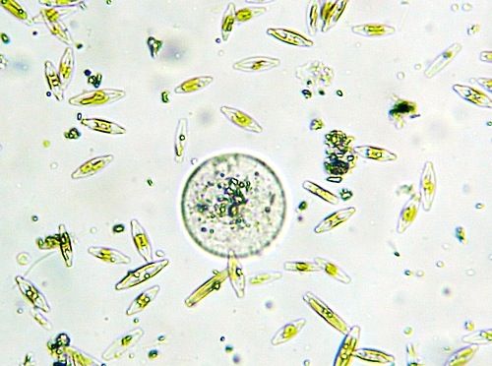These pictures show different types of cells as they would appear under a microscope. (**A**) depicts several single-celled organisms living in pond water, (**B**) shows living plant cells (with chloroplasts), and (**C**) is an image of stained human cheek cells.

**C**

**B**

**A**

Before you start the lesson and activity, get the students thinking about ways they can investigate cells. How would they be able to tell if something is made of individual cells? How can they look at or understand something so small? What would be the best way to look at cells? What types of things would they look at in search of cells?

What types of organisms are single-cellular? Multicellular?

**Supplies**

* Compound microscope
* Microscope slides x 3 or 4 per group
* Cover slips x 3 or 4 per group
* Distilled water
* Pond water sample
* Elodea leaves
* Sterile toothpicks
* Food coloring (or other stain)
* Carrot cross-sections

**Investigation**

Because cells are so small, we will be conducting this investigation using a microscope. You may choose to have students look at the supplementary handout on microscopes located on the website. This will allow us to get an up-close and personal look at many different types of cells.

**Pond Water**

Alternatively, this portion of the investigation can be performed with any number of samples – the main goal we’re trying to achieve here is observing single-celled organisms. Some suggestions for sample sources include: samples from puddles around school or in a student’s backyard (the key is sampling from water that is fairly stagnant and has been there for a while). Additionally, this observation could be done using wet-mounted swabs of drinking fountains or desktops. This may be a good opportunity to get the students involved in the sampling process, teaching them how to use proper collection techniques.

*What kinds of organisms do you expect to see in this sample - single-cellular organisms, multicellular organisms, or both? Give a few examples of what you expect to find.*

To look at the cells lurking in the pond water, we must first learn how to properly make a slide. The type of slide mounting that we will be using today is called wet mounting. A wet mount consists of taking a small amount of your sample and putting it in a drop of water on the microscope slide, like in the diagram below.

Macintosh HD:Users:christinemitchell:Desktop:Wet Mount.pdf

**Step 1:** Ensure your slide is clean

**Step 2:** Place ONE drop of your distilled water

onto the microscope slide and lightly tap or swish

your toothpick/swab (containing your sample)

into the drop of water.

**Step 3:** Take the coverslip (BE CAREFUL, THIS IS

GLASS!) and gently drop it onto the slide at an

angle. Placing the cover slip on at an angle allows

the sample to be evenly dispersed underneath the

coverslip, it also largely eliminates air bubbles.

Because our pond water sample is a liquid sample, there is no need to add additional water, so we can prepare a wet mount following the steps in the following diagram.

Macintosh HD:Users:christinemitchell:Desktop:Wet Mount Liquid Sample.pdf **The only step that differs is** **Step 2**.

Instead of adding distilled water, you simply

add ONE drop of your sample of pond water

and cover it with a cover slip.

Once you have made a wet mount of your pond water sample, place the slide under the microscope and scan around the slide until you are able to see some organisms.

***Draw*** *what you see in the space provided below. Be sure to note the level of magnification you are using to view your sample*.

*Is anything moving? Is there anything that resembles a cell? What kind of organisms do you think you’re looking at* (hint: *bacteria, algae, etc.)?*

Magnification: ___________

**Plant Cells**

To view the plant cells, you will need to cut off one leaf of Elodea and place it on a slide. Then add one drop of water over the leaf and place the coverslip on top. Elodea can be purchased at most pet retailers; it is an aquatic plant frequently used in fish tanks. This is a great plant to use because it’s leaves are only about two cells thick, this allows students to get a great view of the plant cells without much prep work. If you have extra time, it is also fun to look at carrot cells, specifically the chromoplast pigment cells. (This optional portion of the exercise is included below and in the second version of the student handout, but it does require some extra prep work).

***Draw*** *what you see in the space provided below.* ***Label*** *the nucleus, cytoplasm, and cell wall. Be sure to note the level of magnification you are using to view your sample*.

*Is anything moving? Can you see chloroplasts?*

Magnification: ___________

Now we’ll look at some specialized cells in a carrot. The cells we will be focusing on in this exercise are called chromoplasts. Chromoplasts are cells that accumulate and store pigments. So the only reason a carrot appears orange is because it has chromoplasts that store an abundance of carotene, a yellow-orange pigment. Chloroplasts also store pigments (e.g. chlorophyll), but the pigments found in chloroplasts are different in color and function than those found in chromoplasts.

In order to view the chromoplasts in your carrot you will need to slice the carrot into very thin cross-sections. Your teacher will do this by slicing the carrot (with a razor blade) into sections so thin you can partially see through them with your naked eye. You will then take one of these cross-sections and place them onto a microscope slide with a drop of water and cover with a coverslip.

***Draw*** *what you see in the space provided below. Be sure to note the level of magnification you are using to view your sample*.

*Do you see chromoplasts (cells containing the orange pigments)? Do you think these pigments have a purpose in the plant? If so, what purpose do you think they serve?*

Magnification: ___________

**Human Cells**

The human cells you will be looking at today are your own! To collect a sample, use the long, flat side of a sterile toothpick to scrape the inside of your cheek. You should scrape for at least three seconds to ensure that you will be able to see your cells. You will need to make a wet mount (refer to the diagram on page 2) before you view your cells under the microscope. You will also need to stain you cheek cells - this can be done with food coloring or a chemical stain that your teacher will provide. Just follow the instructions in the diagram below!

Macintosh HD:Users:christinemitchell:Desktop:Staining.pdf**Step 1:** Place ONE drop of food coloring at one edge of the coverslip

**Step 2:** Hold a paper towel against the opposite edge of the coverslip (This will ‘pull’ the stain from one edge of the coverslip to the other)

Place your slide with stained cheek cells under the microscope and note what you see.

***Draw*** *what you see in the space provided below.* ***Label*** *the nucleus, cytoplasm, and cell membrane. Be sure to note the level of magnification you are using to view your sample*.

*Do these cells look any different from the cells you previously examined?*

Magnification: ___________

**Follow-up Activity**

This is a great opportunity to have your students work on their scientific writing skills. It is important to emphasize to your students that writing is one of the most important parts of being a scientist (e.g communicating your results to the larger scientific community).

One suggestion is to have your students each pick a topic under the larger umbrella of cells (e.g. stem cells, cell aging and how it affects our aging process, etc.) and have them write a research paper detailing some of the more recent findings in their chosen subject. Use whichever guidelines you deem appropriate for your students.

In order to ensure that the students get the most out of this writing assignment, it is beneficial to require them to turn in multiple copies, to which you make detailed remarks. A portion of their grade should rely on their corrections based on your comments.