More than just the sum of its parts: An investigation into cell structure and function

Background
Cells are the tiny workhorses that hold all of the biological machinery necessary for life. There are numerous types of cells, each of which perform very different functions. Have you ever thought about what is inside of a cell? Or what cells really do? Today we’ll be taking a much closer look at these questions while learning about the structure and function of cells.

There are two main groups of cells – prokaryotic cells and eukaryotic cells. Let’s take a look at these two cell groups.

Characteristic | Prokaryotes | Eukaryotes
Example of Cell | 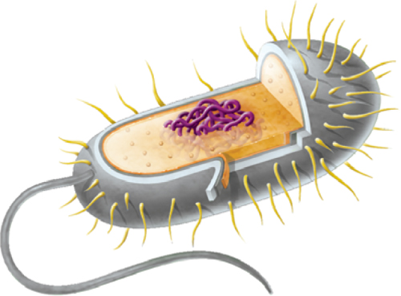 | 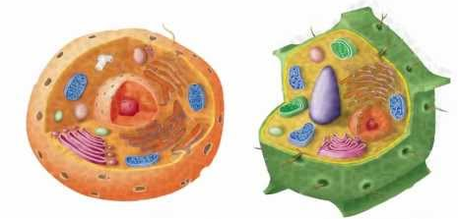
Organisms | Bacteria | Protists, Fungi, Plants, Animals
Nucleus | No membrane bound nucleus | Membrane bound nucleus
Cell Wall | Made of peptidoglycan | If present, made of cellulose or chitin
Organelles | No membrane bound organelles | Membrane bound organelles
DNA | Single circular chromosome | Multiple linear chromosomes
Number of Cells | Always unicellular | Can be unicellular or multicellular

Think of the human body for a moment. We have one body with many organs inside, each performing a different function. Eukaryotic cells have a similar structure; each cell has many organelles inside that all perform unique tasks. Let’s take a moment to learn about these organelles.

Activity
Take some time to familiarize yourself with the organelles of eukaryotic cells. Today you will be creating a diagram of a cell that will help you remember the organelles and their functions.

Make a diagram of a plant or animal cell and be sure to include all of the appropriate organelles. Next to each organelle add a picture that symbolizes the function of that organelle (e.g. next to the nucleus you may choose to draw a brain because the nucleus is the control center of a cell).

Organelle | Example | Function
Cell Membrane | 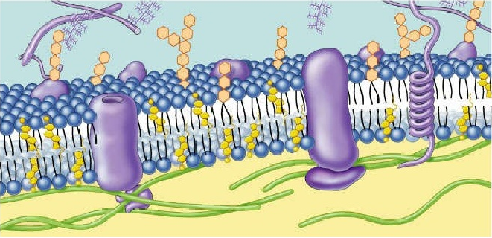 | Controls what comes into and out of a cell; found in plant and animal cells
Cell Wall |  | Ridged outer layer of a plant cell
Cytoplasm | 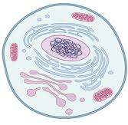 | Gel-like fluid where the organelles are found
Mitochondria |  | Produces the energy a cell needs to carry out its functions
Lysosome |  | Uses chemicals to break down food and worn out cell parts
Vacuole |  | Stores food, water, wastes, and other materials
Golgi complex |  | Receives proteins & materials from the ER, packages them, & distributes them
Chloroplast |  | Captures energy from the sunlight and uses it to produce food in a plant cells
Endoplasmic Reticulum (ER) |  | Has passageways that carry proteins and other materials from one part of the cell to another
Ribosome |  | Assembles amino acids to create proteins
Nucleus |  | Contains DNA, which controls the functions of the cell and production of proteins
Nucleolus |  | Found inside the nucleus and produces ribosomes

