How to use a Microscope

The type of microscope you will most likely be using is a compound light microscope. This type of microscope uses multiple lenses, one near the object and one (or a few) in the eyepiece, to magnify the object you are observing.

Microscopes are incredibly helpful tools for scientists, but there are a few things you should know about microscopes before you begin using them.

Parts of a Microscope
The image below shows the parts of a microscope you should be familiar with.

Eyepiece: the part of the microscope you look through to observe your specimen (10x magnification)
Objectives: the lower lenses with different magnification levels (example: 4x, 10x, 40x)
Stage: where your slide is placed on the microscope
Focus knobs: The larger coarse focus knob allows you to quickly raise or lower the stage to bring the slide into view. The smaller fine focus knob allows you to bring your slide into clearer focus.
Light source: this allows your slide to be viewed in the eyepiece. The light is bent or refracted by the lenses to magnify the object you are viewing. The level of light intensity can be adjusted using the illumination intensity wheel on the base of the microscope.
Frame: the ‘backbone’ of the microscope
Base: This is the sturdiest portion of the microscope. For this reason a microscope should always be carried with one hand under the base and one hand around the frame.

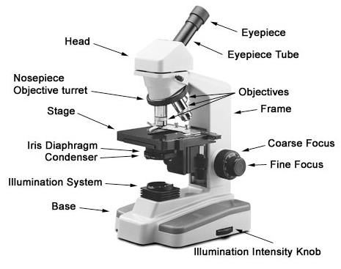
Magnification
Your microscope will generally have three or four magnification levels (objectives). In addition to the objective magnification, the ocular lens in the eyepiece has a magnification level of 10x. To get the total magnification level you must multiply the magnification of the ocular lens by the magnification of the objective lens. So, if you are viewing your slide under the 40x objective lens you would multiply that by the 10x of the ocular lens for a total magnification of 400x.

Objective Lens | Ocular Lens | Total Magnification
4x | 10x | 40x
10x | 10x | 100x
40x | 10x | 400x

General Procedures
- Carry your microscope by the base and frame to your desk.
- Plug in your microscope and turn on the light.
- Place your slide on the stage and using the lowest power objective lens, slowly turn the coarse focus knob until you start to see the specimen on the slide come into focus (at this step, what you see will still be blurry, the goal is just to bring your specimen into better view before really focusing in on it). You may need to move the slide around in order to begin to see your specimen.
- Now use the fine focus knob to bring your specimen into perfect focus. If you are sharing your microscope with other students, each student will use the fine focus knob to focus the specimen best for their eyes.
- Once you have your slide in focus on the lowest magnification level, you can switch to the next highest objective lens. You may need to re-focus slightly with the fine focus knob.
- Repeat this focusing process until you have reached the objective lens you want to use to inspect your specimen.
- If the image of your slide seems too dark or bright to see anything, try adjusting the light intensity.
- When you are done with your microscope be sure to lower the stage as far as it will go and switch back to the lowest objective. Unplug your microscope and carry it properly back to storage.

Name: ______________________________________________

Fill in the blanks on this diagram and hand this page to your teacher before checking out your microscope for today’s activity.

