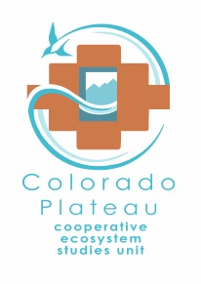
Award Number: P14AC01067
Project Number: UNM-106
CFDA #: 15.945
Park/NPS Unit: Bandelier National Monument
Title of Project: University of New Mexico Archeological Site Investigations, 2014-2017

Administered through the: Colorado Plateau Cooperative Ecosystem Studies Unit Cooperative Agreement Number P14AC00921

CESU Partner: REGENTS OF THE UNIVERSITY OF NEW MEXICO

PROJECT CONTACTS:
Principal Investigator: Robert Dello-Russo, PhD, Director, UNM Office of Contract Archeology, 1 University of New Mexico, Albuquerque, NM 871310-0001 (505) 277-2870, (505) 277-6726, rdellorusso@unm.edu
Partner Administrative Contact: Timothy Wester, Contract and Grant Administrator, Office of Sponsored Projects, 1700 Lomas Blvd NE, Suite 2200, MSC01 1247, Albuquerque, NM 87131-0001 (505) 277-0591, twester@unm.edu
NPS Certified ATR: Brian Jacobs, Park Botanist, Bandelier National Monument, 15 Entrance Road, Los Alamos, NM 87544, (505) 672-3861 x707, (505) 672-9607, brian_jacobs@nps.gov
NPS Technical Expert: Barbara Judy, Chief of Resources, Bandelier National Monument, 15 Entrance Road, Los Alamos, NM 87544, (505) 672-3861 x701, (505) 672-9607, Barbara_judy@nps.gov

FUNDING INFORMATION:
Amount Funded: $73,170
NPS Account Numbers (amounts in parentheses): PF.FBF5PS014.00.1 ($26,150) and PH.P0197771A.00.1 ($33,000) and Fund Center/Cost Center:PPIMBANDR1/Functional Area:PPMRSCR1Z.CA0000 ($14,020)
Fund Source (e.g., ONPS, FLREA, CRPP, CESU, etc.): Burned Area Rehabilitation (BAR), Cyclic Maintenance and ONPS Base

NPS Funding

Is this funded using a reimbursable account number? If yes, IMR contracting needs a copy of the Interagency Agreement.

PROJECT DATES:
Start Date: September 1, 2014

NOTE: This Task Agreement will become effective on the date of final signature or the effective date of the Award document, whichever is later.

End Date: June 30, 2017

NPS Administrative Contacts
Interim CESU Coordinator (May 18 – September 13, 2014): Todd Chaudhry, National Park Service/CPCESU, NAU P.O. Box 5765, Flagstaff, AZ 86011, 928-523-6638, Fax: 928-523-2014; todd_chaudhry@nps.gov

Intermountain Region Administrative Contact: Kelly Adams, Grants and Agreements Specialist, National Park Service, 12795 West Alameda Pkwy, Lakewood, CO 80228. Phone: 303-969-2303 Fax: 303-969-2992 Email: Kelly_adams@nps.gov

UNM/OCA Administrative Contact
Timothy Wester, Contract and Grant Administrator, Office of Sponsored Projects, 1700 Lomas Blvd NE, Suite 2200, MSC01 1247, Albuquerque, NM 87131-0001 (505) 277-0591, twester@unm.edu

FEDERAL FINANCIAL REPORTS:
Federal Financial Reports (Check as required for project based on spending plan, period of performance, risk, cooperator history, etc.)

{ } Quarterly { } Semi-annually {X} Annually

Final (required)

Project SCHEDULE AND TECHNICAL REPORT DEADLINES:

List all technical reports and products in sequential order as required in the scope (more lines and milestones can be added as needed):

Technical progress reports – { } Quarterly { } Semi-annually {X} Annually
(Check as needed from PI to monitor progress of specific project. Content should be addressed in the scope.)

Work by Others that Effects the Agreement Schedule | Date
Provision of archaeological site data including GIS data (by BAND Resource Management Division) | Nov 2014
Spike Camp aviation support (by BAND Resource Management Division) | June 2015 and June 2016
Spike Camp Equipment support (by BAND Resource Management Division) | June 2015 and June 2016
Agreement Deliverables | Date
Site Visit and Orientation to Bandelier National Monument archaeological resources | Sept 2014 – June 2015
FY14 Investigator’s Annual Report: The accomplishment report shall be an abstract not to exceed 300 words in length. | Due, on or before, October 30^{th,} 2014
Research/Survey Plan – one electronic version to be provided to the ATR. Plan to detail research topics, field methods, documentation strategy, analysis and approach. | Dec 2014-Jan 2015
Park Orientation to Park operations and safety | Mar-Apr 2015
Sample Field Survey Results | Apr 2015
FY15 Mobilization and field work at either or all of Locations 1, 2 and 3 | May 2015-Oct 2015
FY15 Investigator’s Annual Report: The accomplishment report shall be an abstract not to exceed 300 words in length. | Due, on or before, October 30^{th,} 2015
Interim Technical Report and presentation of interim results to project team. Provide digital versions of all documentation, including photographs and field notes organized by site location (LA) number. | Oct 2015
FY16 Mobilization and field work at either or all of Locations 1, 2 and 3 | May 2016-Oct 2016
FY16 Investigator’s Annual Report: The accomplishment report shall be an abstract not to exceed 300 words in length. | Due, on or before, October 30^{th,} 2016
Draft Final Technical Report, including peer review results, and presentation of final results to project team. Provide digital versions of all documentation, including photographs and field notes organized by site location (LA) number. | Nov-Dec 2016
Documentation: originals or copies of all completed surveys. | Jan-Feb 2017
Abstract of Final Accomplishment Report: A one paragraph (300-word) abstract of the work completed during the entire project. Please explain anything in the detailed implementation plan that has not been completed. | Jan-Feb 2017
Final Accomplishment Report: The final written report Final report will consist of four (4) hard copy reports and one (1) digital copy. The report will contain a description of all work completed on each archeological site, a photographic record including before and after photographs taken from established photo points; photographs supporting the work completed on each site. Each image will have a photo-board with the site number and date clearly visible. Copies all site forms will be included as an Appendix. The final report will also include the cooperator’s recommendations on future indicators, and management strategies based on the data analysis to allow for the information to be more meaningfully interpreted and applied. In the likelihood that some of the final report may be used in NPS public documents, the report should be prepared using NPS/DSC Editing Reference Manual. The cooperator will deliver the PowerPoint presentation of the final study results during an on-site or webinar meeting to park and remote staff. Products that are due to the ATR include four hard copies and one copy on electronic media, preferably on a DVD-R. | Jan-Feb 2017
Project Close-out | March 2017
Final SF425 FFR must be submitted within 90 days of project end date | June 2017

Note: Bandelier National Monument and the CP CESU will be acknowledged in any peer-reviewed publication generated from the agreement. The National Park Service will have unlimited rights to all the records, images, maps and notes produced in relation to this agreement.

PAYMENTS

2 CFR PART 215.22: Cash advance (drawdown) to recipient organization shall be limited to the minimum amounts needed and be timed to be in accordance with the actual immediate cash requirements of the recipient organization in carrying out the purpose of the approved program or project. The timing and amount of cash advances shall be as close as is administratively feasible to the actual disbursements by the recipient organization for direct program or project costs and the proportionate share of any allowable indirect costs.

2 CFR PART 215.25 (8)(e)(1): Incur pre-award costs 90 calendar days prior to award or more than 90 calendar days with the prior approval of the Federal awarding agency. All pre-award costs are incurred at the recipient’s risk. (i.e. the Federal awarding agency is under no obligation to reimburse such costs if for any reason the recipient does not receive an award or if the award is less than anticipated and inadequate to cover such costs.)

CESU REQUIRED PRODUCTS (may be different from those products required by the ATR – See Statement of Work for Products required by the NPS unit):

The Principal Investigator will prepare a brief report abstract suitable for public distribution and two hard copies and an electronic version (in PDF file format) of the final report and mail all to Todd Chaudhry, National Park Service, CPCESU, NAU P.O. Box 5765, Flagstaff, AZ 86011. Please be sure to include the project number (e.g.; NAU-###, UMT-###, UAZDS-###) and the P number on the cover page of the final report.

PROJECT ABSTRACT:

Bandelier National Monument seeks to cooperatively implement archeological site management measures, including documentation and preservation treatments and establishing monitoring points to determine on-going erosion rates and effectiveness of individual site treatments. The University of New Mexico Office of Contract Archeology (UNM/OCA) seeks to educate undergraduate and graduate students in field archeology site management, including documentation and treatment. The Bandelier National Monument – University of New Mexico Archeological Site Preservation agreement will align the goals of both organizations for mutual exchange and benefit.
The monument is located in Los Alamos, Sandoval, and Santa Fe Counties in northern New Mexico and the cultural resources addressed by this agreement are located on mesa top areas between 6000-7000 feet elevation. Terrain within the agreement area includes relatively flat mesas, gentle to moderate slopes, and primary drainage swales. Current vegetation is a piñon-juniper woodland mosaic with recent widespread piñon mortality, scattered Ponderosa Pine savanna stringers in the swales, and occasional patches of grass and shrub vegetation types interspersed throughout. The archeological sites that are included in the agreement are located within the 2011 Las Conchas Fire perimeter and was subjected to light to moderate burn severity.
Areas where the cultural resources are located were treated in 2010 to reverse the effects of soil erosion that was impacting natural and cultural resource stability. These treatments consisted of removing up to 40-percent of live juniper and dead piñon and subsequent lop and scatter of the cut trees into bare soil intercanopy locations as a slash mulch.
In 2011 several of these treated areas (priority areas 2 and 3) were burned during the Las Conchas Fire, effectively removing the slash mulch treatment. This agreement will investigate re-treating a select number of cultural resource sites (map attached). Investigations will include pre- and post-treatment documentation, and may include management actions such as replacing the original slash mulch treatments with new material gathered from the nearest source areas and removal of fire-killed trees on select archeological sites (most are located in priority 1). Where management actions include tree removal, investigators will use chainsaw utilizing accepted industry standards. Logs will be limbed and cut into sections no longer than six feet. Limbs will be utilized for slash/mulch treatment and logs will be placed on contour to mitigate soil erosion.

Scope of Work:
Each archeological site to be treated will have pre-treatment photo points established, utilizing points established by the Bandelier Archeological Survey. In addition, pre-treatment activities will also include completion of assessment forms (NM State site revisit forms and Bandelier BAER fire assessment forms). Upon completion of treatments, all work areas will be documented by digital photography and site maps will also be annotated showing work areas.
Treatments may consist of slash placed within archeological site boundaries in areas defined with soils and vegetation sufficient to support an understory response to restoration treatments. If used, slash material will be gathered from the closest source areas and will consist of standing or down dead trees. All slash generated will be cut into small enough pierces so that the average depth of mulch is less than 18 inches above ground surface and scattered sufficiently so that individual slash pieces are generally not overlapping. Trunk section will be cut into lengths not exceeding 6 feet and placed perpendicular to slope in adjacent bare soil intercanopy locations.
Treatments will also include establishing representative monitoring photo points and gradient measurement points intended to determine on-going erosion rates and effectiveness of individual site treatments.

Final report will consist of four (4) hard copy reports and one (1) digital copy. The report will contain a description of all work completed on each archeological site, a photographic record including before and after photographs taken from established photo points; photographs supporting the work completed on each site. Each image will have a photo-board with the site number and date clearly visible. Copies all site forms will be included as an Appendix.

C. Protection of Cultural and Natural Resources
1. Cultural sites and threatened and endangered species habitat have been identified by park staff and any additional information required for mitigating impacts to these sites will be provided prior to any fieldwork.
2. No off road vehicle use is permitted; a map of approved public and administrative access roads will be provided to UNM/OCA prior to the start of the field season.
3. During periods of extreme fire danger (or other emergency situations), the Superintendent may temporarily restrict access to the work area (36 CFR 1.5). The cooperators will mutually agree to adjustments to site locations visited as a consequence of any such closures.
4. Standard park regulations and policies applicable to the visiting public will be provided at the pre-fieldwork briefing; UNM/OCA is responsible for ensuring all employees and have read and understood these regulations.

D. Safety
1. UNM/OCA will be responsible for skill development in management techniques applied as part of the agreement, including skills training, hazardous materials spill training, safety training and adhering to all OSHA safety regulations including any applicable standards for periodic rest periods while operating chainsaws to minimize occurrence of fatigue related injuries.
2. UNM/OCA will be responsible for equipping its participants with personal protective equipment (PPE) including hardhats with protective visor, ear, and mesh guards, leather gloves, chainsaw chaps, safety glasses, hearing protection, etc.
3. All chainsaws will be equipped with an approved chain break, chain guard, and spark arrestor, and equipment will be regularly maintained in a safe operating condition to prevent accidental chain breakage during routine cutting operation.
4. UNM/OCA will ensure that all participants are qualified to safely perform their work and present such qualifications if requested by monument administrators. Standards of qualifications will include documentation of training and/or use of needed equipment such as chainsaws.
5. All motorized equipment will be maintained in such a manner to ensure that no gas, oil or other contaminates are leaked or spilled onto the ground. UNM/OCA will provide participants with appropriate ground protection barriers in refueling areas. Ground contamination resulting from spills of greater than one-quart of oil or gas may require the UNM/OCA to incur costs of rehabilitating contaminated areas including removal and disposal of contaminated soil.
6. UNM/OCA will ensure that an ABC type fire extinguisher and shovel are present during fueling operations.
7. Work and rest areas will be maintained in a clean and orderly manner; in dispersed work areas, soil human waste must be buried several inches under soil, and soiled toilet paper should be packed out.
8. All trash, including food and food wastes, brought in will be removed by UNM/OCA. No food or food wastes shall be fed to wildlife or disposed of in the backcountry.
9. UNM/OCA will provide an accurate list of participants on the project and vehicle descriptions to the Bandelier representative.
10. Communications. NPS will provide radios, batteries and recharge units to ensure that field crews can contact park rangers.
11. Job Hazard Analysis. A JHA will be developed by UNM/OCA for field work tasks.
12. Park Orientation and Safety Briefing. NPS will provide a field safety briefing covering field communications, emergency response, fire safety, weather safety and wildlife specific to the monument.

E. Detail Notes on Management Methods – to be developed further during the active phase of the Agreement

1. No live piñon or ponderosa trees will be cut. Recent down and dead piñon may be reduced to slash. No shrubs, sub-shrubs, or other vegetation will be intentionally cut or disturbed.
2. Stumps will be flush-cut as close to the ground as possible, factoring in adjacent rocks, vegetation, etc., where contact with a revolving chain could damage the saw or compromise the operator’s safety. All cuts will be parallel to the ground. Branches below stump grade will be removed with an axe or other appropriate tool to minimize resprouting.
3. Industry approved falling techniques will be utilized to ensure the safety of participants.
4. No limbing or partial cutting of individual trees is permitted; all targeted trees must be completely removed and the stumps flush cut.
6. Slash will be uniformly distributed on the adjacent exposed inter-canopy soils, and off the litter mound where the tree was removed.
7. Field activities will be conducted in manner to minimize foot traffic, soil compaction, and vegetation disturbance within the archeological site areas.

F. Archeological Site Areas
Three groups of archeological sites are the focus of this agreement as indicated on the attached maps. The areas are grouped in order of accessibility – expressed as priority - with the Horse Mesa Sites listed as first priority. The cooperator may adjust the order of priority based on development of a detailed field schedule.

Horse Mesa (Priority 1-e.g. least accessible)
LA 16044
LA 16051
LA 16052
LA 77741
LA 77824
LA 77828
LA 77831
LA 77843
LA 77844
LA 77852

Sanchez Mesa Sites (Priority 2-e.g. moderate challenge to access)
LA 3834
LA 3835
LA 3836
LA 60194
LA 60195
LA 60196
LA 60197
LA 60198
LA 60199
LA 60250
LA 60251
LA 60252
LA 60253
LA 70893
LA 70944
LA 70945
LA 70946

Mesa del Rito Sites (Priority 3-most accessible)
LA 3753
LA 3763
LA 3764
LA 3765
LA 3766
LA 3767
LA 3768
LA 3769
LA 3770
LA 16056
LA 60224
Archeological site documentation is on file at Bandelier National Monument and copies of all material will be provided to UNM/OCA.
Bandelier – UNM/OCA Archeological Site Preservation
Bandelier Provides | UNM/OCA Provides
Helicopter transport of water, fuel equipment and supplies | Tents
Tables, Kitchen for 5 | Sleeping bags
Chairs and communal shade shelter | Field equipment
Archeological site information | Personal items (toiletries, clothing)
 | Food and water

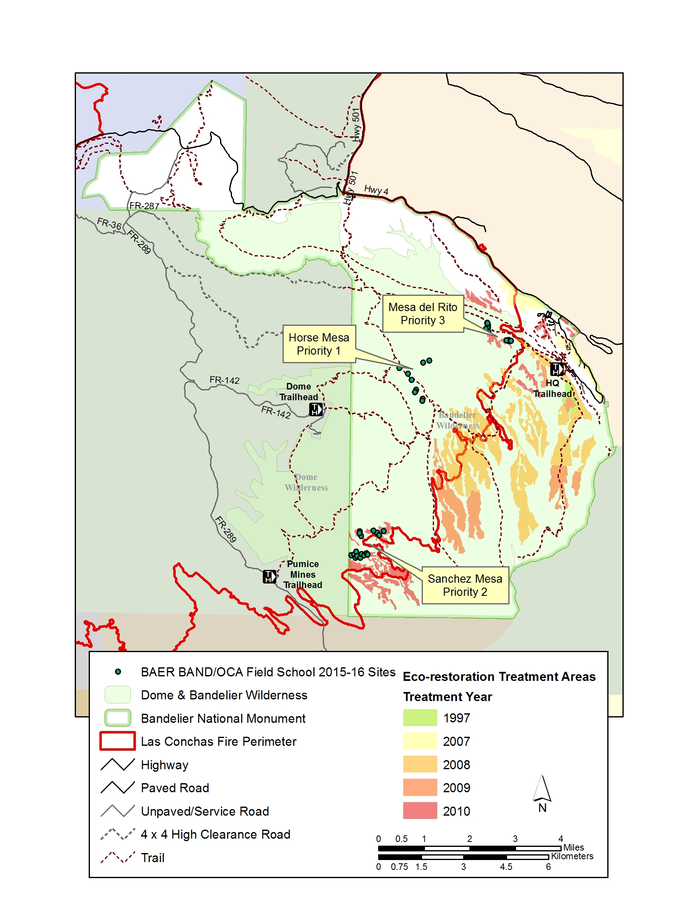

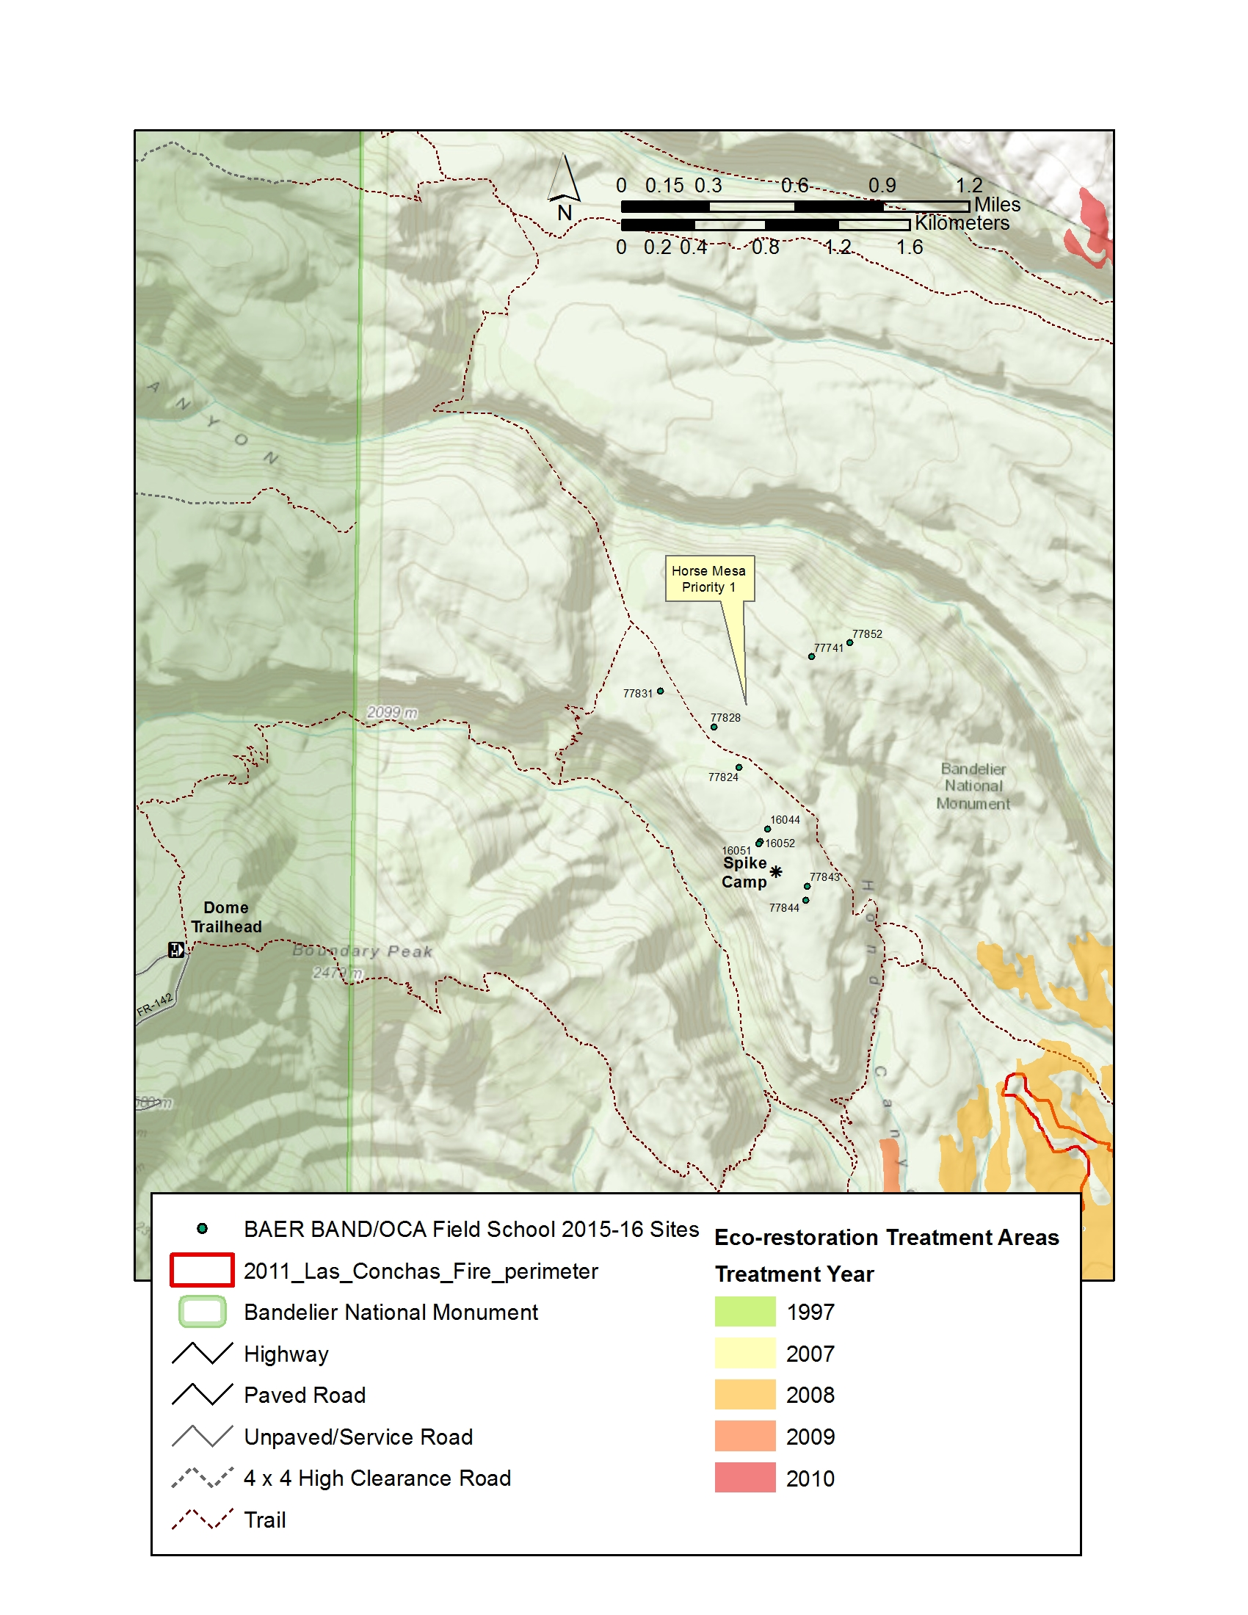
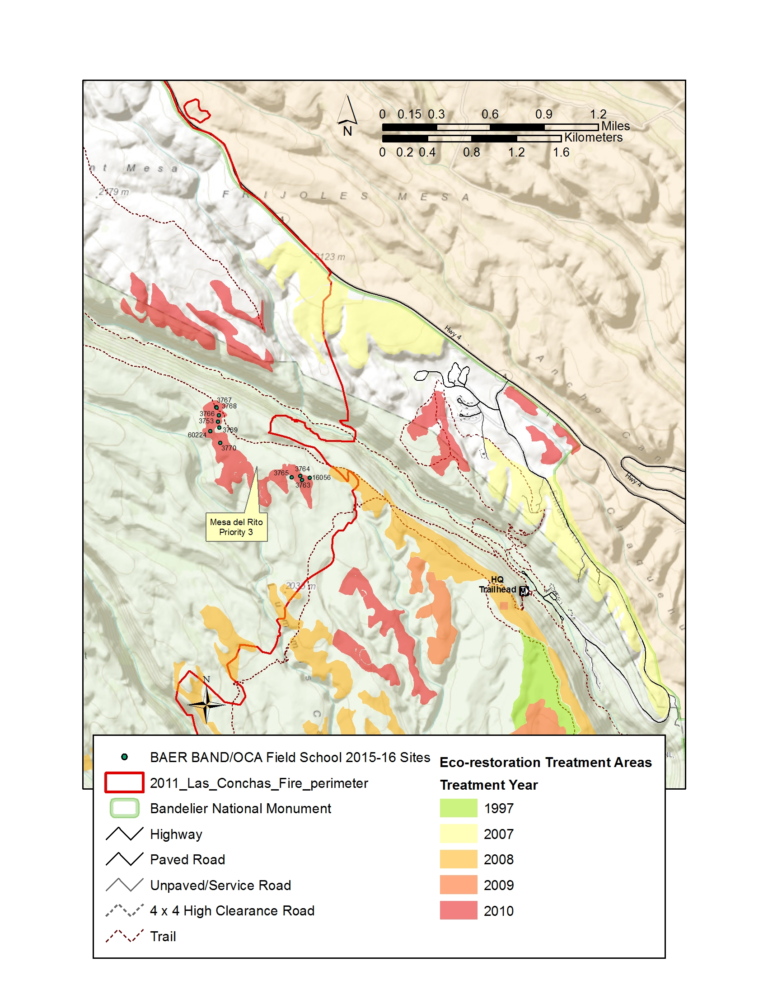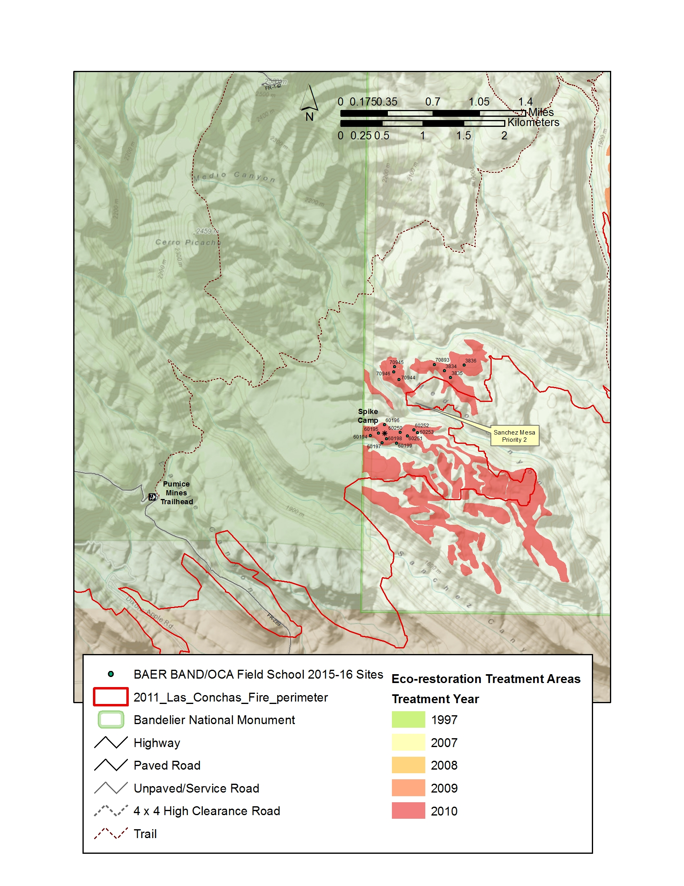

COOPERATIVE AGREEMENTS OR TASK AGREEMENTS INVOLVING COOPERATORS WORKING ON-SITE

Background
In cooperative agreements or task agreements with universities where the university utilizes interns, student employees, research associates (RAs) or cooperators on-site (hereafter called “cooperator personnel”), these cooperator personnel sometimes work on government sites in close proximity to federal employees. It is illegal (without specific statutory authority) for federal employees to directly supervise the cooperator personnel or any university employees or for the students or other university employees to supervise federal employees. When cooperator personnel are working on an NPS site, it is important that there is a clear distinction between students and federal employees.

Office Environment and Vehicles

- The office space of the cooperator personnel and NPS personnel should be clearly labeled (Name and NPS or University affiliation on office or cubicle space).
- Cooperator personnel should be listed separately from NPS personnel in telephone lists, other identification or organizational rosters, and publication credits.
- Cooperator personnel should not receive “all-employee” e-mail or other communications intended for NPS personnel (unless it relates directly to the work the cooperator is doing for the NPS). When the e-mail does relate to the work being done, a copy of the same e-mail message should be sent to the University or cooperator’s supervisor.
- Cooperator personnel may use NPS e-mail systems when the communication relates directly to the work the cooperator is doing for the NPS. The e-mail addresses of the cooperator personnel must include a label associated with their NPS e-mail address that identifies the cooperator’s status (i.e., “Linda Webb, Cooperator” would be the label associated with the e-mail address, linda_webb@contractor.nps.gov). Doing so clearly identifies this individual each time they send an e-mail message using the NPS system, and it identifies their status as a research associate, student intern or student employee in the e-mail directory.
- Unless stipulated in the agreement, cooperator personnel should not drive government vehicles.
- Unless stipulated in the agreement, cooperator personnel should not ride as a passenger in a government vehicle. When this is planned as part of the agreement, an appropriate amount of liability insurance should be negotiated.
- Prior written approval by the Park Superintendent or Center Manager must be obtained in order for a task to allow cooperator personnel to drive or ride in government vehicles.

Supervision and Scheduling

- Each task must specify the university’s/cooperator’s supervisor for the cooperator personnel.
- Unless stipulated in the agreement, NPS staff should not set hours for cooperator personnel, specify where the work should be done, or conduct performance appraisals. National Park Service staff may give performance feedback to the cooperator personnel supervisor.
- Cooperator personnel should report leave, scheduling, and other related issues to the university or cooperator’s supervisor, not to NPS employees. The supervisor of the cooperator personnel should then communicate with the NPS. National Park Service employees cannot directly supervise cooperator personnel on a day-to-day basis. Work should be given to the cooperator personnel (via the cooperator’s supervisor) on a “task basis.” Cooperators should work without NPS supervision to accomplish each task, although technical consultations and cooperation is permissible.
- The Cooperator will be responsible for any disciplinary action needed to correct student employee conduct or performance problems. The NPS agreements technical representative will inform the university/cooperator’s supervisor of any conduct or performance problems.
- The Cooperator will remove student employees from their positions if they fail to improve performance or address conduct issues.
- The NPS will review and provide feedback to students or interns regarding work assignments.
- The NPS will inform the cooperator of conduct or performance problems with cooperator personnel so that the university can counsel employees and correct the performance problems.
- The NPS will recommend to the cooperator dismissal of cooperator personnel based on conduct or performance issues.
- The Cooperator will hire students, interns or RAs to work on NPS tasks identified in the agreement. Hiring will be conducted in consultation with the NPS Agreements Technical Representative (ATR).
- The Cooperator will: pay students, interns or RAs for hours they have worked in support of the agreement.

Representation and Communication

- Cooperator personnel cannot in any way represent themselves to the public as NPS employees.
- Cooperator personnel are required to wear visible identification at all times.

Other Issues

- Cooperator personnel should not list an NPS affiliation on publications, but rather should list the cooperative agreement under which the work was performed.
- Cooperator personnel should not be invited to official NPS “social” events.
- Cooperator personnel will follow the local policy of the facility when federal facilities are closed due to early release for holidays, snow days, etc.

PRODUCTS:
FY14 Investigator’s Annual Report
FY15 Mobilization and Field Season
FY15 Investigator’s Annual Report
FY16 Mobilization and Field Season (if required)
FY16 Investigator’s Annual Report (if required)
Draft Final Technical Report
Documentation: originals or copies of all completed surveys.
Abstract of Final Accomplishment Report
Final Accomplishment Report and Powerpoint Presentation
BUDGET:

Item |  | Justification | Total
Salary |  | Faculty Dello-Russo – 4 days salary | $1,340
 |  | Leave at 28% | $375
 |  | Fringe-on-Leave at 26% | $98
 |  | Field Staff – 4.5 crew X 32 days salary | $23,630
 |  | Leave at 28% | $6,617
 |  | Fringe-on-Leave at 26% | $1,720
 |  | Admin Staff – 4 days Unit Admin. / Office Mgr. | $1001
 |  | Leave at 28% | $280
 |  | Fringe-on-Leave at 26% | $73
 |  | Post-field Staff – 2 crew X 8 days salary | $3,218
 |  | Leave at 28% | $901
 |  | Fringe-on-Leave at 26% | $234
 |  | GIS Specialist – 4.5 days salary | $930
 |  | Leave at 28% | $261
 |  | Fringe-on-Leave at 26% | $68
Total Salary |  |  | $30,120
Total Leave |  |  | $8,434
Total Fringe-on-Leave |  |  | $2,193
Total Personnel |  |  | $40,726
Travel (Per Diem) |  | $85/day / person x 32 days X 5 people | $13,600
Vehicle Cost |  | 2 vehicles @ $85/day each for 32 days | $5,440
Vehicle Mileage |  | $0.50/mile each for total of 1980 miles | $990
Materials and supplies |  | Materials/Supplies (Software, printing supplies) | $500
Field equipment & fuel |  |  | $1000
Direct costs total |  |  | $62,276
Indirect costs: |  | at the CESU rate of 17.5% | $10,894
GRAND TOTAL: |  |  | $73,170

