Joint Research on the Endemism of White Sands National Monument
and Cuatrociénegas Protected Area: Arthropods

Annual Progress Report 2010

Prepared By:

Division of Arthropods
and
Natural Heritage New Mexico
Museum of Southwestern Biology
Biology Department
University of New Mexico
Albuquerque, NM 87131

Presented To:

White Sands National Monument
PO Box 1086
Holloman AFB, NM 88330

March 1, 2011

1. Introduction and Background

This annual report provides information on the first year (2010) of a two-year survey of the arthropods of White Sands National Monument, New Mexico, USA, and Cuatrocienegas Protected Area, Coahuila, Mexico. The project title is “Joint research on The endemism of White Sands National Monument and Cuatrociénegas Protected Area: Arthropods,” a U.S. National Park Service (NPS), Sister Parks Program funded study, awarded to White Sands National Monument, and to the Biology Department, University of New Mexico, Museum of Southwestern Biology, Division of Arthropods. This report also serves to provide information on the project for the 4th quarter of 2010.

The purpose of this research is to comparatively inventory White Sands National Monument (White Sands), New Mexico, USA, and Cuatrociénegas Protected Area (Cuatrociénegas), Coahuila, Mexico (both hereafter referred to as parks), for undescribed (not yet formally named or recognized by the scientific community) and potentially endemic (restricted in geographic distribution to those locations) species of arthropods. Both areas are located within the Chihuahuan Desert, and both areas consist of desert basin gypsum deposits, including gypsum flats, gypsum outcrops, gypsum dunes, and surface water springs, ponds, and streams. Both desert basins are surrounded by limestone fault-block mountains, also containing gypsum deposits. This research is being supported by the NPS to comply with the NPS Chihuahuan Desert Network, Inventory and Monitoring Program’s mandate to expand understanding of the full complement of species diversity across the Chihuahuan Desert. This comparative study is meant to provide a cost-effective approach to gaining better information on potentially endemic and under-represented animal groups (arthropods in this case) in the parks.

1.1. Study Areas: White Sands National Monument, and Cuatrociénegas Protected Area.

Both of the study areas, or parks, are located in the Chihuahuan Desert (Figure 1.1). White Sands is located in the Tularosa Basin of southern New Mexico, USA, and Cuatrociénegas is located in central Coahuila, Mexico, both within the Chihuahuan Desert Level III ecoregion type (USEPA 2007, web site:
http://www.epa.gov/wed/pages/ecoregions/level_iii.htm (accessed March 2010).

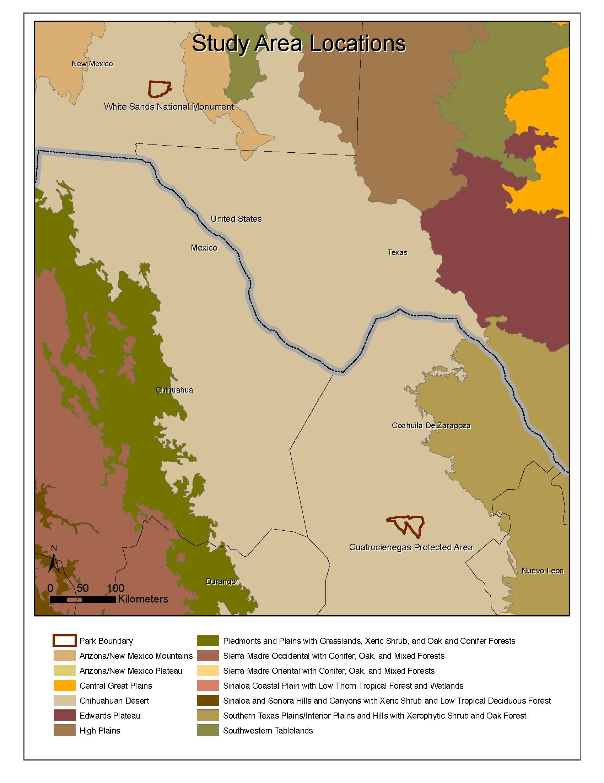
Figure 1.1. Map showing the geographic locations of White Sands National Monument and Cuatrociénegas Protected Area within the Chihuahuan Desert ecoregion, relative to surrounding ecoregions (source: Commission for Environmental Cooperation, 1997).

1.2. Project Tasks.

This research project is partitioned into six principal tasks which are being completed in chronological order as follows:

Task 1. Literature Review. Review of existing research publications pertaining to both parks to ensure no duplication of work with previous studies. The findings from this task were presented in the first quarterly report for 2010, and are again presented here.

Task 2. Sampling Plan. To develop a sampling plan to inventory both parks for potentially undescribed and endemic arthropods. The sampling plan includes a presentation of which arthropod taxa will be targeted in this study, what methods will be used to search for those arthropods, and potential locations plotted on maps where searches or sampling will conducted, and a time schedule for when sampling will be conducted. This information also was presented in the first 2010 quarterly report, and is again presented here.

Task 3. Field Campaign. The field campaign consists of the sampling efforts that were identified and scheduled in the Task 2 Sampling Plan, and implemented in field trips during the summer of 2010, and to be continued during the summer of 2011. The number of potential sampling locations identified was a function of the heterogeneity of landscapes or habitats within each park. The original planned potential sampling locations were identified based on New Mexico Natural Heritage Program GIS (Geographic Information System) maps representing topography, soils, vegetation, surface waters, and road access. Modifications to sampling locations were anticipated once researchers visited the sites, and some predetermined locations were found to be inadequate, while new sampling locations were identified in the field, and such changes were made. Field survey forms were used to document environmental conditions and to record sampling efforts at all sampling locations. The first field campaign was in April and May of 2010 and was reported in the 2nd Quarterly Report. The second part of the field campaign occurred in July and August, 2010, and was reported in the 3rd Quarterly Report. Information from both of those quarterly reports is presented in this annual report.

Task 4. Data entry and quality control. Data from the field survey forms has been entered into spreadsheet data or information tables, and those are presented in the appendices of this annual report for 2010 surveys. Task 4 also includes the laboratory work of processing field collected samples to isolate and identify target taxa. During this task, potentially undescribed species are being recognized. All target taxa specimens are being curated (mounted as museum specimens, provided with specimen labels), and sent to taxonomic experts for positive identification and determination of whether or not they represent undescribed taxa. There is no one universally accepted taxonomic classification system for arthropods. We are following the higher taxonomic classification of Triplehorn and Johnson (2005) which is one of the most current and widely accepted classifications for North American insects and related arthropods. Lower level (genus, species, subspecies) classifications follow the appropriate primary literature classifications specific to the different arthropod groups.

Task 5. Final Report. A draft final report will be prepared at the end of the second year (2011), and submitted early in 2012. That report will present information on all new and endemic species found at both parks, and submitted to staff at both parks for review.

Task 6. Translation of the Final Report and other materials. This annual report and the final report will be translated into Spanish, and both English and Spanish versions will be submitted. Translation will take place once the English version has been approved by White Sands National Monument.

1.3. Task Time Schedule

Table 1.1 presents the task/time schedule for this project. In addition to the key tasks and dates presented in Table 1, annual progress reports will be submitted in December 2010 (this report), and December 2011.

Table 1.1. Task/time schedule for this project.

Task Description Dates

1 Literature review Spring 2010 (March 31)
2 Sampling plan Spring 2010 (March 31)
3 Field campaign Spring/Summer/Fall 2010, 2011
4 Data entry & lab work Fall 2010-Winter 2012
5 Final Report Winter 2012 (January 30)
6 Translation of Final Report Summer 2012 (May 31)

2. Literature Review (Task 1)

2.1. Introduction

We performed a broad literature review to determine the scope and depth of previous research on arthropods at both parks. Only those publications directly pertaining to taxonomic studies are included here, however a record was kept of all ecological papers on arthropods as well as general background papers on conservation or habitat of the two parks. The general publications serve to provide background information, and to help determine where we will most likely find new and endemic species, and the taxonomic papers will serve to prevent duplication of efforts.

2.2. Methods

An internet literature search including relevant biological literature reference sites such as Web of Science and other internet resources available through the University of New Mexico Libraries, was performed to provide a literature review for publications about arthropods from both White Sands National Monument and Cuatrociénegas Protected Area. Both parks had well developed bibliographies on their respective web sites, and all relevant publications on arthropods were recorded and compiled into lists.

2.3. Results and Discussion

The only comprehensive arthropod survey at White Sands National Monument was conducted in 1946-47 by Stroud (1950). Stroud collected and identified 371 taxa, 352 were identified to the species level, and 8 undescribed species were recognized. We find no evidence in the literature that any of those 8 species were ever subsequently formally described and there is no follow up publication as was suggested in the original paper. Therefore, we cannot be certain that those 8 undescribed species hypothesized to be distinct species are actually valid species. The 8 undescribed taxa reported by Stroud included: 1 cricket (Gryllacrididae), 1 blister beetle (Meloidae), 3 parasitic wasps (1 Braconidae and 2 Ichneumonidae), 1 sapromyzid fly (Sapromyzidae), and 2 sarcophagid flies (Sarcophagidae). The new species of gryllacridid cricket reported by Stroud was likely one of the two new species described by Strohecker (1947) in the same year (see below). We will collect blister beetles, but the other seven taxa belong to groups that we do not have expertise in.

Six species of arthropods have been described from White Sands, but only four of those appear to be endemic there (Table 2.1). Strohecker (1947) collected and described two new species of sand-treader camel crickets Ammobaenetes arenicolous and Daihiniodes larvale. Both of those sand-treader camel crickets are white, gypsum sand specialists, and are endemic to White Sands. Metzler et al. (2008) described two new and apparently endemic species of noctuid moths from White Sands (Euxoa lafontainei and Protogygia whitesandsesis) as part of a current and ongoing survey of the moths of White Sands, begun in 2007. Metzler has found a number of additional apparent new species of moths that are likely endemic to White Sands, and is in the process of formally describing those species (E. Metzler, personal communication, 2010). Metzler has agreed to serve as the moth expert for this project, and he will examine all moth specimens that we collect, both from White Sands and Cuatrociénegas. We will not collect moths at the White Sands locations where Metzler is conducting his light-trap sampling, and any new taxa that Meztler describes over the duration of this project will be included in our final report.

Mackay and Mackay (1994) described a new ant Lasius xerophilus, from White Sands, but that species occurs elsewhere in New Mexico as far away as Santa Fe, and is not a gypsum specialist, or endemic to White Sands. Platnick (1975) described a new spider Callilepis mumai from White Sands, but the species occurs throughout the Southwest, and Planick reported it from Arizona, Utah, and elsewhere. C. mumae is not a gypsum specialist. Hicks and Whitcomb (1996) described a new leafhopper Athysanella blockeri, a specialist on gyp grama (Bouteloua breviseta) from gypsum areas near Carlsbad, New Mexico, and reported two other Athysanella as being specialists on gyp grama and gyp dropseed (Sporobolus nealleyi). Those leafhoppers occur in gypsum areas across southeastern New Mexico, and in the Tularosa Basin, but none of those leafhoppers are endemic to White Sands. We are not aware of any other described arthropod taxa that are endemic to White Sands.

No comprehensive surveys of arthropods have been conducted at Cuatrociénegas, yet 14 endemic arthropods species, mostly crustaceans and scorpions, are reported from Cuatrociénegas (Table 2.1). A number of studies of particular arthropod groups have been conducted, focusing on aquatic crustaceans and terrestrial scorpions. Dinger et al. (2005) conducted a survey of aquatic invertebrates from a number of springs, ponds, lakes, and streams at Cuatrociénegas, but did not report finding any new or endemic species. However, most of the taxa reported from that study were never identified below the family or genus level, and Dinger did not deposit voucher specimens in any public museums. Dinger conducted his research for a Masters of Science degree at Northern Arizona University, but the insect collection there does not contain his specimens (N.Cobb, Curator, personal communication). Cole (1984) reported that 12 species of aquatic crustaceans were known from Cuatrociénegas. Six of the 12 species were endemic to Cuatrociénegas, including 2 recently described endemic genera (Paramexiweckelia and Sphaerolana) consisting of 6 newly described species. The genera Paramexiweckelia and Sphaerolana are the only arthropod genera known to be endemic to Cuatrociénegas.

In addition to endemic aquatic arthropods, a number of endemic terrestrial arthropods also are known. Cazier (1982) described two new species of endemic apiocerid flies from Cuatrociénegas, Apiocera minkleyi and A. bigelowi. Six species of scorpions were described from Cuatrocienegas, and five of those species are apparently endemic to Cuatrociénegas. Williams (1968) described five species of scorpions of the genus Vejovis (V. gilvus, V. pallidus, V. casieri, V. coahuilae, and V. minckleyi) from the Cuatrociénegas basin, and according to Williams, all but V. coahuilae appear to be endemic to the Cuatrociénegas basin. Soleglad (1974) described another endemic species of Vejovis (V. calidus) from Cuatrociénegas. Haradon (1985) described the scorpion Paruroctonus coahuilanus from Cuatrociénegas, and the species appears to be endemic there. In total, eight species of scorpions were described from and are currently known to occur only in the Cuatrociénegas basin. We are not aware of any other described arthropod species known to be endemic to Cuatrociénegas.

Table 2.1. Arthropod taxa described from and apparently endemic to White Sands National Monument and Cuatrociénegas Protected Area. Higher classification follows Triplehorn and Johnson ( 2005).

White Sands National Monument

Class Order Family Genus Species Literature Source
Hexapoda Lepidoptera Noctuidae Euxoa lafontainei Metzler et al., 2009
Hexapoda Lepidoptera Noctuidae Protogygia whitesandsesis Metzler et al., 2009
Hexapoda Orthoptera Rhaphidioridae Ammobaenetes arenicolous Strohecker, 1947
Hexapoda Orthoptera Rhaphidioridae Daihiniodes larvale Strohecker, 1947

Cuatrociénegas Protected Area

Class Order Family Genus Species Literature Source
Hexapoda Diptera Apioceridae Apiocera minckleyi Cazier, 1982
Hexapoda Diptera Apioceridae Apiocera bigelowi Cazier, 1983
Arachnida Scorpiones Vejovidae Paruroctonus coahuilanus Haradon, 1985
Arachnida Scorpiones Vejovidae Vejovis calidus Soleglad, 1974
Arachnida Scorpiones Vejovidae Vejovis gilvus Williams, 1968
Arachnida Scorpiones Vejovidae Vejovis pallidus Williams, 1968
Arachnida Scorpiones Vejovidae Vejovis casieri Williams, 1968
Arachnida Scorpiones Vejovidae Vejovis minckleyi Williams, 1968
Malacostraca Amphipoda Hadziidae Mexiweckelia colei Cole, 1984
Malacostraca Amphipoda Hadziidae Paramexiweckelia particeps Cole, 1984
Malacostraca Isopoda Stenasellidae Mexistenasellus coahuila Cole, 1984
Malacostraca Isopoda Cirolanidae Speocirolana thermydronis Cole, 1984
Malacostraca Isopoda Cirolanidae Sphaerolana interstitialis Cole, 1984
Malacostraca Isopoda Cirolanidae Sphaerolana affinis Cole, 1984

Although a number of arthropod species have been described from both White Sands and Cuatrociénegas, until thorough surveys are conducted in the surrounding regions, they are only presumed to be endemic to those parks. Further research may find that they occur in similar gypsum environments outside of the park boundaries. Additionally, any new species of arthropods found in this study will only be presumed endemic to either park until through sampling is conducted throughout the adjacent regions. New species of arthropods found associated with environments that are unique to either park are most likely to be truly endemic to the particular park. The scope of this study is to survey target arthropods only within the boundaries of the parks.

2.4. Bibliography for White Sands

Hicks, A,L. and R.F. Whitcomb. 1996. Diversity of the leafhopper (Homoptera: Cicadellidae) fauna of northern Chihuahuan grasslands, with emphasis on gypsum grassland and description of a new species of Athysanella (Cicadellidae: Deltocephalinae). Proceedings of the Entomological Society of Washington. 98:145-157.

Mackay, W.P. and E.E. Mackay. 1994. Lasius xerophilus (Hymenoptera: Formicidae), a new ant species from White Sands National Monument, New Mexico. Psyche. 101:37-43.

Metzler, E.H. 2006. Assessment of insects, especially butterflies and moths (Lepidoptera) at White Sands National Monument: proposal for research at White Sands National Monument.

Metzler, E., D. Bustos, G. Forbes. 2009. The Lepidoptera of White Sands National Monument, Otero County, New Mexico, USA 1. Two new species of Noctuidae (Lepidoptera, Noctuinae, Agrotini); ZooKeys. 9:47-62.

Platnick, N.I. 1975. A revision of the Holarctic spider genus Callilepis (Araneae, Gnaphosidae). American Museum Novitates. 2573:1-73.

Santos, P.F. and W.G. Whitford. 1983a. Seasonal and spatial variation in the soil microarthropod fauna of the White Sands National Monument. Southwestern Naturalist. 28:417-422.

Santos, P.F. and W.G. Whitford. 1983b. The influence of soil biota on decomposition of plant material in a gypsum sand dune habitat. Southwestern Naturalist. 28: 423-427.

Strohecker, H.F. 1947. Some Southwestern Gryllacrididae. Annals of the Entomological Society of America. 40:241-246.

Stroud, C.P. 1950. A survey of the insects of White Sands National Monument, Tularosa Basin, New Mexico. American Midland Naturalist. 44:659-677.

2.5. Bibliography for Cuatrociénegas
Cazier, M. 1982. A review of the genus Apioceras (Diptera:Asilidae). Bulletin of the American Museum of Natural History. 171:285-464.
Clench, H.K. 1968. Butterflies from Coahuila, Mexico. Journal of the Lepidopterists' Society. 22:227-231.
Cole, G.A. & Minckley, W.L. 1970. Sphaerolana, a new genus of cirolanid isopod from northern Mexico, with description of two species. The Southwestern Naturalist, 15:71-81.
Cole, G.A. & Minckley, W.L. 1972. Stenasellid isopod crustaceans in the western hemisphere-a new genus species from Mexico-with a review of other North American freshwater isopod genera. Proceedings of the Biological Society of Washington, 84(39): 313-326.
Cole, G.A. 1984. Crustacea from the Bolson of Cuatro Cienegas, Coahuila, Mexico. Journal of the Arizona-Nevada Academy of Science, 19:3-12.
Contreras-Balderas, A.J. & Warren, A.D. 2006. Cercyonis pegala texana (Lepidoptera: Nymphalidae: Satyrinae): New record from the state of Coahuila, México. The Southwestern Naturalist. 51:552-553.
Dinger, E.C. 2001. Aquatic Invertebrates of Cuatro Ciénegas, Coahuila, México and Effects of Fish on Stromatolite Invertebrate Assemblages, Master of Science thesis, Northern Arizona University, Flagstaff, 70 pp.
Dinger, E.C., Cohen, A.E., Hendrickson, D.A. & Marks, J.C. 2005. Aquatic invertebrates of Cuatro Ciénegas, Coahuila, México: natives and exotics. The Southwestern Naturalist. 50:237-246.
Dinger, E.C. 2006. Aquatic Conservation Biology in Arid Ecosystems, Ph.D. thesis, Northern Arizona University, Flagstaff.
Haradon, R.M. 1985. New groups and species belonging to the nominate subgenus Paruroctonus (Scorpiones, Vaejovidae). Journal of Arachnology. 13:19-42.
Llorente-Bousquets, J. & Gonzáez Soriano y Nelson, E. editors. 2000. Biodiversidad, taxonomía y biogeografía de artrópodos de México: Hacia una síntesis de su conocimiento, volumen II. CONABIO, México, D.F., 676 pp.
Lourenco, W.R. & Sissom, D.W. 2000. Scorpiones. IN:Biodiversidad, taxonomía y biogeografía de artrópodos de México, Volumen II, 115-135.
Soleglad, M. 1974. Vejovis calidus, a new species of scorpion from Coahuila, Mexico (Scorpionida: Vejovidae). Entomological News. 85:108-115.
Solis-Rojas, C. & Rodriguez-Almaraz, G.A. 1994. The Arachnids (Chelicerata: Arachnida) of the Valley of Cuatro Ciéñegas, Coahuila, México. Proceedings of the Desert Fishes Council. 25:42.
Stahnke, H.L. & Calos, M. 1977. A key to the species of the genus Centruroides Marx (Scorpionida: Buthidae). Entomological News. 88:111-120.
Williams, S.C. 1968. Scorpions from Northern Mexico: Five New Species of Vejovis from Coahuila, Mexico. Proceedings of the California Academy of Sciences. 68:1-24.
Yanega, D. 1994. Nest and hosts of three species of megachilid bees (Hymenoptera:Apoidea:Megachilidae) from Coahuila, México. Journal of the Kansas Entomological Society. 67:415-417.

3. Sampling Plan (Task 2)

3.1. Introduction

The purpose of the sampling plan was to define how potentially new and endemic arthropod species will be searched for and collected, processed in the laboratory, and determined to be new or undescribed species. The above literature review provides background information on what arthropods are known from each park. We then developed a list of target taxa for this research project, in context to what arthropods are already known from both parks. That target taxa list not only includes groups of arthropods that are likely to be represented by endemic species at each park, but also includes only those taxonomic groups for which we have taxonomic expertise in order to determine whether or not collected taxa represent undescribed species. Based upon that list of target taxa, we then developed a list of proposed field sampling methods that will best focus sampling efforts on collecting specimens representing those arthropod taxa. Higher taxonomic classification for all arthropods follows that of Triplehorn and Johnson (2005).

3.2. Target Arthropod Taxa

The Phylum Arthropoda is one of the most diverse groups of life on the planet. Of the four extant Subphyla, we will focus on Chelicerata, Myriapoda and Hexapoda. These three Subphyla still make up most of the diversity of land based life and there is no feasible way to study all of them. We have therefore restricted the list of target taxa by limiting it to those groups for which we could find taxonomic experts willing to perform the identifications to the species level. We currently have a list of seven experts from our home institution and 18 experts from other institutions to work on over 70 taxonomic groups. This list will continue to expand over the course of the study as we determine the areas of need.

Each taxonomic group is assigned a level of priority according to the available expertise. Level 1 indicates that we have an expert who is qualified to determine all specimens to the species level and who knows the group well enough to be able to determine if a specimen is a new species and describe it. Level 2 indicates that we have an expert who is qualified to determine most specimens to the species level. Level 3 indicates that we do not have an expert at this time. We will still curate specimens of level 3, but they will not specifically be targeted in our collection methods and will be the lowest priority for curation. Table 3.1 provides a listing of target taxa groups, priority levels, and expert taxonomists who will provide identifications.

Table 3.1. Listing of the taxonomic groups of arthropods targeted for this project, along with their priorities (see text above), and taxonomic experts who will provide identifications and potentially describe new species. Higher taxonomic classification follows Triplehorn and Johnson (2005).
______________________________________________________________________
White Sands National Monument /
Cuatrociénegas Protected Area Comparative Arthropod Inventory Project
1=top priority | 2=second priority | 3=low priority
Phylum Arthropoda
Class Hexapoda
Order | Family | Priority | Expert
Odonata | Aeshnidae | 1 | Miller
 | Coenagrionidae  Cortiliidae  Gomphidae  Lestidae  Macromiidae | 1  1  1  1  1 | Miller  Miller  Miller  Miller  Miller
 | Libellulidae | 1 | Miller
Orthoptera | Acrididae | 1 | Lightfoot
 | Gryllidae | 1 | Lightfoot
 | Raphidophoridae | 1 | Lightfoot
 | Romalidae | 1 | Lightfoot
 | Stenopematidae | 1 | Lightfoot
 | Tetrigidae | 1 | Lightfoot
 | Tettigoniidae | 1 | Lightfoot
 | Tridactylidae | 1 | Lightfoot
Phasmatodea | all families | 2 | Lightfoot
Dictyoptera | Blattodea | 2 | Hopkins
 | Mantodea | 2 | Lightfoot
Dermaptera | all families | 3 | Lightfoot
Heteroptera | Acanthosomatidae | 2 | Bundy
 | Belostomatidae | 2 | Miller
 | Coreidae | 2 | Bundy
 | Corixidae | 2 | Miller
 | Gerridae | 2 | Miller
 | Notonectidae | 2 | Miller
 | Pentatomidae | 1 | Bundy
 | Reduviidae | 2 | Bundy
 | Scutelleridae | 2 | Bundy
 | Thyreocoridae | 1 | Bundy
 | other Heteroptera | 3 | Bundy
Coleoptera | Carabidae | 1 | Ball
 | Cerambycidae | 1 | Nearns
 | Cicindelinae | 1 | Richman
 | Dytiscidae | 1 | Miller
 | Elateridae | 1 | Johnson
 | Glaresidae | 1 | Paulsen
 | Gyrinidae | 1 | Miller
 | Haliplidae | 1 | Miller
 | Hydrophilidae | 1 | Miller
 | Lucanidae | 1 | Paulsen
 | Meloidae | 2 | Bundy
 | Noteridae | 1 | Miller
 | Ochodaeidae | 1 | Paulsen
 | Scarabaeidae | 1 | Ratcliffe/Cave
 | Tenebrionidae | 1 | Triplehorn
Lepidoptera | Gelechiidae | 1 | Metzler
 | Incurvaridae | 1 | Metzler
 | Noctuidae | 1 | Metzler
Diptera | Asilidae | 1 | Forbes
 | Culicidae | 1 | Richman
 | Ephydridae | 2 | Mathis
Hymenoptera | Andrenidae | 2 | Wetherill/Griswold
 | Apidae | 2 | Wetherill/Griswold
 | Bradynobaenidae | 1 | Pitts
 | Colletidae | 2 | Wetherill/Griswold
 | Halictidae | 2 | Wetherill/Griswold
 | Megachilidae | 1 | Griswold
 | Mutillidae | 1 | Pitts
 | Pompilidae | 1 | Pitts
 | Trichogrammatidae | 1 | Avila
Embiidina | webspinners | 1 | Miller
Class Arachnida | Spiders and scorpions
Araneae | Araneidae | 1 | Richman
 | Clubionoid families | 2 | Richman
 | Dictynidae | 1 | Brantley
 | Gnaphosidae | 1 | Brantley
 | Linyphiidae | 1 | Brantley/Richman
 | Salticidae | 1 | Richman
 | Thomisidae | 1 | Brantley
 | all other families | 3 | Brantley/Richman
Opilionids | all families | 2 | Brantley
Scorpiones | scorpions | 1 | Sissom
Solifugae | wind scorpions | 1 | Cushing
Class Diplopoda | Millipedes | 2 | Medrano
Class Chilopoda | Centipedes | 2 | Medrano

3.3. Sampling Methods

The high diversity of arthropods potentially present at the study sites is reflected in the wide variety of sampling methods. The techniques listed below are all standard collection methods and were chosen because of the taxa that they target, their efficiency, and their ease of use. We are using as many different sampling methods as appropriate on each trip for each habitat type. However these methods may differ by habitat type, time of year, and target taxa. Below is a list of the possible sampling techniques that will be used, a brief discussion of the methods, the target taxa, the habitat type(s) and potential impact on the landscape. Arthropod sampling methods follow those presented by Southwood and Henderson (2000), particular aquatic sampling methods are described by Merritt et al. (2008), and sand sifting and oatmeal trail methods are described by Weissman and Lightfoot (2007).

3.3.1. Active Collecting Methods
These methods involve researchers moving around and visually hunting for arthropods, not using stationary trapping devices.

General Collecting
- Target taxa: All types of diurnal and nocturnal arthropods.
- Methods: This general method is where a person wanders around and looks for arthropods, and collects them using a variety of simple methods. Aerial nets, sweep nets, beating sheets, and aquatic dip nets may be used to capture observed arthropods (see details for those methods below). The researcher may also look under rocks and other objects on the ground, and on vegetation. The researcher also may simply grab specimens with forceps or by hand, and place them in collecting containers, cyanide kill jars, or vials containing ethanol.
- Habitat types: Terrestrial, aerial, and aquatic.
- Impact: None.

Aerial Net Collecting
- Target taxa: Diurnal flying insects and insects on vegetation.
- Methods: Aerial nets are lightweight, small mesh nets that can be used to collect insects out of the air or off of vegetation. Aerial nets are usually used to target insects that researchers observe.
- Habitat types: Terrestrial and aerial.
- Impact: None.

Vegetation Sweep Net Collecting
- Target taxa: Arthropods on vegetation.
- Methods: Sweep nets are durable, heavy fabric nets that can be used to collect insects off of vegetation or other substrates. Sweep nets are used by repetitively sweeping them over the vegetation and are usually used to target insects that you cannot see within the vegetation.
- Habitat types: Terrestrial.
- Impact: None, sweeping is done gently enough so as not to damage vegetation foliage.

Vegetation Beating Sheets
- Target taxa: Arthropods on vegetation.
- Methods: Beating sheets are simply a square of fabric made stiff with cross-slats of wood or PVC pipe that is held horizontally under vegetation while a beating stick is used to knock arthropods off of the vegetation, and on to the sheet. The specimens are then individually collected by the investigator.
- Habitat types: Terrestrial vegetated.
- Impact: None, beating is gentle enough not to damage vegetation.

Aquatic Dip Net Collecting
- Target taxa: Aquatic insects.
- Methods: D-ring dip nets are durable, fabric nets that can be used to collect insects in water. Their D-shape allows them to be dragged along the floor of a stream or pond. Screen kitchen sieves will also be used for dip collecting.
- Habitat types: Aquatic.
- Impact: None. The dipping is done gently so as not to disturb aquatic vegetation and other substrates.

Pedestrian UV Light Collecting for Scorpions
- Target taxa: Scorpions.
- Methods: A portable ultra-violet (UV) light unit is carried on pedestrian surveys at night to locate scorpions. They glow pale greenish-yellow in the dark when exposed to UV light.
- Habitat types: Terrestrial.
- Impact: None.

Sand Sifting
- Target taxa: Arthropods that live in sand or lose soil.
- Methods: Sand or lose soil is extracted with a small shovel, and placed in a sieve made from wire screen with 0.2-0.5 mm mesh size. The sieve is then shaken to filter the sand through the screen, and any arthropods larger than the mesh size are held on the screen, and collected by the researcher. Sieves may be made with wooden frames and screen, or large kitchen sieves may be used.
- Habitat types: Terrestrial.
- Impact: Sand or soil is dug in small quantities to sieve. The sand or soil surface is smoothed over after extracting.

Berlaise Funnel Sample Collecting
- Target taxa: Dead plant leaf litter dwelling arthropods.
- Methods: Litter samples will be collected from the soil surface during the day. This litter is taken to a laboratory, and placed in the Berlaise funnel in the evening. The Berlaise funnel uses a low level heat source such as light bulb or chemical warming packs. The heat causes the arthropods to move away from the source an into an container of ethanol preservative below. A screen or other mesh is used to separate them from the litter.
- Habitat types: Terrestrial vegetated.
- Impact: Small samples of leaf litter and soil removed. The sand or soil surface is smoothed over after extracting.

3.3.2. Trapping and Bait Attraction Methods
These methods employ stationary baits or lights to attract arthropods, and often an associated trapping device that is left in place for a period of time. Arthropods are trapped and contained in the trapping devices. Researchers visit the traps or baits and collect the samples.

Aquatic Drift Nets
- Target taxa: Aquatic insects.
- Methods: Drift nets funnel-shaped nets that are installed in flowing water to collect drifting or swimming aquatic arthropods. The arthropods are trapped and contained in a receptacle at the tip of the funnel.
- Habitat types: Aquatic, lentic.
- Impact: The nets are staked in place, but this causes little impact.

Pitfall Traps
- Target taxa: Ground dwelling arthropods.
- Methods: Pitfall traps are containers sunk into the ground so that the top of the container is flush with the ground. They trap ground walking arthropods. Preservatives such as propylene glycol are often used in the bottom of the container. We will use water or water-diluted propylene glycol (one part propylene glycol to one part water) as a trapping medium, since the traps will left open for only several days at a time.
- Habitat types: Terrestrial.
- Impact: Shallow holes (15 cm) will be dug with a small trowel, just big enough for the container. The sand or soil surface is smoothed over after the cup has been removed. Care is taken not to contaminate the soil with propylene glycol.

UV Light Traps
- Target taxa: Nocturnal flying insects attracted to light.
- Methods: These traps consist of a bucket with a fluorescent and/or UV light bulb. The insects are attracted to the light and fly into the bucket. A killing agent is often used in the bucket, generally a no-pest insect strip (vapona).
- Habitat types: Terrestrial.
- Impact: None. Rechargeable motorcycle batteries will be used to power the lights in remote areas.

UV Sheet Lighting
- Target taxa: Nocturnal flying insects attracted to light.
- Methods: A UV or mercury-vapor light bulb is hung in front of a white sheet. Insects attracted to the light land on the sheet and are hand collected by the investigators.
- Habitat types: Terrestrial.
- Impact: UV light units will use D-cell batteries. A portable gasoline powered generator may be used to power the mercury-vapor lamp in remote areas. We will likely only use the portable D-cell UV light units.

Oatmeal Bait Trails
- Target taxa: Nocturnal ground dwelling arthropods.
- Methods: Oatmeal is sprinkled lightly across the ground surface as a person walks, at dusk. Arthropods are attracted to the trail of oatmeal, and the researchers walk the trail several times during the night to collect arthropods that have been attracted to the trail.
- Habitat types: Terrestrial.
- Impact: None.

Fruit Traps
- Target taxa: Fruit and nectar feeding insects.
- Methods: Over-ripe fruit is used as bait placed in containers with open tops, insects enter the containers and are trapped there. The specimens are collected by the researchers from the traps.
- Habitat types: Terrestrial.
- Impact: None.

Bee/Pollinator Traps
- Target taxa: Diurnal flower visiting pollinators such as bees.
- Methods: Small plastic dishes colored red, yellow, white, and blue each are placed in open areas and partially filled with soapy water. Pollinators are attracted to the colored dishes, and trapped in the soapy water. Researchers check the traps during the day to collect the trapped insects.
- Habitat types: Terrestrial.
- Impact: None.

3.4. Sampling Schedule and Number of Sample Sites

The two year study includes field sampling during the summers of 2010 and 2011. We have the resources to conduct eight field trips, four at each park over the two years. Both areas are desert ecosystems that are characterized by a bimodal weather pattern with precipitation occurring mostly during the late winter /early spring and again in the late summer. Since desert biota are largely limited by water, this seasonal bimodality results in a bimodality of the phenologies and life histories of many of the plants and animals, including arthropods. Different species of arthropods have different life histories, and some species are mature and active as adults in the early summer, while others are mature active in the late summer. The greatest diversity of active adult arthropods is likely to occur shortly after these wet periods. We are targeting our efforts in the late spring/ early summer (April-June) and again in the late summer/early fall (July-September).

Sampling trips are being conducted once in the early summer, and once in the late summer in 2010 and 2011, at both parks, and each sampling trip l provides for 6 days of sampling, plus 2 additional days for transit to and from the parks. Given that 1-2 hours are spent sampling at each site during the daytime, with additional time at some sites for night sampling, the number of sites that can be visited during one sampling visit will be on average 6 sites per day, for a total of 36 sites within a given sampling period at each park. Those same 36 sampling sites at each park will be visited twice that year, once in the early summer (April-June) and once in the late summer (July-September) to accommodate the different life histories of different arthropod taxa. A different set of 36 locations will be visited in 2010 and 2011 at each park, providing at total of 72 sample sites at each park over the two-year field campaign, for a total of 144 sample sites for the entire project. Given that each site will be visited twice each year, the total number of sampling efforts generated will be 288. Each of those 288 sampling efforts will be composed of numerous subsamples representing each of the different collecting methods, so potentially producing 288-1000+ samples over the 2 year period, depending upon how many sampling methods are used at each site.

Each 6-day sampling visit or period is partitioned into 6 separate day trips, one each day, from a base location (Visitor Center researcher house at White Sands, Desert Fish Counsel lab at Cuatrociénegas). The UNM field crew meets with representatives from each park on the morning of day 1 to discuss the sampling schedule and map logistics, and arrangements will be made to access restricted areas. Sampling l commences late in the morning of day one, and each day trip will visit approximately 6 different sites. Arthropods are collected for approximately 1-2 hours per site using general collecting methods (described above) at all sites, and other targeted trapping and sampling methods at a subset of sites based on habitat conditions and appropriateness for employing those methods. Stationary trapping devices are left in place for differing periods of time, ranging from 1-4 days. In addition to visiting up to 6 new sites each day, some sites are revisited on any given day to collect trap samples and move the traps to new site locations. Night collecting is conducted at a subset of 1-2 sites visited during the day, beginning in the evening of that day. Light traps are set at dusk, and nocturnal collecting conducted during the evening hours. Generally, samples are organized and labeled as they are collected in the field at each site. All field collected samples are further organized and prepared for transportation to the UNM lab facilities prior to departure on day 8.

Arthropod Survey Field Data Forms are filled out at each site, documenting standardized information including the site name, location, UTM coordinates, descriptions of landscapes, environments, vegetation, collection methods, and descriptions of samples taken. Photograph data is documented on similar field data forms. A listing of all sites and their UTM coordinates, along with GIS produced maps of all sites, is taken to the field and used to navigate to each of the GIS predetermined sampling sites. Adjustments to the center locations and sizes and shapes of each sampling site are made in the field as appropriate based upon actual conditions found at each site. The final UTM coordinates are recorded on the field data form, and photographs are taken providing views of each cardinal direction from the center point of each site.

3.5. Sample Site Locations

Potential sampling locations were determined by examining GIS map data layers representing different environmental features (e.g., soils, vegetation, surface waters) and then stratifying sampling locations among those different environments or habitats to ensure adequate sampling of the key environments or habitats present at both parks. Maps and a geodatabase were created using ESRI ArcGIS 9.3.1 desktop software. GIS work was conducted by Natural Heritage New Mexico. GIS data layers for White Sands were obtained from the Natural Heritage New Mexico Enterprise Geodatabase, and used to produce a Landsat ETM+ image map. Natural Heritage New Mexico utilized Landsat ETM+ imagery with a 30 m spatial resolution acquired in 1999 as base imagery for White Sands taking advantage of the multi-spectral qualities that enhance separation of gypsum from the surrounding surface materials. (Figure 3.1). A Level 2 vegetation map was also created. The White Sands monument was extracted from the Muldavin et al. (2000a, 2000b) vegetation maps (Level I and Level II) which represent plant communities within the monument (Figure 3.2). Surface waters, roads and other landscape features were assessed from the Landsat ETM+ image.

GIS data layers for Cuatrociénegas were obtained from Cuatrocienegas Protected Area GIS archives and were used to produce a Landsat ETM+ image map. Multi-spectral Landsat ETM+ imagery acquired in 2003 having 28.5 m spatial resolution was utilized (Figure 3.3). A vegetation map was also created based on GIS layers obtained from Cuatrocienegas Protected Areas GIS archives (Figure 3.4). Surface waters and roads for Cuatrociénegas were identified from the Landsat ETM+ image, and from locations cited in research articles, especially Dinger et al. (2005). The GIS maps were examined and stratified primarily by vegetation types and surface water features to determine where to sample for arthropods in order to distribute sampling efforts across each of the principal environment types. Unique or unusual environmental features were also targeted for sampling. Finally, road access based on road locations and routes was used to determine where logistically feasible sampling locations would be located within each of the environment types. The sampling sites identified from GIS information, and reported here, are likely to be modified once we visit the sites, and adjust the locations to match environments and other conditions on the ground. These proposed sites provide us with a guide to begin field sampling based on known categories of environments present in both parks. Based on the sampling schedule presented above, a total of 74 sample sites visited at each park over the two year study period, for a total of 148 sample sites over both years at both parks. The final number of sampling locations is changing as we visit the parks and adjust sampling locations.

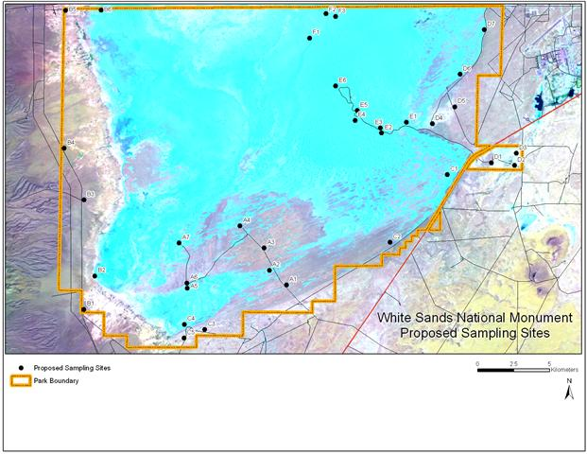

Figure 3.1. White Sands National Monument aerial imagery view including proposed arthropod sampling locations (image from Natural Heritage New Mexico Enterprise Geodatabase 2010).

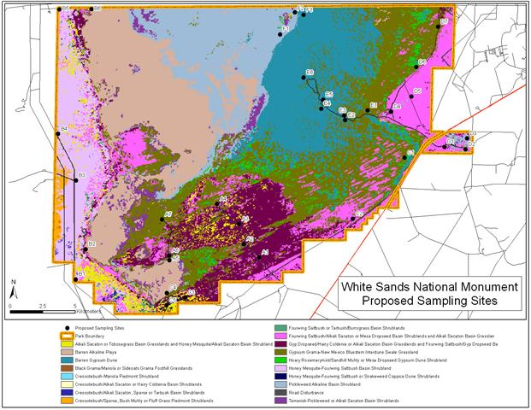

Figure 3.2. White Sands National Monument Level 2 vegetation map including proposed arthropod sampling locations (image from Natural Heritage New Mexico Enterprise Geodatabase 2010 and Muldavin et al. 2000a, 2000b).
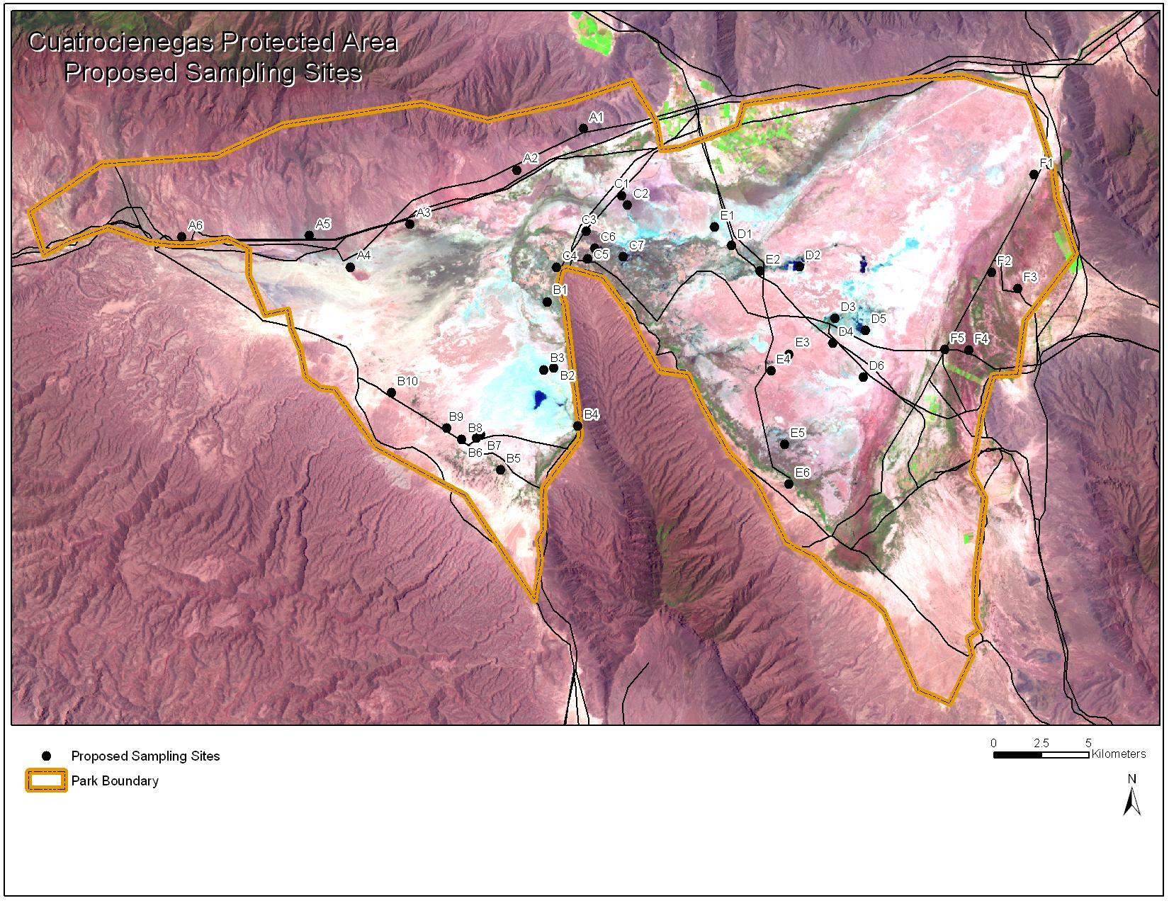

Figure 3.3. Cuatrociengas aerial imagery view including proposed arthropod sampling locations (image prepared from from Cuatrocienegas Protected Area GIS archives, 2010).
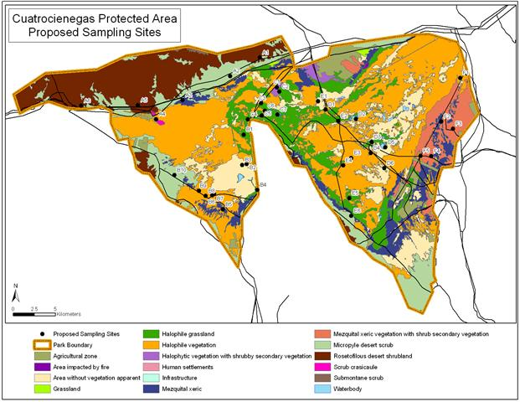

Figure 3.4. Cuatrocienegas vegetation and land use map including proposed arthropod sampling locations (image prepared from Cuatrocienegas Protected Area GIS archives, 2010).
.

3.5.1. White Sands National Monument

White Sands is situated in a desert basin with north-south oriented fault-block mountains on either side. The general elevation of White Sands is 1,200 m (4,000 feet) above sea level. The primary landscapes of White Sands include: gypsum dunes, inter-dune flats, gypsum outcrops on flat or low hilly terrain, and the Lake Lucero ephemeral lake bed and surround shorelines (Figure 3.1). The majority of the monument is covered by gypsum dune and inter-dune flat areas. There are few permanent surface water features only one small permanent surface spring is known at White Sands National Monument.

The principal Level 1 vegetation community types present at White Sands include: gypsum dune land vegetated, gypsum interdune swale grassland, pickleweed shrubland, fourwing saltbush shrubland, vegetated gypsum outcrop, and mesquite shrubland, and the principal Level 2 vegetation community types at White Sands include: alkali sacaton or tobosa grass basin grasslands, gypsum grama-New Mexico bluestem interdune swale grasslands, gyp dropseed/hairy coldenia associations, hoary rosemary mint/sandhill muhly dune shrubland, pickleweed alkaline basin shrubland, and black grama/mariola foothill grasslands (Figure 3.2). Additionally, large areas of White Sands are occupied by barren gypsum dunes and barren alkali flats (Figure 3.2).

Environments or habitats targeted at White Sands for endemic arthropod surveys were prioritized first for those that are unique relative to the surrounding landscapes, and secondarily those that are typical and representative of the monument. Priority habitats for sampling arthropods include: gypsum dunes and interdune swales, gypsum outcrops, surface springs (originating in gypsum substrates), alkali flats and pickleweed shrublands. Other lower priority habitats include saltbush and mesquite shrublands, Similar environments or habitat types also are present at Cuatrociénegas, especially those associated with gypsum, however the dune systems at White Sands are much more extensive than at Cuatrociénegas, and springs and surface waters are much more prevalent at Cuatrociénegas than at White Sands.

34 potential sampling sites were selected at White Sands based on stratification among the different vegetation/habitat types discussed above, road access, and proximity to one another relative to logistics of one-day field trips (Figure 3.4). A list of those sites, the habitats that they represent, their preliminary UTM center point coordinates, and their assignments by day trips is presented in Appendix 2.

3.5.2. Cuatrociénegas Protected Area

Cuatrociénegas protected area also is located in a desert basin surrounded by fault-block mountain ranges on all sides. The general elevation of the Cuatrociénegas basin floor is 700 m (2,400 feet) above sea level. The primary landscapes of Cuatrociénegas include gypsum/salt flats, limited gypsum dunes, and many surface water features including ephemeral playas, permanent springs, ponds, lakes, streams, and canals. Many of the surface water features have been altered by humans such that canals drain most of the springs and ponds. Lower piedmont mountain alluvial slopes also are present, with rocky and gravelly soils. The gypsum dune areas of Cuatrociénegas are much smaller in area than at White Sands, and have been heavily impacted by humans mining the gypsum. In general, environments of Cuatrociénegas have been impacted by humans considerably more than at White Sands.

The principal vegetation community types include halophytic and gypsum adapted associations, mesquite shrublands, rosetofilous/succulent (Agave, Yucca, and cacti) vegetation shrublands, microphyllus desert shrublands, and a variety of human altered vegetation types including irrigated and non-irrigated croplands.

40 potential sampling sites were identified at Cuatrociénegas base on stratification across the different landscape and vegetation types, road access, and proximity for day trips from the town of Cuatrociénegas. A list of those sites, the habitats that they represent, their preliminary UTM center point coordinates, and their assignments by day trips is presented in Appendix 2.

4. 2010 Summer Sampling Trips (Task 3)

A team of three UNM researchers (Wetherill, Hodson and Lightfoot) conducted field sampling at White Sands National Monument from April 23-28, 2010. Sampling was conducted at 20 of the sites proposed in the Sampling Plan. A listing of the sites sampled is presented in Table 1. Copies of field site forms are presented in Appendix 1.

Table 4.1. Locations sampled for arthropods at White Sands National Monument, April, 2010.
______________________________________________________________________
Site East North Landform Description Methods
FS 13S0390277 3627521 clay flat bee traps, UV light trap, general
D3 13S0391944 3627433 gypsum outcrop hill UV light trap, oatmeal trails, general
E6 13S0380412 3632253 gypsum dunes/interdunes pitfall traps, bee traps, general
E2 13S0383841 3628918 gypsum dunes/interdunes pitfall traps, bee traps, general
D2 13S0392689 3626914 clay flat, freshwater spring pitfall traps, bee traps, general
C1 13S0388618 3625470 gypsum dunes/interdunes general
C2 13S0383658 3620513 gypsum outcrop hill, flat general
A4 13S0374394 3622097 gypsum outcrop hill general
A3 13S0376036 3620123 gypsum flat general
A2 13S0386320 3619458 gypsum dunes/interdunes pitfall traps, bee traps, general
A1 13S0378195 3618294 gypsum flat general
B1 13S0363837 3617367 gypsum-playa, lower bajada general
B2 13S0362916 3622696 lower bajada general
B3 13S0362896 3625065 lower bajada general
B4 13S0361691 3628128 lower bajada general
B6 13S0362899 3637637 lower bajada, arroyo general
B5 13S0362165 3638336 gypsum outcrop hill general
F1 13S0379891 3637297 gypsum flat UV light trap, pitfall traps, general
E4 13S0383661 3629348 gypsum dunes/interdunes general
D1 13S0391513 3627265 gypsum outcrop hill pitfall traps, bee traps, general
______________________________________________________________________

In general, conditions were good. Vegetation was green and many wildflowers were present following a relatively wet winter and spring. However, night temperatures were relatively cool during the sampling period, and insect abundance appeared to be low, and many immature arthropods were found, indicating a late spring. A variety of collecting methods were used, including general collecting by hand and aerial nets, sweep net samples of vegetation, pit fall traps and bee traps left in place for 3-4 days, UV light traps and oatmeal bait trails employed for one night at several locations, and dip netting for aquatic arthropods in limited spring and arroyo pool locations.

A team of five UNM researchers (Wetherill, Hodson, Hopkins, Stacy, Lightfoot) conducted field sampling at Cuatrocienegas Protected Area from May 9-17, 2010. We were not able to gain access to a number of the proposed sampling sites on the west side of the basin, including the gypsum dunes, because of a dispute between a non-profit conservation organization Desuvalle A. C. and the federal reserve (Cuatrocienegas Protected Area). Desuvalle owns property on the west side of the basin, including the main portion of the gypsum dunes, and they did not allow us access to those areas. If the dispute is resolved in the future, then we will sample those areas, otherwise, we will focus our efforts on other parts of the basin where we do have access. We did have access to most of the areas that we needed to visit. We were able to sample 12 of the proposed sampling locations as presented in Table 2. Copies of field site forms are presented in Appendix 1.

Table 4.2. Locations sampled for arthropods at Cuatrocienegas Protected Area, May, 2010.
____________________________________________________________________________________
Site East North Landform Description Methods
F4 14R0213816 2985957 gypsum dune oatmeal pitfall, light traps, drift net, general
F1 13R0798110 2966432 basin floor, ponds, streams drift nets, general
F2 14R0202545 2966868 grassland flats pitfalls, bee traps, general
F3 14R0204133 2974674 gypsum outcrop sifting, general
E3 13R0796261 2975716 gypsum flat with sinkholes drift net, general
E2 13R0794343 2979945 saline gypsum marsh UV light traps, general
E4 13R0791660 2979770 basin floor, with large stream UV light traps, drift net, general
D1 13R0793401 2980761 gypsum flat general
B1 13R0782055 2971166 gypsum dune UV light traps, oatmeal lines, general
C7 13R0787794 2980713 basin floor, ponds, streams general
A1 13R0785641 2986564 lower bajada UV light traps, oatmeal lines, general
A6 13R0763839 2981094 desert flat, stock tank general
______________________________________________________________________

Conditions were good for sampling arthropods at Cuatrociengas. Vegetation was green, and spring annual plants were still present, indicating a fairly wet previous spring season. Temperatures were hot to warm during the period. A variety of collecting methods were used, including general collecting by hand and aerial nets, sweep net samples of vegetation, pitfall traps and bee traps left in place for 3-4 days, UV light traps and oatmeal bait trails, employed for one night at several locations, and dip netting for aquatic arthropods in a number of pond and stream locations.

Collection samples from both the White Sands and Cuatrocienegas trips were brought back to the Museum of Southwestern Biology at UNM, and curation (museum preparation) of those specimens is currently underway. Only specimens representing target taxa identified in the Sampling Plan for this project are being curated. Most specimens are being mounted on pins, and arachnids and other soft-bodied specimens are being preserved in ethanol. All specimens are being labeled with specimen collection locality labels. Several hundred specimens representing target taxa groups were collected from the first trips. We have already identified several taxa from White Sands National Monument and several more from Cuatrocienegas as likely undesecribed species. These taxa include grasshoppers, katydids, robber flies, and some beetles. Additional field trips are being conducted over the mid-late summer. A team of researchers is currently now in Cuatrocienegas sampling from July 17-25. Another team will sample at White Sands National Monument from July 31-August 7. We will continue to curate specimens in the lab through the summer and fall, and begin sending specimens to taxonomic experts this fall. An inventory listing of all specimens will be produced over the next year for the final report in 2012.

A team of five UNM researchers (Miller, Smith, Stacy, Tafoya, Wetherill, plus Avila) conducted field sampling at Cuatrocienegas Protected Area from July 18-July 26. They were able to sample 9 sites at Cuatrocienegas, 5 new (C4,A4,B2,A2,C1) and 4 revisits to previously sampled sites. A listing of sites sampled is presented in Table 1. They were still denied access to the main portion of the gypsum dunes owned by Desuvalle A. C., but did gain access to some adjacent dune habitats. Copies of field site forms are presented in Appendix 1.

Table 4.3. Locations sampled for arthropods at Cuatrocienegas Protected Area, July, 2010. * = Newly sampled sites in July, 2010.
____________________________________________________________________________________
Site East North Landform Description Methods
C4* 13R0786187 2979606 lower bajada general, light traps
A4* -102.278545 26920786 basin floor, stock tank, pasture general
B2* 13R0780097 2971756 gypsum dunes, vegetated general
F3 14R0204133 2974674 gypsum outcrop general
E3 13R0796261 2975716 gypsum flat with sinkholes general
A2 * 13R0785850 2986315 posa with cottonwood trees general/aquatic
C1* -102.086685 26888704 posa with mesquite general/aquatic
D1 13R0793401 2980761 gypsum flat general
C7 13R0787794 2980713 basin floor, ponds, streams general
______________________________________________________________________

Conditions were good for sampling arthropods at Cuatrociengas, heavy summer rains occurred in the area prior to the trip. A variety of collecting methods were used, including general collecting by hand and aerial nets, sweep net samples of vegetation, UV light traps employed for one night at one location, and dip netting for aquatic arthropods in a number of pond and stream locations. A team of four UNM researchers (Wetherill, Hodson, Schweettmann, Homziak) conducted field sampling at White Sands National Monument from August 2-8, 2010. Sampling was conducted at 10 of the sites proposed in the Sampling Plan, 2 new sites (A6, B7) were sampled, and the other 8 were re-visits to sites sampled earlier in the summer. A listing of the sites sampled is presented in Table 2. Copies of field site forms are presented in Appendix 1.

Table 4.4. Locations sampled for arthropods at White Sands National Monument, August, 2010. *= Newly sampled sites in July, 2010.

______________________________________________________________________
Site East North Landform Description Methods
A6* 13S0369813 3621263 gypsum dunes/interdunes general
B7* 13S0364126 3615503 lower bajada, stock tank general
E6 13S0380412 3632253 gypsum dunes/interdunes pitfall traps, bee traps, general
E2 13S0383841 3628918 gypsum dunes/interdune flats pitfall traps, bee traps, general
D2 13S0392689 3626914 clay flat, freshwater spring pitfall traps, bee traps, general
C1 13S0388618 3625470 gypsum dunes/interdunes general
C2 13S0383658 3620513 gypsum outcrop hill, flat general
A2 13S0386320 3619458 gypsum dunes/interdunes pitfall traps, bee traps, general
F1 13S0379891 3637297 gypsum flat UV light trap, pitfall traps, general
D1 13S0391513 3627265 gypsum outcrop hill pitfall traps, bee traps, general
______________________________________________________________________

In general, conditions were good. Vegetation was green and many wildflowers were present following relatively good mid-summer rains. A variety of collecting methods were used, including general collecting by hand and aerial nets, sweep net samples of vegetation, pitfall traps and bee traps left in place for 3-4 days, UV and mercury vapor (MV) light traps and oatmeal bait trails employed for one night at several locations, and dip netting for aquatic arthropods in limited spring and playa pool locations.

Collection samples from both the White Sands and Cuatrocienegas trips were brought back to the Museum of Southwestern Biology at UNM, and curation (museum preparation) of those specimens is currently underway. Only specimens representing target taxa identified in the Sampling Plan for this project are being curated. Most specimens are being mounted on pins, and arachnids and other soft-bodied specimens are being preserved in ethanol. All specimens are being labeled with specimen collection locality labels. Several hundred specimens representing target taxa groups were collected from these late summer trips. We have already identified several taxa from White Sands National Monument and several more from Cuatrocienegas as likely undesecribed species. These taxa include grasshoppers, katydids, robber flies, and some beetles. We will continue to curate specimens in the lab through the summer and fall, and begin sending specimens to taxonomic experts this fall. An inventory listing of all specimens will be produced over the next year for the final report in 2012.

5. 2010 Laboratory Work (Task 4)
5.1 Field Sample Sorting and Curation of Specimens
Field collected samples of arthropod specimens are generally placed in 50 ml or 15 ml Falcon Tube plastic vials containing 70% or 95% ethanol. Each sample vial may contain one to many arthropod specimens. Some specimens such as butterflies and moths, and grasshoppers must be preserved dry. Those specimens are collected into cyanide kill jars in the field, and then transferred to glassine envelopes or cellucotton layering boxes and allowed to dry quickly to preserve colors. A field locality label is included with each sample containing information on the location, including GPS coordinates, habitat, any host information, collection method, date, and person(s) who collected the sample.
All of those samples are then transported to the laboratory at the University of New Mexico. Some specimens that were collected into vials containing ethanol have bodies composed of soft exoskeletons, and those specimens must remain in ethanol. Those specimens that must remain preserved in ethanol are transferred to glass storage vials containing clean ethanol. All other specimens that have hard exoskeletons are then placed on paper towels in trays, allowed to dry, and are then placed on insect specimen pins. Specimens that were stored dry in the field such as butterflies and moths, are removed from their storage container, and placed in an insect relaxing chamber (a humid air-tight container) where they absorb moisture and the soft tissues become pliable. Those specimens are then pinned and wings spread using butterfly spreading boards, and allowed to dry.
The label information from each collection sample is then used to type specimen locality labels that are attached to each specimen from that sample. Dry pinned specimen labels are typed in a MicroSoft Word document with a very small font size (3-5 point) and printed on a laser-jet printer on archival cardstock insect specimen label paper. Each label is then cut, and placed with each appropriate specimen. Specimens that are stored in ethanol are provided with labels prepared in a similar way, but printed on a heat imprint printer onto white plastic sheets, and those indelible labels are then placed in the vial with each specimen.
Once all of the specimens have been removed from samples, and prepared and labeled (curated), they are then organized taxonomically or phylogenetically, by Subclass, Order, Family, Genus, and Species. In most cases, we are able to identify all specimens of our target groups to the Family level. Dry pinned specimens are stored and organized in foam-bottom pinning trays within wood drawers with glass tops, and the drawers are organized in steel cabinets. Specimens stored in glass vials with ethanol are organized taxonomically in vial racks. Those specimens are then ready to ship to taxonomic experts for identification.

Inventory of Target Arthropod Taxa Collected in 2010
A total of 3,331 specimens of target taxa were collected and curated during the 2010 field season, and a tabulation by taxonomic group is presented in Table 5.1. A total of 1,638 specimens were collected and curated from White Sands, and at total of 1,693 specimens were collected and curated from Cuatrocienegas.

Table 5.1. Specimen counts of target arthropod taxa collected during the 2010 field season.

Taxonomic Group
Phylum Arthropoda Number of Specimens (not taxa)
Class Hexapoda
Order Family Priority W.S. C.C. Expert
Odonata Aeshnidae 1 0 2 Miller
Odonata Coenagrionidae 1 4 44 Miller
Odonata Cortiliidae 1 7 20 Miller
Odonata Gomphidae 1 0 11 Miller
Odonata Lestidae 1 0 0 Miller
Odonata Macromiidae 1 0 0 Miller
Odonata Libellulidae 1 9 58 Miller
Orthoptera Acrididae 1 8 52 Lightfoot
Orthoptera Gryllidae 1 8 3 Lightfoot
Orthoptera Raphidophoridae 1 3 0 Lightfoot
Orthoptera Romalidae 1 0 1 Lightfoot
Orthoptera Stenopematidae 1 0 0 Lightfoot
Orthoptera Tetrigidae 1 0 0 Lightfoot
Orthoptera Tettigoniidae 1 1 2 Lightfoot
Orthoptera Tridactylidae 1 0 0 Lightfoot
Phasmatodea all families 2 19 5 Lightfoot
Dictyoptera Blattodea 2 4 8 Hopkins
Dictyoptera Mantodea 2 4 2 Lightfoot
Dermaptera all families 3 1 2 Lightfoot
Heteroptera Alydidae 3 3 0 Bundy
Heteroptera Anthocoridae 3 0 1 Bundy
Heteroptera Acanthosomatidae 2 0 0 Bundy
Heteroptera Belostomatidae 2 0 10 Miller
Heteroptera Coreidae 2 1 2 Bundy
Heteroptera Corixidae 2 21 36 Miller
Heteroptera Cydnidae 3 19 0 Bundy
Heteroptera Gerridae 2 0 1 Miller
Heteroptera Hydrometridae 3 0 1 Bundy
Heteroptera Lygaeidae 3 55 41 Bundy
Heteroptera Mesoveliidae 3 0 1 Bundy
Heteroptera Nabidae 3 3 1 Bundy

Order Family Priority W.S. C.C. Expert
Heteroptera Naucoridae 3 0 10 Bundy
Heteroptera Notonectidae 2 11 10 Miller
Heteroptera Pentatomidae 1 43 24 Bundy
Heteroptera Reduviidae 2 15 6 Bundy
Heteroptera Rhopalidae 3 16 15 Bundy
Heteroptera Saldidae 3 3 22 Bundy
Heteroptera Scutelleridae 2 0 1 Bundy
Heteroptera Thyreocoridae 1 4 1 Bundy
Heteroptera Tingidae 3 0 3 Bundy
Heteroptera Veliidae 3 0 17 Bundy
Coleoptera Carabidae 1 176 169 Ball
Coleoptera Dytiscidae 1 57 65 Miller
Coleoptera Elateridae 1 43 38 Johnson
Coleoptera Glaresidae 1 0 0 Paulsen
Coleoptera Gyrinidae 1 0 1 Miller
Coleoptera Haliplidae 1 0 0 Miller
Coleoptera Hydrophilidae 1 66 35 Miller
Coleoptera Lucanidae 1 0 0 Paulsen
Coleoptera Meloidae 2 24 80 Bundy
Coleoptera Noteridae 1 0 0 Miller
Coleoptera Ochodaeidae 1 0 0 Paulsen
Coleoptera Scarabaeidae 1 54 111 Ratcliffe/Cave
Coleoptera Tenebrionidae 1 144 68 Triplehorn
Lepidoptera Gelechiidae 1 4 0 Metzler
Lepidoptera Incurvaridae 1 2 0 Metzler
Lepidoptera Noctuidae 1 172 0 Metzler
Diptera Asilidae 1 49 21 Forbes
Diptera Culicidae 1 0 0 Richman
Diptera Ephydridae 2 0 0 Mathis
Hymenoptera Andrenidae 2 74 79 Wetherill/Griswold
Hymenoptera Apidae 2 69 90 Wetherill/Griswold
Hymenoptera Bradynobaenidae 1 7 4 Pitts
Hymenoptera Colletidae 2 3 2 Wetherill/Griswold
Hymenoptera Halictidae 2 112 82 Wetherill/Griswold
Hymenoptera Megachilidae 1 30 65 Griswold
Hymenoptera Mutillidae 1 18 77 Pitts

Order Family Priority W.S. C.C. Expert
Hymenoptera Pompilidae 1 6 3 Pitts
Hymenoptera Trichogrammatidae 1 0 0 Avila
Embiidina webspinners 1 0 0 Miller
Class Arachnida Spiders and scorpions
Aranea Agelenidae 3 0 2 Brantley/Richman
Aranea Araneidae 1 54 35 Richman
Aranea Dictynidae 1 10 15 Brantley
Aranea Diguetidae 3 4 4 Brantley/Richman
Aranea Dipluridae 3 1 0 Brantley/Richman
Aranea Filistatidae 3 1 3 Brantley/Richman
Aranea Gnaphosidae 1 23 6 Brantley
Aranea Linyphiidae 1 7 7 Brantley
Aranea Lycosidae 3 22 63 Brantley/Richman
Aranea Mimetidae 3 2 1 Brantley/Richman
Aranea Miturgidae 2 1 2 Brantley/Richman
Aranea Oxyopidae 3 1 1 Brantley/Richman
Aranea Philodromidae 3 17 5 Brantley/Richman
Aranea Pisauridae 3 0 10 Brantley/Richman
Aranea Pholcidae 3 9 0 Brantley/Richman
Aranea Salticidae 1 32 32 Richman
Aranea Scytodidae 3 0 2 Brantley/Richman
Aranea Segestriidae 3 0 2 Brantley/Richman
Aranea Sicariidae 3 1 7 Brantley/Richman
Aranea Tetragnathidae 3 5 28 Brantley/Richman
Aranea Theraphosidae 3 1 1 Brantley/Richman
Aranea Theridiidae 3 8 2 Brantley/Richman
Aranea Thomisidae 1 42 29 Brantley
Aranea Uloboridae 3 0 2 Brantley/Richman
Opilionids all families 2 0 0 Brantley
Scorpiones scorpions 1 4 14 Sissom
Solifugae wind scorpions 1 10 9 Cushing
Class Diplopoda
Millipedes 2 9 8 Medrano
Class Chilopoda
Centipedes 2 2 0 Medrano
SubTotals 1638 1693 Grand Total 3331

We are now in the process of sending target taxa arthropod specimens to taxonomic experts listed in tables 3.1 and 5.1. Since all of those experts are volunteering their time to provide us with identifications and determinations of new species, we are not able to control how long it will take to receive determinations on those specimens. However, when those experts were originally contacted, all understood the time frame of this project and agreed to at least provide determinations of new species within a year or so. As we receive determinations, we will report on new taxa identified from this project.
To date, we are aware of 9 taxa that are undescribed new species from both parks resulting from our 2010 field sampling. A listing of those new species and the experts who have determined them to be new, along with which park they are from is presented in Table 5.2.

Table 5.2. Preliminary listing of undescribed arthropod species found during 2010 at White Sands National Monument and Cuatrociénegas Protected Area. Higher classification follows Triplehorn and Johnson (2005).

White Sands National Monument

Class Order Family Genus Identifier
Hexapoda Orthoptera Acrididae Cibolacris D.C. Lightfoot
Hexapoda Orthoptera Acrididae Trimerotropis D.C. Lightfoot (same as Cuatrocienegas)
Hexapoda Diptera Asilidae Efferia G.S. Forbes

Cuatrociénegas Protected Area

Class Order Family Genus Identifier
Hexapoda Dictyoptera Polyphagidae Arenivaga H. Hopkins
Hexapoda Orthoptera Acrididae Anconia D. Lightfoot
Hexapoda Orthoptera Acrididae Trimerotropis D. Lightfoot (same as White Sands)
Hexapoda Orthoptera Acrididae Phoetaliotes D. Lightfoot
Hexapoda Orthoptera Tettigoniidae Eremopedes D. Lightfoot
Hexapoda Orthoptera Tettigoniidae Pediodectes D. Lightfoot
Hexapoda Coleoptera Tenebrionidae Stenomorpha A. Smith

5.3 Plans for 2011
We will continue sampling preselected and new locations at both parks during 2011 as we did in 2010. An early summer (May, June) and a late summer (August, September) trip are planned for both parks. Quarterly progress reports will be submitted at the end of March, June, and September.

Literature Cited

Commission for Environmental Cooperation. 1997. Ecological regions of North America: toward a common perspective. Commission for Environmental Cooperation, Montreal, Quebec, Canada. 71pp.

Merritt, R.W., K.W. Cummins and M.B.Berg, editors. 2008. An introduction to the aquatic insects of North America. 4th edition. Kendall-Hunt Publishing Co., Dubuque, IA, USA.

Muldavin, E., Y. Chauvin, G. Harper and P. Neville. 2000a. The vegetation of White Sands Missile Range, New Mexico. Volume one: handbook of vegetation communities. Cooperative agreement no. 14-16-002-91-233. Unpublished, Natural Heritage New Mexico, Albuquerque, NM. 236 p.

Muldavin, E., G. Harper, P. Neville and Y. Chauvin. 2000b. The vegetation of White Sands Missile Range, New Mexico. Volume two: vegetation map. Cooperative agreement no. 14-16-002-91-233. Unpublished, Natural Heritage New Mexico, Albuquerque, NM. 97 p.

Southwood, T.R.E. and P.A. Henderson. 2000. Ecological Methods. 3rd Edition. Blackwell Science Ltd. Publishers, London, UK.

Triplehorn, C. A. and N.F. Johnson. 2005. Borror and DeLong’s introduction to the study of insects. 7th edition. Brooks/Cole, Thompson Learning, Inc. Belmont, CA, USA.

Weissman, D.B. and D.C. Lightfoot. 2008. Techniques for the field capture and captive rearing of Jerusalem crickets. Sonoran Arthropod Studies Institute. 2007 Invertebrates in Captivity Conference Proceedings, pages 22-29. Tucson, AZ, USA.

