GREATER SAGE-GROUSE INVENTORY AT DINOSAUR NATIONAL MONUMENT

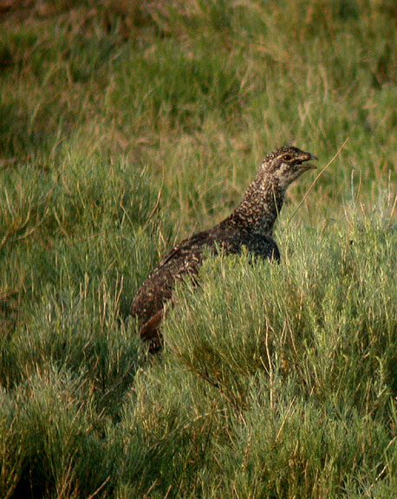

December 2010



Rocky Mountain Bird Observatory

Mission: To conserve birds and their habitats
Vision: Native bird populations are sustained in healthy ecosystems
Core Values: (Our goals for achieving our mission)
- Science provides the foundation for effective bird conservation.
- Education is critical to the success of bird conservation.
- Stewardship of birds and their habitats is a shared responsibility.
RMBO accomplishes its mission by:
Monitoring long-term bird population trends to provide a scientific foundation for conservation action.
Researching bird ecology and population response to anthropogenic and natural processes to evaluate and adjust management and conservation strategies using the best available science.
Educating people of all ages through active, experiential programs that create an awareness and appreciation for birds.
Fostering good stewardship on private and public lands through voluntary, cooperative partnerships that create win-win situations for wildlife and people.

Partnering with state and federal natural resource agencies, private citizens, schools, universities, and other non-governmental organizations to build synergy and consensus for bird conservation.
Sharing the latest information on bird populations, land management and conservation practices to create informed publics.
Delivering bird conservation at biologically relevant scales by working across political and jurisdictional boundaries in western North America.

Suggested Citation:
Beason, Jason P. 2010. Greater Sage-Grouse Inventory at Dinosaur National Monument. Tech Rep. SC-GRSG-NPS-10. Rocky Mountain Bird Observatory, Brighton, Colorado, 20 pp.

Cover Photo:
Male Greater Sage-Grouse by Bill Schmoker. Used with permission.

Contact Information:
Jason Beason jason.beason@rmbo.org
Rocky Mountain Bird Observatory
39405 Lund Road
Paonia, CO 81428
970.310.5117

EXECUTIVE SUMMARY

Rocky Mountain Bird Observatory conducted surveys for Greater Sage-Grouse and their sign 18 May through 9 August, 2010. The survey was accomplished by conducting area searches in 63 randomly chosen grids (46 primary and 17 secondary) of sagebrush habitat in Dinosaur National Monument of northwest Colorado and northeast Utah. Greater Sage-Grouse were detected twice during our surveys in chosen survey grids. Incidental detections of Greater Sage-Grouse were recorded at seven locations outside of chosen survey grids. Greater Sage-Grouse sign (fecal pellets or klockers) was located in Dinosaur National Monument at 115 locations in or near the chosen survey sites. A secondary goal of this project was to identify areas in Dinosaur National Monument occupied by other sage obligate bird species. We recorded Sage Thrasher in two survey grids, Brewer’s Sparrow in 26 survey grids, and Sage Sparrow in four survey grids.

ACKNOWLEDGEMENTS

The National Park Service funded this project through a cooperative agreement with the Rocky Mountain Bird Observatory. This report fulfills requirements in RMBO’s contracts with the National Park Service (SC-GRSG-NPS-10).

I would like to thank Cindy Heyd, of the National Park Service, for assistance before and during the project. Rob Sparks, Geographic Information Specialist for the Rocky Mountain Bird Observatory, assisted with study design and created maps of the survey grids. I am extremely grateful to Brian Long and Rebecca Rosenbaum for conducting surveys sometimes in difficult conditions. Much of the success of this project is due to their hard work. I would also like to thank RMBO staff for careful review of this report.

TABLE OF CONTENTS

EXECUTIVE SUMMARY ii
ACKNOWLEDGEMENTS iii
TABLE OF CONTENTS iv
INTRODUCTION 1
METHODS 2
Site Selection and Protocol 2
Figure 1. Example of 1 Km² grid design for Greater Sage-Grouse survey in Dinosaur National Monument. 3
RESULTS 5
Figure 2. Primary and secondary grids where surveys were conducted. 5
Figure 3. Locations of selected and surveyed primary grids in DNM. 6
Figure 4. Locations of selected and surveyed secondary grids in DNM. 6
Figure 5. Locations of GRSG detections in and near DNM, 2010. 7
Figure 6. Locations of GRSG droppings in and near DNM, 2010. 8
Figure 7. Locations of GRSG klockers in DNM, 2010. 8
Figure 8. Survey grids with detections of Sage Thrasher in DNM, 2010. 9
Figure 9. Survey grids with detections of Sage Sparrow in DNM, 2010. 10
Figure 10. Survey grids with detections of Brewer’s Sparrow in DNM, 2010. 10
DISCUSSION AND RECOMMENDATIONS 11
LITERATURE CITED 12
Appendix A. Center Point UTMs¹ for primary (P) and secondary grids (S) selected for surveys in Dinosaur National Monument, whether or not grid was surveyed, and number of visits, 2010. 13
Appendix B. Locations of Greater Sage Grouse detections in and near Dinosaur National Monument, 2010¹. 16
Appendix C. Locations of Greater Sage Grouse fecal pellets and klockers in or near Dinosaur National Monument, 2010¹. 17
Appendix D. Center point UTMs for survey grids with detections of Sage Thrasher, Brewer’s Sparrow, and Sage Sparrow in Dinosaur National Monument, 2010¹. 20

INTRODUCTION

Greater Sage-Grouse (GRSG) populations are declining throughout their range in the western United States. A recent decision by the U.S. Department of Interior defined the current status of the GRSG as warranted for listing under the Endangered Species Act, but precluded because of limited resources and other listing priorities. In the Colorado Wildlife Action Plan, GRSG is listed as a Species of Greatest Conservation Need and also was chosen by the science forum as a species of most concern for the state (Colorado’s Comprehensive Wildlife Conservation Strategy 2006). GRSG currently occupy only 56% of their historical range in the western United States (Schroeder et al. 2004). Gunnison Sage-Grouse have lost more than 90% of their historical habitat (Schroeder et al. 2004) and in 2006 the species was listed by the Audubon Society as one of the ten most endangered birds in North America. Conserving GRSG, and the sagebrush ecosystem they depend upon, will require cooperation between land management agencies and private landowners throughout their range.

Dinosaur National Monument (DNM) encompasses 210,278 acres in northwest Colorado and northeast Utah. The landscape in DNM is composed of many habitats, with big sagebrush (Artemesia tridentata) a dominant habitat type. The National Park Service (NPS) has conducted habitat improvement projects to enhance the sagebrush habitat in DNM; however, a limited number of wildlife surveys have occurred to determine the impacts of these projects on wildlife such as GRSG. The goal of this project was to determine which areas in DNM are being utilized by GRSG by mapping location of detections and sign. A secondary goal of this project was to map areas occupied by Sage Thrasher, Sage Sparrow, and Brewer’s Sparrow to determine which sagebrush stands are occupied by these sage obligate species. These three species were chosen because they are dependent on sagebrush habitat. DNM biologists will be able to use this information to investigate the effects of past habitat projects and decide the best way to proceed with future projects.
METHODS

Site Selection and Protocol

A 1km² grid was placed over DNM to define the sampling unit. To select survey sites, RMBO used a NPS Geographic Information System (GIS) landcover layer to identify priority sagebrush stands. From these, we created primary and secondary strata. The primary stratum was defined as having 60 percent or greater of the grid comprised of sagebrush, while the secondary stratum was comprised of 40 to 59 percent sagebrush. We selected 51primary stratum samples and 40 secondary stratum samples using a spatially balanced sampling algorithm in program R (R Development Core Team 2010). The 1km² grid was then divided into four 500 meter grids to allow for a robust occupancy design. The primary grids were prioritized because Greater Sage-Grouse are more likely to be located in areas with higher percentages of sagebrush cover. In each of the samples, four area searches were conducted, one per 500 meter grid (Figure 1). The area searches were conducted for 30 minutes in each 500 meter grid. If observers felt that a selected grid was not quality habitat for Sage Grouse after the first visit, the grid was dropped from the survey. In several instances grids were dropped because of access difficulties. To navigate to each grid observers used hand held GPS units, maintaining a distance of at least 250 meters from the center while traversing the grid. We attempted to survey each grid three times during the course of the season. The second visit to each grid did not take place until each grid was completed in order to maximize time between visits. Each grid was then surveyed twice before third visits were initiated.

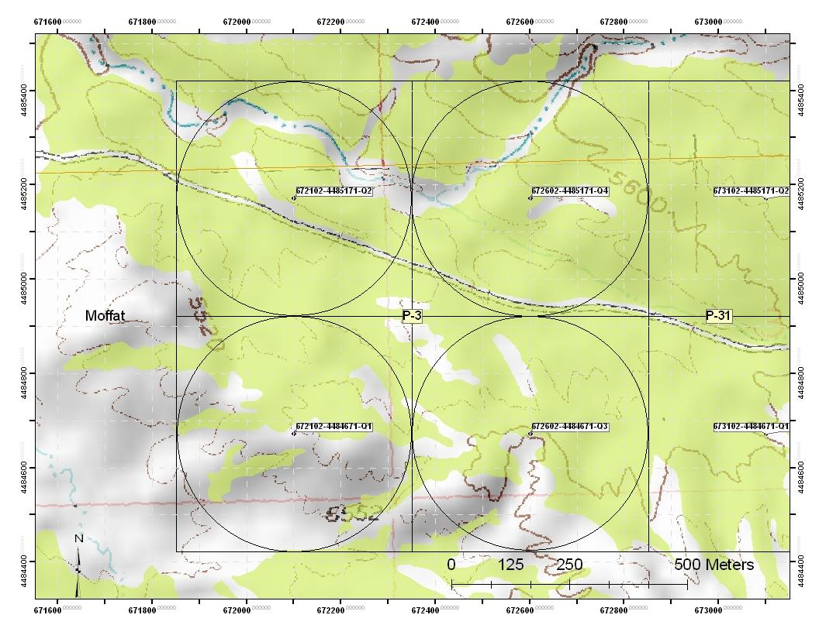

Figure 1. Example of 1 Km² grid design for Greater Sage-Grouse survey in Dinosaur National Monument.

The fraction of sampling units in a landscape where a target species is present (occupancy) is an extensively used concept in ecology. Yet in many applications the species will not always be detected in a sampling unit even when present, resulting in biased estimates of occupancy. Given that sampling units are surveyed repeatedly within a relatively short time frame, a number of similar methods have now been developed to provide unbiased occupancy estimates (Mackenzie and Royle 2005). Mackenzie’s standard occupancy model uses likelihood methods to estimate proportion of sites occupied by a species of interest and probabilities of occupancy in a patch or grid can be modeled as a function of patch characteristics such as habitat. Replication of site visits is used to estimate a species’ detection probability, the probability that a species will be detected given that the species inhabits the area of interest (Mackenzie et al. 2006). We anticipated that the number of GRSG detections would be low and decided that a total of three visits to each grid would be required.

As observers surveyed selected grids the ultimate goal was to detect GRGS; however, locations of all GRSG sign (droppings, cecal casts, and klockers) were recorded when encountered. Differentiating GRSG droppings from Dusky Grouse droppings was done by crushing fecal pellets to determine if they consisted of sage. If a sage odor was not detected the dropping was assumed to belong to Dusky Grouse. The same applied to klockers; they were broken apart and if no sage odor was detected it was assumed to be a Dusky Grouse klocker.
To determine which areas were occupied by other sagebrush obligate bird species, RMBO recorded their presence during each half-hour area search. The species were recorded as present or absent if seen or heard in each 1km² grid.

Surveys were conducted by two RMBO seasonal staff dedicated specifically to this project. Both field workers had previous experience conducing bird surveys when they were hired for this project. A training session was held 17 and 18 May to ensure that surveyors were able to identify GRSG sign, GRSG vocalizations, and to ensure that field surveyors had a complete understanding of the survey protocol. Surveyors were also made familiar with vocalizations of Sage Thrasher, Brewer’s Sparrow, and Sage Sparrow at the training session.

RESULTS

RMBO surveyed 63 grids in DNM between 18 May and 9 August, 2010 (Figure 2; Appendix A). A total of 46 primary survey grids (Figure 3) and 17 secondary survey grids (Figure 4) were surveyed.
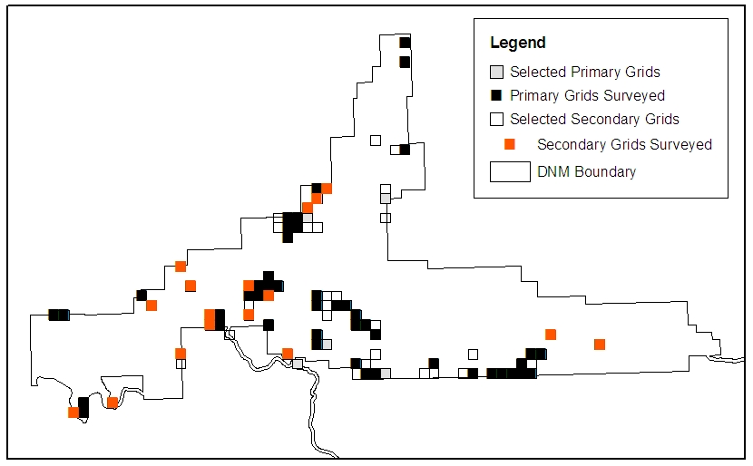

Figure 2. Primary and secondary grids where surveys were conducted.

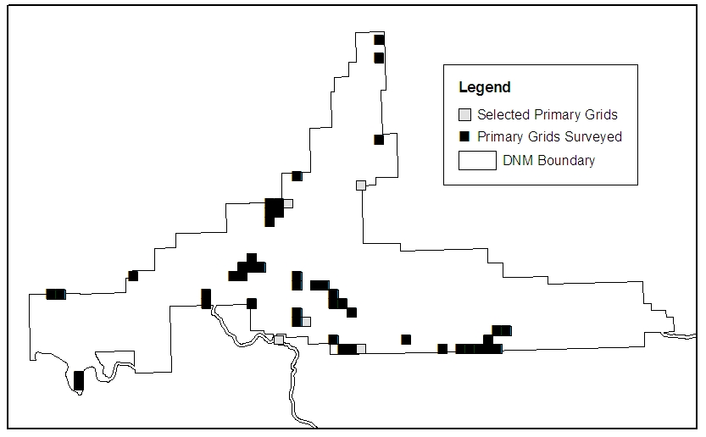

Figure 3. Locations of selected and surveyed primary grids in DNM.

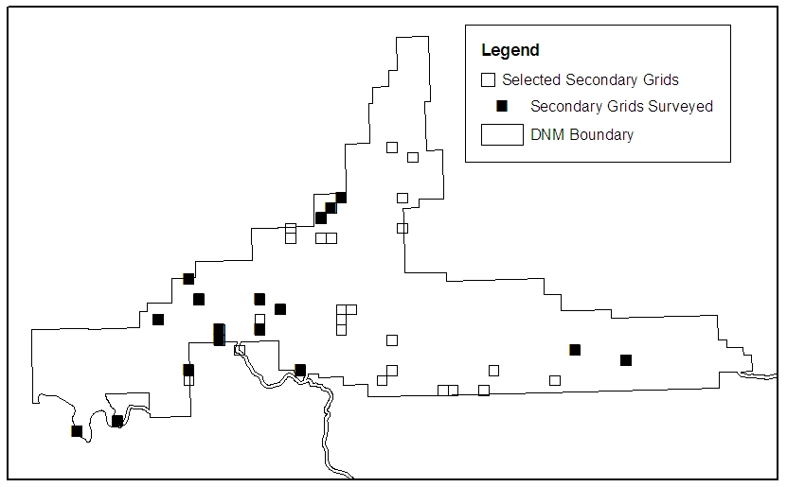

Figure 4. Locations of selected and surveyed secondary grids in DNM.

GRSG were detected in two survey grids and incidental detections were recorded at six locations in Dinosaur National Monument (Figure 5; Appendix B). The survey grids where GRSG were detected were the grids labeled P14 and P22 in the south-central section of DNM. Four of the incidental detections occurred along the Harpers Corner Road in DNM. One incidental detection consisted of an adult hen GRSG with brood found dead along US Highway 40 west of Dinosaur, Colorado in Utah on 19 July. Another hen with brood was detected on 1 August along the Harpers Corner Road.

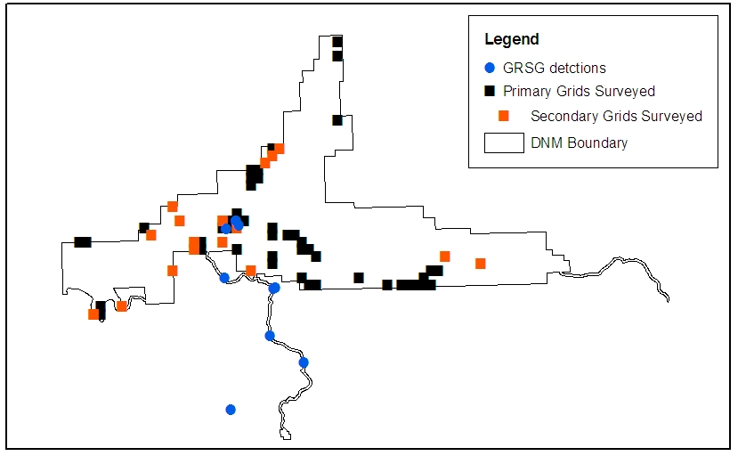

Figure 5. Locations of GRSG detections in and near DNM, 2010.

GRSG droppings were found and collected at 104 locations in 22 of the chosen survey grids (Figure 6; Appendix C). All of these droppings were found in primary grids except 14 were discovered in three secondary survey grids and five droppings were discovered outside of survey grids and included in this report. GRSG klockers were found at six locations in three primary survey grids (Figure 7; Appendix C). Klockers are considered physiological evidence of breeding because they are deposited by incubating or brooding females only. They are the result of female grouse storing fecal matter while spending long periods of time on the nest.

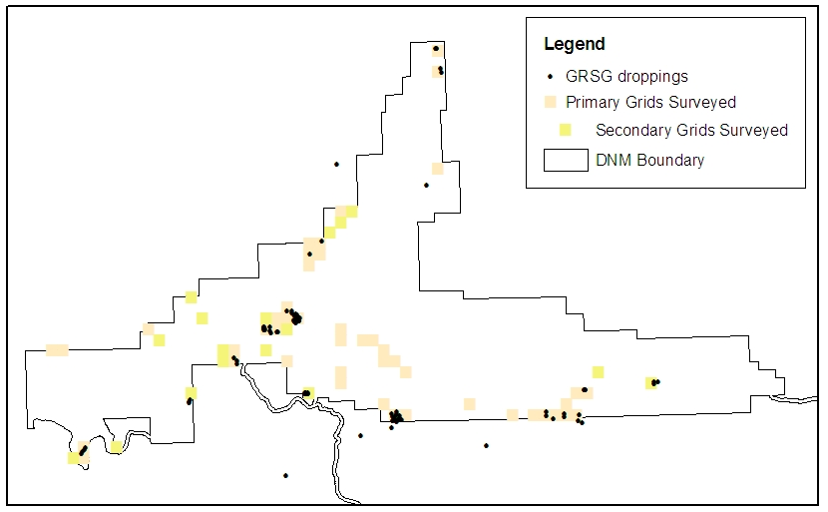

Figure 6. Locations of GRSG droppings in and near DNM, 2010.

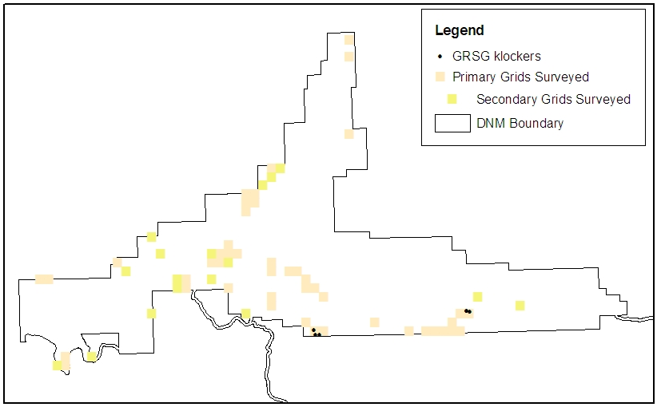

Figure 7. Locations of GRSG klockers in DNM, 2010.

Other targeted sage obligate bird species (Sage Thrasher, Brewer’s Sparrow, and Sage Sparrow) were discovered in 27 primary survey grids and one secondary survey grid (Appendix D). Sage Thrashers were detected in four primary survey grids (Figure 8) and Sage Sparrows were found in four primary survey grids (Figure 9). Sage Thrashers or Sage Sparrows were not located in secondary grids. We found Brewer’s Sparrows in 25 primary survey grids and one secondary survey grid (Figure 10).

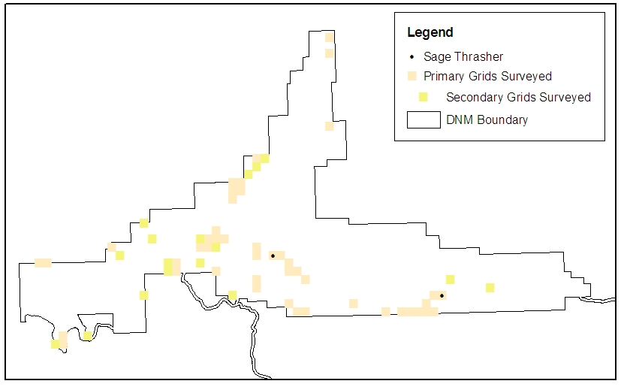

Figure 8. Survey grids with detections of Sage Thrasher in DNM, 2010.

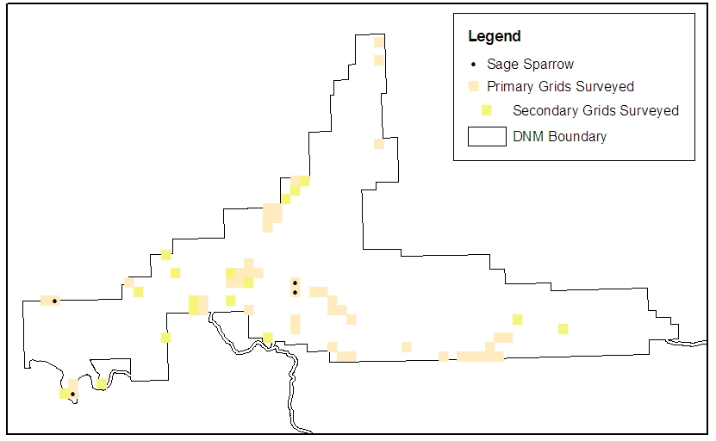

Figure 9. Survey grids with detections of Sage Sparrow in DNM, 2010.

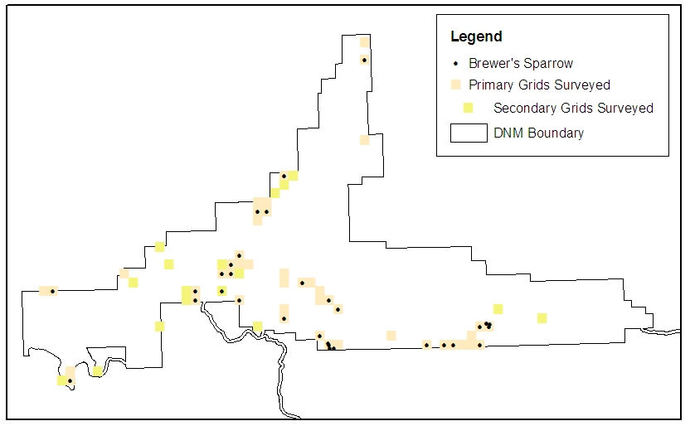

Figure 10. Survey grids with detections of Brewer’s Sparrow in DNM, 2010.

DISCUSSION AND RECOMMENDATIONS

The NPS has expressed interest in continuing surveys for GRSG in DNM. If surveys continue we recommend sampling sage stands in the monument not surveyed in 2010. We recommend beginning surveys earlier in the year, possibly as early as late-March when lekking behavior could begin. Locating and protecting lek sites in DNM is very important for GRSG conservation in DNM. We attempted to visit each survey grid three times in order to determine a population size for GRSG in DNM. We originally believed that we would be able to detect sufficient numbers of GRSG to accomplish this. However, surveying each grid three times resulted in not being able to visit every sagebrush stand that exists in DNM. We believe that future survey efforts should involve just one visit to selected survey grids in order to survey more area. Most likely, detecting sufficient numbers of GRSG to estimate a population size will not be possible unless surveys take place during the lekking period. Also, more data could be gathered for other sage obligate species if more area is covered in one season. We would also like to recommend that a point-count survey take place before each area search to provide better information for other bird species occupying sagebrush habitat in DNM.

We recommend that the Colorado Division of Wildlife be contacted to explore the possibility of a GRSG telemetry study. Even though it is an expensive endeavor, tracking GRSG using telemetry methods would provide detailed location information and provide insight into which areas are occupied during specific times of the year.

Some populations of GRSG migrate between summer and winter ranges and it is possible that many of the GRSG that occupy DNM do not remain in the monument year-round (Schroeder et al. 1999). In order to conserve GRSG in DNM the NPS will need to manage GRSG cooperatively with the Bureau of Land Management and the adjacent private landowners. RMBO Stewardship Division staff and Natural Resource Conservation Service biologists are available to conduct site visits to assist landowners who would like to learn about conservation programs available for GRSG on private property.

LITERATURE CITED

Colorado’s Comprehensive Wildlife Conservation Strategy. 2006. Colorado Division of Wildlife, 6060 Broadway, Denver, Colorado 80216. http://wildlife.state.co.us/NR/rdonlyres/D26A4806-8776-4460-831E- AA654EC7DDED/0/CWCS_FinalReport2006.pdf

Mackenzie, D. L. and J. A. Royle. 2005. Designing occupancy studies: general advice and allocating survey effort. Journal of Applied Ecology 42:1105-1114.

Mackenzie, D. L., J. D., Nichols, J. A. Royle, K. H. Pollock, L .L. Bailey, and J. E. Hines. 2006. Occupancy Estimation and Modeling. Elsevier-Academic, San Diego, California.
R Development Core Team. 2010. R: A language and environment for statistical computing, reference index version 2.10.1. R Foundation for Statistical Computing, Vienna, Austria. ISBN 3-900051-07-0, URL http://www.R-project.org.
Schroeder, M.A., J.R. Young, and C.E. Braun. 1999. Sage Grouse (Centrocercus urophasianus). In The Birds of North America, No. 425 (A. Poole and F. Gill, eds.). The Birds of North America, Inc., Philadelphia, PA.

Schroeder, M.A., C.L. Aldridge, A.D. Apa, J.R. Bohn, C.E. Braun, S.D. Bunnell, J.W. Connelly, P.A. Deibert, S.C. Gardner, M.A. Hilliard, G.D. Kobriger, S.M. McAdam, C.W. McCarthy, J.J. McCarthy, D.L. Mitchell, E.V. Rickerson, and S.J. Stiver. 2004. Distribution of Sage Grouse in North America. Condor 106:363–376.

Appendix A. Center Point UTMs¹ for primary (P) and secondary grids (S) selected for surveys in Dinosaur National Monument, whether or not grid was surveyed, and number of visits, 2010.
Grid Label | Zone | Easting | Northing | Surveyed | Number of Visits
P1 | 12 | 643352 | 4483921 | yes | 2
P2 | 12 | 674352 | 4483921 | yes | 3
P3 | 12 | 672352 | 4484921 | yes | 3
P4 | 12 | 691352 | 4477921 | yes | 3
P5 | 12 | 660352 | 4483921 | yes | 2
P6 | 12 | 674352 | 4478921 | yes | 1
P7 | 12 | 670352 | 4485921 | yes | 3
P8 | 12 | 693352 | 4479921 | yes | 3
P9 | 12 | 646352 | 4473921 | yes | 3
P10 | 12 | 682352 | 4478921 | yes | 1
P11 | 12 | 667352 | 4492921 | yes | 1
P12 | 12 | 679352 | 4500921 | yes | 1
P13 | 12 | 670352 | 4480921 | yes | 1
P14 | 12 | 665352 | 4486921 | yes | 3
P15 | 12 | 689352 | 4477921 | yes | 2
P16 | 12 | 668352 | 4493921 | yes | 1
P17 | 12 | 652352 | 4485921 | yes | 3
P18 | 12 | 677352 | 4477921 | no | -
P19 | 12 | 665352 | 4487921 | yes | 3
P20 | 12 | 679352 | 4511921 | yes | 3
P21 | 12 | 670352 | 4481921 | yes | 3
P22 | 12 | 664352 | 4485921 | yes | -
P23 | 12 | 668352 | 4492921 | yes | 1
P24 | 12 | 677352 | 4495921 | no | -
P25 | 12 | 668352 | 4478921 | no | -
P26 | 12 | 664352 | 4486921 | yes | 3
P27 | 12 | 688352 | 4477921 | yes | 2
P28 | 12 | 669352 | 4493921 | no | -
P29 | 12 | 644352 | 4483921 | yes | 2
P30 | 12 | 676352 | 4477921 | yes | 2
P31 | 12 | 673352 | 4484921 | yes | 3
P32 | 12 | 691352 | 4478921 | yes | 1
P33 | 12 | 671352 | 4480921 | no | -
P34 | 12 | 663352 | 4485921 | yes | 3
P35 | 12 | 686352 | 4477921 | yes | 2
P36 | 12 | 667352 | 4493921 | yes | 1
P37 | 12 | 675352 | 4482921 | yes | 3
P38 | 12 | 666352 | 4486921 | yes | 3
P39 | 12 | 690352 | 4477921 | yes | 3
P40 | 12 | 670352 | 4496921 | yes | 1
P41 | 12 | 660352 | 4482921 | yes | 2
P42 | 12 | 675352 | 4477921 | yes | 2
P43 | 12 | 670352 | 4484921 | yes | 3
P44 | 12 | 692352 | 4479921 | yes | 3
P45 | 12 | 646352 | 4474921 | yes | 3
P46 | 12 | 676352 | 4481921 | yes | 3
P47 | 12 | 667352 | 4491921 | yes | 1
P48 | 12 | 679352 | 4509921 | yes | 3
P49 | 12 | 674352 | 4482921 | yes | 3
P50 | 12 | 665352 | 4482921 | yes | 3
P51 | 12 | 692352 | 4477921 | yes | 3
P52 | 12 | 725352 | 4475921 | no | -
S1 | 12 | 653352 | 4484921 | yes | 2
S2 | 12 | 661352 | 4481921 | no | -
S3 | 12 | 675352 | 4478921 | no | -
S4 | 12 | 666352 | 4493921 | no | -
S5 | 12 | 656352 | 4478921 | no | -
S6 | 12 | 657352 | 4486921 | yes | 1
S7 | 12 | 676352 | 4482921 | no | -
S8 | 12 | 656352 | 4488921 | yes | 1
S9 | 12 | 663352 | 4484921 | no | -
S10 | 12 | 685352 | 4477921 | no | -
S11 | 12 | 671352 | 4483921 | no | -
S12 | 12 | 671352 | 4496921 | yes | 1
S13 | 12 | 663352 | 4486921 | yes | 1
S14 | 12 | 694352 | 4481921 | yes | 1
S15 | 12 | 699352 | 4480921 | yes | 2
S16 | 12 | 677352 | 4493921 | no | -
S17 | 12 | 656352 | 4479921 | yes | 1
S18 | 12 | 645352 | 4473921 | yes | 1
S19 | 12 | 671352 | 4485921 | no | -
S20 | 12 | 678352 | 4500921 | no | -
S21 | 12 | 665352 | 4485921 | yes | 2
S22 | 12 | 681352 | 4477921 | no | -
S23 | 12 | 669352 | 4494921 | yes | 1
S24 | 12 | 670352 | 4492921 | no | -
S25 | 12 | 649352 | 4474921 | yes | 3
S26 | 12 | 659352 | 4482921 | yes | 1
S27 | 12 | 676352 | 4479921 | no | -
S28 | 12 | 669352 | 4492921 | no | -
S29 | 12 | 663352 | 4483921 | yes | 2
S30 | 12 | 692352 | 4478921 | no | -
S31 | 12 | 671352 | 4484921 | no | -
S32 | 12 | 676352 | 4501921 | no | -
S33 | 12 | 667352 | 4479921 | yes | 2
S34 | 12 | 686352 | 4479921 | no | -
S35 | 12 | 672352 | 4485921 | no | -
S36 | 12 | 677352 | 4496921 | no | -
S37 | 12 | 659352 | 4483921 | yes | 1
S38 | 12 | 682352 | 4477921 | no | -
S39 | 12 | 666352 | 4492921 | no | -
S40 | 12 | 670352 | 4495921 | yes | 1
¹ NAD 83 projection

Appendix B. Locations of Greater Sage Grouse detections in and near Dinosaur National Monument, 2010¹.
Date | Grid Label | Zone | Easting | Northing | Notes
5/18/2010 | Incidental | 12 | 669986 | 4470872 | one hen
5/19/2010 | P14 | 12 | 665237 | 4486853 | one hen
6/6/2010 | Incidental | 12 | 665573 | 4486236 | one grouse (not identified to sex)
7/15/2010 | Incidental | 12 | 670655 | 4477542 | one grouse (not identified to sex)
7/17/2010 | Incidental | 12 | 674694 | 4467095 | one grouse (not identified to sex)
7/19/2010 | Incidental | 12 | 664488 | 4460595 | one hen with brood found dead
7/20/2010 | P22 | 12 | 663812 | 4485729 | one grouse (not identified to sex)
7/27/2010 | Incidental | 12 | 670370 | 4477492 | one grouse (not identified to sex)
8/1/2010 | Incidental | 12 | 663551 | 4478967 | one hen with three young
¹UTMs are NAD 83 projection

Appendix C. Locations of Greater Sage Grouse fecal pellets and klockers in or near Dinosaur National Monument, 2010¹.
Grid Label | Zone | Easting | Northing | Type
P4 | 12 | 690146 | 4477657 | Dropping
P4 | 12 | 691163 | 4478072 | Dropping
P4 | 12 | 691199 | 4477850 | Dropping
P4 | 12 | 692540 | 4477394 | Dropping
P5 | 12 | 660326 | 4483350 | Dropping
P5 | 12 | 660626 | 4483069 | Dropping
P8 | 12 | 693033 | 4480351 | Klocker
P8 | 12 | 693072 | 4480355 | Dropping
P8 | 12 | 693079 | 4480355 | Dropping
P8 | 12 | 693084 | 4480355 | Klocker
P8 | 12 | 693163 | 4480362 | Dropping
P8 | 12 | 693188 | 4480283 | Dropping
P8 | 12 | 693189 | 4480283 | Dropping
P8 | 12 | 693432 | 4480272 | Klocker
P9 | 12 | 646086 | 4474319 | Dropping
P11 | 12 | 667416 | 4493030 | Dropping
P12 | 12 | 678339 | 4499439 | Dropping
P15 | 12 | 689484 | 4477872 | Dropping
P15 | 12 | 689551 | 4478291 | Dropping
P19 | 12 | 665349 | 4487686 | Dropping
P19 | 12 | 665816 | 4487459 | Dropping
P19 | 12 | 666178 | 4486987 | Dropping
P20 | 12 | 679233 | 4512162 | Dropping
P20 | 12 | 679254 | 4512171 | Dropping
P20 | 12 | 679266 | 4512173 | Dropping
P22 | 12 | 663791 | 4485660 | Dropping
P22 | 12 | 664424 | 4485715 | Dropping
P22 | 12 | 664448 | 4485691 | Dropping
P23 | 12 | 668573 | 4494205 | Dropping
P30 | 12 | 675857 | 4477861 | Dropping
P30 | 12 | 675877 | 4477598 | Dropping
P30 | 12 | 675916 | 4477559 | Klocker
P30 | 12 | 676005 | 4477534 | Dropping
P34 | 12 | 663144 | 4485961 | Dropping
P34 | 12 | 663154 | 4486053 | Dropping
P34 | 12 | 663166 | 4486014 | Dropping
P34 | 12 | 663170 | 4486108 | Dropping
P34 | 12 | 663179 | 4486126 | Dropping
P34 | 12 | 663179 | 4486126 | Dropping
P34 | 12 | 663188 | 4486191 | Dropping
P34 | 12 | 663192 | 4486150 | Dropping
P34 | 12 | 663205 | 4486022 | Dropping
P34 | 12 | 663215 | 4485991 | Dropping
P34 | 12 | 663224 | 4485910 | Dropping
P34 | 12 | 663730 | 4486182 | Dropping
P34 | 12 | 663749 | 4485823 | Dropping
P38 | 12 | 665733 | 4487691 | Dropping
P38 | 12 | 665937 | 4486825 | Dropping
P38 | 12 | 665985 | 4486747 | Dropping
P38 | 12 | 665991 | 4487288 | Dropping
P38 | 12 | 666010 | 4486702 | Dropping
P38 | 12 | 666137 | 4487111 | Dropping
P38 | 12 | 666145 | 4487384 | Dropping
P38 | 12 | 666159 | 4486556 | Dropping
P38 | 12 | 666185 | 4486677 | Dropping
P38 | 12 | 666201 | 4487351 | Dropping
P38 | 12 | 666214 | 4486745 | Dropping
P38 | 12 | 666242 | 4487279 | Dropping
P38 | 12 | 666256 | 4487179 | Dropping
P38 | 12 | 666257 | 4487024 | Dropping
P38 | 12 | 666258 | 4487010 | Dropping
P38 | 12 | 666258 | 4487008 | Dropping
P38 | 12 | 666296 | 4487156 | Dropping
P38 | 12 | 666322 | 4487055 | Dropping
P38 | 12 | 666375 | 4486822 | Dropping
P38 | 12 | 666380 | 4487030 | Dropping
P38 | 12 | 666381 | 4486788 | Dropping
P38 | 12 | 666411 | 4486918 | Dropping
P38 | 12 | 666418 | 4486788 | Dropping
P38 | 12 | 666419 | 4486778 | Dropping
P38 | 12 | 666426 | 4486785 | Dropping
P38 | 12 | 666440 | 4486785 | Dropping
P38 | 12 | 666444 | 4486935 | Dropping
P38 | 12 | 666445 | 4486841 | Dropping
P38 | 12 | 666520 | 4487025 | Dropping
P41 | 12 | 660679 | 4482781 | Dropping
P42 | 12 | 675045 | 4478047 | Dropping
P42 | 12 | 675143 | 4477857 | Dropping
P42 | 12 | 675165 | 4477451 | Dropping
P42 | 12 | 675178 | 4477475 | Dropping
P42 | 12 | 675269 | 4478130 | Klocker
P42 | 12 | 675349 | 4477538 | Dropping
P42 | 12 | 675449 | 4477500 | Klocker
P42 | 12 | 675480 | 4477455 | Dropping
P42 | 12 | 675483 | 4477901 | Dropping
P42 | 12 | 675513 | 4478321 | Dropping
P42 | 12 | 675528 | 4478130 | Dropping
P42 | 12 | 675563 | 4477312 | Dropping
P42 | 12 | 675654 | 4477507 | Dropping
P45 | 12 | 646242 | 4474552 | Dropping
P45 | 12 | 646408 | 4474773 | Dropping
P45 | 12 | 646503 | 4474887 | Dropping
P48 | 12 | 679624 | 4510355 | Dropping
P48 | 12 | 679713 | 4509950 | Dropping
P51 | 12 | 692638 | 4478036 | Dropping
P51 | 12 | 692900 | 4477250 | Dropping
S15 | 12 | 699603 | 4480902 | Dropping
S15 | 12 | 699622 | 4481080 | Dropping
S15 | 12 | 699964 | 4481043 | Dropping
S17 | 12 | 656144 | 4479135 | Dropping
S17 | 12 | 656167 | 4479193 | Dropping
S17 | 12 | 656278 | 4479384 | Dropping
S33 | 12 | 666973 | 4480072 | Dropping
S33 | 12 | 667029 | 4479953 | Dropping
S33 | 12 | 667053 | 4479949 | Dropping
S33 | 12 | 667062 | 4480077 | Dropping
S33 | 12 | 667075 | 4479969 | Dropping
S33 | 12 | 667248 | 4479979 | Dropping
S33 | 12 | 667277 | 4479973 | Dropping
S33 | 12 | 667294 | 4480018 | Dropping
Incidental | 12 | 665232 | 4472320 | Dropping
Incidental | 12 | 669956 | 4501417 | Dropping
Incidental | 12 | 672220 | 4476036 | Dropping
Incidental | 12 | 675111 | 4476773 | Dropping
Incidental | 12 | 683931 | 4475101 | Dropping
¹UTMs in NAD 83 projection

Appendix D. Center point UTMs for survey grids with detections of Sage Thrasher, Brewer’s Sparrow, and Sage Sparrow in Dinosaur National Monument, 2010¹.
Grid Label | Sage Thrasher | Brewer's Sparrow | Sage Sparrow | Zone | Easting | Northing
P3 | Present | Present |  | 12 | 672352 | 4484921
P5 |  | Present |  | 12 | 660352 | 4483921
P6 |  | Present |  | 12 | 674352 | 4478921
P7 |  |  | Present | 12 | 670352 | 4485921
P8 | Present | Present |  | 12 | 693352 | 4479921
P9 |  | Present | Present | 12 | 646352 | 4473921
P11 |  | Present |  | 12 | 667352 | 4492921
P13 |  | Present |  | 12 | 670352 | 4480921
P15 |  | Present |  | 12 | 689352 | 4477921
P19 |  | Present |  | 12 | 665352 | 4487921
P22 |  | Present |  | 12 | 664352 | 4485921
P23 |  | Present |  | 12 | 668352 | 4492921
P26 |  | Present |  | 12 | 664352 | 4486921
P27 |  | Present |  | 12 | 688352 | 4477921
P29 |  | Present | Present | 12 | 644352 | 4483921
P34 |  | Present |  | 12 | 663352 | 4485921
P35 |  | Present |  | 12 | 686352 | 4477921
P37 |  | Present |  | 12 | 675352 | 4482921
P40 |  | Present |  | 12 | 670352 | 4496921
P41 |  | Present |  | 12 | 660352 | 4482921
P42 |  | Present |  | 12 | 675352 | 4477921
P43 |  |  | Present | 12 | 670352 | 4484921
P44 |  | Present |  | 12 | 692352 | 4479921
P46 |  | Present |  | 12 | 676352 | 4481921
P48 |  | Present |  | 12 | 679352 | 4509921
P50 |  | Present |  | 12 | 665352 | 4482921
P51 |  | Present |  | 12 | 692352 | 4477921
S29 |  | Present |  | 12 | 663352 | 4483921
¹UTMs in NAD 83 projection

