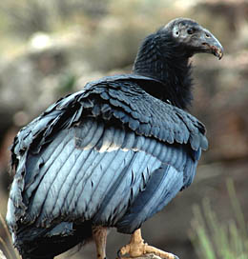
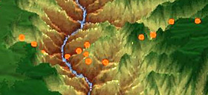

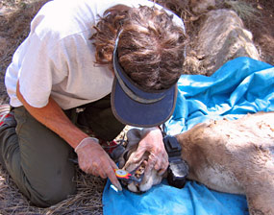

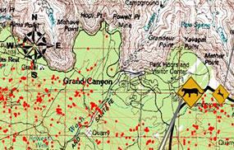

Wildlife Division Database
and Research Interface

A Partnership Project of the Grand Canyon National Park and
Northern Arizona University’s Landsward Institute

Final Report
June 2011

Abraham Henn, M.S. Environmental Science and Policy
Owain Moss, Computer Science
Jeff Burk, Computer Science
Michael McCormick, Computer Science

TABLE OF CONTENTS

- Executive Summary 3
- Project Description 4
- Methods 4
- Results 5
- Project-specific Functional Requirements 5
- Entity/Relationship Diagrams 9
- Metadata 23

EXECUTIVE SUMMARY

The primary objective of this project is to provide Grand Canyon National Park (GRCA) with design, programming, and development assistance in order to produce a SQL Server hosted Wildlife Database module, and an intranet web application to facilitate data management, data entry, and reporting of information related to the program at Grand Canyon National Park.

The first phase of this project involved gathering and compilation of the requirements for the database module and web application. Upon consultation of the Wildlife Division Staff as well as review of the wildlife records, it became clear that although intern Abraham Henn had considerable knowledge and experience with the wildlife research and data collection methods, a more extensive knowledge of database design and programming was necessary to realize a formal database schema. This was when Dr Li and her intern team were asked to take over the project at the beginning of the fall semester of 2010.

After meeting with GIS Coordinator Mark Nebel and Wildlife Biologist Tim Bowden, it was decided that the core functional requirements of the system were: searching, editing, and entering data, as well as a cross-project location search component and a file management system. After analyzing the wildlife data records, the software development team agreed that due to the inherent disparities across the project data sets, that the database should be organized as a set of mini-databases separated by project. Effectively, this design approach was adopted in order to provide data querying, entering, and editing functions within specific subprojects, and to provide a separation of concerns across the wildlife project set. It was also agreed that Tim Bowden was to meet with the wildlife project leaders and acquire from each a set of metadata that was to provide a listing of the required, valid, and searchable fields for each of the subprojects in order to generate a set of constraints to guide the development of the web-based application.

It also became clear that although core requirements of the system had been established, many of the lower-level requirements were still unclear. As a result, the software development team decided to adopt an agile development approach, which involved deriving a subset of functional requirements, submitting them to the client for approval, developing the subset of functionality, and then obtaining feedback from the client. It is due to this development approach and the fact that not all of the final datasets have been provided from the client, that the design of the database did not meet the initial timeline. At the time of publication of this report, most of the datasets were provided, and a general convention for designing the database around the aforementioned datasets was established. Documentation for the design of the database that has been realized to this point is provided in section 6 of this report.

Programming of the database and web application falls under the scope of a separate task agreement with Northern Arizona University and will be presented in the final report required under that agreement.

PROJECT DESCRIPTION
The goal of this project was to consult with the Grand Canyon National Park’s Wildlife Division to: 1) locate, compile, catalog and prioritize archival data related to the wildlife program at Grand Canyon National Park; 2) identify common elements across the datasets; and 3) develop a database schema including recommendations for fields, tables and relationships. This task involved collaboration with the NAU database programmer (Dan Li) and her intern team working under a separate but related Task Agreement with the Park. The result of this project is a conceptual design of a web-based user interface for Grand Canyon National Park’s Wildlife Division staff which will be further developed and programmed under a separate agreement.

methods

3.1 Phase 1 – Initial requirements analysis
The project team consulted with Wildlife Division staff to obtain the requirements and functions of the database, reviewed existing wildlife datasets and files and made recommendations regarding possible database relationships. This was the basis for programming of the final application.

Mid-project, it became clear that although the initial intern had a thorough understanding of natural resources and wildlife research and data along with a conceptual understanding of databases, more in-depth knowledge of database structure was needed to successfully produce recommendation for the database schema. At this point, the computer science interns hired for the follow-on programming phase of this project were brought in to assist in development of the schema. The initial intern oriented two computer science interns in summer 2010 to continue the project and remained available on an as-needed basis for facilitation and consultation. A third intern joined the team in spring 2011 to complete the project.

3.2 Phase 2 – Functional requirements analysis
During this phase, the computer science interns met with Tim Bowden and Mark Nebel to further reify the functional requirements associated with the programming of the database and web-based application. The Wildlife Division staff provided the software development team with a CD containing the data around which the database and web application was to be programmed. This enabled the software development team to do a thorough analysis of the data and to make recommendations for the design of the database and the web application.

Due to the fact that the functional requirements of the project were not clear to either team, it was decided by the software team that an agile development approach was to be adopted. This kind of development process is characterized by gathering requirements specific to a given part of the project, developing the associated functionality, and then submitting it to the client in order to obtain valuable feedback. The software development team also organized several meetings amongst team members to delegate development tasks. It was decided that Jeff Burk would be responsible for the web development, and Owain Moss would handle the design and programming of the database.

results

4.1 Phase 1 – Initial requirements analysis
In the first months of the project, the initial intern was able to meet once with all of the wildlife staff and twice with the designated wildlife staff representative. Following these meetings, the intern created a short document outlining some general requirements and functions for the database application.

4.2 Phase 2 – Functional requirements analysis
After meeting with Tim Bowden and Mark Nebel, it was decided that the core functionality of the database module and web application was to be centered on searching, editing, and entering data, as well as a cross-project location search component and a file management system. It was proposed that the file management system was to facilitate organization of compliance files, permits, consultation and proposal documents, as well as general reports, GIS files, and safety documents. As far as the subset of functionality associated with wildlife project data, it was further decided that this functionality of the database module and web-based application was going to be organized according to specific projects instead of in a cross-project manner. This was due to the inherent disparities across the wildlife data. A detailed listing of general project requirements is provided in section 5.

Tim Bowden agreed to meet with the project leaders in order to obtain a set of metadata for each subproject, which would effectively provide a listing of the required/searchable fields in addition to valid entries for each data set. This metadata was provided for the Mexican spotted owl, Northern goshawk, California condor, point counts, Southwestern willow flycatcher, Brown-headed cowbird, puma, and Bighorn sheep projects. A listing of this metadata is provided in section 7 of this report.

5. PROJECT-SPECIFIC FUNCTIONAL REQUIREMENTS
For each project component, a set of functional requirements was realized that outlined in detail the specific functionality that was to be provided by the software development team. Each project was separated into two categories of data and files – long term monitoring and past projects. A general listing of these functional requirements is provided below.

5.1 Long term monitoring
5.1.1 User:
5.1.1.1 User will be able to login to the user interface with username and password
5.1.1.2 User will be able to select the project type and then the specific subproject from a list of
species
5.1.1.3 User will be able to select “Long Term Monitoring”
5.1.1.4 User will be able to choose to upload a file
2.1.1.4.1 User will be able to designate the specific kind of file to upload (e.g. Long Term
Monitoring/Inventory or Long Term Monitoring/MSO_Compliance
5.1.1.4.2 User will be able to specify the file extension of the file to be uploaded
(This assures valid user input)
5.1.1.4.3 User will be able to see a list of files in the current directory before and after
uploading (These files should be listed as hyperlinks so the user can download)
5.1.1.4.4 User will be required to enter metadata for the file such as author and keywords
5.1.1.5 User will be able to choose to download a file
5.1.1.5.1 User will be able to specify what kind of file to download (e.g. Long Term
Monitoring/Inventory or Long Term Monitoring/Inventory/MSO_Compliance)
5.1.1.5.2 User will be able to view all files in the user specified directory/table
5.1.1.5.3 User will be able to select the file to download by clicking on it
5.1.1.6 User will be able to choose to delete a file
5.1.1.6.1 User will be able to specify what kind of file to delete (e.g. Long Term
Monitoring/Inventory or Long Term Monitoring/Inventory/MSO_Compliance)
5.1.1.6.2 User will be able to view a list of files in the user specified directory/table
5.1.1.6.3 User will be able to select the file to download from aforementioned list
5.1.1.6.4 User must confirm their choice of file to delete
5.1.1.7 User will be able to edit an existing file
5.1.1.7.1 User will be able to download the file they want to edit (see 1.1.5) so they can make
the necessary changes
5.1.1.7.2 User will be able to specify what kind of file to upload (e.g. Long Term
Monitoring/Inventory or Long Term Monitoring/Inventory/MSO_Compliance)
5.1.1.7.3 User will be able to specify the file extension of the file to be uploaded (This
assures valid user input)
5.1.1.7.4 The system will check whether the file to be uploaded is a replacement of an
existing file
5.1.1.7.5 The system will notify the user that the file to be uploaded will replace an existing
file
5.1.1.7.6 User will be required to enter metadata for the file such as author, keywords, title,
date, and last person to modify
5.1.1.7.7 The system will keep a history of changes
5.1.1.8 User will be able to choose to search for files
5.1.1.8.1 User will be able to specify what type of file to search for (e.g. Long Term
Monitoring/Inventory Compliance) and then view a list of files of the specified
type
5.1.1.8.2 User will also be able to specify search criteria such as author or keywords and
view a listing of files that fit the search criteria
5.1.1.9 User will be able to choose to view data entries from data menu
2.1.1.9.1 User will be able to specify the type of results to view from a list
5.1.1.9.2 User will be able to search data collection results by all related fields
5.1.1.9.3 User will be able to specify a range of coordinates and search data entries that fall
within the user specified range
5.1.1.10 User will be able to choose to enter data from data menu
2.1.1.10.1 User will be able to specify the type of data to enter from a list
5.1.1.10.2 User will be presented with a form for data entry
5.1.1.10.3 User will be able to choose to “Enter Data” once they have filled out the form
5.1.1.10.4 User will be able to view the new data set upon entry
5.1.1.11 User will be able to choose to edit an existing data entry
5.1.1.11.1 User will be able to view relevant data entries
5.1.1.11.2 User will be able to choose to edit the an existing data entry by clicking on an edit
link
5.1.1.11.3 User will be presented with a form for data modification
5.1.1.11.4 User will be able to save the modified data entry
5.1.1.11.5 User will be able to view the modified data entry
5.1.1.11.6 User will be able to delete an existing data entry by clicking on a delete link

5.2 Past Projects:
5.2.1 User
5.2.1.1 Once on the Project page, the user will be able to select “Past Projects” from a list of choices
5.2.1.2 User will be able to choose to upload a file
5.2.1.2.1 User will be able to designate the specific kind of file to upload (e.g. Past
Projects/Habitat_Definitions/Critical_Habitat)
5.2.1.2.2 User will be able to specify the file extension of the file to be uploaded (This
assures valid user input)
5.2.1.2.3 User will be able to see a list of files in the current directory before and after
uploading (These files should be listed as hyperlinks so the user can download)
5.2.1.2.4 User will be required to enter metadata for the file such as author and keywords
5.2.1.3 User will be able to choose to download a file
5.2.1.3.1 User will be able to specify what kind of file to download (e.g. Past
Projects/Habitat_Definitions/Critical_Habitat)
5.2.1.3.2 User will be able to view all files in the user specified directory/table
5.2.1.3.3 User will be able to select the file to download by clicking on it
5.2.1.4 User will be able to choose to delete a file
5.2.1.4.1 User will be able to specify what kind of file to delete (e.g. Past
Projects/Habitat_Definitions/Critical_Habitat)
5.2.1.4.2 User will be able to view a list of files in the user specified directory/table
5.2.1.4.3 User will be able to select the file to download from aforementioned list
5.2.1.4.4 User must confirm their choice of file to delete
5.2.1.5 User will be able to edit an existing file
5.2.1.5.1 User will be able to download the file they want to edit so they can make
the necessary changes
5.2.1.5.2 User will be able to specify what kind of file to upload (e.g. Past
Projects/Habitat_Definitions/Critical_Habitat)
5.2.1.5.3 User will be able to specify the file extension of the file to be uploaded (This
assures valid user input)
5.2.1.5.4 The system will check whether the file to be uploaded is a replacement of an
existing file
5.2.1.5.5 The system will notify the user that the file to be uploaded will replace an existing
file
5.2.1.5.6 User will be required to enter metadata for the file such as author, keywords, title,
date, and last person to modify
5.2.1.5.7 The system will keep a history of changes
5.2.1.6 User will be able to choose to search for files
5.2.1.6.1 User will be able to specify what type of file to search for (e.g. Past
Projects/Habitat_Definitions/Critical_Habitat) and then view a list of files of the
specified type
5.2.1.6.2 User will also be able to specify search criteria such as author or keywords and
view a listing of files that fit the search criteria
5.2.1.7 User will be able to choose to add a directory to the current existing structure
5.2.1.7.1 User will be able to specify the location of the new directory
5.2.1.7.2 User will be able to view the new directory and add and remove contents within the
directory

6. ENTITY/RELATIONSHIP DIAGRAMS
In order to realize and document an architectural design for the database module, a set of entity-relationship diagrams were created. These diagrams reveal the tables in the database and the fields associated with each. The majority of these E/R diagrams is listed according to project name and subproject designation. Any general tables are listed according to their general designation.

6.1 Files

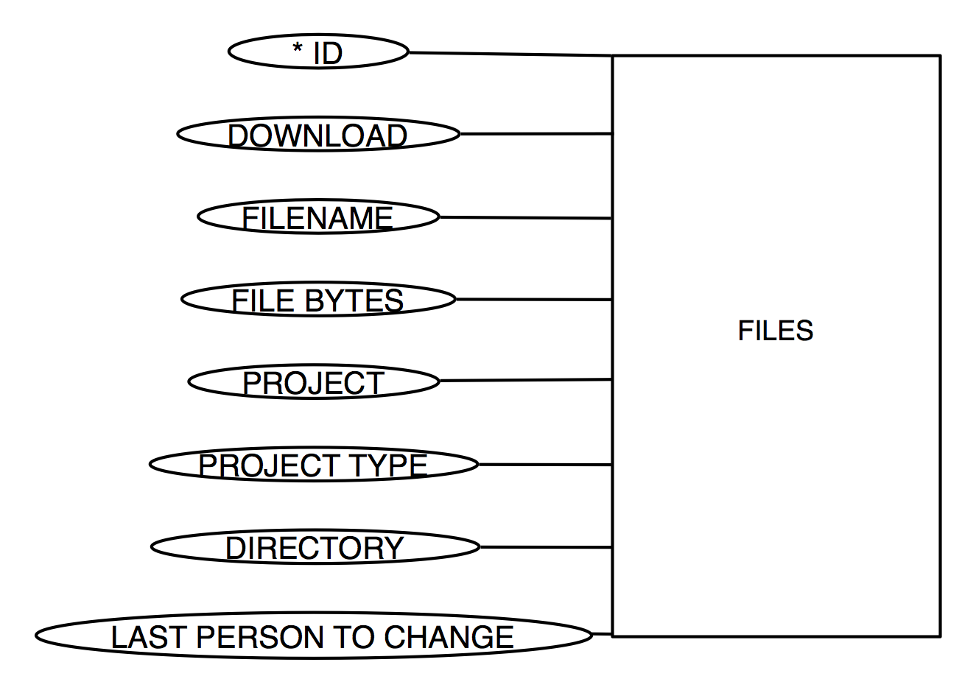

6.2 Authors and Keywords

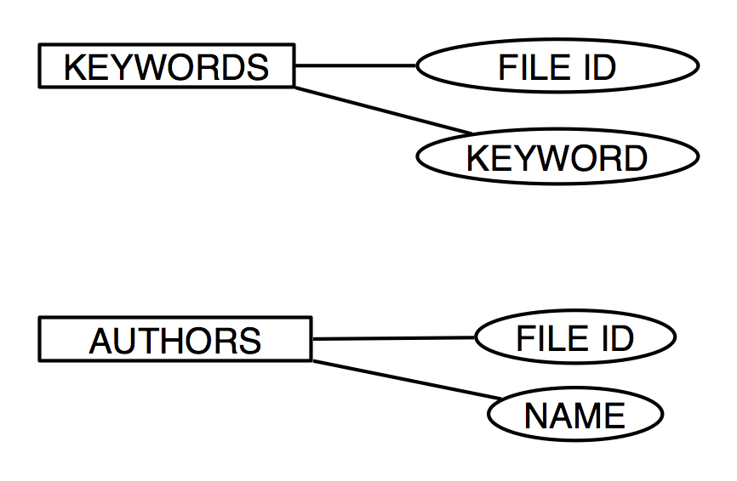

6.3.1 MSO – Long Term Monitoring/Inventory Compliance

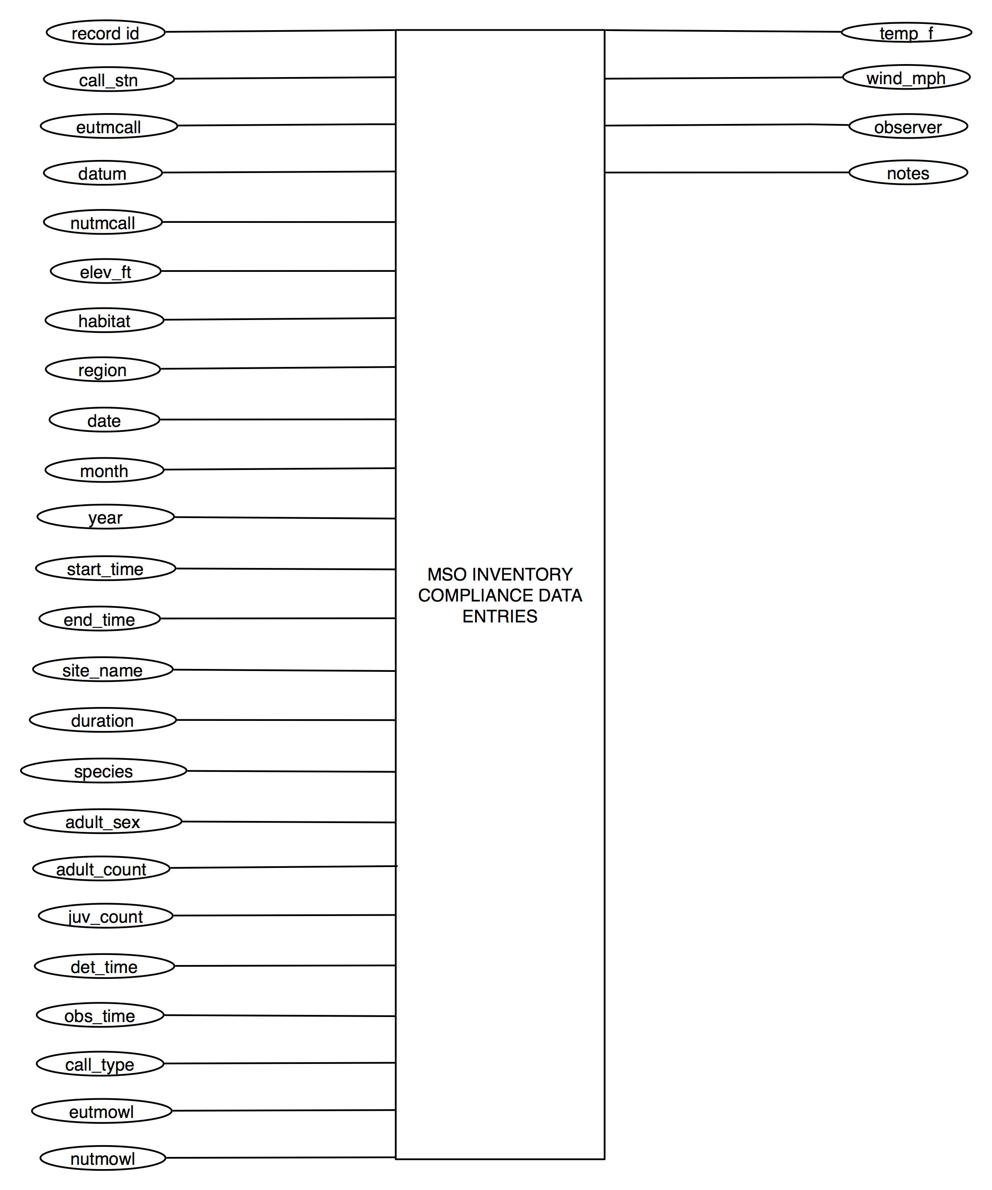

6.3.2 MSO – Long Term Monitoring/Reproductive Monitoring

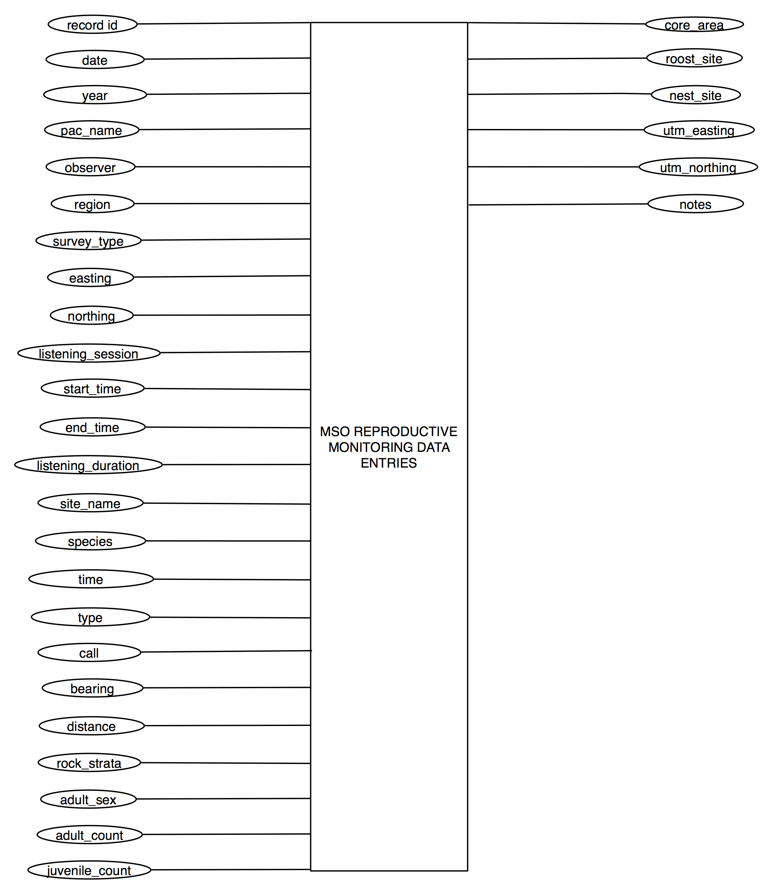

6.4.1 Point Counts – Long Term Monitoring/CRMP Point Count

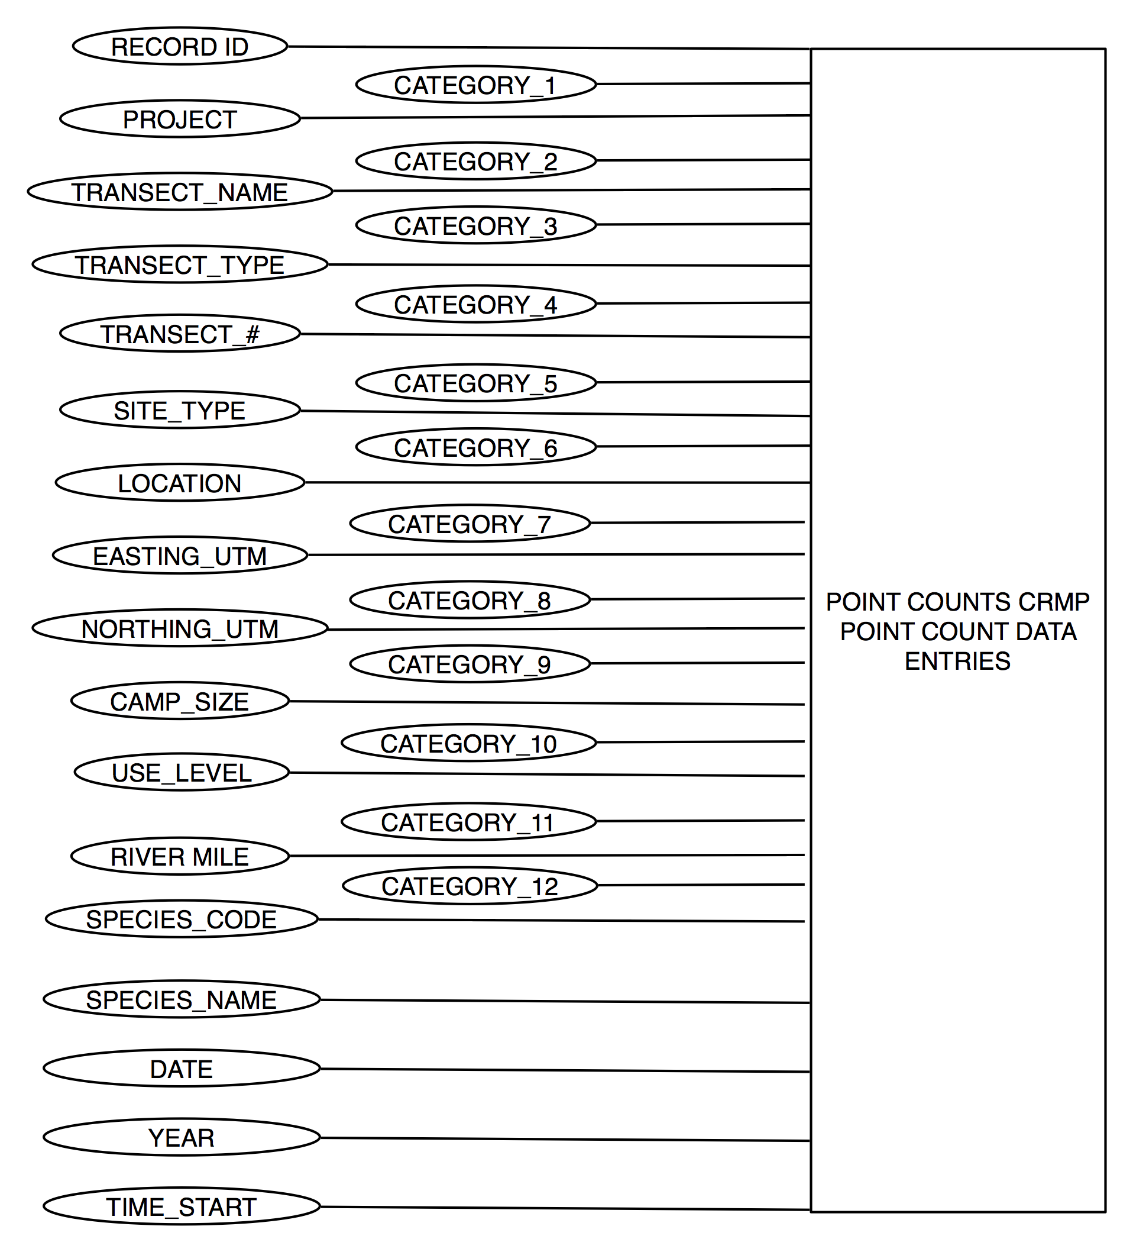

6.5.1 Northern Goshawk – Long Term Monitoring/Inventory Compliance

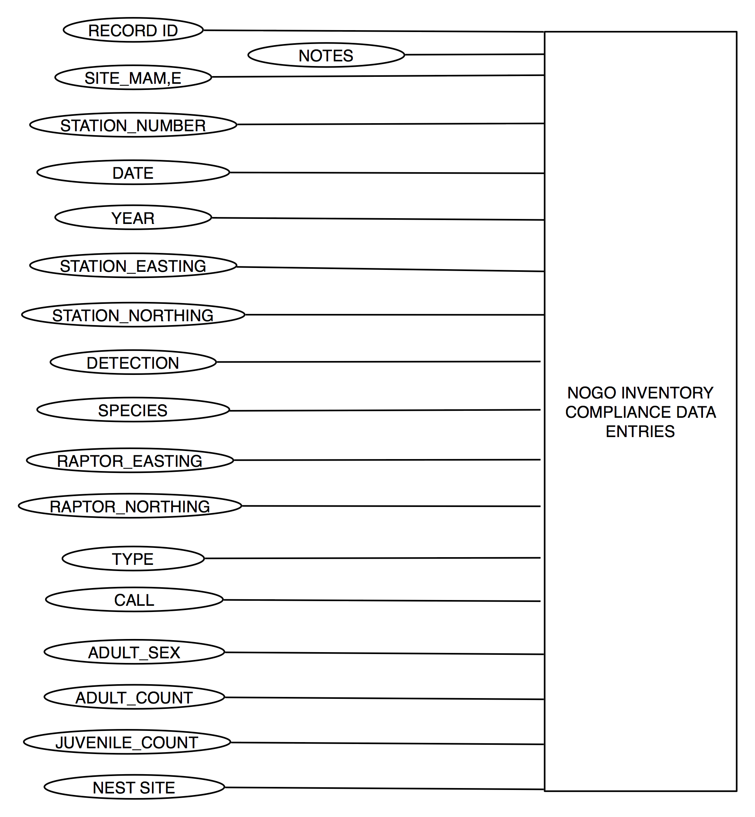

6.6.1 Puma – Long Term Monitoring/Cluster Investigation

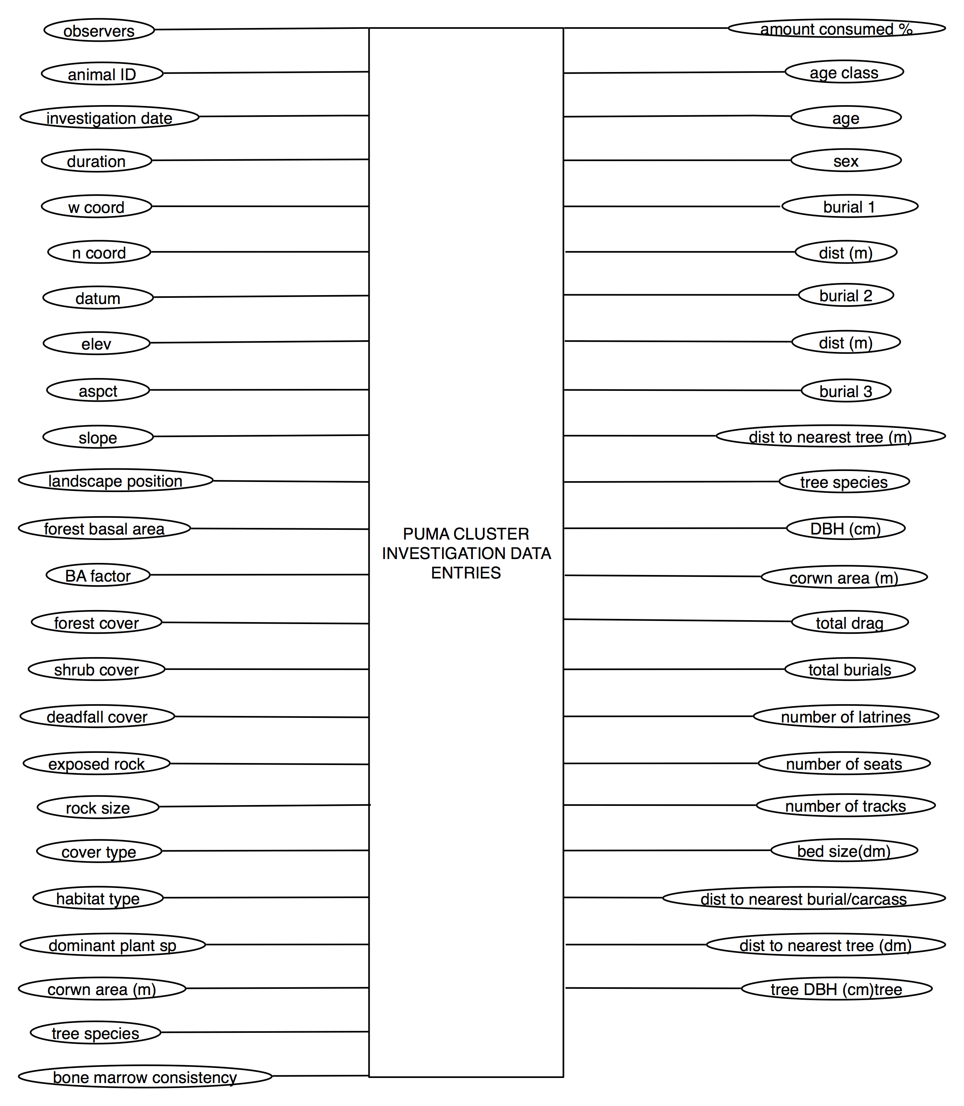

6.6.2 Puma – Long Term Monitoring/Clusters GRCA

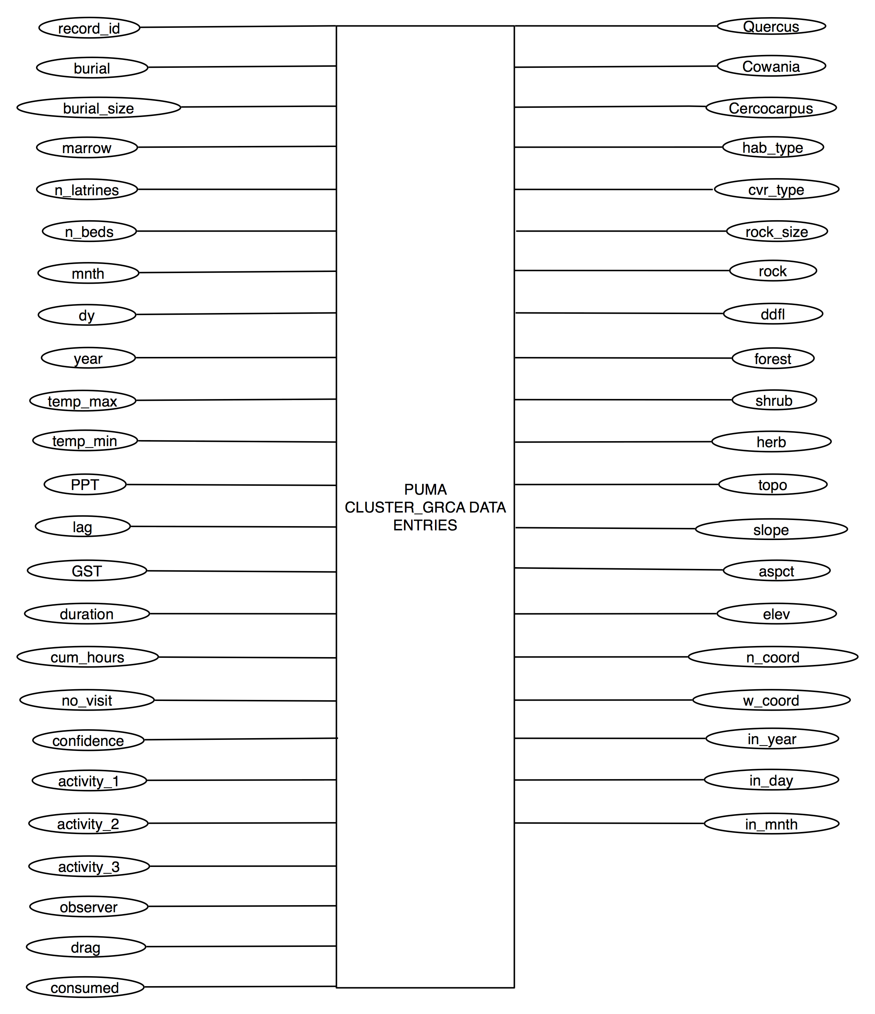

6.6.3 Puma – Long Term Monitoring/Trapping Locations

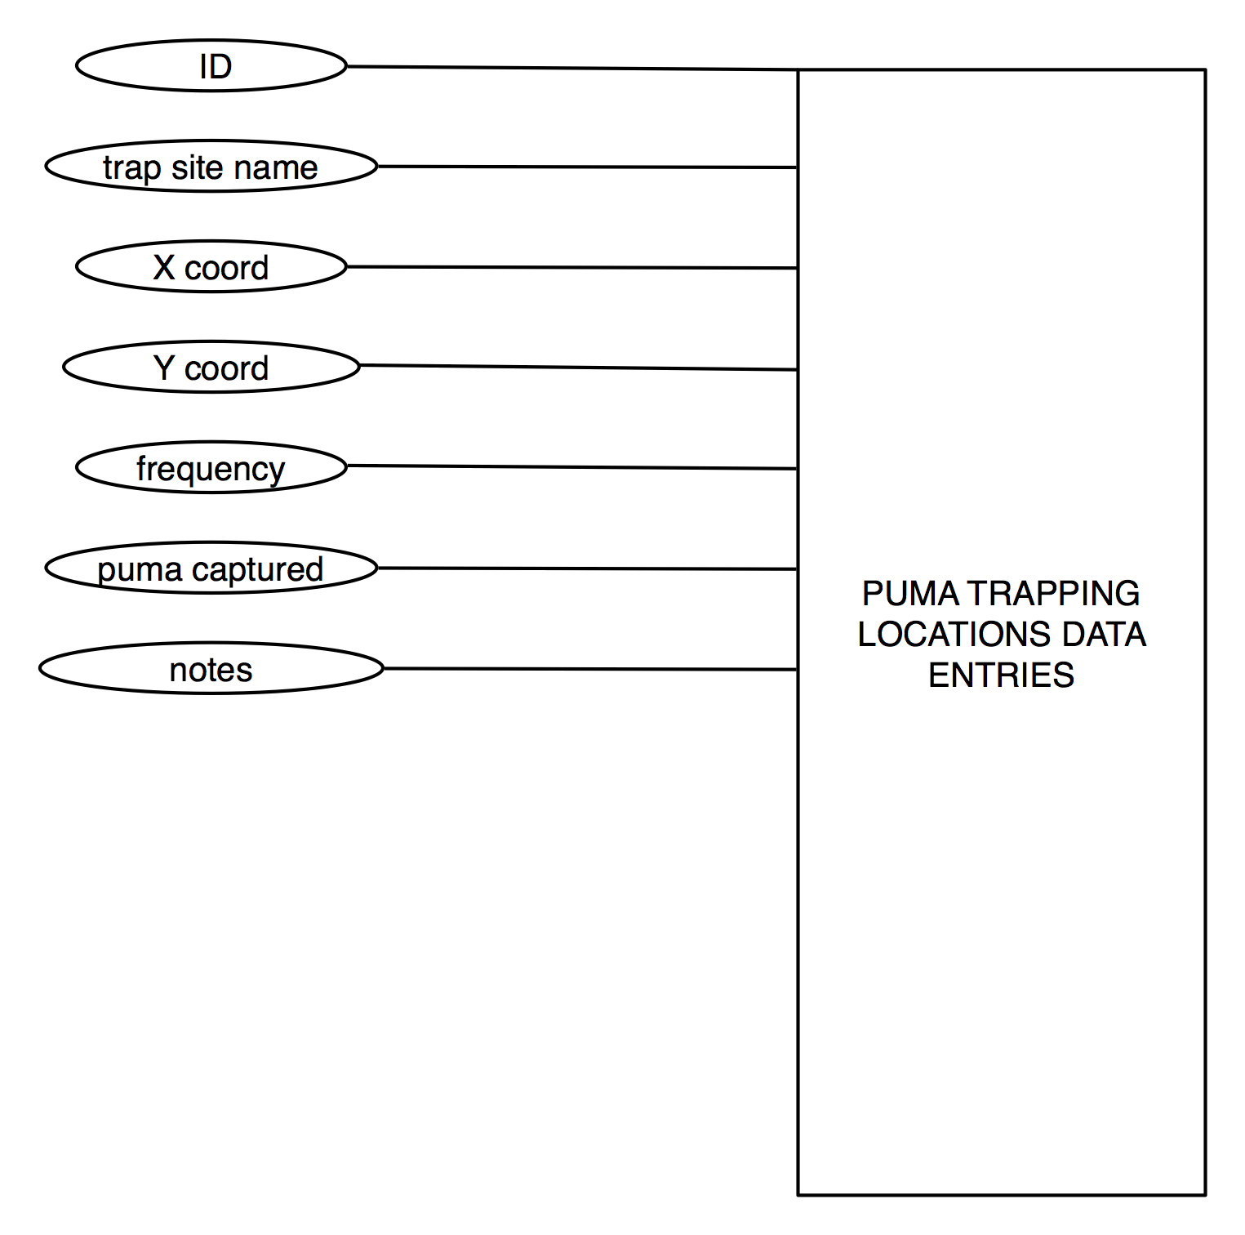

6.6.4 Puma – Long Term Monitoring/Capture Locations

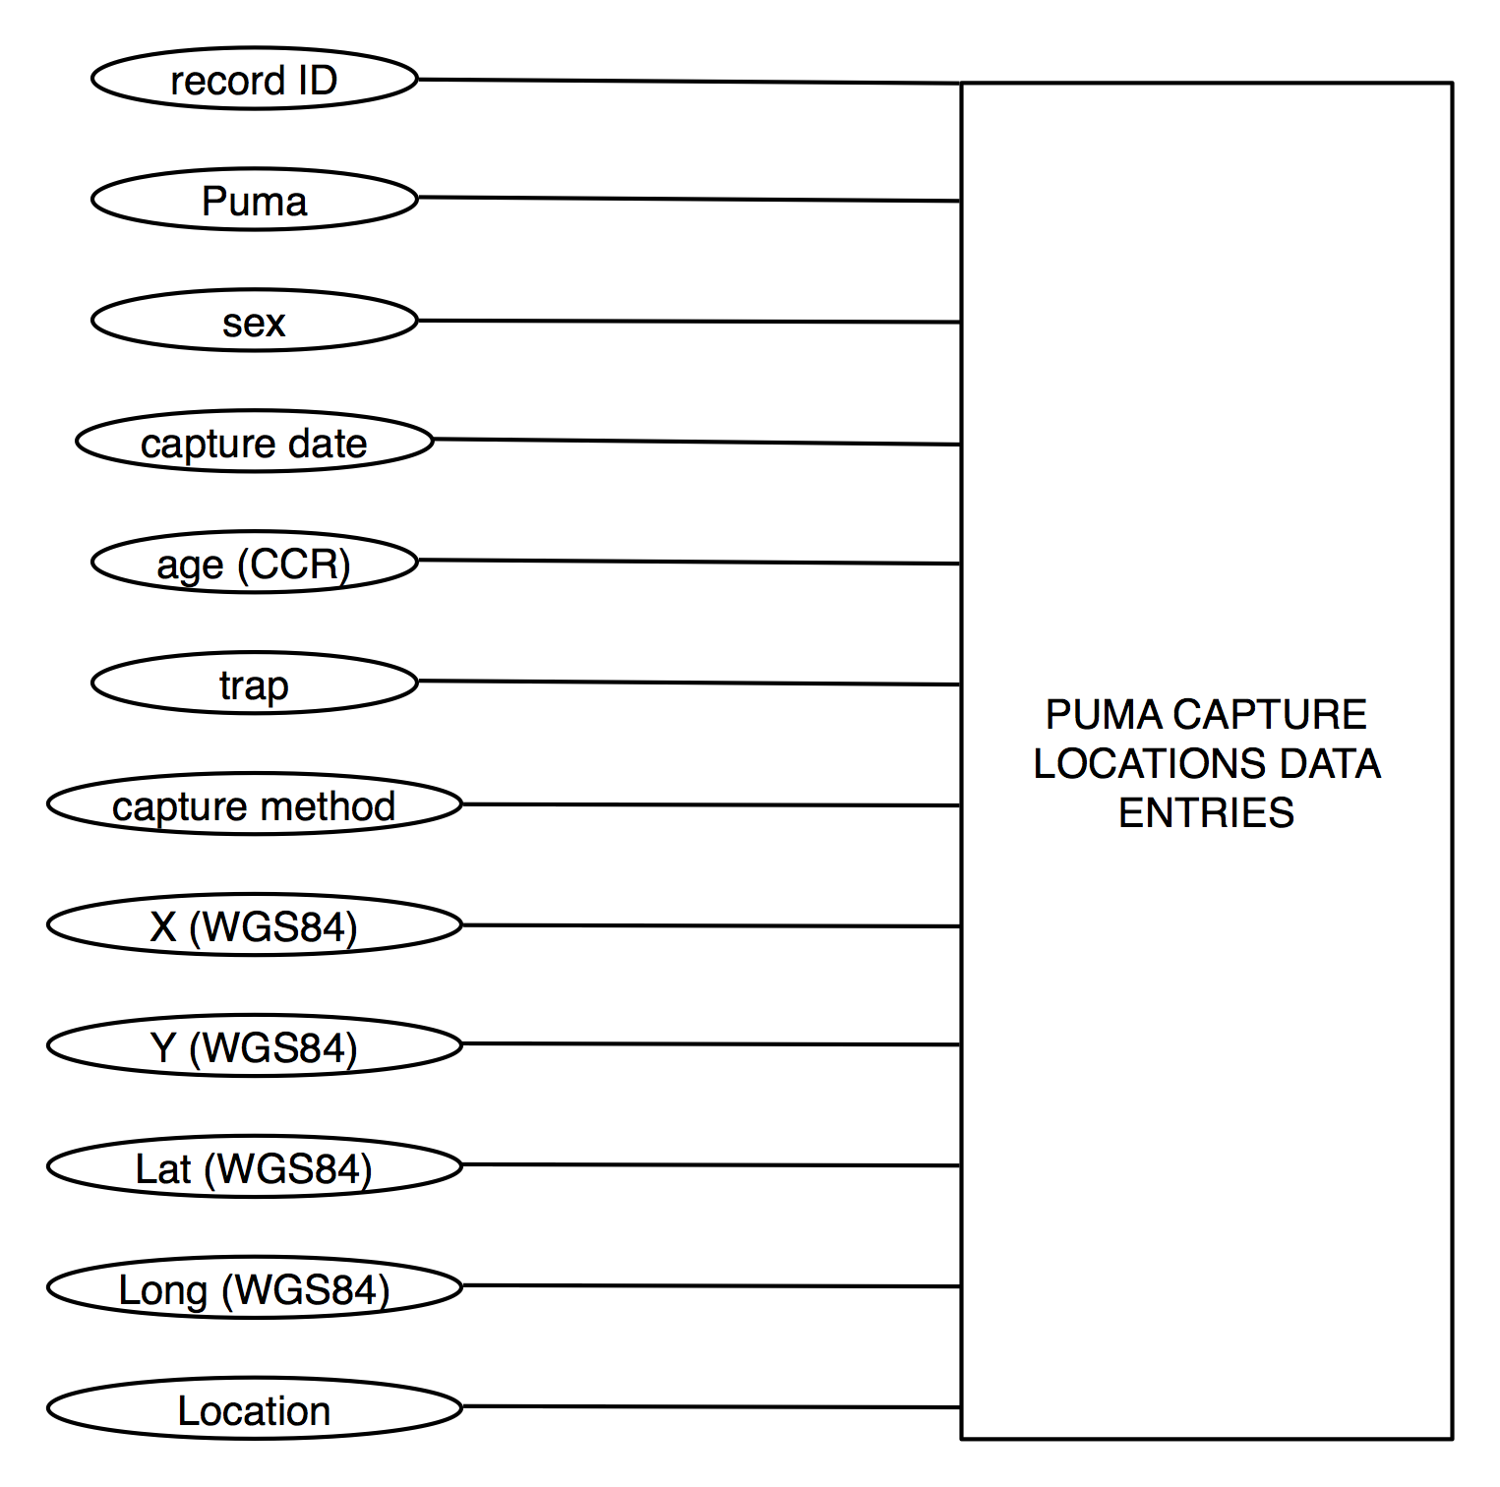

6.7.1 California Condor – Long Term Monitoring/Calc Observation

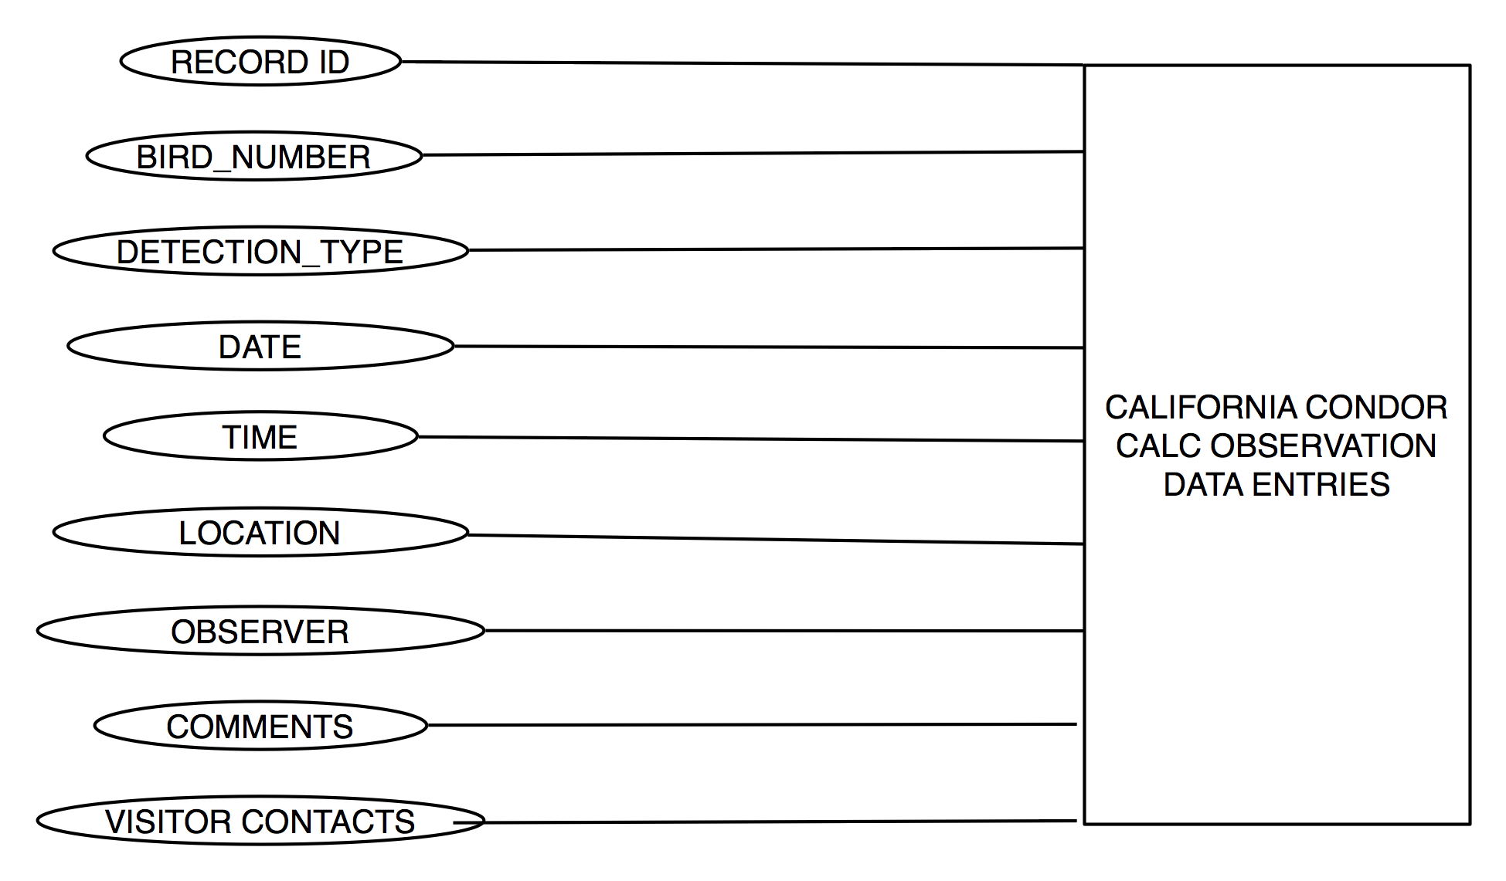

6.8.1 Southwestern Willow Flycatcher – Long Term Monitoring/Habitat Assessment

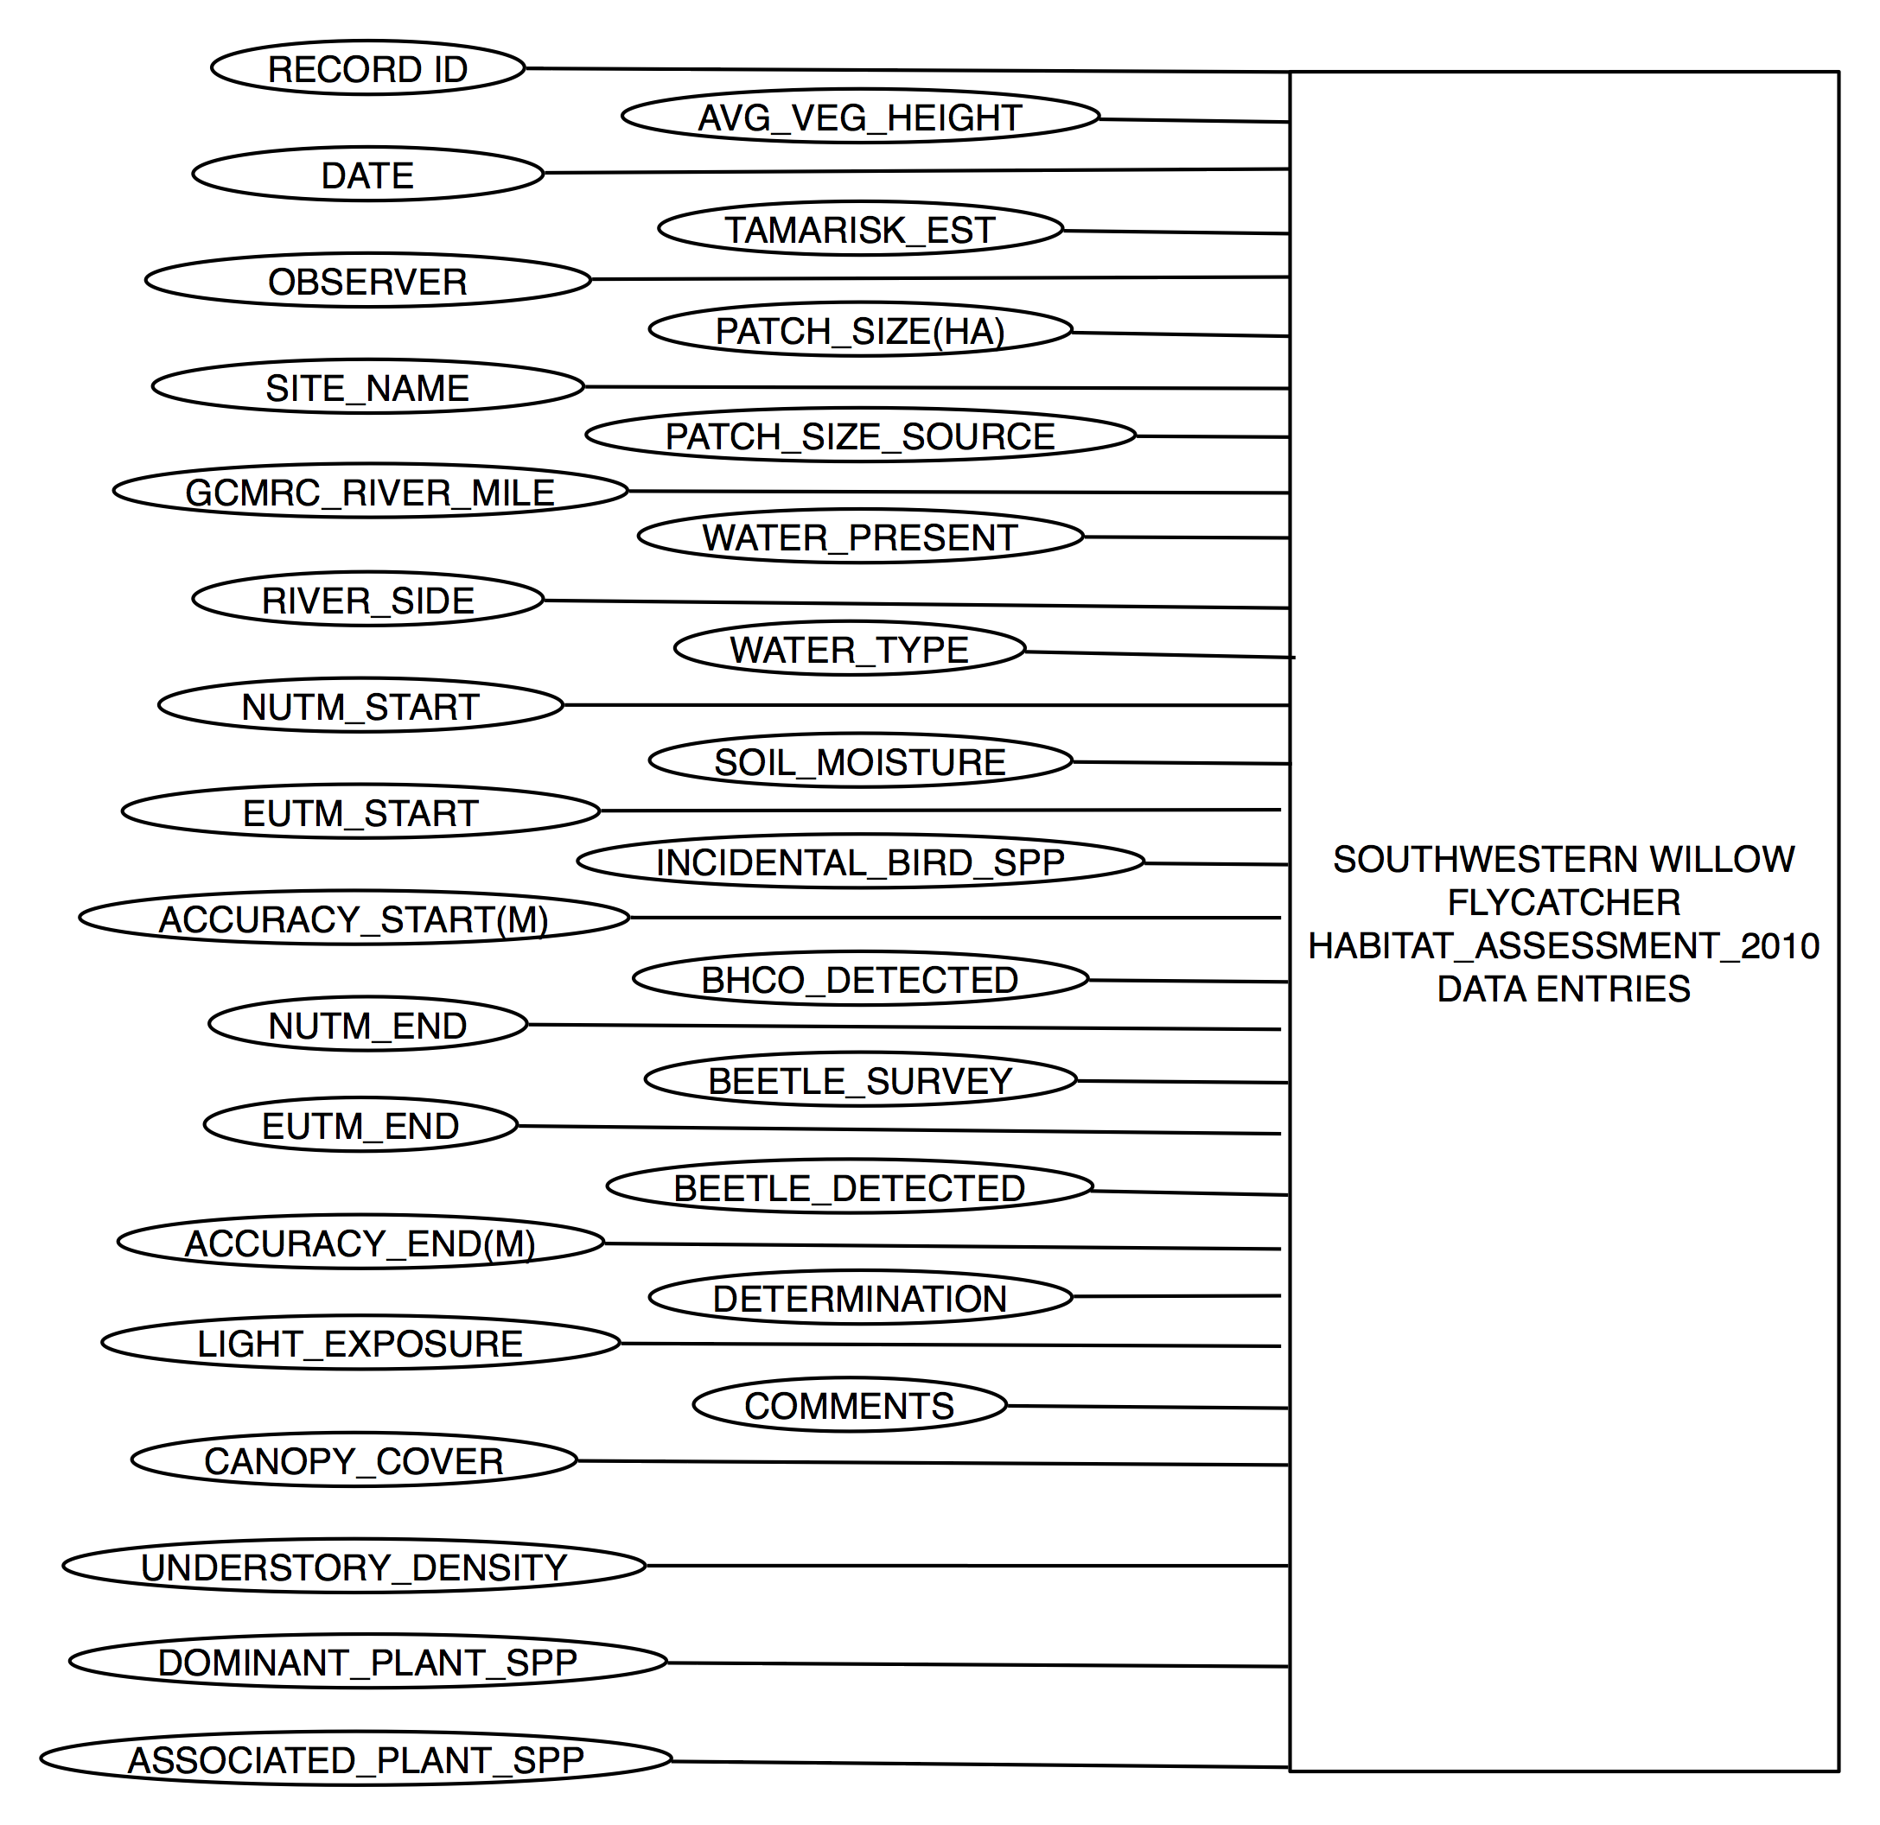

6.8.2 Southwestern Willow Flycatcher – Long Term Monitoring/Songmeter 2010

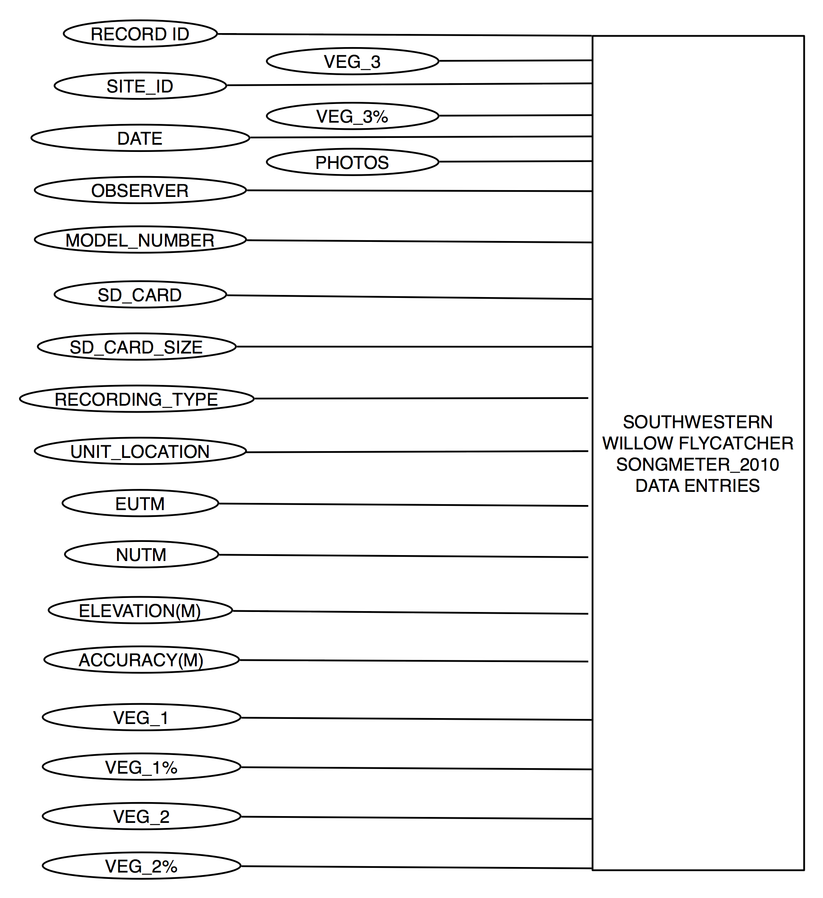

6.8.3 Southwestern Willow Flycatcher – Long Term Monitoring/SWFL Survey 2006-2010

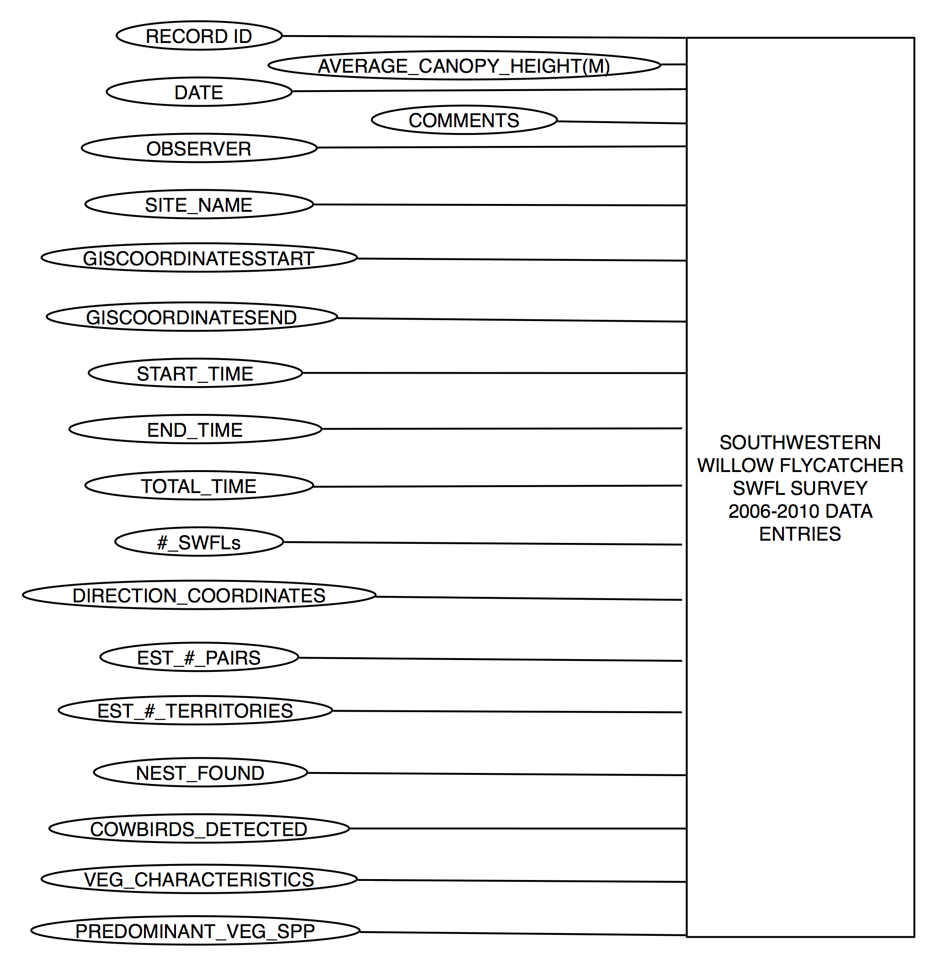

7. METADATA
Metadata was provided by Tim Bowden for each subproject that provides a listing of all required and searchable fields, as well as the constraints for valid entries. Listed below are these metadata files, which are listed according to project and the given subproject.

7.1 Mexican Spotted Owl Metadata

Updated_MSO_Database_2007.mdb |  |  | MSO_Inv&Comp_Data_Form.xls
Field | Searchable (Y/N) | Valid Entries | Enter Data
RECORD_ID | N | Integer: 1:10,000 | Automatic sequential number
SITE_NAME | Y | Text | Dynamic DDM or create new site
CALL_STN | N | Integer: 1:999 | DDM*: user input or NA=999
REGION | Y | Text | DDM: PLATEAU, RIM, or CANYON
DATUM | N | Text | DDM: 12 S NAD83
EUTMCALL | Y | Integer: 6 digits | User input; must = 6 digits
NUTMCALL | Y | Integer: 7 digits | User input; must = 7 digits
ELEV_FT | N | Integer: 1:10,000 | User input
HABITAT | Y | Text | DDM: DS, PJ, PP, MC, or SF
DATE | Y | Date: mm/dd/yyyy | User input
MONTH | Y | Text | DDM: January – December
YEAR | Y | Integer: 4 digits | User input
START_TIME | N | Time: hh:mm | User input
END_TIME | N | Time: hh:mm | User input
DURATION | N | Time: hh:mm | Auto Calculation = END_TIME – START _TIME
SPECIES | Y | Text: 4 letters | DDM: STOC, BUVI, GLGN, AEAC, OTFL, ASOT, ASFL
ADULT_SEX | N | Text | DDM: M, F, MF, MFM, or User input
ADULT_COUNT | N | Integer: 0:9 | User input
JUV_COUNT | N | Integer: 0:9 | User input
DET_TIME | N | Time: hh:mm | User input
OBS_TYPE | Y | Text | DDM: H, V, or B
CALL_TYPE | Y | Text | DDM: T, C, B, PD, J
EUTMOWL | Y | Integer: 6 digits | User input; must = 6 digits
NUTMOWL | Y | Integer: 7 digits | User input; must = 7 digits
TEMP_F | N | Integer | User input
WIND_MPH | N | Integer | User input
OBSERVER | N | Text | User input
NOTES | N | Text | User input

MSO_Reproductive_Monitoring_Table.xls |  |  | MSO_Reproductive_Monitoring_Form.xls
Field | Searchable (Y/N) | Valid Entries | Entry Type
RECORD_ID | N | Integer: 1:10,000 | Automatic sequential number
DATE | Y | Date: mm/dd/yyyy | User input
YEAR | Y | Date: yyyy | User input
PAC NAME | Y | Text | Dynamic DDM: See PAC_Name_List  or Create New
OBSERVER | N | Text | User input
REGION | Y | Text | DDM: Rim, Canyon
SURVEY_TYPE | Y | Text | DDM: Core Visit, Dish
EASTING | Y | Integer 6 digits | User input, must = 6 digits
NORTHING | Y | Integer 7 digits | User input, must = 7 digits
LISTENING SESSION | Y | Text | DDM: Dusk, Midnight, Dawn
START_TIME | Y | hh:mm | User input
END_TIME | Y | hh:mm | User input
LISTENING_DURATION | Y | hh:mm | User input
SPECIES | Y | Text: 4 Letters | DDM: STOC, BUVI, GLGN, AEAC, OTFL, ASOT, ASFL, WIND
TIME | Y | hh:mm | User input
TYPE | Y | Text | DDM: Heard only, Visual only, Both
CALL | Y | Text: | DDM: T, C, B, PD, J
BEARING | N | Integer: 0:364 | User input
DISTANCE | N | Integer: 1:3000 | User input
ROCK_STRATA | Y | Text | DDM: MUAV,MUAV/REDWALL, REDWALL, SUPAI, HERMIT, COCONINO, TOROWEAP, KAIBAB
ADULT_SEX | Y | Text | DDM: M, F, MF, Unknown, User Input
ADULT_COUNT | Y | Integer: 1:9 | User input
JUVENILE_COUNT | Y | Integer: 0:9 | User input
CORE AREA | Y | Text | DDM: Y, N, U
ROOST SITE | Y | Text | DDM: Y, N, U
NEST SITE | Y | Text | DDM: Y, N, U
UTM_EASTING | Y | Integer: 6 Digits | User input, must = 6 digits
UTM_NORTHING | Y | Integer: 7 Digits | User input, must = 7 digits
NOTES | N | Text | User input

7.2 Point Count Metadata

CRMP_Point_Count_Data |  |  | CRMP_Point_Count_Form.xls
Field | Searchable (Y/N) | Valid Entries | Enter Data
RECORD_ID | N | Integer: 1:10,000 | Automatic sequential number
PROJECT | Y | Text | DDM: CRMP
TRANSECT_NAME | Y | Text | DDM: See list of Names
TRANSECT_TYPE | Y | Text | DDM: E, F, G, H
TRANSECT_# | Y | Integer: 1:2 | DDM: 1, 2
SITE_TYPE | Y | Text | DDM: Camp, Control
LOCATION | Y | Text | DDM: NHWZ, OHWZ
EASTING_UTM | Y | Integer: 6 Digits | User Input: 6 Digits
NORTHING_UTM | Y | Integer: 7 Digits | User Input: 7 Digits
CAMP_SIZE | Y | Text | DDM: S, M, L
USE_LEVEL | Y | Text | DDM: L, M, H, NA
RIVER MILE | Y | Integer: 1.0 : 300.0 | User Input
SPECIES_CODE | Y | Text | DDM: See list of Codes
SPECIES_NAME | Y | Text | DDM: See list of Names
CATEGORY_1 | Y | Integer:0:100 | DDM: 1:100
CATEGORY_2 | Y | Integer:0:100 | DDM: 1:100
CATEGORY_3 | Y | Integer:0:100 | DDM: 1:100
CATEGORY_4 | Y | Integer:0:100 | DDM: 1:100
CATEGORY_5 | Y | Integer:0:100 | DDM: 1:100
CATEGORY_6 | Y | Integer:0:100 | DDM: 1:100
CATEGORY_7 | Y | Integer:0:100 | DDM: 1:100
CATEGORY_8 | Y | Integer:0:100 | DDM: 1:100
CATEGORY_9 | Y | Integer:0:100 | DDM: 1:100
CATEGORY_10 | Y | Integer:0:100 | DDM: 1:100
CATEGORY_11 | Y | Integer:0:100 | DDM: 1:100
CATEGORY_12 | Y | Integer:0:100 | DDM: 1:100
DATE | Y | Date: mm/dd/yyyy | User Input: mm/dd/yyyy
YEAR | Y | Integer: 4 Digits | User Input
TIME_START | Y | Time: hh:mm | User Input: hh:mm

7.3 Northern Goshawk Metadata

Goshawk_Survey_Table.xls |  |  | Goshawk_Survey_Form.xls
Field | Searchable (Y/N) | Valid Entries | Entry Type
RECORD_ID | N | Integer: 1:10,000 | Automatic sequential number
SITE_NAME | Y | Text | DDM: Populate from: Unit_Name_List.xls or Create New
STATION_NUMBER | Y | Interger: 1:200 | User Input
DATE | Y | Date: mm/dd/yyyy | User input
YEAR | Y | Date: yyyy | User input
TIME | Y | hh:mm | User input
STATION_EASTING | Y | Integer 6 digits | User input, must = 6 digits
STATION_NORTHING | Y | Integer 7 digits | User input, must = 7 digits
DETECTION | Y | Text | DDM: Y,N
SPECEIS | Y | Text: 4 Letters | DDM: ACGE, ACCO, ACST, BUJA, FAPE
RAPTOR_EASTING | Y | Integer 6 digits | User input, must = 6 digits
RAPTOR_NORTHING | Y | Integer 7 digits | User input, must = 7 digits
TYPE | Y | Text | DDM: Heard only, Visual only, Both
CALL | Y | Text: | DDM: A, W, BE, BE/A, NA
ADULT_SEX | Y | Text | DDM: M, F, P, U, NA
ADULT_COUNT | Y | Integer: 0:9 | User input
JUVENILE_COUNT | Y | Integer: 0:9 | User input
NEST SITE | Y | Text | DDM: Y, N
NOTES | N | Text | User input
7.4 Puma Metadata

Cluster Investigation_Form.xls
Field | Searchable (Y/N) | Valid Entries | Entry Type
observers | Y | Text: | User input
animal ID | Y | Text, Integer: 2 | User input
investigation date | Y | Integer: 6 | User input
duration | Y | Integer: 1:3 | User input
w coord (utm) | Y | Integer: 7 | User input
n coord (utm) | Y | Integer: 6 | User input
datum | Y | Text | User input
elev | Y | Integer: 1:4 | User input
aspct | Y | Integer: 3 | User input
slope | Y | Integer: 3 | User input
landscape position | Y | Text | DDM: BNCH, BTM, FLAT, LS, MS, US, RDG
forest basal area | Y | Integer: 1:2 | User input
BA factor | Y | Integer: 2 | DDM: 5,10,20,40
forest cover | N | Integer: 3 | User input
shrub cover | Y | Integer: 3 | User input
deadfall cover | Y | Integer: 3 | DDM: M, F, MF, Unknown, User Input
exposed rock | Y | Integer: 3 | User input
rock size | Y | Text | DDM: G, C, SB, MB, LB
cover type | Y | Text | DDM: DF, DW, F, W, FW, G, OF, OW, S
habitat type | Y | Text, Integer: 2 | User input
dominant plant sp | Y | Text: 4 | User input
species | Y | Text | User input
sex | Y | Text | User input
age | Y | Integer: 1:2 | User input
age class | Y | Text | User input
amount consumed (%) | Y | Integer: 1:3 | User input
bone marrow consistency | Y | Text | User input
burial 1 | Y | Integer: 1:2 x 1:2 | User input
dist (m) | Y | Integer: 1:2 | User input
burial 2 | Y | Integer: 1:2 x 1:2 | User input
dist (m) | Y | Integer: 1:2 | User input
burial 3 | Y | Integer: 1:2 x 1:2 | User input
dist to nearest tree (m) | Y | Integer: 1:2 | User input
tree species | Y | Text | User input
DBH (cm) | Y | Integer: 1:2 | User input
crown area (m) | Y | Integer: 1:2 x 1:2 | User input
total drag | Y | Integer: 1:3 | User input
total burials | Y | Integer: 1:2 | User input
number of latrines | Y | Integer: 1:2 | User input
number of scats | Y | Integer: 1:2 | User input
number of tracks | Y | Integer: 1:2 | User input
bed size (dm) | Y | Integer: 1:2 x 1:2 | User input
dist to nearest burial/carcass | Y | Integer: 1:2 | User input
dist to nearest tree (dm) | Y | Integer: 1:2 | User input
tree species | Y | Text | User input
tree DBH (cm)tree | Y | Integer: 1:2 | User input
crown area (m) | Y | Integer: 1:2 x 1:2 | User input

Clusters_GRCA_Table.xls |  |  | Cluster Investigation_Form.xls
Field | Searchable (Y/N) | Valid Entries | Entry Type
ID | N | Text,Integer: 1:3 | User input
mnth | Y | Integer: 2 | User input
dy | Y | Integer: 2 | User input
year | Y | Integer: 4 | User input
temp max | Y | Integer: 1:3 | User input
temp min | Y | Integer: 1:3 | User input
PPT | Y | Integer: 1:4 | User input
lag | Y | Integer 1:5 | User input
GST | Y | Integer: 4 | User input
duration | Y | Integer: 1:3 | User input
cum hours | Y | Integer: 1:3 | User input
no visit | Y | Integer: 1:2 | User input
confidence | Y | Integer: 1:3 | User input
activity1 | Y | Integer: 0-99 | User input
activity2 | Y | Integer: 0-99 | User input
activity3 | Y | Integer: 0-99 | User input
observer | Y | Text: | User input
in mnth | Y | Integer: 2 | User input
in day | Y | Integer: 2 | User input
in year | Y | Integer: 4 | User input
w coord | N | Integer: 1:8 | User input
n coord | N | Integer: 1:9 | User input
elev | Y | Integer: 1:4 | User input
aspct | Y | Integer: 3 | User input
slope | Y | Integer: 3 | User input
topo | Y | Text | DDM: BNCH, BTM, FLAT, LS, MS, US, RDG
herb | Y | Integer: 3 | User input
shrub | Y | Integer: 3 | User input
forest | N | Integer: 3 | User input
ddfll | Y | Integer: 3 | DDM: M, F, MF, Unknown, User Input
rock | Y | Integer: 3 | User input
rock size | Y | Text | DDM: G, C, SB, MB, LB
cvr type | Y | Text | DDM: DF, DW, F, W, FW, G, OF, OW, S
hab type | Y | Text, Integer: 1:2 | User input
Cercocarpus | Y | Integer: 0 or 1 | User input
Cowania | Y | Integer: 0 or 1 | User input
Quercus | Y | Integer: 0 or 1 | User input
consumed | Y | Integer: 1:3 | User input
drag | Y | Integer: 1:3 | User input
burial | Y | Integer: 0 or 1 | User input
burial size | Y | Integer: 3 | User input
marrow | Y | Integer: 1-9 | User input
n latrines | Y | Integer: 1:10 | User input
n beds | Y | Integer: 1:10 | User input

Puma Capture Locations_Table.xls
Field | Searchable (Y/N) | Valid Entries | Entry Type
Puma | Y | Text; Integer: 1:3 | User input
sex | Y | Text:M,F | DDM: M,F
wgt | Y | Integer: 2 | User input
capture date | Y | Date: mm/dd/yyyy | User input
age (CCR) | Y | Integer: 1:3 | User input
trap | Y | Text | User input
capture method | Y | Text | DDM: snare, hounds, cage
X (WGS84) | N | Integer: 6 | DDM: 6 digits
Y (WGS84) | N | Integer: 7 | DDM: 7 digits
Lat (WGS84) | N | Integer: 1:10 | User input
Long (WGS84) | N | Integer: 1:10 | User input
Location | Y | Text | User input

Clusters_GRCA_Table.xls
Field | Searchable (Y/N) | Valid Entries | Entry Type
ID | Y | Integer: 1:3 | User input
trap site name | Y | Text | User input
X coord | N | Integer: 6 | DDM: 6 digits
Y coord | N | Integer: 7 | DDM: 7 digits
frequency | Y | Integer: 1:8 | User input
puma captured | Y | Text | User input
notes | Y | Text | User input

7.5 California Condor Metadata

CALC_Observation_Table.mdb
Field | Searchable (Y/N) | Valid Entries | Enter Data
BIRD_NUMBER | Y | Text | User input
DETECTION_TYPE | N | Text | DDM: Signal; Visual; Both; None
DATE | Y | Date: mm/dd/yyyy | User input
TIME | N | Time: hh:mm | User input
LOCATION | Y | Text | DDM: Village Cove; South Rim; Yaki; Trail View; Desert View; Hopi; Navajo; Yavapai; Grandview; Lipan; Mohave; Hermit; Pima; Abyss; Powell; Maricopa; Church Rocks; Roger's Roost; Mather; Shoshone; Moran; Phantom; Clear Creek; Utah Flats; TipOff
OBSERVER | Y | Text | User input
COMMENTS | Y | Text | User input
VISITOR CONTACTS | N | Text | User input

7.6 Southwestern Willow Flycatcher Metadata

Habitat_Assessment_2010_Table.mdb |  |  | Habitat_Assessment_2010_Form.doc
Field | Searchable (Y/N) | Valid Entries | Enter Data
DATE | Y | Date: mm/dd/yyyy | User input
OBSERVER | N | Text | Dynamic DDM or create new observer
SITE_NAME | Y | Text | User input
GCMRC_RIVER_MILE | Y | Text | User input
RIVER_SIDE | N | Text | DDM: Left; Right
NUTM_START | Y | Integer: 6 digits | User input; must = 6 digits
EUTM_START | Y | Integer: 7 digits | User input; must = 7 digits
ACCURACY_START(M) | N | Integer | User input
NUTM_END | Y | Integer: 6 digits | User input; must = 6 digits
EUTM_END | Y | Integer: 7 digits | User input; must = 7 digits
ACCURACY_END(M) | N | Text | User input
LIGHT_EXPOSURE | N | Text | DDM: Full Sun; Partial Sun; Full Shade
CANOPY_COVER | Y | Text | DDM: Sparse; Low; Moderate; High
UNDERSTORY_DENSITY | Y | Text | DDM: Sparse; Low; Moderate; High
UNDERSTORY_COMPOSITION | N | Text | DDM: Live Foliage; Dead Branches; Both
DOMINANT_PLANT_SPP | N | Text | User input
ASSOCIATED_PLANT_SPP | N | Text | User input
AVG_VEG_HEIGHT | N | Text | User input
TAMARISK_EST | Y | Text | DDM: Sparse; Low; Moderate; High
PATCH_SIZE(HA) | Y | Text | User input
PATCH_SIZE_SOURCE | N | Text | DDM: Aerial Photo; Field Estimate
WATER_PRESENT | N | YES/NO | User input
WATER_TYPE | Y | Text | DDM: Seep; Spring; Stream; Pothole; River
SOIL_MOISTURE | Y | Text | DDM: Dry; Moist; Saturated; Standing Water
INCIDENTAL_BIRD_SPP | N | Text | User input
BHCO_DETECTED | Y | YES/NO | User input
BEETLE_SURVEY | N | YES/NO | User input
BEETLE_DETECTED | Y | YES/NO | User input
DETERMINATION | Y | Text | DDM: Suitable; Potential; Unsuitable
COMMENTS | N | Text | User input

Songmeter_2010_Table.mdb |  |  | Songmeter_2010_Form.xls
Field | Searchable (Y/N) | Valid Entries | Enter Data
RECORD_ID | N | Integer: 1:10,000 | Automatic sequential number
SITE_ID | Y | Text | User input
DATE | Y | mm/dd/year | User input
OBSERVER | N | Text | User input
MODEL_NUMBER | N | Integer | User input
SD_CARD | N | Integer | User input
SD_CARD_SIZE | N | Text | DDM: 16 GB; 32GB
RECORDING_TYPE | N | Text | DDM: Stereo; Mono-R; Mono-L
UNIT_LOCATION | N | Text | User input
EUTM | Y | Integer: 6 digits | User input; must = 6 digits
NUTM | Y | Integer: 7 digits | User input; must = 7 digits
ELEVATION(M) | N | Text | User input
ACCURACY(M) | N | Text | User input
VEG_1 | N | Text | User input
VEG_1_% | N | Text | User input
VEG_2 | N | Text | User input
VEG_2_% | N | Text | User input
VEG_3 | N | Text | User input
VEG_3% | N | Text | User input
PHOTOS | N | Text | User input

SWFL_Survey_2006-2010_Table.mdb |  |  | Survey_2010_Form.xls
Field | Searchable (Y/N) | Valid Entries | Enter Data
RECORD_ID | N | Integer: 1:10,000 | Automatic sequential number
DATE | Y | Date: mm/dd/yyyy | User input
OBSERVER | N | Text | Dynamic DDM or create new observer
SITE_NAME | Y | Text | Dynamic DDM or create new site
GISCOORDINATESSTART | Y | Text | User input
GISCOORDINATESEND | Y | Text | User input
START_TIME | N | Time: hh:mm | User input
END_TIME | N | Time: hh:mm | User input
TOTAL_TIME | N | Time: hh:mm | Auto Calculation = END_TIME – START _TIME
#_SWFLs | Y | Integer: 1:10,000 | User input
DETECTION_COORDINATES | Y | Text | User input
EST_#_PAIRS | N | Text | User input
EST_#_TERRITORIES | N | Text | User input
NEST_FOUND | Y | YES/NO | User input
COWBIRDS_DETECTED | Y | YES/NO | User input
VEG_CHARACTERISTICS | N | Text | DDM: entirely or almost entirely, >90%native; mostly native, 50-90% native; mostly exotic, 50-90% exotic; entirely or almost entirely, >90% exotic
PREDOMINANT_VEG_SPP | N | Text | User input
AVERAGE_CANOPY_HEIGHT(M) | N | Text | User input
COMMENTS | N | Text | User input

