Final Report and Products to the

National Park Service Intermountain Region

FY03 and FY04

Colorado Plateau CESU

Cooperative Agreement #1200-99-009

December, 2005

Colorado State University, Natural Resource Ecology Laboratory
Fort Collins, CO

Contact: Tom Stohlgren, USGS
Natural Resource Ecology Laboratory, CSU
Campus Mail 1499
Fort Collins, CO 80523-1499
toms@nrel.colostate.edu

Field/Accuracy Evaluations of Various Remote Sensing Techniques in Identifying Tamarisk

Plot Design, Methods and Results
Tracy Davern, Tom Stohlgren

Colorado State University’s Natural Resource Ecology Laboratory has been funded by the National Park Service Intermountain Region to develop a field sampling regime to locate tamarisk (saltcedar; Tamarix spp.) in remotely sensed images. This data collection was part of a bigger project started by the Tamarisk Coalition to find the most cost effective and efficient way to locate tamarisk for early detection and rapid response. The National Park Service and Colorado State University were responsible for collecting data for an accuracy assessment.

Introduction
Tamarisk (Tamarix spp.) is an invasive shrub native to Eurasia that was introduced into the United States in the 1800s. By the 1920s, tamarisk had already invaded 4,000 ha of waterways and riparian habitat throughout the American West (Brotherson and Field 1987, Di Tomaso 1998). Since that time, it has spread rapidly and now covers almost a million hectares (~2.5 million acres) (Pearce and Smith 2003). Tamarisk spreads quickly with seed production as high as 500,000 seeds per mature tree per growing season (Brotherson and Field 1987). It forms dense stands in the areas it invades and can result in increased soil salinity, increased flood potential, and decreased resource availablity for native vegetation (Di Tomaso 1998).
Our main purpose of this project was to develop an effective field sampling methodology to validate tamarisk locations identified with remote sensing. While tamarisk is already well established in many riparian areas of Colorado, land managers could still benefit from accurate maps of its current distribution and local and sub-regional models of potential habitat. Knowing the current species distribution could help land managers concentrate on the frontier of invasion and control small invasions in new areas separate from the main invasion. Identifying these small, isolated areas would be beneficial because the most effective time for control is when an invasion is small (Rejmanek and Pitcairn 2002). Determining the potential distribution of tamarisk would help managers focus on the areas at a high risk of being invaded, aiding in prevention and early detection/rapid response efforts.
Determining the spatial extent and severity of invasions is of utmost importance (Simberloff et al. 2005), as described above. Unfortunately, ground surveys of each invasive species like tamarisk require large amounts of time and funding, and most managers do not have the resources required to complete the task. Statistical techniques linked to targeted field surveys may be able to achieve fairly accurate measurements of potential plant distributions in large areas. These models can also provide information on habitat suitability or barriers to invasion. The information contained in remotely sensed images can be used in these spatial models of habitat suitability. Reich et al. (1998, 2004) and Crosier (2004) have developed methods to model spatial relationships between key variables including field data, GIS data, and Landsat TM images. These methods determine potential habitat using a regression analysis to model large-scale variability and other statistical methods such as Generalized Least Squares and regression trees to explain small-scale variability. In this report, we provided examples of the analyses described above that can be run with the data collected using the methods that we suggest.

Study Sites
The two sites selected by the Tamarisk Coalition for analysis were the USGS 7.5’ quadrangles, Debeque and Mack. These sites are both in Western Colorado’s Mesa County and each quad contains tamarisk and portions of the Colorado River. The Tamarisk Coalition obtained Landsat 7 data that covers all of these two 7.5’ quads.
Objectives
The main objective of this study was to estimate the potential habitat and percent cover of tamarisk using spatial modeling. In addition, we wanted to see if the Tasseled Cap index (Crist and Cicone 1984) improved model performance. This is of interest because many predictive models are run using only the raw digital numbers of remote sensed images. We were interested to see if using a derivation of these raw numbers would improve the model. If the model is not significantly improved, the derivation may be an unnecessary time sync. A third objective was to determine if the percent cover model fit the regression better with all of the data or with just presence data. This objective is important as we are still in the exploratory stages of predictive modeling with absence points. It is important to see if including the absence points improves the model. The final objective we examined in this study involved plot size. We examined the influence that scale had on the regressions by comparing a 30 m data model with a 10 m data model.

Methods

Plot Design
A nested pixel plot design was used to collect data for identifying tamarisk in remotely sensed images. This design is ideal for examining multiple resolutions of data and images and was laid out in a purposive sample design using relevé principles (Mueller-Dombois and Ellenberg 1974) to maximize variation in habitat. Briefly described, the relevé method quickly records the relative cover by species in a plot that represents a particular species, habitat, or vegetation classification. This method has been commonly used to document a variety of North American ecosystems, including Alaskan tundra (Talbot and Talbot 1994), deserts and semi-arid systems (Peinado et al. 1995), western woody vegetation (Rivas-Martinez 1997), and Pacific Northwest conifer forests (Klinka et al. 1966).

Pixel Plot
The pixel plot design (Figure 1) is often used to complement a 30 m resolution satellite image such as Landsat Thematic Mapper 7 (Joy 2002, Kalkhan 2004). The plot was 30 m x 30 m, covering 900 m² of ground surface. Within this 900 m² area there were nine primary subplots, each 10 m x 10 m (100 m²). This allowed for analysis at a finer resolution than the 30 m that Landsat images provide. A smaller resolution also provided a better breakdown of the data contained within the 900 m² plot. Within each of these plots and subplots we recorded the percent cover of tamarisk and other major vegetation. Figure 2 shows the distribution and locations of the 94 pixel plots we established, 54 on the Mack quad and 40 on the Debeque quad.

Figure 1.

G | H | I
F | E | N  D
A | B | 10 m  C
30 m

Figure 1. The Nested Pixel Plot design is a 30 m x 30 m plot that can be used to analyze data at multiple resolutions. Data is collected in each of the primary subplots at a 10 m x 10 m scale.

Figure 2a.
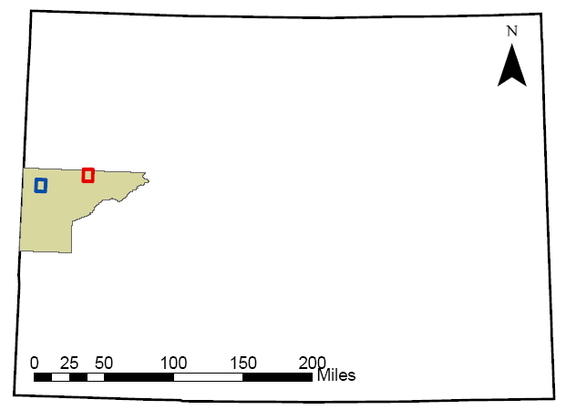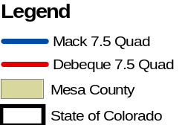
Figure 2a. The two study sites selected by the Tamarisk Coalition are in Mesa County, CO. Plots were collected in the Mack 7.5’ Quad and the Debeque 7.5’ Quad.

Figure 2b. 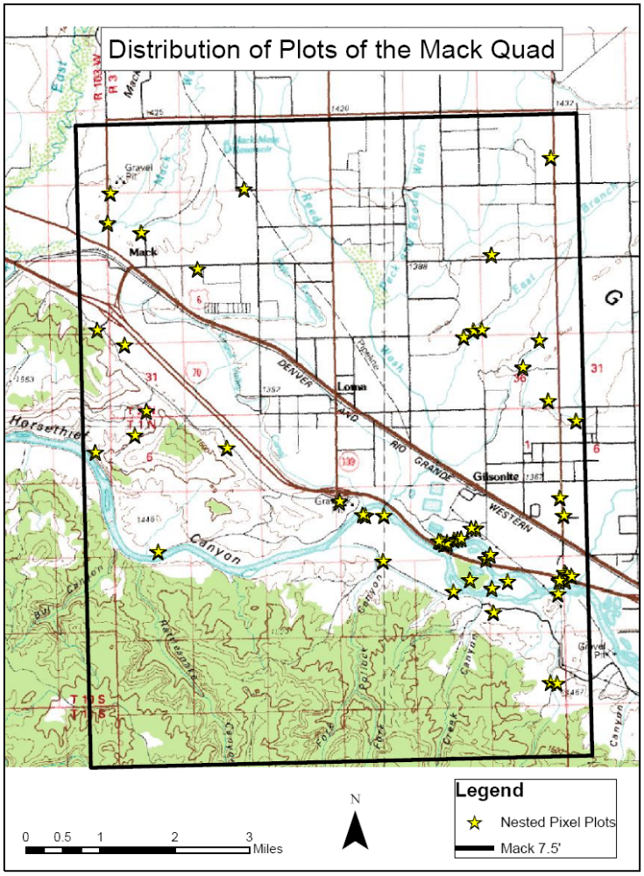
Figure 2b. Distribution of plots on the Mack quad.

Figure 2c. 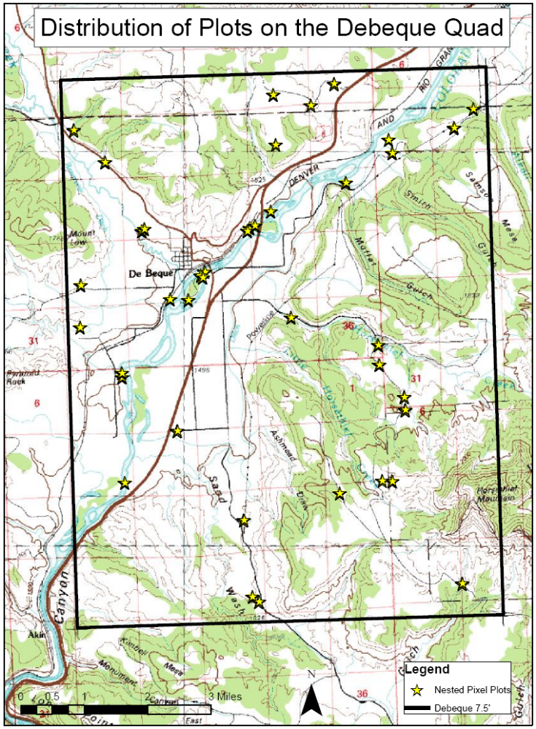
Figure 2c. Distribution of plots on the Debeque quad.

Collection Protocols
The nested pixel plots were always oriented north for consistency. A flag designated the middle of the plot where GPS coordinates were taken. Next, the grid was laid out with flags in the center of each of the 10 m x 10 m plots. Vegetation cover was visually estimated for each subplot within the plot. The same person collected all of the data to ensure that estimates of cover were consistent. Plots were selected using relevé principles to maximize variation. Plots data was collected in nine of the twelve vegetation types that exist on the study sites. The remaining three vegetation types, developed lands, mixed forest, and bare rock occur on less than one percent of these quads and are not typical tamarisk habitats. With these plots we could link tamarisk presence and absence to a wide range of vegetation and soil characteristics.

Analyses
GIS and Remote Sensing Data
Independent variables used in this analysis were comprised of 16 layers including elevation, slope, absolute aspect, hydrology, roads, geology, vegetation type , the raw digital numbers of Landsat Thematic Mapper bands 1-5 and 7, and three Tasseled Cap images, derived from Landsat, representing brightness, wetness, and greenness. Band 6 is a thermal band and was not used in this analysis. We acquired 10 m digital elevation models (DEM) from the United States Geological Survey (USGS) and derived grids of slope and absolute aspect from the DEMs using the raster calculator in ARC/INFO (ESRI 2002). Absolute aspect was used instead of aspect because it is linear instead of circular, maximizing the difference between north and south facing slopes. Distance to water and distance to roads were derived from the hydrology and roads layers using Find Distance in the Spatial Analyst extension of ArcView 3.2 (ESRI 1999). Bedrock type was used from a geology layer from the USGS (http://pubs.usgs.gov/of/1992/ofr-92-0507/). The vegetation layer was a Colorado Vegetation Model developed by Theobald et al. (2004). The Colorado Vegetation Model contained 24 vegetation types within the study areas, which we collapsed to eleven more general types. All grids were clipped to the outline of the USGS quadrangles (LATTICECLIP, Arc Module, ARC/INFO; (ESRI 2002)). All grids were then resampled to a 10 m resolution to match the field data (RESAMPLE, Grid Module, ARC/INFO; (ESRI 2002)). The original 30 m data was kept for the 30 m analysis. All grids were reprojected to Universal Transverse Mercator, NAD83 projection, zone 12. Data values at each plot location were extracted using Visual Basic code (Microsoft 1987-2001) (Appendix A).
We used a Landsat Thematic Mapper 7 image over western Colorado from June 12, 2002. Three Tasseled Cap images were derived from this Landsat image. Tasseled Cap 1 corresponds to brightness, Tasseled Cap 2 corresponds to wetness, and Tasseled Cap 3 corresponds to greenness (Crist 1985). These transformations were performed using Erdas Imagine (ERDAS 1998). All of the datasets were collected from various sources (for metatdata on all of the original datasets used in this analysis see Appendix B).

Model Fitting
We created models to determine the potential habitat and percent canopy cover of tamarisk. These models were fit using either tamarisk presence/absence or with tamarisk percent cover as the dependant variable. Statistics for these models were run using S-Plus (S-PLUS 6.2 2003) and a spatial library developed by Reich and Davis (1998). Classification and regression trees formed the foundation of these models. Classification trees were used for categorical data, presence or absence of tamarisk, and regression trees were used for continuous data, tamarisk percent cover. Classification and regression trees explain variation in the dependant variable by splitting the independent variables into two groups that are more homogenous than the original group (De'ath and Fabricius 2000). New relationships are formed in the two new groups and the data is split repeatedly until each group is either entirely homogeneous or has too few observations in it (<5) to be split further. Classification and regression trees are non-parametric approaches to regression that are fairly robust to sparse data (Reich et al. 2004). To avoid overfitting the data, we used a pruning algorithm that uses a 10-fold cross validation to minimize noise created in a tree with too many terminal nodes (Breiman et al. 1984, Friedl and Brodley 1997, De'ath and Fabricius 2000).
The first model fit predicted tamarisk habitat as 0 (tamarisk absent) or 1 (tamarisk present) with a classification tree using all sixteen independent variables. Once the classification tree was built, the data layers were passed through the tree to create the presence/absence surface. This model was run for 10 m data, 30 m data, with tasseled cap and without tasseled cap. This model was not run without absence points because absence points are essential to create a presence/absence surface.
The second model fit is the percent cover of tamarisk, which involves several steps. The first step was a trend surface analysis to explain large-scale variability in the percent cover data. Multiple regression analysis using ordinary least squares (OLS:Reich and Davis 1998) was used to create this trend surface, using all the independent variables except vegetation and geology, which are categorical and cannot be used in Ordinary Least Squares. For each individual model, stepwise variable selection was used to identify the best subset of variables to use in the regression. Then, to create a surface from the OLS we created an equation using the independent variables and their coefficients.
The second step of the percent cover model was a regression tree with the residuals from the multiple regression analysis as the dependant variable. This analysis helped explain the small-scale variability by explaining the variation in the data that remained after OLS removed the large-scale trend. The same variables were used in this analysis as were used in the presence/absence classification tree with the addition of the trend surface layer as a variable. Using this trend surface as a variable in the regression tree links the two analysis and allows for the trend surface to explain some of the small scale variability. The small-scale variability grid (error) was created similarly to the presence/absence grid, by passing each variable selected in the regression tree through the regression tree.
The final surface was a sum of the trend surface (large-scale variability) and the regression tree (small-scale variability) multiplied by the presence/absence grid to mask areas without suitable habitat. Overall prediction accuracy of these models was determined by the coefficient of determination (R²) value of the model which described how much of the variability in the data was explained by the model (Guisan and Zimmermann 2000).

Model Evaluation
To determine the accuracy of the presence/absence models, a cross validation was run, identifying which of the data points collected were accurately modeled. This validation yields an accuracy of presence and an accuracy of absence, called an error matrix that is commonly used in remote sensing (Campbell 2002). This matrix shows the number of tamarisk presence points modeled accurately and the number wrongly predicted (accuracy of presence) and the inverse, accuracy of absence. An overall accuracy and Kappa statistic were determined from this matrix (Monserud and Leemans 1992). A Kappa statistic between 0.85 and 1.00 indicated there was an excellent degree of agreement between the data and the model, between 0.55 and 0.85 represented good or very good agreement, and 0.4 to 0.55 was considered fair agreement. If the Kappa statistic was < 0.4 the agreement between the data and the model was poor to non-existent.
The percent cover model was evaluated by 10-fold cross-validation by removing 10 % of the data, re-running the model, and determining the accuracy of prediction for the data points that were removed. This process was repeated 10 times so that each data point was excluded once from the model and the model’s response to that data point was predicted. Another way to perform model evaluation is to split a data set in half and then use one half to create the model and one half to evaluate the model. This method requires a large number of data points, and in this case, there were not enough points. As time and monetary constraints often create this obstacle, 10-fold cross validations have been widely used since Stone (1974) and Geisser (1975) evaluated the method.
The residuals of the regression were examined for spatial dependencies using semi-variograms. When significant spatial autocorrelation was found in the residuals of any of the OLS models, we ran a generalized least squares model, obtaining generalized least squares estimates of the regression coefficients associated with the trend surface model (Upton and Fingleton 1985). The residuals were then re-examined to ensure the spatial autocorrelation was removed.
Several methods were used to evaluate the effectiveness of the percent cover models. Prediction bias was determined as:
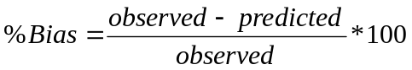
(Williams 1997). Accuracy was determined by using the residuals to find the mean absolute error (MAE) which is a measure of the sum of the residuals, and the root mean square error (RMSE) which is the square root of the sum of the squared residuals (Kravchenko and Bullock 1999, Schloeder et al. 2001). According to Schloeder (2001), small MAE values indicate a model with few overall errors and small RMSE values indicate more accurate predictions locally, or point by point. To determine if the variance was over estimated or underestimated, we used the standardized mean-square error (SMSE) which was an indication of the consistency of the estimation variances (Hevesi et al. 1992). If the value of the SMSE was within the range of 1 ± 2(2/n)^{0.5}, then the estimation variances were considered consistent (Hevesi et al. 1992). For more detailed information on these methods see also Reich et al. (2004).

Results
Tamarisk Models
The presence/absence models of tamarisk yielded absence accuracies between 81% and 94% (Error: Reference source not found). The accuracy of presence ranged from 94% to 96%, except for the Colorado 30m data without Tasseled Cap with 69% accuracy. All of the Kappa statistics showed excellent agreement between the models and the data, except again, the Colorado 30 m data without Tasseled Cap which still had fair agreement.

Table 1. Overall accuracy of the presence/absence models for tamarisk in Colorado. (Tass = Tasseled Cap)
Model | Accuracy of Absence | Accuracy of Presence | Overall Accuracy | Kappa Statistic
30m all data | 0.81 | 0.96 | 0.89 | 0.78
10m all data | 0.94 | 0.94 | 0.94 | 0.87
30m all data No Tass | 0.84 | 0.69 | 0.76 | 0.52
10m all data No Tass | 0.94 | 0.94 | 0.94 | 0.88

Semi-variograms found significant spatial autocorrelation in the 10 m data at each sites (Appendix C). Generalized least squares estimates were used in the creation of the trend surface for these models.
The field data collected were highly skewed to the right (Table 2), because of many absence values, but normality was not assumed by the methods so the data was not transformed to remove this skew. However, the residuals of the trend surface model tended to have a normal distribution.
Table 2. Summary statistics of observed and estimated Tamarisk percent cover for two quadrangles in Colorado from 10-fold cross-validation. (Obs = observed, Est. = estimated, N = sample size)
 | With Tasseled Cap
Statistic | All Data |  |  |  | Only presence Points
Statistic | 30m |  | 10m |  | 30m |  | 10m
Statistic | Obs. | Est. | Obs. | Est. | Obs. | Est. | Obs. | Est.
N | 94 | 94 | 846 | 846 | 51 | 51 | 353 | 353
Mean | 25.0 | 26.9 | 24.1 | 24.8 | 45.0 | 43.0 | 57.9 | 52.9
Standard Deviation | 32.3 | 28.1 | 35.6 | 26.48 | 32.1 | 26.7 | 33.5 | 22.3
Coefficient of Variation (%) | 135 | 104 | 149 | 107 | 73 | 62 | 62 | 42
Minimum | 0 | 0 | 0 | 0 | 1.9 | 0 | 3.8 | 0
First quantile | 0 | 6.4 | 0 | 3.4 | 15.8 | 24.3 | 29.1 | 35.5
Median | 7.0 | 16.3 | 0 | 15.7 | 39.6 | 41.8 | 56.9 | 55.6
Third quantile | 42.3 | 37.7 | 41.6 | 38.2 | 69.2 | 68.9 | 100 | 67.5
Maximum | 100 | 100 | 100 | 100 | 100 | 92.8 | 100 | 100
Bias% | -7.67 |  | -2.69 |  | 4.40 |  | 8.57

Table 2 cont’d. Summary statistics of observed and estimated Tamarisk percent cover for two quadrangles in Colorado from 10-fold cross-validation. (Obs = observed, Est. = estimated, N = sample size)
 | Without Tasseled Cap
Statistic | All Data |  |  |  | Only presence Points
Statistic | 30m |  | 10m |  | 30m |  | 10m
Statistic | Obs. | Est. | Obs. | Est. | Obs. | Est. | Obs. | Est.
N | 94 | 94 | 846 | 846 | 51 | 51 | 353 | 353
Mean | 25.0 | 25.2 | 24.1 | 26.2 | 45.0 | 48.3 | 57.9 | 54.5
Standard Deviation | 32.3 | 24.4 | 35.6 | 30.02 | 32.1 | 27.0 | 33.5 | 27.5
Coefficient of Variation (%) | 135 | 97 | 149 | 115 | 73 | 56 | 62 | 50
Minimum | 0 | 0 | 0 | 0 | 1.9 | 0 | 3.8 | 0
First quantile | 0 | 2.7 | 0 | 3.0 | 15.8 | 28.8 | 29.1 | 34.7
Median | 7.0 | 20.6 | 0 | 11.9 | 39.6 | 49.3 | 56.9 | 55.8
Third quantile | 42.3 | 36.9 | 41.6 | 42.5 | 69.2 | 61.6 | 100 | 76.9
Maximum | 100 | 95.9 | 100 | 100 | 100 | 100 | 100 | 100
Bias% | -0.60 |  | -8.70 |  | -7.81 |  | 5.50

Variables that were commonly selected in removing large-scale variability included elevation, distance to water, and Landsat bands 2 and 7 (Table 3). Tasseled Cap 1, representing brightness, was selected in all trend surface models where it was a potential predictor, while Tasseled Cap indices 2 and 3, representing wetness and greenness, were never selected when they were potential predictors. In the regression trees, elevation was again selected in almost all models as a predictor (Table 4). Other commonly selected variables were the trend surface, distance to roads, and vegetation. The tree sizes selected to avoid over-fitting the model varied from 2 nodes to 41 nodes (Appendix D).
Table 3. Trend surface models for describing the coarse-scale variability in tamarisk percent cover in two quadrangles of Colorado. Circles indicate the inclusion of a variable in the trend surface. Open circles were not used in those models.
Model | Topography¹ |  |  | Landsat TM Bands² |  |  |  |  |  |  |  |  | Environmental
Model | E | S | A | B1 | B2 | B3 | B4 | B5 | B7 | T1 | T2 | T3 | W | R
30m all data | ● |  |  |  |  |  |  | ● | ● | ● |  |  | ●
30m pres only | ● |  |  |  | ● |  |  |  | ● | ●
10m all data | ● |  | ● | ● | ● | ● |  | ● | ● | ● |  |  | ●
10m pres only | ● |  |  |  | ● |  |  |  | ● | ● |  |  | ●
30m all data No Tass | ● |  |  |  |  |  |  | ● | ● | ○ | ○ | ○ | ●
30m pres only No Tass | ● |  |  |  | ● |  |  |  | ● | ○ | ○ | ○ | ●
10m all data No Tass | ● |  |  | ● | ● |  | ● | ● | ● | ○ | ○ | ○ | ●
10m pres only No Tass | ● | ● |  |  | ● |  |  |  | ● | ○ | ○ | ○ | ●
¹ E – elevation, S - slope, A – absolute aspect
² B1 – Landsat band 1, B2 – Landsat band 2, B3 – Landsat band3, B4 – Landsat band 4, B5 – Landsat band 5, B7 – Landsat band 7, T1 – Tasseled Cap 1, T2- Tasseled Cap 2, T3 - Tasseled Cap 3
³ W – distance to water, R – distance to roads, V – vegetation, G - geology

.
Table 4. Variables used in the binary regression trees to describe the error in the trend surface model of tamarisk percent cover in two quadrangles of Colorado. Vegetation type and geology were treated as a categorical variables in the regression trees. Open circles were not used in those models.
Model | Topography¹ |  |  |  | Landsat TM Bands ² |  |  |  |  |  |  |  |  | Environmental ³
Model | E | S | A | B1 |  | B2 | B3 | B4 | B5 | B7 | T1 | T2 | T3 | W | R | V | G | TS
30m all data |  |  |  |  |  |  |  |  |  |  |  |  |  |  |  |  |  | ●
30m pres only | ● |  |  |  |  |  |  |  | ●
10m all data | ● | ● | ● |  |  |  | ● | ● | ● | ● | ● | ● |  | ● | ● | ● | ● | ●
10m pres only | ● | ● | ● | ● |  | ● | ● | ● | ● | ● |  |  |  | ● | ● | ● |  | ●
30m all data No Tass | ● |  |  |  |  |  |  |  |  |  | ○ | ○ | ○ |  | ● | ● |  | ●
30m pres only No Tass | ● |  |  |  |  |  |  |  | ● |  | ○ | ○ | ○ |  |  |  |  | ●
10m all data No Tass | ● |  | ● | ● |  | ● | ● | ● |  |  | ○ | ○ | ○ | ● | ● | ● | ● | ●
10m pres only No Tass |  | ● | ● | ● |  | ● | ● | ● |  | ● | ○ | ○ | ○ | ● | ● | ● |  | ●
¹ E – elevation, S - slope, A – absolute aspect
² B1 – Landsat band 1, B2 – Landsat band 2, B3 – Landsat band3, B4 – Landsat band 4, B5 – Landsat band 5, B7 – Landsat band 7, T1 – Tasseled Cap 1, T2- Tasseled Cap 2, T3 - Tasseled Cap 3
³ W – distance to water, R – distance to roads, V – vegetation, G – geology, TS – trend surface.
The regression models alone explained 24% (10m presence only, no Tasseled Cap) to 47% (30 m) of the variation in the data, while the regression trees accounted for an additional 1% (30 m) to 51% (10 m no Tasseled Cap) of the variation in the residuals of the trend surface models (Table 5). Overall performance of the final surfaces ranged from 55% for the 30 m model to 85% for the 10 m model. The final model with the highest overall model performance was the 10 m model (Figure 3a, b). The rest of the final surfaces are in Appendix E. All of the models show the areas at highest risk of invasion to be in the riparian areas, especially adjacent to rivers. On the Mack quad, it also looked as if agricultural ditches were at risk of invasion.
Table 5. Overall model performance (R-squared) of the trend surface models (TS) and the use of regression trees (RT) in describing the residuals in the TS models of tamarisk.
Model | TS | RT | TS + RT
30m all data | 0.47 | 0.08 | 0.55
30m pres only | 0.45 | 0.21 | 0.66
10m all data | 0.36 | 0.49 | 0.85
10m pres only | 0.25 | 0.49 | 0.74
30m all data No Tass | 0.42 | 0.27 | 0.69
30m pres only No Tass | 0.42 | 0.28 | 0.70
10m all data No Tass | 0.33 | 0.51 | 0.84
10m pres only No Tass | 0.24 | 0.48 | 0.72

Figure 3a.
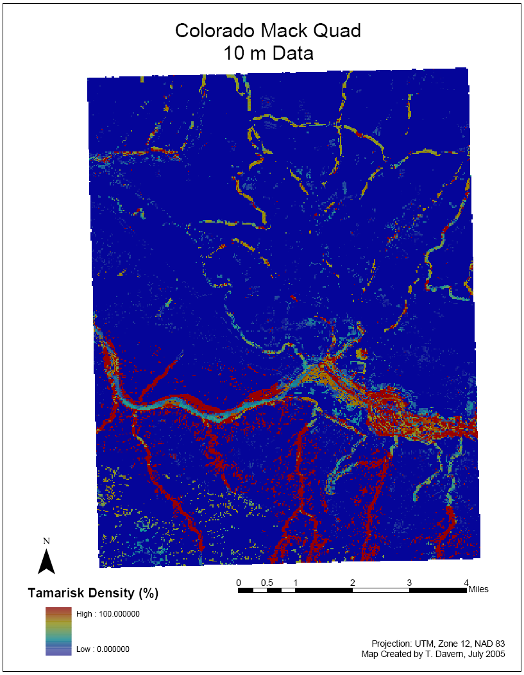
Figure 3a. Predicted percent cover of tamarisk for the Mack Quadrangle of Colorado, modeled using 10m Data.

Figure 3b.

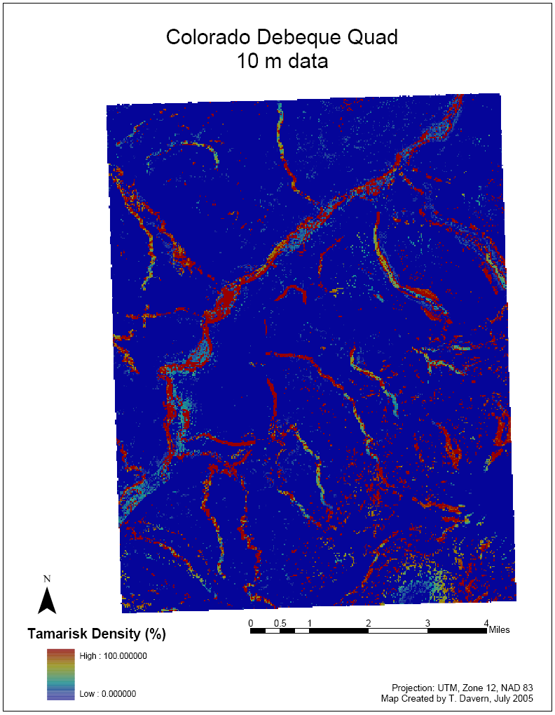
Figure 3b. Predicted percent cover of tamarisk for the Debeque Quadrangle of Colorado, modeled using 10m Data.

Model Evaluation

Prediction bias was nominal for all models, ranging from 8.6% (10 m/presence only/with TC) to -8.7% (10 m/all data/no TC). The observed and estimated minimum, maximum, and quartile distribution values were similar for all models (Table 6). All models that were run had a similar spread in estimation errors, with the 30 m/all data/ with TC having the smallest error spread and the 10 m/presence only/with TC having the largest error spread. The MAE was smaller than the RMSE for all models indicating that the models were generally better at predicting regional or global means than specific points (Schloeder et al. 2001).
SMSE results show that for most models the variance was within a 95% confidence interval using Hevesi’s (1992) formula, 1 ± 2(2/n)^{0.5} (Table 6). All but one model was within a 99% confidence interval. The model outside this interval was the 10 m/all data/no TC model, which slightly underestimated the variance.

Table 6. Summary statistics of estimation errors for the percent cover of tamarisk for Colorado based on the 10-fold cross-validation.
Statistic ¹ | 30m  All Data  Tass Cap | 10m  All Data  Tass Cap | 30m  Pres Only  Tass Cap | 10m  Pres Only  Tass Cap | 30m  All data  No Tass Cap | 10m  All Data  No Tass Cap | 30m  Pres Only No Tass Cap | 10m Pres Only No Tass Cap
N | 94 | 846 | 51 | 353 | 94 | 846 | 51 | 353
Mean | 1.9 | 0.6 | 2.0 | 5.0 | 0.2 | 2.1 | 3.5 | 3.2
IQR | 25.1 | 28.6 | 50.53 | 55.89 | 28.93 | 26.46 | 31.46 | 47.26
MAE | 21.7 | 22.5 | 27.93 | 28.86 | 21.99 | 27.04 | 24.19 | 28.90
RMSE | 30.6 | 32.2 | 32.42 | 34.30 | 30.62 | 39.56 | 30.67 | 35.97
SMSE | 0.8 | 0.9 | 0.76 | 0.79 | 0.71 | 1.21 | 0.65 | 0.80
0.95 confidence coverage rate | 0.92 | 0.95 | 1.00 | 0.99 | 0.96 | 0.87 | 0.96 | 0.97
¹ IQR = interquartile range, MAE = mean absolute error, RMSE = root mean square error, SMSE = standardized mean square error.

Discussion
After comparing all eight models, the model using the 10 m resolution data, both presence and absence locations, and the Tasseled Cap variables was the best fit for the field data collected (Figure 3a, b). With 85% of the variability in the data explained by this top model, the main objective of this study has been met. We estimated the potential habitat and percent cover of tamarisk using the data set collected.
Our second objective was to see if the Tasseled Cap index improved the models. Adding the Tasseled Cap indices to the percent cover model did improve the fit of the final 10 m/all data model, but only by 1%. But, in the presence absence model the Kappa statistic of the model without the Tasseled Cap index is one percent better. This means that we have failed to prove that using the Tasseled Cap index makes a significant improvement on the model. Using the raw digital numbers from the Landsat bands 1-5 and 7 alone fits a model that is very similar to a model fit with the Tasseled Cap index derived from these bands. The most common Landsat bands chosen in the large scale variability were two and seven. Band two records green radiation and is used to assess plant vigor, and band seven discriminates between rock types and is used in hydrothermal mapping (Campbell 2002). These two bands are also logically useful in delineating tamarisk habitat. The green of the leaves can be picked up by the sensor and possibly even distinguished from the green of other plants if the stand is big enough. And Band seven may be detecting hydrothermal zones that are associated with the evapotranspiration of tamarisk. The Tasseled Cap bands were just not selected as often as Landsat bands, but when selected, TC 1 was the only one chosen. This band represents brightness. Greenness and wetness were not selected either because when they were combined into the index the part that identified tamarisk was less apparent, or the landsat bands were serving the same purpose and did it better. Again, we find that using the raw digital numbers and the Tasseled Cap index is superfluous.
The third objective of determining if the percent cover model fit the regression better with all of the data or with just the presence data was evaluated using the coefficient of variation. When absence points were excluded from the data set the coefficient of variation consistently dropped to nearly half of what it was when the absence points were included (Table 2). This means that variation of the data when compared to the mean is minimized when the absence points are removed. This could be because there are so many absence points causing a large skew in the data that when these points are removed the model fits better. With this particular data set, the model fits better without the absence points. But it could be the case that a data set with less zeros would find a different result. This is a topic for future research.
The final objective examined scale and the difference between the 10 m x 10 m data and the 30 m x 30 m data. Aggregating the data into 30 m plots yielded much lower R² values than leaving the data in its original 10 m format. The best of the 10 m data was the 10 m/all data/with TC with an R² value of 85% and the equivalent 30 m model, 30 m/all data/with TC had an R² value of 55%. While the quality of the data did not change when it was resampled to a 10 m resolution, using 10 m x 10 m plot sizes may have allowed for the centroid of one plot to fall in a different Landsat pixel than the centroid of the one next to it, pulling more information out of identical data. For instance three of the plots in a nine plot cluster may have fallen into one Landsat pixel, and the remaining six in a different pixel. This may correspond to where the tamarisk is and were it is not within the plot, fitting a better model than a 30 m x 30 m plot size could have created.
Some of the data layers that were most important in these models include distance to water, elevation, and the Landsat band 7. Because tamarisk needs a steady supply of water and its most frequent habitat is riparian areas (Everitt 1980), it makes sense that distance to water was an important variable in these models. Elevation could be acting in tandem with distance to water, as lower areas would tend to be closer to water, but elevation also could be acting as a surrogate for climate variables such as temperature. According to Peet, (1988), the largest sources of environmental variation in the Rocky Mountains region are elevation, moisture, and temperature. The third most common variable chosen in the trend surface models was Landsat band 7 which discriminates between different types of rock and is used for hydrothermal mapping (Campbell 2002). This variable could have been important because the two study sites were in arid environments. There were large areas of bare soil and sparse vegetation in the field areas sampled, which was a major factor in the large number of absence points and could explain why the Landsat band 7 emerged as such an important layer in this analysis. Tamarisk requires bare, moist, high-light environments for germination and establishment (Shafroth et al. 1998) and since Landsat band 7 distinguishes hydrothermal areas, that could be the reason why band 7 emerged as a predictor so often in the trend surface model.
The analyses performed here all served unique purposes. The presence/absence model determined potential habitat. This model delineated areas with favorable conditions for tamarisk survival if it were to spread (i.e, habitat suitability). The percent cover model predicted areas most suitable for tamarisk cover. When these two surfaces were multiplied together the final surface yielded the potential canopy cover of tamarisk in the habitat where it could grow. The same type of analysis has been done by Reich et al. (2004) on forest fuel types, but this type of study has not yet been published for tamarisk and could help land managers determine the frontier of the invasion, optimizing the application of control methods. For example, if you look at bottom third of the Mack Quad final model (Figure 3a), you will see several red fingers reaching down from the main stretch of the river. These areas are not yet heavily invaded, but the red color indicates that they are at high risk of invasion. These would be high priority areas for monitoring, early detection, and rapid response.
Past research has been done to locate other invasive species with multispectral and hyperspectral images. There have been many studies conducted that locate invasive species using multispectral images such as Landsat, which was used here. Arzandeh and Wang (2003) used Landsat to monitor the change in Phragmites australis distribution, and Bradley and Mustard (2005) used it to find land cover change of cheatgrass (Bromus tectorum). Unfortunately, there is a limit to what can be done with Landsat because of its 30 m resolution and seven spectral bands. The modeling techniques used in this paper are excellent resources, but share the same limitations. Many of the data layers used in these models have a resolution of 30 m even when resampled to 10 m (See Appendix B). This resolution may not detect infestations that are smaller than the size of the Landsat pixel (30 m), which is important for early detection of small infestations. Secondly, these predictions are models; our best estimates of what nature’s next move will be based on current conditions. They are vulnerable to sources of error. They give an excellent prediction of what may come next, but environmental conditions can change, especially with disturbances like wildfires or floods. However, the presence/absence model can identify potential areas of future invasion and guide targeted surveys and monitoring.
Several areas could be examined in order to improve on the models created. More data sets such as plant dispersion, wind directions, and invasion process would be useful to create a better model. In addition, a temporal data set could provide information on how fast and where this plant is spreading. Products like Moderate Resolution Imaging Spectroradiometer (MODIS) data are moving towards this temporal aspect. MODIS data is collected every day, which gives data at a very fine temporal resolution; unfortunately it is at a very coarse spatial resolution. We are making progress, and hopefully will have better datasets in the future to help improve the results of these modeling techniques even further.
It would also be useful to expand this model to a larger area. Two quarter quads are a great place to start, but we need to increase the extent and look at a larger geographic distribution. This of course will create its own problems. It will be difficult to determine the extent that one model will fit before the environmental variables change enough to affect the fit. These are questions for future research on this topic.
Fortunately no matter which analysis or imagery is chosen, the field sampling methods outlined in this paper will be effective due to the multi-scale plot design. These plots can be used to validate imagery from 30 m to 10 m and will complement a variety of analyses.

References:

Arzandeh, S., and J. F. Wang. 2003. Monitoring the change of Phragmites distribution using satellite data. Canadian Journal of Remote Sensing 29:24-35.
Bradley, B. A., and J. F. Mustard. 2005. Identifying land cover variability distinct from land cover change: Cheatgrass in the Great Basin. Remote Sensing of Environment 94:204-213.
Breiman, L., J. H. Friedman, R. A. Olshen, and C. G. Stone. 1984. Classification and Regression Trees. Wadsworth International Group, Belmont, California, USA.
Brotherson, J. D., and D. Field. 1987. Tamarix: Impacts of a successful weed. Rangelands 9:110-112.
Campbell, J. B. 2002. Introduction to remote sensing, 3rd edition. Guilford Press, New York.
Crist, E. P. 1985. A Tm Tasseled Cap Equivalent Transformation for Reflectance Factor Data. Remote Sensing of Environment 17:301-306.
Crist, E. P., and R. C. Cicone. 1984. A Physically-Based Transformation of Thematic Mapper Data - the Tm Tasseled Cap. Ieee Transactions on Geoscience and Remote Sensing 22:256-263.
Crosier, C. S. 2004. Synergistic methods to generate predictive models at large spatial extents and fine resolution. Colorado State University, Fort Collins.
De'ath, G., and K. E. Fabricius. 2000. Classification and regression trees: A powerful yet simple technique for ecological data analysis. Ecology 81:3178-3192.
Di Tomaso, J. M. 1998. Impact, biology, and ecology of saltcedar (Tamarix spp.) in the southwestern United States. Weed Technology 12:326-336.
ERDAS. 1998. IMAGINE. ERDAS, Inc, Atlanta, GA.
ESRI. 1999. ArcView GIS 3.2. Environmental Systems Research Institute, Redlands, California.
ESRI. 2002. Arc/Info. Version 8.2. Environmental Systems Research Institute, Redlands, California.
Everitt, B. L. 1980. Ecology of Saltcedar - Plea for Research. Environmental Geology 3:77-84.
Friedl, M. A., and C. E. Brodley. 1997. Decision tree classification of land cover from remotely sensed data. Remote Sensing of Environment 61:399-409.
Geisser, S. 1975. Predictive Sample Reuse Method with Applications. Journal of the American Statistical Association 70:320-328.
Guisan, A., and N. E. Zimmermann. 2000. Predictive habitat distribution models in ecology. Ecological Modelling 135:147-186.
Hevesi, J. A., J. D. Istok, and A. L. Flint. 1992. Precipitation Estimation in Mountainous Terrain Using Multivariate Geostatistics .1. Structural-Analysis. Journal of Applied Meteorology 31:661-676.
Joy, S. 2002. Northern Goshawk habitat on the Kaibab National Forest in Arizona: Factors affecting nest locations and territory quality. Colorado State University, Fort Collins.
Kalkhan, M. A. 2004. Pixel Square Plot Sampling Designs: A Landscape-Scale Assessment Approach. in 89th Annual Meeting Ecological Society of America, Portland, Oregon, USA.
Klinka, K., H. Quan, J. Pojar, and D. U. Meidinger. 1966. Classification of natural forest communities of coastal British Columbia. Vegetatio 125:125-168.
Kravchenko, A., and D. G. Bullock. 1999. A comparative study of interpolation methods for mapping soil properties. Agronomy Journal 91:393-400.
Microsoft. 1987-2001. Visual Basic 6.3. Microsoft Corp., Redmond, Washington.
Monserud, R. A., and R. Leemans. 1992. Comparing Global Vegetation Maps with the Kappa-Statistic. Ecological Modelling 62:275-293.
Mueller-Dombois, D., and H. Ellenberg. 1974. Aims and Methods of Vegetation Ecology. Wiley, New York.
Pearce, C. M., and D. G. Smith. 2003. Saltcedar: Distribution, abundance, and dispersal mechanisms, northern Montana, USA. Wetlands 23:215-228.
Peet, R. K. 1988. Forests of the Rocky Mountains. Pages 63-102 in M. G. Barbour and W. D. Billings, editors. North American terrestrial vegetation. Cambridge University Press.
Peinado, M., F. Alcaraz, J. L. Aguirre, and J. Delgadillo. 1995. Major plant communities of warm North American deserts. Journal of Vegetation Science 8:505-528.
Reich, R. M., and V. A. Bravo. 1998. Integrating spatial statistics with GIS and remote sensing in designing multiresource inventories. Pages 202-207 in North America Science Symposium: Toward a unified framework for inventorying and monitorin forest ecosystem resources. USDA Rocky Mountain Research Station Proceedings, RMRS-P-12, Guadalajara, Jalisco, Mexico.
Reich, R. M., and R. A. Davis. 1998. On-line spatial library for the S-PLUS statistical software package. in. Colorado State University, Fort Collins, CO.
Reich, R. M., J. E. Lundquist, and V. A. Bravo. 2004. Spatial models for estimating fuel loads in the Black Hills, South Dakota, USA. International Journal of Wildland Fire 13:119-129.
Rejmanek, M., and M. J. Pitcairn. 2002. When is eradication of exotic pest plants a realistic goal? Pages 249-253 in M. N. Clout, editor. Turning the tide: the eradication of invasive species. IUCN SSC Invasive Species Specialist Group, IUCN, Gland, Switzerland and Cambridge, UK.
Rivas-Martinez, S. 1997. Syntaxonomical synopsis of the potential natural plant communities of North America. Itinera Geobotanica 10:5-148.
Schloeder, C. A., N. E. Zimmerman, and M. J. Jacobs. 2001. Comparison of methods for interpolating soil properties using limited data. Soil Science Society of America Journal 65:470-479.
Shafroth, P. B., G. T. Auble, J. C. Stromberg, and D. T. Patten. 1998. Establishment of woody riparian vegetation in relation to annual patterns of streamflow, Bill Williams River, Arizona. Wetlands 18:577-590.
Simberloff, D., I. M. Parker, and P. N. Windle. 2005. Introduced species policy, management, and future research needs. Frontiers in Ecology and the Environment 3:12-20.
S-PLUS 6.2. 2003. S-PLUS 6.2. Insightful Corp., Seattle, Washington.
Stone, M. 1974. Cross-Validatory Choice and Assessment of Statistical Predictions. Journal of the Royal Statistical Society Series B-Methodological 36:111-147.
Talbot, S. S., and S. L. Talbot. 1994. Numerical classification of the coastal vegetation of Attu Island, Aleutian Islands, Alaska. Journal of Vegetation Science 5:867-876.
Theobald, D. 2003. point_rasterValue. in, Fort Collins, CO.
Theobald, D. M., N. Peterson, and W. Romme. 2004. The Colorado Vegetation Model: Using National Land Cover Data and Ancillary Spatial Data to Produce a High Resolution, Fine-Classification Map of Colorado (v8), 4 February. in. Unpublished Report, Natural Resource Ecology Lab, Colorado.
Upton, G. J. G., and B. Fingleton. 1985. Spatial Data Analysis by Example. John Wiley & Sons, New York.
Williams, M. S. 1997. A Regression Technique Accounting for Heteroscedastic and Asymmetric Errors. Journal of Agricultural, Biological, and Environmental Statistics 2:108-129.

APPENDIX A
Examples of Computer Code Used
Sample S-PLUS code used to create models
This is Colorado 30m with No Tasseled Cap.

Presence Absence model

S-PLUS : Copyright (c) 1988, 2003 Insightful Corp.
S : Copyright Lucent Technologies, Inc.
Academic Site Edition Version 6.2.1 for Microsoft Windows : 2003
Working data will be in C:\PROGRA~1\INSIGH~1\splus62\users\tdavern
This program will expire in 82 days.

Original dataset = co30m
Took columns 6:14,18,20:23
> co30ntpa[1,]
tam.p.a veg2 geol b1 b2 b3 b4 b5 b7 hyddst rdsdst elevation
1 0 500 113 64 45 71 63 91 85 183.0185 773.3884 1435

slope abasp
1 15.21589 107.2799
> co30ntpa[,1]<-as.factor(co30ntpa[,1])
> co30ntpa[,2]<-as.factor(co30ntpa[,2])
> co30ntpa[,3]<-as.factor(co30ntpa[,3])
> co30ntpah<-tree(tam.p.a~.,data=co30ntpa)
> summary(co30ntpah)

Classification tree:
tree(formula = tam.p.a ~ ., data = co30ntpa)
Variables actually used in tree construction:
[1] "geol" "veg2" "abasp" "rdsdst" "hyddst" "elevation"
Number of terminal nodes: 10
Residual mean deviance: 0.5143 = 43.2 / 84
Misclassification error rate: 0.1064 = 10 / 94
> plot(co30ntpah)
> text(co30ntpah,cex=.8
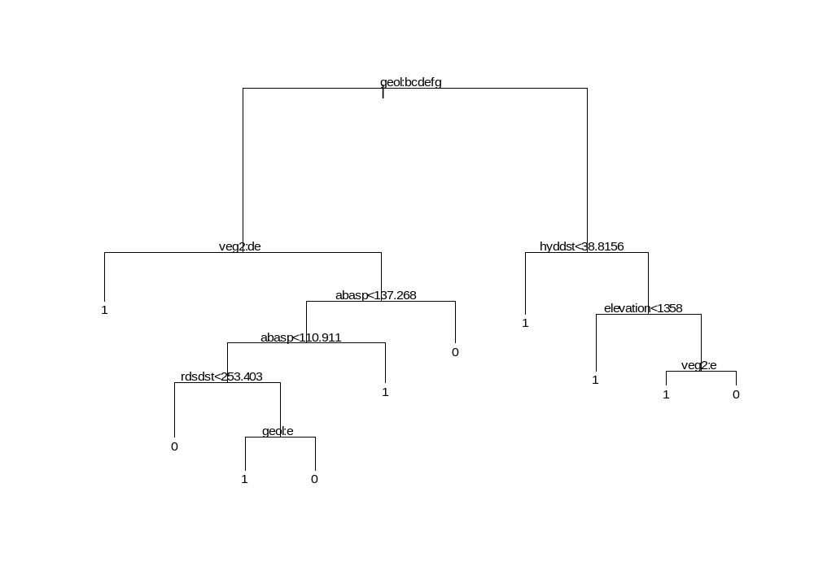
> co30ntpah.cv<-cv.tree(co30ntpah)
> co30ntpah.cv
$size:
[1] 1.040093 1.570568 3.033218 5.241923 6.589799 7.533759 8.398069 9.017296 9.483185 9.846638

$dev:
[1] 134.5429 134.0285 135.7693 140.7792 144.6422 149.3541 156.6574 166.6346 181.0854 209.7554

$k:
[1] 0.0500000 0.1052632 0.1666667 0.2352941 0.3125000 0.4000000 0.5000000 0.6153846 0.7500000 0.9090909

attr(, "class"):
[1] "shrink" "tree.sequence"
> plot(co30ntpah.cv)
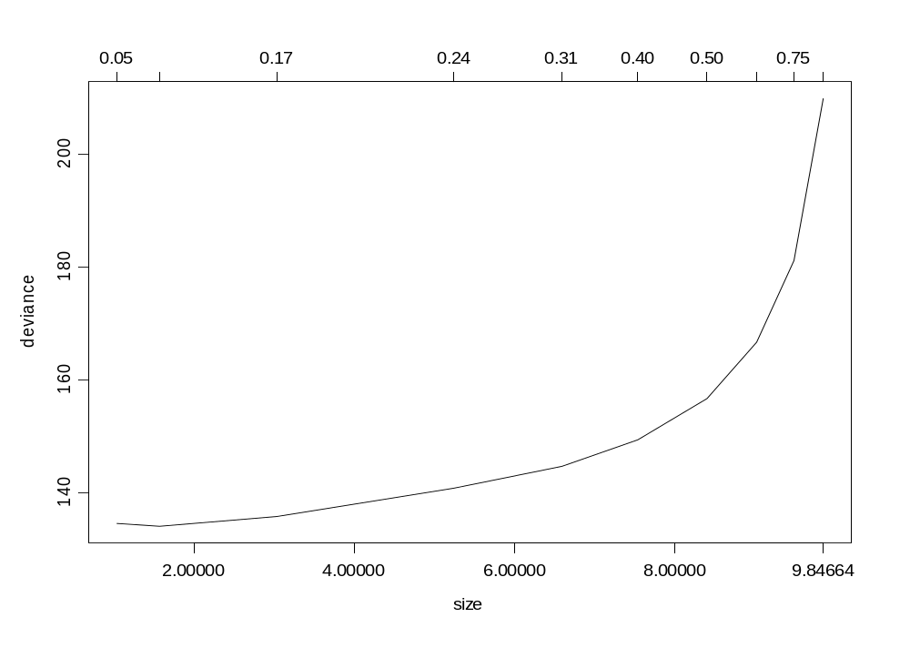
> co30ntpah.prune<-prune.tree(co30ntpah, best=3)
> summary(co30ntpah.prune)

Classification tree:
snip.tree(tree = co30ntpah, nodes = c(2., 7.))
Variables actually used in tree construction:
[1] "geol" "hyddst"
Number of terminal nodes: 3
Residual mean deviance: 1.008 = 91.71 / 91
Misclassification error rate: 0.2447 = 23 / 94
> co30ntpah.prune
node), split, n, deviance, yval, (yprob)
* denotes terminal node

1) root 94 129.60 1 ( 0.4574 0.5426 )
2) geol:2,12,37,91,94,113 52 64.19 0 ( 0.6923 0.3077 ) *
3) geol:1,121 42 37.85 1 ( 0.1667 0.8333 )
6) hyddst<38.8156 20 0.00 1 ( 0.0000 1.0000 ) *
7) hyddst>38.8156 22 27.52 1 ( 0.3182 0.6818 ) *
> plot(co30ntpah.prune)
> text(co30ntpah.prune,cex=.8)
>
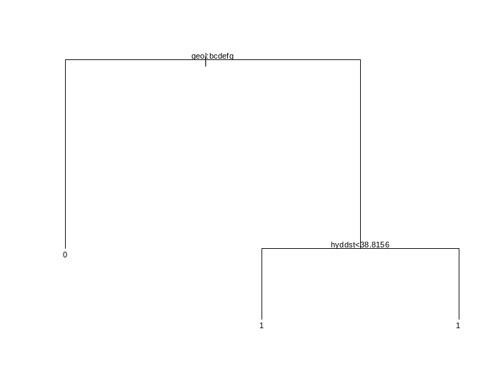
> co30ntpah.pred<predict.tree(co30ntpah.prune,type="class")
Problem: Object "co30ntpah.pred" not found
Use traceback() to see the call stack
> co30ntpah.pred<-predict.tree(co30ntpah.prune,type="class")
> table(co30ntpa[,1],co30ntpah.pred)
0 1
0 36 7
1 16 35
> 36/43
[1] 0.8372093
> 35/51
[1] 0.6862745
>

CO 30m no tc % cover model

> co30m[1,]
site site.name utmx utmy tam.cov tam.p.a veg2 geol b1 b2 b3 b4 b5 b7 tass1 tass2 tass3 hyddst veg rdsdst elevation
1 1 mk222 683734.1 4339605 0 0 500 113 64 45 71 63 91 85 208 108 112 183.0185 517 773.3884 1435

slope abasp
1 15.21589 107.2799
> co30ntd<-co30m[,c(5,7:14,18,20:23)]
> co30ntd[1,]
tam.cov veg2 geol b1 b2 b3 b4 b5 b7 hyddst rdsdst elevation slope abasp
1 0 500 113 64 45 71 63 91 85 183.0185 773.3884 1435 15.21589 107.2799
> stepwise(co30ntd[,4:14],co30ntd[,1])
$rss:
[1] 81084.72 71501.71 60840.16 56362.60

$size:
[1] 1 2 3 4

$which:
b1 b2 b3 b4 b5 b7 hyddst rdsdst elevation slope abasp
1(+7) F F F F F F T F F F F
2(+9) F F F F F F T F T F F
3(+5) F F F F T F T F T F F
4(+6) F F F F T T T F T F F

$f.stat:
[1] 18.127713 12.196264 15.771475 7.070356

$method:
[1] "efroymson"

> library(robin)
> co30ntd.ols<-ols(co30ntd[,1],co30ntd[,c(8:10,12)])

Residual Standard Error = 25.1652, Multiple R-Square = 0.4193
N = 94, F-statistic = 16.0666 on 4 and 89 df, p-value = 0

coef std.err t.stat p.value
Intercept 242.6766 40.4426 6.0005 0.0000
b5 -1.1211 0.2406 -4.6596 0.0000
b7 0.6997 0.2631 2.6590 0.0093
hyddst -0.0230 0.0078 -2.9597 0.0039
elevation -0.1264 0.0250 -5.0494 0.0000

Log(like) = -434.0047
AIC = 878.0095
AICC = 878.6913
Schwartz = 890.7259
> co30ntd<-cbind(co30ntd,(co30ntd[,1]-co30ntd.ols$resid),co30ntd.ols$resid)
> co30ntd[1,]
tam.cov veg2 geol b1 b2 b3 b4 b5 b7 hyddst rdsdst elevation slope abasp ..2 ..3
1 0 500 113 64 45 71 63 91 85 183.0185 773.3884 1435 15.21589 107.2799 14.54964 -14.54964
> co30ntd.den<-tree(..3~.,data=co30ntd[,-c(1)])
> summary(co30ntd.den)

Regression tree:
tree(formula = ..3 ~ ., data = co30ntd[, - c(1)])
Variables actually used in tree construction:
[1] "elevation" "..2" "rdsdst" "b4" "b7" "abasp" "hyddst"
Number of terminal nodes: 13
Residual mean deviance: 255.6 = 20700 / 81
Distribution of residuals:
Min. 1st Qu. Median Mean 3rd Qu. Max.
-36.3400 -9.1790 -0.7544 0.0000 8.5720 50.2900
> co30ntd.den.cv<-cv.tree(co30ntd.den)
> co30ntd.den.cv
$size:
[1] 1.000000 1.706977 2.668852 4.704011 6.928432 8.370590 9.307941 10.351205 11.623574 12.595211

$dev:
[1] 57259.97 56588.54 53232.29 53116.87 52981.57 53108.59 53553.78 53919.06 54558.05 55317.85

$k:
[1] 0.0500000 0.1052632 0.1666667 0.2352941 0.3125000 0.4000000 0.5000000 0.6153846 0.7500000 0.9090909

attr(, "class"):
[1] "shrink" "tree.sequence"
> plot(co30ntd.den.cv)
>
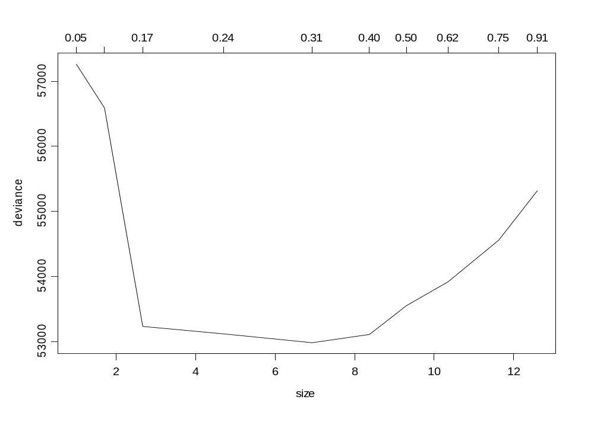
> co30ntd.den.prune<-prune.tree(co30ntd.den,best=7)
> plot(co30ntd.den.prune)
> text(co30ntd.den.prune,cex=.6)
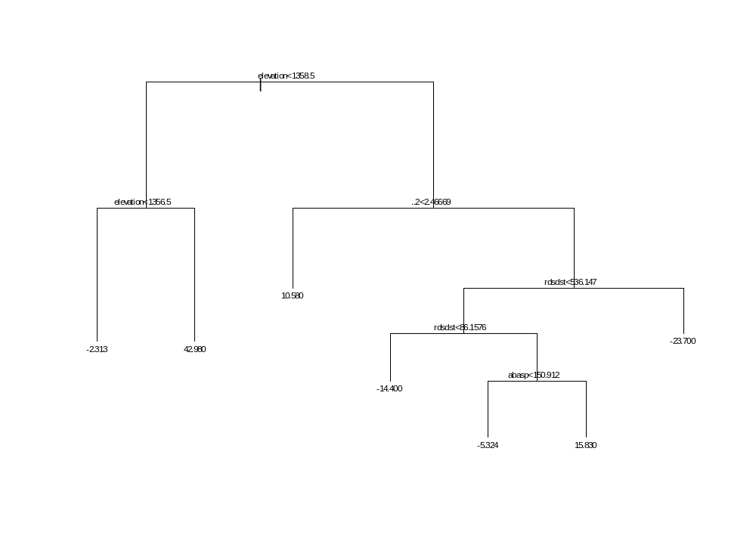
>
> summary(co30ntd.den.prune)

Regression tree:
snip.tree(tree = co30ntd.den, nodes = c(6., 28., 58.))
Variables actually used in tree construction:
[1] "elevation" "..2" "rdsdst" "abasp"
Number of terminal nodes: 7
Residual mean deviance: 345.3 = 30040 / 87
Distribution of residuals:
Min. 1st Qu. Median Mean 3rd Qu. Max.
-36.3400 -10.5500 0.9563 0.0000 8.7470 68.6600
> co30ntd.den.prune
node), split, n, deviance, yval
* denotes terminal node

1) root 94 56360.0 1.304e-015
2) elevation<1358.5 14 12960.0 2.033e+001
4) elevation<1356.5 7 4496.0 -2.313e+000 *
5) elevation>1356.5 7 1280.0 4.298e+001 *
3) elevation>1358.5 80 36610.0 -3.558e+000
6) ..2<2.46669 17 1053.0 1.058e+001 *
7) ..2>2.46669 63 31240.0 -7.373e+000
14) rdsdst<536.147 55 28210.0 -4.997e+000
28) rdsdst<86.1576 19 4198.0 -1.440e+001 *
29) rdsdst>86.1576 36 21450.0 -3.554e-002
58) abasp<150.912 27 13960.0 -5.324e+000 *
59) abasp>150.912 9 4471.0 1.583e+001 *
15) rdsdst>536.147 8 585.3 -2.370e+001 *
> 1-var(residuals.tree(co30ntd.den.prune))/var(co30ntd[,1])
[1] 0.6905169
>

Visual Basic Code (Microsoft 1987-2001) used to extract data from raster layers in ArcGIS
Code written by Dave Theobald (2003).

' Gets value from raster for each point
' Returns: DOUBLE
' Input: Gets values from 1st layer in active dataframe,
' which is assumed to be a raster.
' Note that if No Data value, returns 999999999.9999
' Written by: David Theobald, 20 October 2003
' Modified 26 January 2004
Dim pMxDoc As IMxDocument
Set pMxDoc = ThisDocument

Dim pMap As IMap
Set pMap = pMxDoc.FocusMap
Dim pPoint As IPoint
Dim dValue as Double
Dim dString as String

If (Not IsNull([Shape])) Then
Set pPoint = [Shape]
pPoint.Project pMap.SpatialReference
End If
Dim pLayer as IRasterLayer
Set pLayer = pMap.Layer(0)

Dim pIdentify as IIdentify
Set pIdentify = pLayer
Dim PIDArray as IArray
Set pIDArray = pIDentify.Identify ( pPoint )
Dim pRIDObj as IRasterIdentifyObj

if ( pIDArray is Nothing ) then
' point got a NO Data
dValue = 999999999999.9999
else
Set PRIDObj = pIDArray.Element(0)
dString = pRIDObj.Name

if ( IsNumeric ( dString ) ) then
dValue = CDbl( dString )
else
' dValue = vbNull
dValue = 999999999999.9999
End if
end if
__esri_field_calculator_splitter__
dValue

APPENDIX B
Colorado Data Layers Metadata

Metadata:
Identification_Information: Colorado Vegetation Model

Originator: Dave Theobald, Natural Resource Ecology Laboratory
Publication_Date:
Name and contact information:
David M. Theobald
Natural Resource Ecology Lab
Colorado State University
Fort Collins, CO 80523-1499
davet@nrel.colostate.edu

Online_Linkage: http://www.nrel.colostate.edu/~davet/cvm.html
Description:

The goal of the Colorado Vegetation Model (CVM) is to provide a fine-grained, fine-classed, statewide land cover map for Colorado. Our approach to developing a statewide land cover map was to refine the general NLCD classes using surrogate spatial data and knowledge of ecological processes that control the distribution of land cover types to produce a fine-grained (~1 ha minimum mapping unit) map of land cover types for Colorado. (Theobald et al. 2004)

Spatial_Domain:
Bounding_Coordinates:
West_Bounding_Coordinate: 140061.687500
East_Bounding_Coordinate: 763491.687500
North_Bounding_Coordinate: 4546270.000000
South_Bounding_Coordinate: 4093870.000000

Datum: NAD 27

Projection: UTM

File type: Grid

Cell size: 30 m

How data created: I took the original CVM layer and created a raster grid from it. Then I reclassified the grid to simplify the model, basically into the major classes, while leaving some of the riparian areas distinct.

Table 7. Original values in the Colorado Vegetation Model.
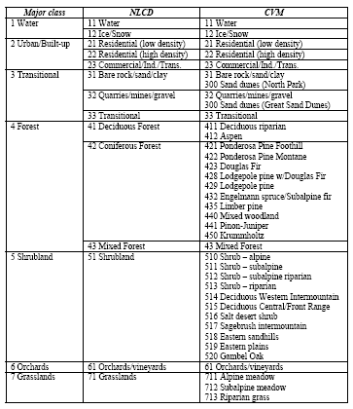
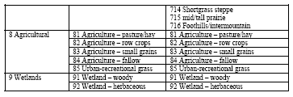

Table 8. Reclass table for Colorado Vegetation.
OrigCode | Original Label | New Code | New Label
11 | Water | 11 | Water
21 | Residential - high | 20 | Developed
22 | Residential - low | 20 | Developed
23 | Commercial | 20 | Developed
31 | Transitional (quarries/ mines/ gravel) | 30 | Transitional
32 | Urban/ recreational grasses | 30 | Transitional
43 | Mixed forest | 43 | Mixed Forest
81 | Pasture/ hay | 80 | Agriculture
82 | row crops | 80 | Agriculture
83 | Small grains | 80 | Agriculture
85 | Urban Recreational Grass | 85 | Agriculture
91 | Bare rock/ sand/ clay | 91 | Bare rock/sand/clay
92 | Wetlands - woody | 92 | Wetland - woody
411 | Deciduous riparian | 400 | Alpine vegetation
412 | Aspen | 400 | Alpine vegetation
440 | Mixed woodland | 400 | Alpine vegetation
441 | Pinon/ Juniper | 400 | Alpine vegetation
513 | Riparian shrub | 513 | Riparian Shrub
514 | Deciduous intermountain | 500 | mid-elevation vegetation
516 | Salt desert shrub | 500 | mid-elevation vegetation
517 | Sagebrush intermountain | 500 | mid-elevation vegetation
520 | Gambel oak | 500 | mid-elevation vegetation
713 | Riparian grassland | 700 | Grassland
716 | Foothills grassland | 700 | Grassland

Metadata:
Identification_Information: Colorado Geology

Originator: United States Geological Survey
Publication_Date:
Name and contact information: Digital geologic map of Colorado
Online_Linkage: http://pubs.usgs.gov/of/1992/ofr-92-0507/READ.2ND
Description:
This geologic map was prepared as a part of a study of digital
methods and techniques as applied to complex geologic maps. The
geologic map was digitized from the original scribe sheets used to
prepare the published Geologic Map of Colorado (Tweto 1979).
Consequently the digital version is at 1:500,000 scale using the
Lambert Conformal Conic map projection parameters of the state base
map. Stable base contact prints of the scribe sheets were scanned on
a Tektronix 4991 digital scanner. The scanner automatically converts
the scanned image to an ASCII vector format. These vectors were
transferred to a VAX minicomputer, where they were then loaded into
ARC/INFO. Each vector and polygon was given attributes derived from
the original 1979 geologic map.

Spatial_Domain:
Bounding_Coordinates:
West_Bounding_Coordinate: -647872.3236005
East_Bounding_Coordinate: 1551150.9309275
North_Bounding_Coordinate: 5419721.75124
South_Bounding_Coordinate: 3220698.496712

Projection: Lambert Conformal Conic

File type: ARC/INFO coverage

Scale: 1:500,000

How data created: Used as is

Metadata:
Identification_Information: De Beque DEM

Originator: United States Geological Survey
Publication_Date: 17-SEP-01
Name and contact information:
Online_Linkage: http://data.geocomm.com/
Description:

Spatial_Domain:
Bounding_Coordinates:
NORTH_LATITUDE: 39.375000
SOUTH_LATITUDE: 39.250000
WEST_LONGITUDE: -108.250000
EAST_LONGITUDE: -108.125000

Datum: North American Datum of 1927

Projection: Transverse Mercator

Zone: 12

Shperoid:

File type: Grid

Cell size: 30 m

How data created: This grid was first resampled to 10 m. From this elevation grid I also derived slope and absolute aspect using ArcView 3.2.

Metadata:
Identification_Information: Mack DEM

Originator: United States Geological Survey
Publication_Date: 17-SEP-01
Name and contact information:
Online_Linkage: http://data.geocomm.com/
Description:

Spatial_Domain:
Bounding_Coordinates:
NORTH_LATITUDE: 39.250000
SOUTH_LATITUDE: 39.125000
WEST_LONGITUDE: -108.875000
EAST_LONGITUDE: -108.750000

Datum: North American Datum of 1927

Projection: Transverse Mercator

Zone: 12

Shperoid:

File type: Grid

Cell size: 10 m

How data created: From this elevation grid I also derived slope and absolute aspect using ArcView 3.2.

APPENDIX C
Variograms used to fit the Generalized Least Squares
Colorado 10 m
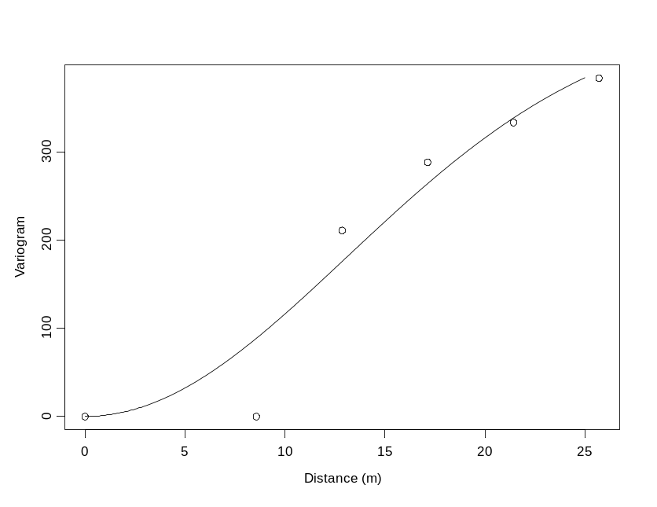
Colorado 10 m, presence only

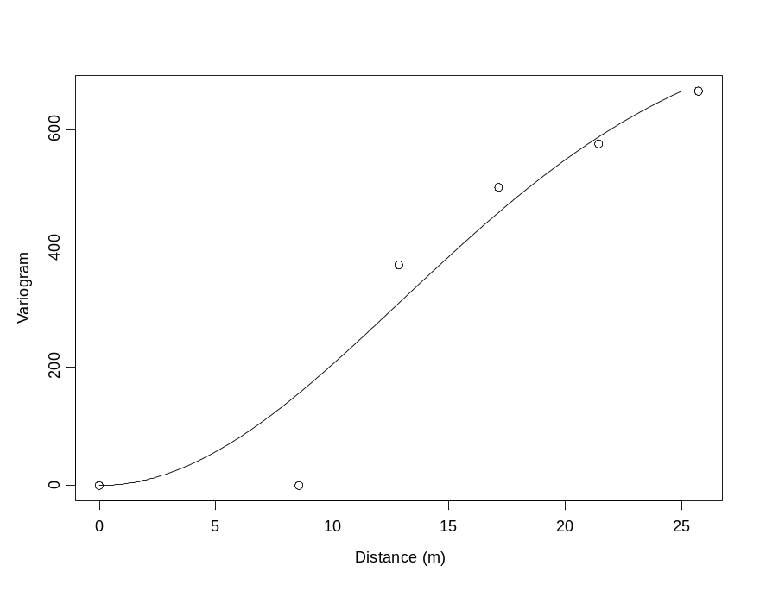

Colorado 10 m, no tasseled cap
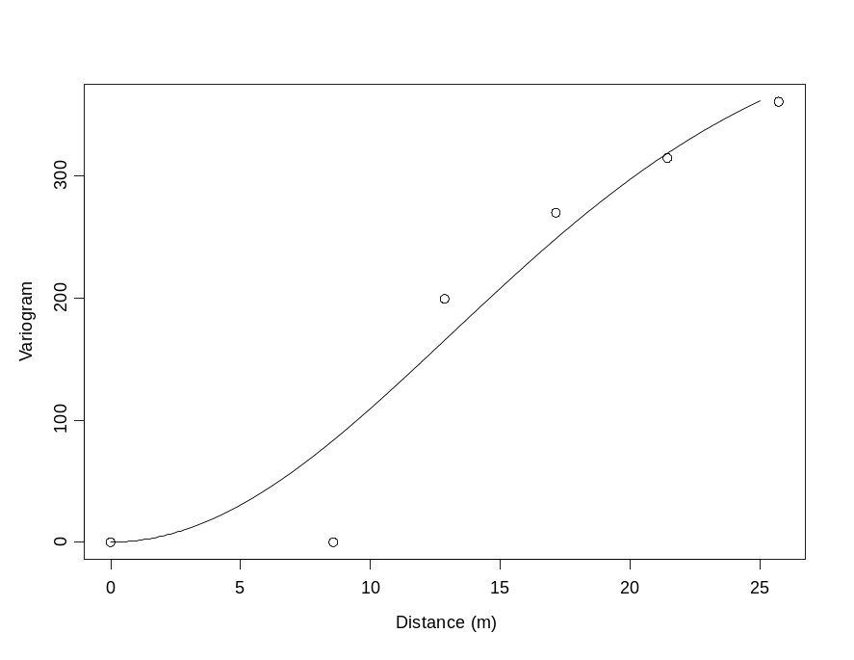

Colorado 10 m, not tasseled cap, presence only
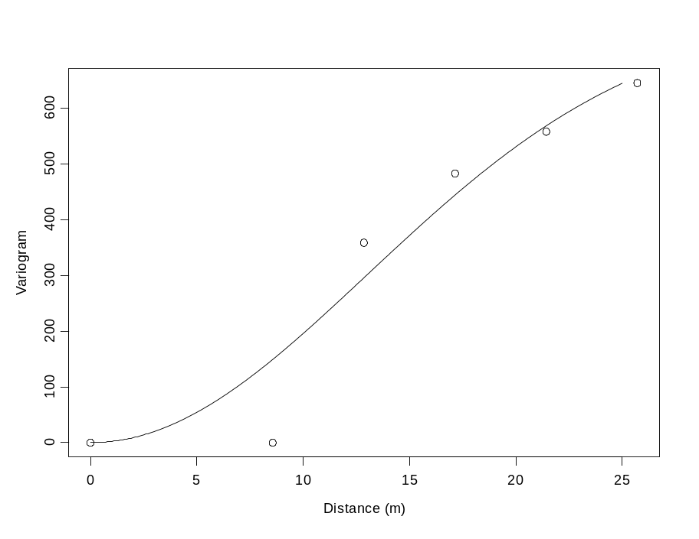

APPENDIX D
Trees of the pruned Presence/Absence models and the pruned regression tree.
Where text overlaps because tree is too intricate, text of the tree has been added for clarity.

Colorado 10 m/all data/with Tasseled Cap
Presence/Absence Tree
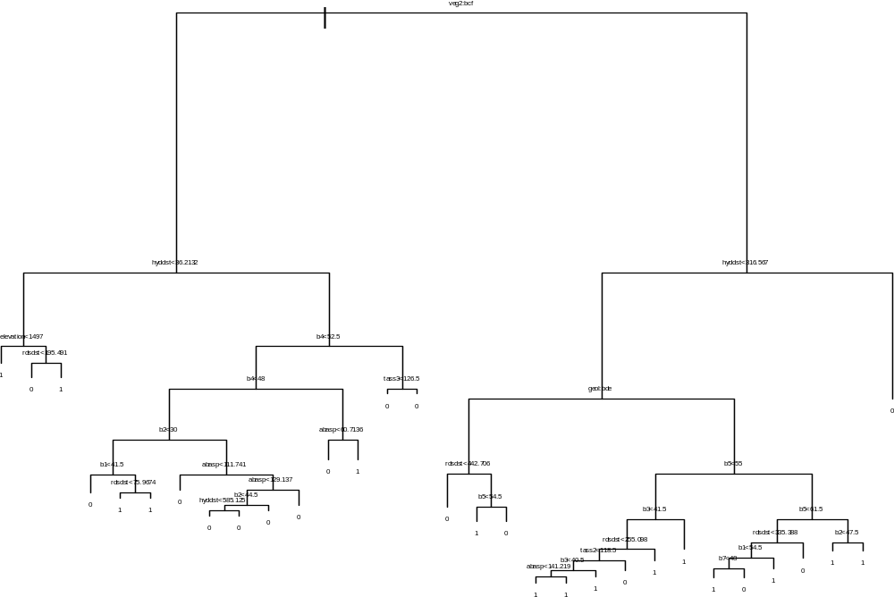
1) root 846 1150.000 0 ( 0.58270 0.417300 )
2) veg2:30,80,500 435 396.800 0 ( 0.82990 0.170100 )
4) hyddst<36.2132 41 49.570 1 ( 0.29270 0.707300 )
8) elevation<1497 16 0.000 1 ( 0.00000 1.000000 ) *
9) elevation>1497 25 34.620 1 ( 0.48000 0.520000 )
18) rdsdst<195.491 10 6.502 0 ( 0.90000 0.100000 ) *
19) rdsdst>195.491 15 15.010 1 ( 0.20000 0.800000 ) *

5) hyddst>36.2132 394 279.900 0 ( 0.88580 0.114200 )
10) b4<52.5 242 229.500 0 ( 0.81820 0.181800 )
20) b4<48 209 140.700 0 ( 0.89470 0.105300 )
40) b2<30 27 37.390 0 ( 0.51850 0.481500 )
80) b1<41.5 9 0.000 0 ( 1.00000 0.000000 ) *
81) b1>41.5 18 21.270 1 ( 0.27780 0.722200 )
162) rdsdst<75.9674 6 0.000 1 ( 0.00000 1.000000 ) *
163) rdsdst>75.9674 12 16.300 1 ( 0.41670 0.583300 ) *
41) b2>30 182 71.670 0 ( 0.95050 0.049450 )
82) abasp<111.741 94 0.000 0 ( 1.00000 0.000000 ) *
83) abasp>111.741 88 58.090 0 ( 0.89770 0.102300 )
166) abasp<129.137 42 43.640 0 ( 0.78570 0.214300 )
332) b2<44.5 34 39.300 0 ( 0.73530 0.264700 )
664) hyddst<585.125 20 26.920 0 ( 0.60000 0.400000 ) *
665) hyddst>585.125 14 7.205 0 ( 0.92860 0.071430 ) *
333) b2>44.5 8 0.000 0 ( 1.00000 0.000000 ) *
167) abasp>129.137 46 0.000 0 ( 1.00000 0.000000 ) *
21) b4>48 33 42.010 1 ( 0.33330 0.666700 )
42) abasp<60.7136 11 10.430 0 ( 0.81820 0.181800 ) *
43) abasp>60.7136 22 13.400 1 ( 0.09091 0.909100 ) *
11) b4>52.5 152 12.040 0 ( 0.99340 0.006579 )
22) tass3<126.5 137 0.000 0 ( 1.00000 0.000000 ) *
23) tass3>126.5 15 7.348 0 ( 0.93330 0.066670 ) *
3) veg2:11,92,400,513,700 411 516.000 1 ( 0.32120 0.678800 )

6) hyddst<316.567 366 401.400 1 ( 0.23770 0.762300 )
12) geol:2,37,91 52 60.580 0 ( 0.73080 0.269200 )
24) rdsdst<442.706 29 0.000 0 ( 1.00000 0.000000 ) *
25) rdsdst>442.706 23 30.790 1 ( 0.39130 0.608700 )
50) b5<54.5 15 11.780 1 ( 0.13330 0.866700 ) *
51) b5>54.5 8 6.028 0 ( 0.87500 0.125000 ) *
13) geol:1,113,121 314 272.000 1 ( 0.15610 0.843900 )
26) b5<55 247 138.900 1 ( 0.08097 0.919000 )
52) b3<41.5 130 111.600 1 ( 0.15380 0.846200 )
104) rdsdst<255.098 103 101.400 1 ( 0.19420 0.805800 )
208) tass2<118.5 90 74.330 1 ( 0.14440 0.855600 )
416) b3<40.5 81 56.510 1 ( 0.11110 0.888900 )
832) abasp<141.219 43 41.320 1 ( 0.18600 0.814000 ) *
833) abasp>141.219 38 9.249 1 ( 0.02632 0.973700 ) *
417) b3>40.5 9 12.370 1 ( 0.44440 0.555600 ) *
209) tass2>118.5 13 17.940 0 ( 0.53850 0.461500 ) *
105) rdsdst>255.098 27 0.000 1 ( 0.00000 1.000000 ) *
53) b3>41.5 117 0.000 1 ( 0.00000 1.000000 ) *
27) b5>55 67 91.670 1 ( 0.43280 0.567200 )
54) b5<61.5 40 51.800 0 ( 0.65000 0.350000 )
108) rdsdst<335.388 27 37.390 1 ( 0.48150 0.518500 )
216) b1<54.5 21 27.910 0 ( 0.61900 0.381000 )
432) b7<48 8 8.997 1 ( 0.25000 0.750000 ) *
433) b7>48 13 11.160 0 ( 0.84620 0.153800 ) *
217) b1>54.5 6 0.000 1 ( 0.00000 1.000000 ) *
109) rdsdst>335.388 13 0.000 0 ( 1.00000 0.000000 ) *
55) b5>61.5 27 18.840 1 ( 0.11110 0.888900 )
110) b2<47.5 18 0.000 1 ( 0.00000 1.000000 ) *
111) b2>47.5 9 11.460 1 ( 0.33330 0.666700 ) *
7) hyddst>316.567 45 0.000 0 ( 1.00000 0.000000 ) *

Regression Tree
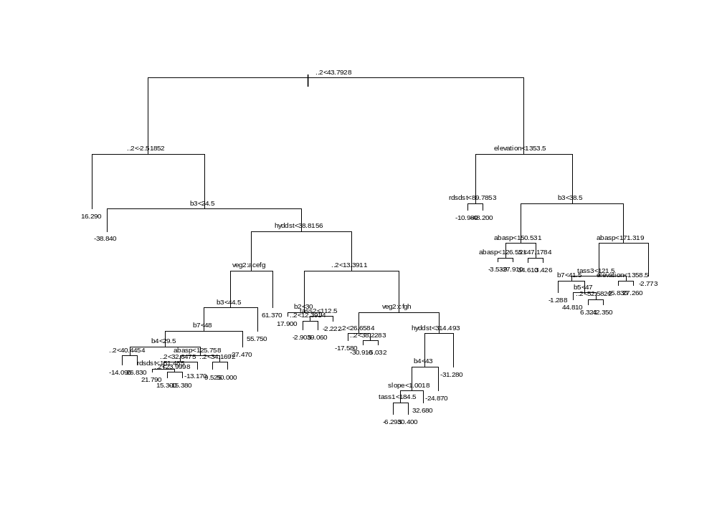
1) root 846 687200.00 8.525e-016
2) ..2<43.7928 682 435400.00 -4.018e+000
4) ..2<-2.51852 86 7701.00 1.629e+001 *
5) ..2>-2.51852 596 387200.00 -6.948e+000
10) b3<24.5 16 256.30 -3.884e+001 *
11) b3>24.5 580 370200.00 -6.068e+000

22) hyddst<38.8156 115 151800.00 8.201e+000
44) veg2:11,80,400,500,513 106 124200.00 3.687e+000
88) b3<44.5 100 105800.00 5.628e-001
176) b7<48 87 91130.00 4.751e+000

352) b4<29.5 30 17870.00 -7.267e+000
704) ..2<40.4454 25 7776.00 -1.409e+001 *
705) ..2>40.4454 5 3121.00 2.683e+001 *

353) b4>29.5 57 66640.00 1.108e+001

706) abasp<125.758 44 45780.00 6.016e+000
1412) ..2<32.6475 34 38130.00 1.166e+001
2824) rdsdst<151.485 14 21170.00 2.179e+001 *
2825) rdsdst>151.485 20 14520.00 4.562e+000
5650) ..2<23.9998 13 9441.00 1.530e+001 *
5651) ..2>23.9998 7 791.20 -1.538e+001 *
1413) ..2>32.6475 10 2884.00 -1.317e+001 *

707) abasp>125.758 13 15920.00 2.821e+001
1414) ..2<34.1692 7 9369.00 9.525e+000 *
1415) ..2>34.1692 6 1259.00 5.000e+001 *
177) b7>48 13 2913.00 -2.747e+001 *
89) b3>44.5 6 1134.00 5.575e+001 *
45) veg2:700 9 64.06 6.137e+001 *

23) hyddst>38.8156 465 189200.00 -9.597e+000
46) ..2<13.3911 197 33750.00 -7.978e-002
92) b2<30 9 1650.00 1.790e+001 *
93) b2>30 188 29050.00 -9.404e-001

186) tass2<112.5 16 11040.00 1.283e+001
372) ..2<12.3914 10 1010.00 -2.905e+000 *
373) ..2>12.3914 6 3428.00 3.906e+001 *

187) tass2>112.5 172 14690.00 -2.222e+000 *
47) ..2>13.3911 268 124500.00 -1.659e+001
94) veg2:80,500,513,700 178 20530.00 -2.202e+001
188) ..2<26.6584 109 5134.00 -1.758e+001 *
189) ..2>26.6584 69 9852.00 -2.903e+001
378) ..2<38.2283 64 1699.00 -3.091e+001 *
379) ..2>38.2283 5 5048.00 -5.032e+000 *
95) veg2:400 90 88310.00 -5.856e+000
190) hyddst<314.493 63 61240.00 5.042e+000
380) b4<43 48 39820.00 1.439e+001
760) slope<1.0018 31 23140.00 4.359e+000
1520) tass1<184.5 22 12580.00 -6.295e+000 *
1521) tass1>184.5 9 1957.00 3.040e+001 *
761) slope>1.0018 17 7879.00 3.268e+001 *
381) b4>43 15 3813.00 -2.487e+001 *
191) hyddst>314.493 27 2120.00 -3.128e+001 *
3) ..2>43.7928 164 195000.00 1.671e+001
6) elevation<1353.5 14 10010.00 -3.225e+001
12) rdsdst<89.7853 6 3169.00 -1.098e+001 *
13) rdsdst>89.7853 8 2095.00 -4.820e+001 *
7) elevation>1353.5 150 148300.00 2.128e+001
14) b3<38.5 34 35230.00 -4.692e+000

28) abasp<150.531 21 12600.00 -1.863e+001
56) abasp<126.551 8 3791.00 -3.539e+000 *
57) abasp>126.551 13 5869.00 -2.791e+001 *

29) abasp>150.531 13 11960.00 1.782e+001
58) ..2<47.1784 6 2847.00 3.461e+001 *
59) ..2>47.1784 7 5975.00 3.426e+000 *
15) b3>38.5 116 83420.00 2.889e+001

30) abasp<171.319 96 47510.00 3.549e+001
60) tass3<121.5 43 31210.00 2.879e+001
120) b7<41.5 8 7014.00 -1.288e+000 *
121) b7>41.5 35 15310.00 3.566e+001
242) b5<47 22 465.60 4.481e+001 *
243) b5>47 13 9886.00 2.018e+001
486) ..2<52.5822 8 5815.00 6.321e+000 *
487) ..2>52.5822 5 77.40 4.235e+001 *
61) tass3>121.5 53 12800.00 4.092e+001
122) elevation<1358.5 39 3272.00 4.583e+001 *
123) elevation>1358.5 14 5976.00 2.726e+001 *

31) abasp>171.319 20 11680.00 -2.773e+000 *

Colorado 10 m data, presence only, with Tasseled Cap
Regression Tree

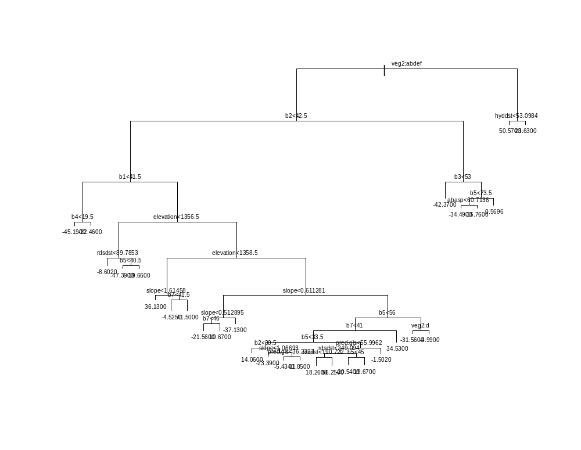

1) root 459 511300.0 1.5830

2) veg2:11,80,400,500,513 435 460300.0 -0.7481
4) b2<42.5 354 360100.0 4.5210
8) b1<41.5 27 9530.0 -30.0400
16) b4<19.5 9 163.2 -45.1900 *
17) b4>19.5 18 6268.0 -22.4600 *
9) b1>41.5 327 315700.0 7.3740

18) elevation<1356.5 42 30510.0 -18.1000
36) rdsdst<89.7853 26 13830.0 -8.6020 *
37) rdsdst>89.7853 16 10530.0 -33.5300
74) b5<40.5 8 594.2 -47.3900 *
75) b5>40.5 8 6859.0 -19.6600 *

19) elevation>1356.5 285 253900.0 11.1300
38) elevation<1358.5 63 26110.0 31.0900
76) slope<1.61458 45 2972.0 36.1300 *

77) slope>1.61458 18 19140.0 18.4900
154) b7<41.5 9 9543.0 -4.5250 *
155) b7>41.5 9 63.9 41.5000 *
39) elevation>1358.5 222 195600.0 5.4630

78) slope<0.611281 33 24850.0 -17.0200
156) slope<0.512895 24 16770.0 -9.4750
312) b7<46 15 8971.0 -21.5600 *
313) b7>46 9 1960.0 10.6700 *
157) slope>0.512895 9 3070.0 -37.1300 *
79) slope>0.611281 189 151100.0 9.3890
158) b5<56 171 134000.0 11.8300
316) b7<41 153 119000.0 9.1650
632) b5<33.5 77 56670.0 3.5670
1264) b2<30.5 26 16590.0 14.0600 *
1265) b2>30.5 51 35760.0 -1.7840
2530) slope<1.06693 6 1986.0 -23.3900 *
2531) slope>1.06693 45 30600.0 1.0970
5062) pred.gls<36.2327 28 7410.0 -5.4340 *
5063) pred.gls>36.2327 17 20020.0 11.8500 *
633) b5>33.5 76 57470.0 14.8400
1266) pred.gls<55.9962 62 41320.0 18.5200
2532) rdsdst<249.094 41 17180.0 23.8200
5064) rdsdst<190.722 35 9490.0 18.2600 *
5065) rdsdst>190.722 6 300.7 56.2500 *
2533) rdsdst>249.094 21 20740.0 8.1830
5066) b5<45 6 2890.0 -20.5400 *
5067) b5>45 15 10930.0 19.6700 *
1267) pred.gls>55.9962 14 11570.0 -1.5020 *
317) b7>41 18 4637.0 34.5300 *
159) b5>56 18 6401.0 -13.8500
318) veg2:400 6 1326.0 -31.5600 *
319) veg2:500,513 12 2251.0 -4.9900 *
5) b2>42.5 81 47360.0 -23.7800
10) b3<53 27 5049.0 -42.3700 *
11) b3>53 54 28310.0 -14.4800
22) b5<73.5 36 14140.0 -22.0000
44) abasp<60.7136 12 833.1 -34.4900 *
45) abasp>60.7136 24 10500.0 -15.7600 *
23) b5>73.5 18 8053.0 0.5696 *
3) veg2:92,700 24 5858.0 43.8300
6) hyddst<53.0984 18 1069.0 50.5700 *
7) hyddst>53.0984 6 1524.0 23.6300 *

Colorado 30 m data, with Tasseled Cap
Presence/Absence Tree
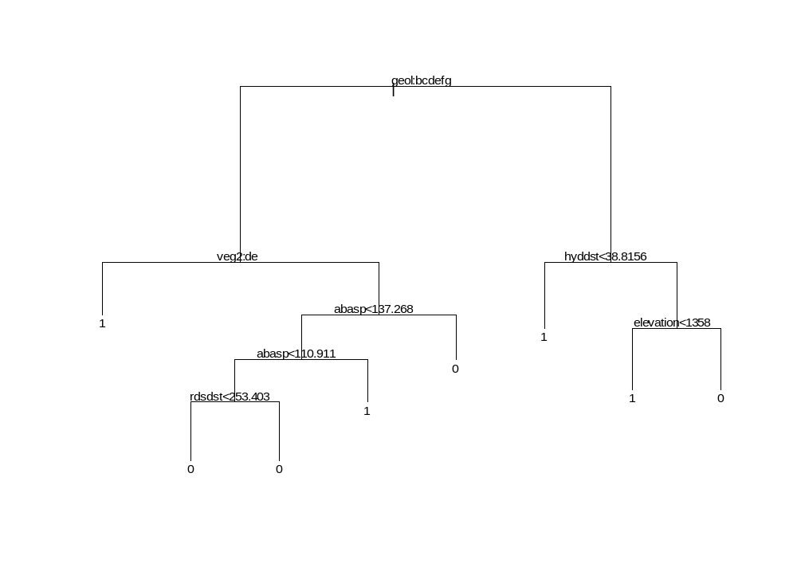
Regression Tree

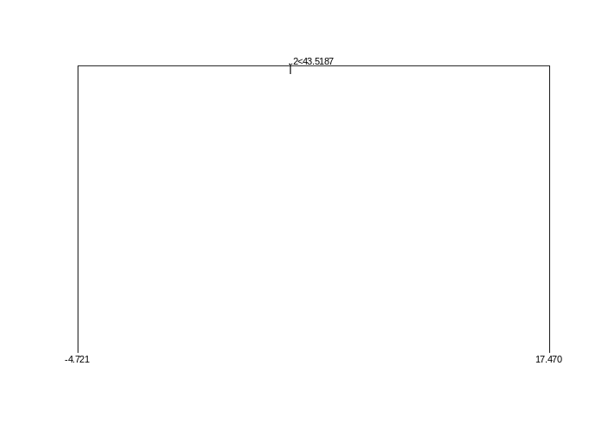
Colorado 30 m data, presence only, with Tasseled Cap
Regression Tree
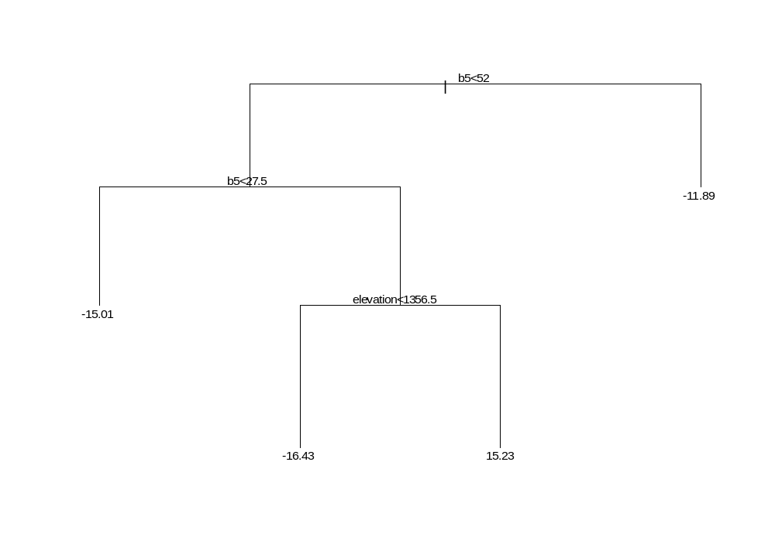

Colorado 10 m data, no Tasseled Cap
Presence/Absence Tree
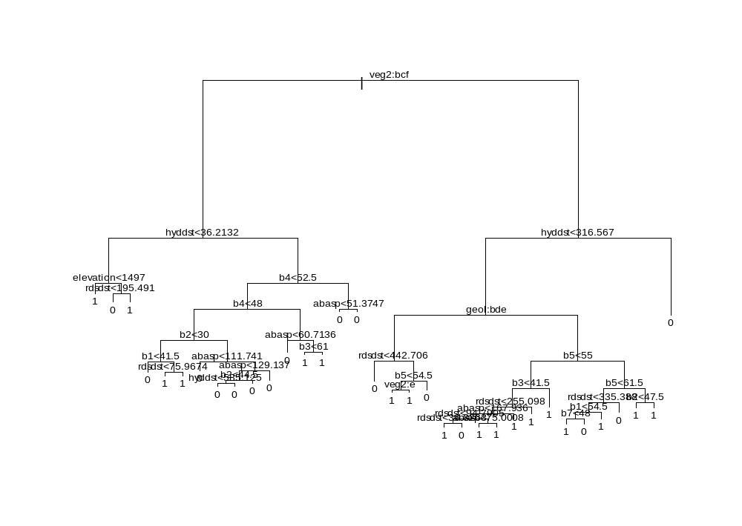
1) root 846 1150.000 0 ( 0.58270 0.417300 )
2) veg2:30,80,500 435 396.800 0 ( 0.82990 0.170100 )
4) hyddst<36.2132 41 49.570 1 ( 0.29270 0.707300 )
8) elevation<1497 16 0.000 1 ( 0.00000 1.000000 ) *
9) elevation>1497 25 34.620 1 ( 0.48000 0.520000 )
18) rdsdst<195.491 10 6.502 0 ( 0.90000 0.100000 ) *
19) rdsdst>195.491 15 15.010 1 ( 0.20000 0.800000 ) *

5) hyddst>36.2132 394 279.900 0 ( 0.88580 0.114200 )
10) b4<52.5 242 229.500 0 ( 0.81820 0.181800 )
20) b4<48 209 140.700 0 ( 0.89470 0.105300 )
40) b2<30 27 37.390 0 ( 0.51850 0.481500 )
80) b1<41.5 9 0.000 0 ( 1.00000 0.000000 ) *
81) b1>41.5 18 21.270 1 ( 0.27780 0.722200 )
162) rdsdst<75.9674 6 0.000 1 ( 0.00000 1.000000 ) *
163) rdsdst>75.9674 12 16.300 1 ( 0.41670 0.583300 ) *
41) b2>30 182 71.670 0 ( 0.95050 0.049450 )
82) abasp<111.741 94 0.000 0 ( 1.00000 0.000000 ) *
83) abasp>111.741 88 58.090 0 ( 0.89770 0.102300 )
166) abasp<129.137 42 43.640 0 ( 0.78570 0.214300 )
332) b2<44.5 34 39.300 0 ( 0.73530 0.264700 )
664) hyddst<585.125 20 26.920 0 ( 0.60000 0.400000 ) *
665) hyddst>585.125 14 7.205 0 ( 0.92860 0.071430 ) *
333) b2>44.5 8 0.000 0 ( 1.00000 0.000000 ) *
167) abasp>129.137 46 0.000 0 ( 1.00000 0.000000 ) *
21) b4>48 33 42.010 1 ( 0.33330 0.666700 )
42) abasp<60.7136 11 10.430 0 ( 0.81820 0.181800 ) *
43) abasp>60.7136 22 13.400 1 ( 0.09091 0.909100 )
86) b3<61 10 10.010 1 ( 0.20000 0.800000 ) *
87) b3>61 12 0.000 1 ( 0.00000 1.000000 ) *
11) b4>52.5 152 12.040 0 ( 0.99340 0.006579 )
22) abasp<51.3747 21 8.041 0 ( 0.95240 0.047620 ) *
23) abasp>51.3747 131 0.000 0 ( 1.00000 0.000000 ) *
3) veg2:11,92,400,513,700 411 516.000 1 ( 0.32120 0.678800 )

6) hyddst<316.567 366 401.400 1 ( 0.23770 0.762300 )
12) geol:2,37,91 52 60.580 0 ( 0.73080 0.269200 )
24) rdsdst<442.706 29 0.000 0 ( 1.00000 0.000000 ) *
25) rdsdst>442.706 23 30.790 1 ( 0.39130 0.608700 )
50) b5<54.5 15 11.780 1 ( 0.13330 0.866700 )
100) veg2:400 9 0.000 1 ( 0.00000 1.000000 ) *
101) veg2:513 6 7.638 1 ( 0.33330 0.666700 ) *
51) b5>54.5 8 6.028 0 ( 0.87500 0.125000 ) *
13) geol:1,113,121 314 272.000 1 ( 0.15610 0.843900 )
26) b5<55 247 138.900 1 ( 0.08097 0.919000 )
52) b3<41.5 130 111.600 1 ( 0.15380 0.846200 )
104) rdsdst<255.098 103 101.400 1 ( 0.19420 0.805800 )
208) abasp<167.936 76 85.470 1 ( 0.25000 0.750000 )
416) rdsdst<94.7905 25 34.300 1 ( 0.44000 0.560000 )
832) rdsdst<36.8263 11 10.430 1 ( 0.18180 0.818200 ) *
833) rdsdst>36.8263 14 18.250 0 ( 0.64290 0.357100 ) *
417) rdsdst>94.7905 51 44.310 1 ( 0.15690 0.843100 )
834) abasp<75.0008 9 12.370 1 ( 0.44440 0.555600 ) *
835) abasp>75.0008 42 26.420 1 ( 0.09524 0.904800 ) *
209) abasp>167.936 27 8.554 1 ( 0.03704 0.963000 ) *
105) rdsdst>255.098 27 0.000 1 ( 0.00000 1.000000 ) *
53) b3>41.5 117 0.000 1 ( 0.00000 1.000000 ) *
27) b5>55 67 91.670 1 ( 0.43280 0.567200 )
54) b5<61.5 40 51.800 0 ( 0.65000 0.350000 )
108) rdsdst<335.388 27 37.390 1 ( 0.48150 0.518500 )
216) b1<54.5 21 27.910 0 ( 0.61900 0.381000 )
432) b7<48 8 8.997 1 ( 0.25000 0.750000 ) *
433) b7>48 13 11.160 0 ( 0.84620 0.153800 ) *
217) b1>54.5 6 0.000 1 ( 0.00000 1.000000 ) *
109) rdsdst>335.388 13 0.000 0 ( 1.00000 0.000000 ) *
55) b5>61.5 27 18.840 1 ( 0.11110 0.888900 )
110) b2<47.5 18 0.000 1 ( 0.00000 1.000000 ) *
111) b2>47.5 9 11.460 1 ( 0.33330 0.666700 ) *
7) hyddst>316.567 45 0.000 0 ( 1.00000 0.000000 ) *

Regression Tree
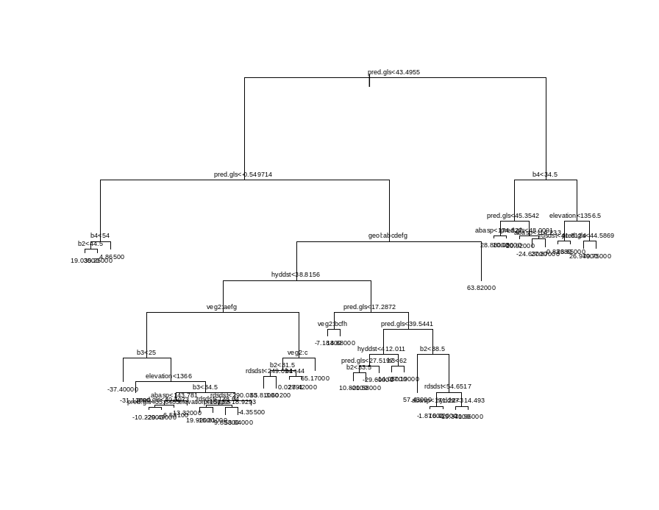
1) root 846 7.588e+005 1.03300

2) pred.gls<43.4955 705 5.133e+005 -3.69600
4) pred.gls<-0.549714 105 2.070e+004 17.76000
8) b4<54 75 1.333e+004 22.92000
16) b2<44.5 57 9.596e+003 19.03000 *
17) b2>44.5 18 1.353e+002 35.25000 *
9) b4>54 30 3.848e+002 4.86500 *
5) pred.gls>-0.549714 600 4.358e+005 -7.45100
10) geol:1,2,12,37,91,94,113 593 3.997e+005 -8.29200
20) hyddst<38.8156 144 1.917e+005 4.19700
40) veg2:11,400,500,513 108 1.072e+005 -5.66300
80) b3<25 18 3.135e+002 -37.40000 *
81) b3>25 90 8.512e+004 0.68430
162) elevation<1366 9 2.593e+003 -31.12000 *
163) elevation>1366 81 7.242e+004 4.21800
326) b3<34.5 37 2.273e+004 -6.51100

652) abasp<143.781 29 1.466e+004 -11.98000
1304) pred.gls<40.5973 24 7.747e+003 -15.84000
2608) pred.gls<33.6483 17 5.250e+003 -10.22000 *
2609) pred.gls>33.6483 7 6.549e+002 -29.49000 *
1305) pred.gls>40.5973 5 4.847e+003 6.53100 *

653) abasp>143.781 8 4.050e+003 13.32000 *
327) b3>34.5 44 4.185e+004 13.24000

654) rdsdst<290.035 35 3.692e+004 17.76000
1308) rdsdst<138.64 20 1.890e+004 10.74000
2616) elevation<1503.5 15 1.178e+004 19.92000 *
2617) elevation>1503.5 5 2.056e+003 -16.81000 *
1309) rdsdst>138.64 15 1.572e+004 27.13000
2618) pred.gls<18.9293 9 7.309e+003 9.85800 *
2619) pred.gls>18.9293 6 1.696e+003 53.04000 *

655) rdsdst>290.035 9 1.424e+003 -4.35500 *
41) veg2:80,700 36 4.254e+004 33.78000
82) veg2:80 27 3.042e+004 23.31000
164) b2<31.5 12 1.681e+004 38.72000
328) rdsdst<249.094 7 3.485e+002 63.81000 *
329) rdsdst>249.094 5 5.886e+003 3.60200 *
165) b2>31.5 15 8.480e+003 10.99000
330) b1<44 9 1.876e+003 0.02891 *
331) b1>44 6 3.903e+003 27.42000 *
83) veg2:700 9 2.956e+002 65.17000 *
21) hyddst>38.8156 449 1.783e+005 -12.30000

42) pred.gls<17.2872 200 2.274e+004 -5.76600
84) veg2:30,80,500,700 187 6.243e+003 -7.18800 *
85) veg2:400,513 13 1.069e+004 14.68000 *

43) pred.gls>17.2872 249 1.402e+005 -17.54000
86) pred.gls<39.5441 191 4.478e+004 -22.86000
172) hyddst<412.011 179 2.463e+004 -24.83000
344) pred.gls<27.5197 74 1.151e+004 -18.08000
688) b2<33.5 8 3.586e+003 10.80000 *
689) b2>33.5 66 4.419e+002 -21.58000 *
345) pred.gls>27.5197 105 7.360e+003 -29.60000 *
173) hyddst>412.011 12 9.059e+003 6.57100
346) b3<62 6 5.589e+002 -14.05000 *
347) b3>62 6 3.399e+003 27.19000 *
87) pred.gls>39.5441 58 7.226e+004 -0.03660
174) b2<38.5 9 2.258e-001 57.43000 *
175) b2>38.5 49 3.707e+004 -10.59000
350) rdsdst<54.6517 27 1.628e+004 4.09300
700) abasp<171.227 18 7.695e+003 -1.87000 *
701) abasp>171.227 9 6.664e+003 16.02000 *
351) rdsdst>54.6517 22 7.825e+003 -28.61000
702) hyddst<314.493 13 5.089e+003 -19.37000 *
703) hyddst>314.493 9 2.277e+001 -41.96000 *

11) geol:121 7 5.056e+001 63.82000 *

3) pred.gls>43.4955 141 1.509e+005 24.68000
6) b4<34.5 49 4.767e+004 2.12700

12) pred.gls<45.3542 22 1.217e+004 20.33000
24) abasp<174.827 12 2.307e+003 28.88000 *
25) abasp>174.827 10 7.933e+003 10.08000 *

13) pred.gls>45.3542 27 2.226e+004 -12.71000
26) pred.gls<48.0091 16 9.570e+003 -20.92000 *
27) pred.gls>48.0091 11 1.005e+004 -0.76950
54) abasp<114.233 6 7.843e+002 -24.63000 *
55) abasp>114.233 5 1.748e+003 27.87000 *
7) b4>34.5 92 6.505e+004 36.69000

14) elevation<1356.5 20 1.448e+004 10.18000
28) rdsdst<41.8124 11 6.296e+003 -0.83680 *
29) rdsdst>41.8124 9 5.220e+003 23.65000 *

15) elevation>1356.5 72 3.261e+004 44.06000
30) pred.gls<44.5869 18 1.491e+004 26.97000 *
31) pred.gls>44.5869 54 1.069e+004 49.75000 *
Colorado 10 m data, presence only, no Tasseled Cap

Regression Tree

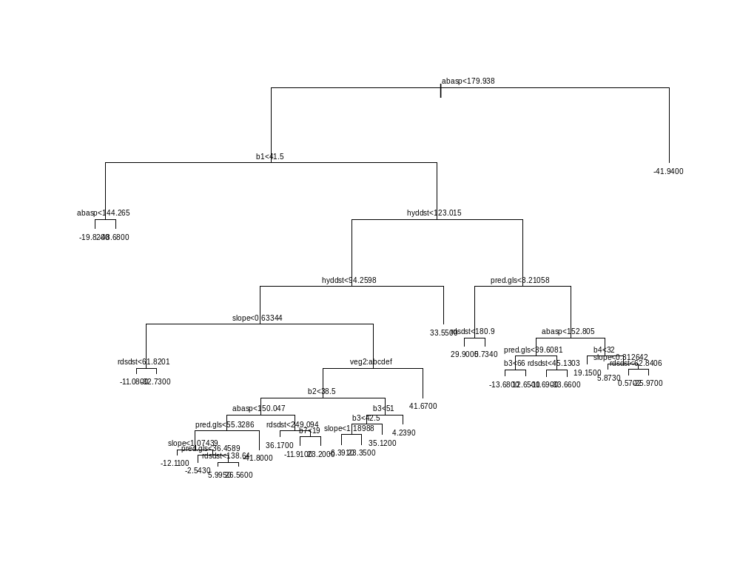
1) root 459 498500.0 1.5850
2) abasp<179.938 438 451200.0 3.6720
4) b1<41.5 27 11390.0 -29.4400
8) abasp<144.265 18 6232.0 -19.8200 *
9) abasp>144.265 9 165.3 -48.6800 *
5) b1>41.5 411 408200.0 5.8470

10) hyddst<123.015 258 257900.0 13.1600
20) hyddst<94.2598 216 227500.0 9.2000

40) slope<0.63344 24 18180.0 -21.0000
80) rdsdst<61.8201 13 7571.0 -11.0800 *
81) rdsdst>61.8201 11 7816.0 -32.7300 *

41) slope>0.63344 192 184700.0 12.9800
82) veg2:11,80,92,400,500,513 174 164200.0 10.0100
164) b2<38.5 102 109700.0 3.8140

328) abasp<150.047 75 73720.0 -1.7390
656) pred.gls<55.3286 69 62370.0 1.7450
1312) slope<1.07439 12 9765.0 -12.1100 *
1313) slope>1.07439 57 49820.0 4.6610
2626) pred.gls<36.4589 33 22430.0 -2.5430 *
2627) pred.gls>36.4589 24 23320.0 14.5700
5254) rdsdst<138.64 14 14640.0 5.9950 *
5255) rdsdst>138.64 10 6215.0 26.5600 *
657) pred.gls>55.3286 6 878.0 -41.8000 *

329) abasp>150.047 27 27270.0 19.2400

658) rdsdst<249.094 8 11850.0 36.1700 *

659) rdsdst>249.094 19 12160.0 12.1100
1318) b7<19 6 3063.0 -11.9100 *
1319) b7>19 13 4037.0 23.2000 *
165) b2>38.5 72 45000.0 18.7800

330) b3<51 54 34150.0 23.6300

660) b3<42.5 30 19030.0 14.4300
1320) slope<1.18988 9 4784.0 -6.3910 *
1321) slope>1.18988 21 8676.0 23.3500 *
661) b3>42.5 24 9410.0 35.1200 *
331) b3>51 18 5772.0 4.2390 *
83) veg2:700 18 4143.0 41.6700 *
21) hyddst>94.2598 42 9603.0 33.5500 *

11) hyddst>123.015 153 113200.0 -6.4900

22) pred.gls<3.21058 32 10620.0 20.0800
44) rdsdst<180.9 19 4015.0 29.9000 *
45) rdsdst>180.9 13 2103.0 5.7340 *

23) pred.gls>3.21058 121 74020.0 -13.5200
46) abasp<152.805 82 36430.0 -19.8000

92) pred.gls<39.6081 38 14040.0 -9.5210
184) b3<66 32 7145.0 -13.6800 *
185) b3>66 6 3389.0 12.6500 *

93) pred.gls>39.6081 44 14920.0 -28.6700
186) rdsdst<45.1303 10 2452.0 -11.6900 *
187) rdsdst>45.1303 34 8739.0 -33.6600 *
47) abasp>152.805 39 27560.0 -0.3139
94) b4<32 9 1822.0 19.1500 *

95) b4>32 30 21300.0 -6.1540
190) slope<0.312642 12 5883.0 5.8730 *
191) slope>0.312642 18 12530.0 -14.1700
382) rdsdst<62.8406 8 5752.0 0.5702 *
383) rdsdst>62.8406 10 3645.0 -25.9700 *
3) abasp>179.938 21 5657.0 -41.9400 *
Colorado 30 m data, no Tasseled Cap
Presence/Absence Tree
Regression tree
Colorado 30 m data, presence only, no Tasseled Cap
Regression Tree
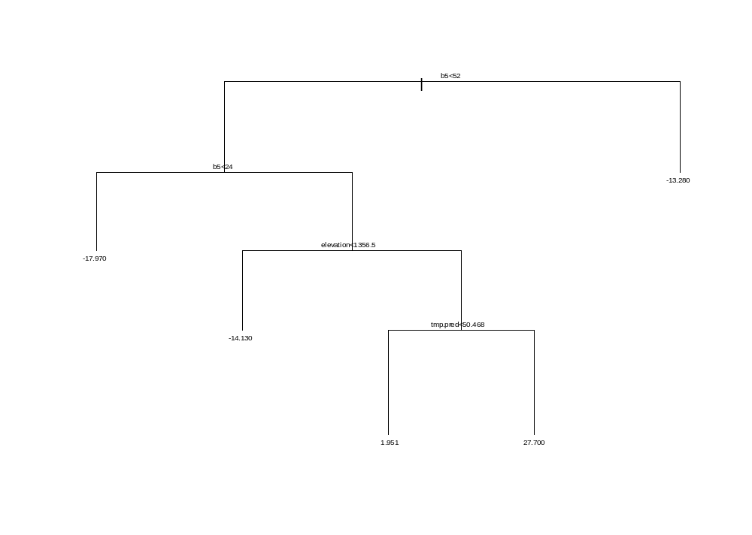

APPENDIX E
Tamarisk percent cover surfaces


